QUALITY ASSURANCE (QA) AND
QUALITY CONTROL (QC) PROGRAM

― Eureka High Arctic Weather Station ―

In support of the
Nunavut Water Board License
No. 8BC-EUR2131

Prepared by Environment and Climate Change Canada
Corporate Services and Finance Branch (CSFB)

September 2021

Control Page

On receipt of revisions and/or amendments, the Corporate Services and Finance Branch (CSFB) shall complete this control page to ensure that the Quality Assurance (QA) and Quality Control (QC) Program at Eureka High Arctic Weather Station (HAWS) is always current and consistently reflects the operations and activities taking place on site.

Version | Date in Force | Expiry Date | Description / Purpose
1 | November. 23rd, 2007 | November 22nd , 2008 | Original Program
2 | October 10, 2021 | October 9, 2022 | Update
3 | April 28, 2023 | April 27, 2024 | 3.3 Added remark “travel blanks”
 |  |  | 6.2 edited to “telescopic sampling pole with sampling canister”
 |  |  | Appendix A – Taiga Lab Instructions Updated
 |  |  | Appendix B – Monthly Water Testing Updated

Table of Contents
Control Page i
Table of Contents ii
Acronyms iii
1. Introduction 1
2. Program Objectives 2
3. Sample Handling 2
3.1 Preservation 2
3.2 Sample Identification 4
3.3 Transportation 4
4. Laboratory Analyses 5
4.1 Laboratory Accreditation 5
4.2 Detection Limits 5
4.3 Laboratory Methods 5
5. Reporting Requirements 6
6. Sample Collection 7
6.1 Sample Locations 7
6.1.1 EUR-1 Raw water supply prior to treatment at Station Creek 7
6.1.2 EUR-2 Runoff from the Solid Waste Disposal Facilities 7
6.1.3 EUR-3 Discharge from the Sewage Lagoon 8
6.1.4 EUR-4 Effluent discharge from the Landfarm 8
6.1.5 EUR-5 Runoff from quarry operations 8
6.1.6 EUR-6 Effluent discharge from Contaminated Soil Storage 8
6.1.7 EUR-7 Raw water supply at West Remus Creek 8
6.1.8 EUR-8 Raw water supply at Blacktop Creek 8
6.2 Sampling Equipment 12
6.3 Sampling Methods 12
6.3.1 EUR-1 Raw water supply prior to treatment at Station Creek 12
6.3.2 EUR-2 Runoff from the Solid Waste Disposal Facilities 13
6.3.3 EUR-3 Discharge from the Sewage Lagoon 13
6.3.4 EUR-4 Effluent discharge from the Landfarm 14
6.3.5 EUR-5 Runoff from quarry operations 14
6.3.6 EUR-6 Effluent discharge from Contaminated Soil Storage 15
6.3.7 EUR-7 Raw water supply at West Remus Creek 15
6.3.8 EUR-8 Raw water supply at Blacktop Creek 15
7. References 16
Appendix A 17
Taiga Laboratory Sampling Instructions 17
Appendix B 19
Eureka HAWS Potable Water Testing 19
Appendix C 32
Sewage Lagoon Decant 32

Acronyms

BOD | Biochemical Oxygen Demand
BTEX | Benzene, Toluene, Ethylbenzene and Xylene
CFSB | Corporate Services and Finance Branch
CIRNAC | Crown-Indigenous Relations and Northern Affairs Canada
CoC | Chain of Custody
ECCC | Environment and Climate Change Canada
GPS | Global Positioning System
HAWS | High Arctic Weather Station
HDPE | High Density Polyethylene
NWB | Nunavut Water Board
PPE | Personal Protective Equipment
pH | Measure of acidity and alkalinity
QA | Quality Assurance
QC | Quality Control
TKN | Total Kjeldahl Nitrogen
TSS | Total Suspended Solids
UV | Ultraviolet

1. Introduction

This document has been prepared in response to the requirements of the Nunavut Water Board License number 8BC-EUR2131, issued to Environment and Climate Change Canada (ECCC) on July 22, 2021. Specifically, this document satisfies the requirements set out in the above mentioned license, Part I, point 9, which states:

“Licensee shall submit for review of the Board, within ninety (90) days of issuance of this Licence, a revised Quality Assurance / Quality Control (QA/QC) Plan that includes field and laboratory procedures for sampling and analysis. The Plan shall include up to date sampling methods to all applicable standards, acceptable to an accredited laboratory as required by Part I, Item 8. The Plan submission shall include a cover letter from an accredited laboratory confirming acceptance of the Plan for analyses to be performed under this Licence.”

The requirements of the Nunavut Water Board License number 8BC-EUR2131 specifically target ECCC’s Eureka High Arctic Weather Station (HAWS) which is located on the north side of Slidre Fjord, at the north-western tip of Fosheim Peninsula on Ellesmere Island at 80º 0’ N and 85º56’ W.

Eureka HAWS is a weather monitoring facility that has been in operation since 1947. The Eureka HAWS is a centre of activity for ECCC, the Department of National Defence, Natural Resources Canada, and the Canadian Network for the Detection of Atmospheric Change. Most of the work is carried out in the short Arctic summer – June, July and August. The number of people located on-site varies between 8 and 34.

2. Program Objectives

This document will ensure that water samples collected in the field, as part of the requirements of the water licence, accurately reflect the physical and chemical nature of the water tested. The procedures described below refer to samples that are collected for:

- Quantity assessment of raw water supply.
  - Station Creek
  - Blacktop Creek
  - West Remus Creek
- Quantity assessment of wastewater discharge.
- Quality assessment of wastewater discharge.
- Quality assessment of runoff from waste disposal site.
- Quality assessment of runoff from quarry operations.
- Quality assessment of runoff from contaminated soil stockpiles.

To ensure a common understanding of these two terms, a definition for each is provided below:

- Quality Assurance (QA): is the system of activities designed to maintain a certain level of service or product.

- Quality Control (QC): is the system of procedures designed to maintain test sample outputs against specification.

3. Sample Handling

The following section describes the procedures for handling the samples collected at Eureka HAWS. See Appendix A for Taiga Laboratories Sampling Instructions.

3.1 Preservation

Raw and potable water testing are not required by the licence however are required for Occupational Health and Safety. Quality tests of raw and potable water are carried out on-site. See Appendix B for raw and potable water testing procedures.

The samples collected from EUR-2 Solid Waste Disposal Facility are preserved using the following methods:

Bottle | Preservative | Parameter
500 mL  plastic bottle | Nitric acid | Total metals
1 L  glass bottle | None | BTEX, total volatile hydrocarbons and total extractable hydrocarbons
Table 1. Methods for preserving samples collected from the solid waste disposal area.

The samples collected from EUR-3 Sewage Lagoon are preserved using the following methods: See Appendix C for Decanting Procedure.

Bottle | Preservative | Parameter
500 mL  plastic bottle | None | TSS and nitrate-nitrite (as N)
250 mL  plastic bottle | 50 mL 20% nitric acid | Total silver
1 L  plastic bottle | None | BOD
250  sterilized plastic bottle | Sodium thiosulfate | Fecal coliform
100  amber glass bottle | 1 ml 1:1 sulfuric acid | Phenols
500 mL  plastic bottle | 2 mL 1:1 sulfuric acid | Ammonia-N, TKN, P
Table 2. Methods for preserving samples collected from the sewage lagoon discharge and mixing zone.

3.2 Sample Identification

All sample locations from Section 6.1 will be used to label and identify all sample bottles respectively.

A clear Chain of Custody (CoC) record must be generated at the time of sampling, and must be part of the final report describing the sampling and results by either ECCC personnel or by contractors. The record must contain the following information:

- Identification of sampling site – general and specific (ex: Eureka - Sewage Lagoon);
- Sample ID (ex: EUR-3);
- Date, time and time zone of Collection;
- Name and affiliation of person(s) collecting the samples;
- Size of sample container;
- Analysis required; and
- Name and signature of all individuals involved in the chain of possession.

Sample bottles must be correctly labelled and must contain the following:

- Submission Number: Month Number (ex: March = 3);
- Field Sample Number: Sample Location ID (ex: EUR-3);
- Sample Description: general and specific (ex: Eureka - Sewage Lagoon);
- Date, Time and Time Zone; and
- Sampler Name.

3.3 Transportation

Samples from all media must be stored on-site in appropriate storage containers (ex: coolers with ice packs). The samples must not be frozen unless this is identified by the laboratory that shall be carrying out the analysis.

Travel Blanks are to be included in the storage container (cooler) so that it can be used to check for background contamination, contamination from transport and handling or both.

For some analysis (i.e. bacteriological analyses), it is imperative that the samples reach a laboratory in a specified time period. The sampling must be timed to align with a plane destined to the location where the samples shall be analyzed. The samples, when shipped, must be well packed to protect them from any harm along the way, especially if glass bottles are used. Also, if required, a label must be attached to the container to indicate what is contained in the container and if any special care is required (i.e. keeping the container cool).

4. Laboratory Analyses

The following section describes the requirements relating to the laboratory analyses of the samples collected at Eureka HAWS.

4.1 Laboratory Accreditation

Analysis of all samples collected for the Eureka Haws in support of the water license must be carried out by an accredited laboratory, ideally accredited by the Canadian Association for Environmental Analytical Laboratories. The laboratory must provide a certificate of their accreditation along with a copy of the methods used to analyze the samples and a copy of their QA/QC methods that were in place when the analyses were being carried out.

4.2 Detection Limits

The laboratory must provide detection limits for all of the methods that are used for the analysis of the samples.

4.3 Laboratory Methods

As stated in section 5.1, the laboratory must provide a copy of the methods used to analyze the samples.

5. Reporting Requirements

Eureka HAWS will select two sampling locations annually and must collect duplicate samples at these sampling points. These duplicates will serve as internal/external check for Eureka HAWS and the commercial laboratory.

Each full report must consist of the following (electronic or hard copy format):

- Objective – shall include who was doing the sampling, dates, site conditions.
- Description of sampling – equipment and sample containers used
- Identification of sampling point locations – GPS co-ordinates, photographs, narrative description, etc.
- List of samples collected, method of collection, preservation and transportation methods.
- Identification of laboratory that shall carry out the analysis of samples, letter of accreditation of the laboratory, description of methods used or clear references to already published methods that are being used for the analysis, method detection limits and full QA/QC used when analysing the samples.

All results shall be presented in a tabular format (electronic or hard copy) and shall include any special conditions that were associated with sample collection, transportation or analysis.

6. Sample Collection

The following section describes the various locations and methods used for collecting samples at Eureka HAWS.

6.1 Sample Locations

Station | Description | Parameter
EUR-1 | Raw water supply prior to treatment at Station Creek | Active (Volume)
EUR-2 | Runoff from the Solid Waste Disposal Facilities | Active (Quality)
EUR-3 | Effluent discharge from the Sewage Lagoon to the ocean | Active (Quality, Volume)
EUR-3 | Quantity in cubic meters of sludge removed from the Sewage Lagoon | Active (Quality, Volume)
EUR-4 | Effluent Discharge from the Landfarm | Active (Quality)
EUR-5 | Runoff from the quarry development at the exit point of ditches designed to collect and hold runoff water prior to release | Active (Quality)
EUR-6 | Effluent Discharge from the Temporary Contaminated Soil Storage | Active (Quality)
EUR-7 | Raw water supply at West Remus Creek | Active (Volume)
EUR-8 | Raw water supply at Blacktop Creek | Active (Volume)

6.1.1 EUR-1 Raw water supply prior to treatment at Station Creek

Located at the south west side of the fresh water lagoon near the Station Creek Bridge.

6.1.2 EUR-2 Runoff from the Solid Waste Disposal Facilities

Located near the east end of the runway, the solid waste disposal facility faces south into a ravine. There is a natural swale that runoff collects into where water sample is taken. It is not always possible to collect the samples and transport them to the lab within 24 hours.

6.1.3 EUR-3 Discharge from the Sewage Lagoon

Located at the south west end of the Sewage Lagoon near the Pump Shack. Two activities occur here; first to collect quality samples and second to measure quantity discharged.

6.1.4 EUR-4 Effluent discharge from the Landfarm

Located at the former tank farm just north west of the main complex. Runoff is collected from the natural drainage swales. It is not always possible to collect the samples and transport them to the lab within 24 hours.

6.1.5 EUR-5 Runoff from quarry operations

Originally located at Blacktop Creek quarry until the usable material was exhausted and then relocated to West Remus Creek quarry. Collected from drainage swales resulting from quarry operations. It is not always possible to collect the samples and transport them to the lab within 24 hours.

6.1.6 EUR-6 Effluent discharge from Contaminated Soil Storage

Located east of the barrel crushing site and south of the runway. Temporary storage area of contaminated soil excavated during the north apron runway upgrade and reconstruction. It is not always possible to collect the samples and transport them to the lab within 24 hours.

6.1.7 EUR-7 Raw water supply at West Remus Creek

Located at the West Remus Creek quarry where water is extracted for carwash or dust control purposes.

6.1.8 EUR-8 Raw water supply at Blacktop Creek

Located at the Blacktop Creek quarry where water is extracted for carwash or dust control purposes.

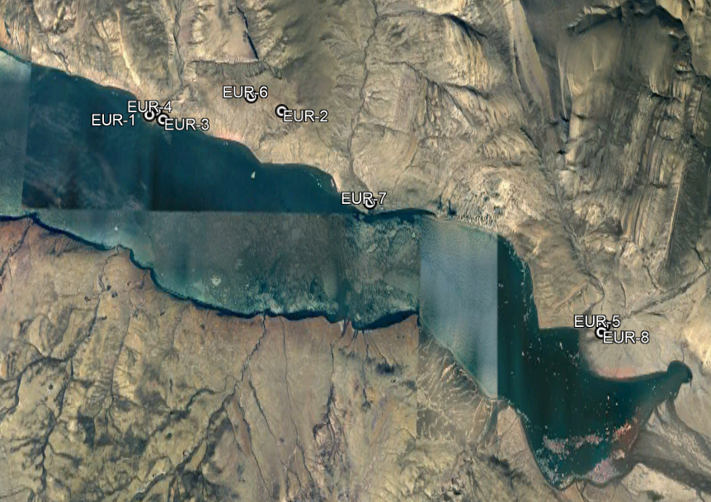
Eureka Site Plan: Water Sample Locations
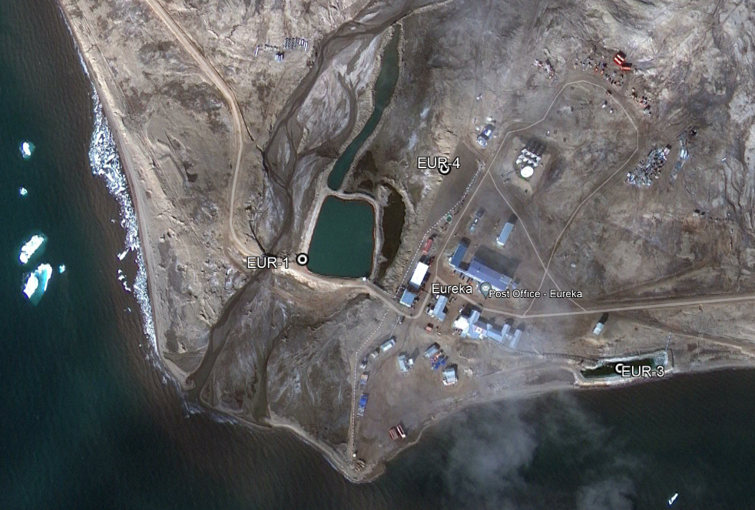
Eureka Site Plan: Main Complex Area
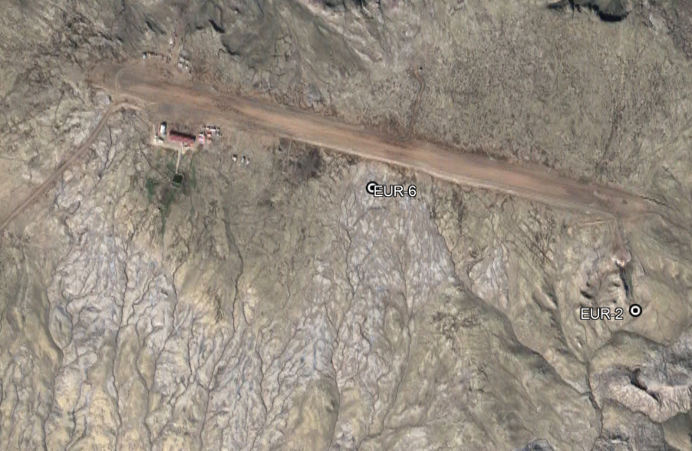
Eureka Site Plan: Airport
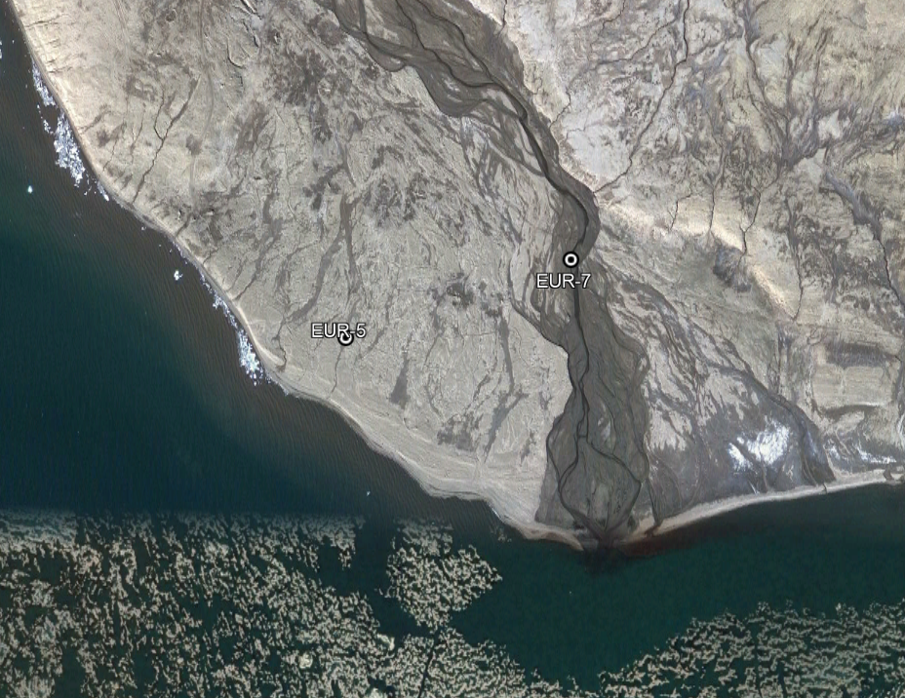
Eureka Site Plan: Black Top Creek Quarry
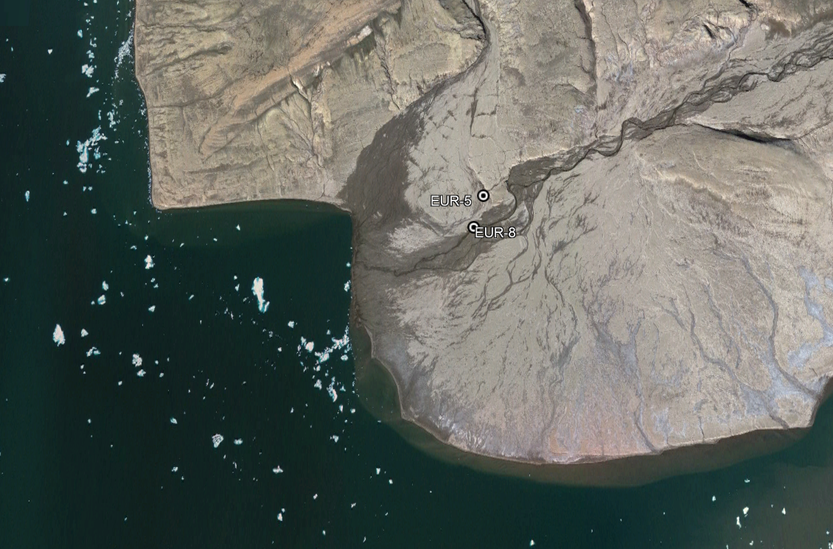
Eureka Site Plan: West Remus Creek Quarry

6.2 Sampling Equipment

- Safety footwear with skid proof soles or rubber boots
- Protective gloves; chemical resistant
- Safety glasses/face shield
- Respirator/face mask (if necessary)
- Coveralls or apron
- High visibility vest
- Sample bottles including field blanks
- Cooler full of ice
- Chain of Custody form
- Telescopic sampling pole with sampling canister
- Sample transfer funnel
- Paper towel or Kim-Wipes

6.3 Sampling Methods

All quantity samples are measured using inline mechanical flow meters that account for pump efficiency.

All quality samples are grab samples. A sample will be collected in its dedicated container and transferred into the sample bottles for transport.

6.3.1 EUR-1 Raw water supply prior to treatment at Station Creek

At location EUR-1, submersible water pumps with a 50mm NPT connection are positioned into Station Creek for water collection. These pumps are encased in a fine screen mesh to preserve aquatic life from being devastated by the pumps impeller. The submersible pumps have rigid 50mm PVC piping attached that matches the head output of the pumps. 50mm lay flat hose is connected to the PVC via cam lock connections which are then connected to the mechanical flow meters input. The output of the mechanical meters is a 1m length of 50mm PVC.

- Prior to operation the mechanical meters reading is recorded along with the date and time.
- At the end of operation a final reading is recorded along with the date and time.
- If the run time spanned overnight then the daily amount recorded is extrapolated by:
  - determining the total quantity pumped
  - determining the total run time
  - m³/hr pumped = total quantity / total run time
  - Q = m³/hr pumped x hours remaining that day

6.3.2 EUR-2 Runoff from the Solid Waste Disposal Facilities

- The timing is during periods of observed flow; this means during thaw months when it is raining. During or shortly after periods of rain, travel to the solid waste disposal site and go to the bottom of the valley. There are some natural drainage swales that should have the observable flow desired.
- Donne PPE.
- Collect runoff into a container and transfer it into the sample bottles.
  - Follow Appendix A Taiga Laboratory Sampling Instructions for details about specific bottles.
- Sample bottles need to be labeled with date, time, location and person.
- Store the samples just above freezing temperatures until transportation to the lab can be arranged.

6.3.3 EUR-3 Discharge from the Sewage Lagoon

This sample should be collected as the monthly during periods of ice free conditions within the lagoon. Time the collection of the sample to correspond with the arrival of the monthly resupply airplane. When timed correctly the samples should make it to the lab within about 18 hours. Samples fail if the holding time exceeds 24 hours.

- When the monthly produce charter has radioed into the station to say they are about 20mins out, travel to the sewage lagoon.
- Donne PPE.
- Use the telescopic sampling pole with the sampling canister fixed to the end and dip the sampling canister into the sewage lagoon to collect a sample.
- Transfer the sample from the sampling canister into a sample bottle.
  - Follow Appendix A Taiga Laboratory Sampling Instructions for details about specific bottles.
- Sample bottles need to be labeled with date, time, location and person.
- Place the bottles into a cooler full of ice.
- Label the cooler for transportation.
- Complete a CoC form to transfer custody to the airplane pilot.

6.3.4 EUR-4 Effluent discharge from the Landfarm

The timing is during periods of observed flow; this means during thaw months when it is raining.

- During or shortly after periods of rain travel to the landfarm and search for standing water or natural drainage swales on the embankment facing west.
- Donne PPE.
- Collect runoff into a collection container and transfer the runoff into the sample bottles.
  - Follow Appendix A Taiga Laboratory Sampling Instructions for details about specific bottles.
- Sample bottles need to be labeled with date, time, location and person.
- Store the samples just above freezing temperatures until transportation to the lab can be arranged.

6.3.5 EUR-5 Runoff from quarry operations

The timing is during periods of observed flow; this means during thaw months when it is raining.

- During or shortly after periods of rain travel to the West Remus Quarry and search for standing water or natural drainage swales on the landscape.
- Donne PPE.
- Collect runoff into a collection container and transfer the runoff into the sample bottles.
  - Follow Appendix A Taiga Laboratory Sampling Instructions for details about specific bottles.
- Sample bottles need to be labeled with date, time, location and person.
- Store the samples just above freezing temperatures until transportation to the lab can be arranged.

6.3.6 EUR-6 Effluent discharge from Contaminated Soil Storage

The timing is during periods of observed flow; this means during thaw months when it is raining.

- During or shortly after periods of rain travel to the Contaminated Soil Storage location and search for standing water or natural drainage swales down hill of the pile.
- Donne PPE.
- Collect runoff into a collection container and transfer the runoff into the sample bottles.
  - Follow Appendix A Taiga Laboratory Sampling Instructions for details about specific bottles.
- Sample bottles need to be labeled with date, time, location and person.
- Store the samples just above freezing temperatures until transportation to the lab can be arranged.

6.3.7 EUR-7 Raw water supply at West Remus Creek

General Contractor Nuna East Ltd might collect water from West Remus Creek for carwash or dust control purposes. Nuna has been instructed to use a meter on their water pumps and report all numbers to ECCC to include in the annual report.

6.3.8 EUR-8 Raw water supply at Blacktop Creek

General Contractor Nuna East Ltd might collect water from Blacktop Creek for carwash or dust control purposes. Nuna has been instructed to use a meter on their water pumps and report all numbers to ECCC to include in the annual report.

7. References

Nunavut Water Board Water Licence 8BC-EUR2131 July 22, 2021

Environment and Climate Change Canada’s Task Hazard Analysis #028 Sewage Handling and Sampling 2016-04-20

Environment and Climate Change Canada’s Safe Work Practice #028 Sewage Handling and Sampling 2016-04-20

Environment and Climate Change Canada’s Wastewater Systems Effluent Regulations: Sample Guidance Toolkit 2021

Taiga Environmental Laboratory Water Sampling Instructions February 06, 2021

Environment and Climate Change Canada’s Enforcement Officer’s Field Sampling Manual 2020

Environment and Climate Change Canada’s Water Quality Divisions Standard Operating Procedure Freshwater Sampling Red River at Emmerson December 2014

Department of Indian and Northern Affairs Canada, Water Resources Division and the Northwest Territories Water Board (1996). Quality assurance (QA) and Quality control (QC) Guidelines for use by class “B” licensees in collecting representative water samples in the field and for submission of a QA/QC plan.

Health Canada (2009). Guidelines for Canadian drinking water quality: Guideline technical document-Chlorine. Water Quality and Health Bureau, Healthy Environments and Consumer Safety Branch, Health Canada, Ottawa, Ontario

HACH Colorimeters DR300 Resource Library (hach.com) Documents 316.53.01486 and 316.53.01487

Appendix A

Taiga Laboratory Sampling Instructions
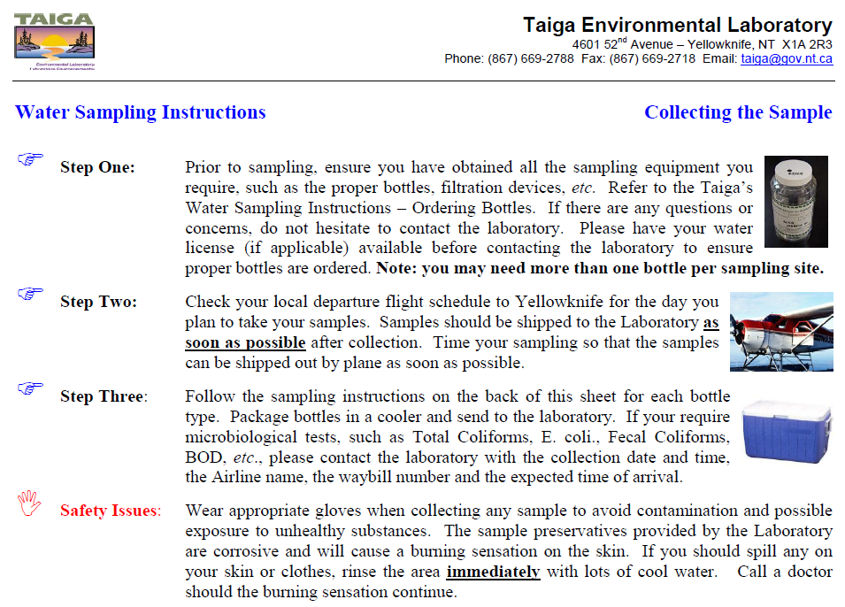
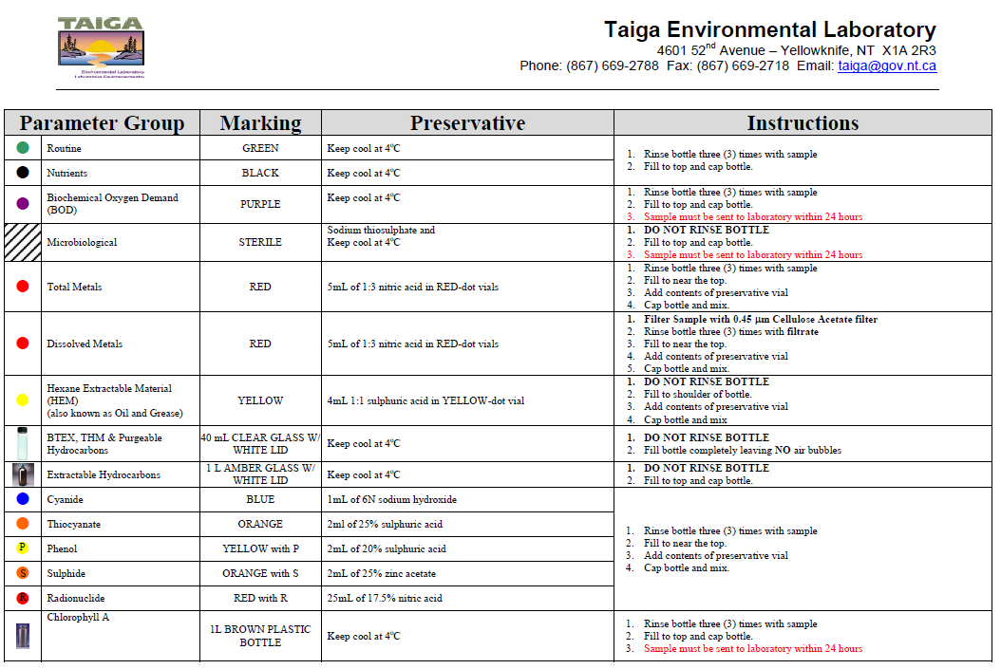

Appendix B

Eureka HAWS Potable Water Testing
Monthly Water Testing
Sample Locations: Weather Office Water Tap
Weather Office Reverse Osmosis Tap
Kitchen Tap
Tank Room Before Filtration - around back of first tank
New Garage Water Tanks – NE, NW, SE, SW
All Water Testing supplies are kept in the weather office.
Regularly check expiry dates of all products, order new supplies as required. It can take 2-3 months for delivery so plan ahead! Further water testing and ordering information can be found in SAO filing cabinet.
* Pre-heat incubator for the Colilert Test as it takes a while. First remove Quanti-Tray Comparator and thermometer, ensure it’s plugged in, then turn on power bar. Insert thermometer into hole on top of incubator. Dial should be set to around four, as marked on front. Allow it to warm up to 35°C ±0.5°C.
See end of document for New Garage Water Tank sampling procedures.
Chlorine Test (Free & Total)
You Will Need: SPEC Colour Standard
HACH Chlorine Test Kit
Stopwatch
Kim-wipes
Procedure Notes:
Start by confirming that the Colorimeter is working properly, using the Spec Colour Standards. See the Colorimeter manual for instrument instructions.
- Zero the colorimeter using the Zero standard.
- Properly align a colour standard in the instrument and record the instrument reading. Repeat steps 1 and 2 with all colour standards.
- Verify the readings are within the tolerance limits:
  - STD 1 – 0.22 +/- 0.09 mg/L
  - STD 2 – 0.92 +/- 0.10 mg/L
  - STD 3 – 1.63 +/- 0.14 mg/L
- If the colorimeter passes the verification test continue onto the water tests; Chlorine testing is done at all eight locations
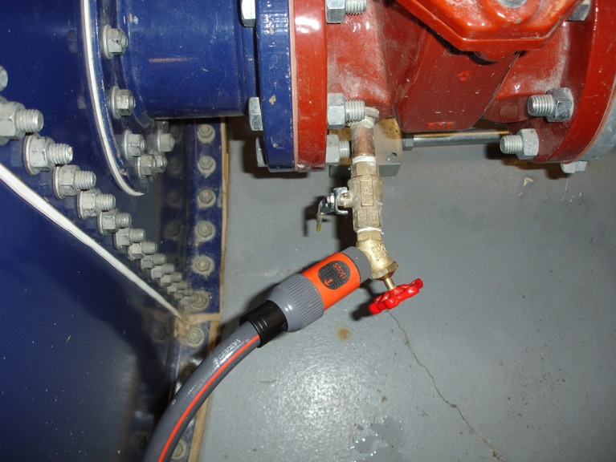
*The Blank Standard is not to be used for the water testing blank.
SAMPLING POINT
Inside the Pocket Colorimeter Test Kit is a manual with complete instructions on how to do the Chlorine tests, see pages 1-16 to 1-19. Test results should be in the Low Range however when testing the New Garage Water Tanks, which are pre-filtration, you may have to switch from Low Range to High Range; Low Range is between 0.02 to 2.00 mg/L and High Range is 0.1 to 8.0 mg/L. See instructions on how to switch the Colorimeter range settings on page 2-4.
The kit contains two test powder dispensers to test for ‘Total’ and ‘Free’ chlorine.
Between samples thoroughly cleanse the inside of sample bottles and lids with the water to be sampled. Be sure to zero the Colorimeter before the next test. Also wipe water and fingerprints from the outside of bottles before placing into cell compartment.
Allowable main complex levels, 0.1 mg/L to 0.2 mg/L

pH TEST
You Will Need: Oakton pH700 meter w/ electrode
Benchmark MiniMag magnetic stirrer
100mL Nalgene beaker
Distilled water
Buffer Solutions (pH 7.0 and at least one other)
Procedure Notes:
Remove the soaker bottle from the probe.
Calibration: a) Turn unit on. Press “CLEAR” for 5 seconds, “ATC”, “pH”, and “AUTO” will light up, “CAL” begins to flash.
b) Rinse probe with distilled water and immerse in first buffer solution (7.0). When temperature stabilizes hold “STAND” for 2 seconds. The “WAIT” will flash until there’s a stable reading. Once calibrated the “7.00” will light up and other values flash.
c) Rinse probe with distilled water and immerse in second buffer (4.01 or 10.0). When temperature stabilizes press “SLOPE/ENTER”. “WAIT” will flash until stable. Once calibrated the two buffers will light up and all others will flash.
d) Repeat step c) for last buffer. When finished press “MODE” to exit calibration.
Measurements: a) “pH” and “AUTO” should be lit up. If not press “MODE” until they are.
b) Rinse probe with distilled water and immerse in sample. Press “MEAS/EFF” key. “WAIT” will flash until stable. When “WAIT” disappears the pH can be recorded.
c) Repeat step b) for all other samples.
Replace the soaker bottle over the probe.
Note: Stable readings can take some time. It sometimes helps to stop the magnetic stirrer.
For more detailed instructions refer to the Oakton pH 700 Operating Instructions and the pH Electrode Instruction Manual.
Allowable levels 6.5 to 8.5

Colilert Test
Colilert simultaneously detects Total coliforms and E. coli in water. When total coliforms metabolize Colilert’s nutrient indicator, the sample turns yellow. When E. coli metabolizes Colilert’s nutrient indicator, the sample fluoresces.
You will need: Eight sterile IDEXX 120mL vessels with Sodium Thiosulphate
Eight Colilert Snap Packs containing white powder
Eight Quanti-Trays
Quanti-Tray Comparator
Procedure:
Label vessels and Quanti-Trays for each of the locations.
At each sample point allow water to run 5 minutes, fill vessel to 100mL line – do not touch faucet to bottle.
Switch the IDEXX Sealer ON to warm it up. Power switch is located on the back. The amber light on front will illuminate. Once both the amber and green lights are ON the Sealer is ready to go. Ensure the Input Shelf is attached to the front, and pull unit away from the wall to allow room for the sealed tray to exit.
Add contents of one Snap Pack to each sample. Tightly secure lid and shake sample until powder is dissolved.
Pour entire contents of sample bottles into Quanti-Trays. To open Quant-Tray: Hold with bubble packs facing palm, squeeze the edges so the backing and tray separates.
As you fill each Quanti-Tray, seal it in the IDEXX Quanti-Tray Sealer. Place a Quanti-Tray into the Rubber Insert. Place the Insert (groove end first) onto the Input Shelf. Slide into Sealer until the motor grabs and draws it in.
Should you need to reverse the movement of the tray, hit the Reverse button (this should not be done unless necessary).
In ~15 seconds the Tray and Insert should come out the back of the Sealer, and the Quanti-Tray will be sealed.
Once all Quanti-Trays have been sealed properly, turn off sealer. Place the stacked trays, bubble side up, into the incubator once the temperature has stabilized at 35°C. Incubate for 24 hours. Incubator takes about 2 hours to reach 35°C. Don’t adjust the setting in front…be patient.
After 24 hours…
Check samples against the Quanti-Tray Comparator using the Results Interpretation table (below). Count the number of positive wells and refer to the MPN table provided with Quanti-Tray shipments.
Look for fluorescence with a 6-watt, 365 nm, UV light. Hold light within 5 inches of the sample, in a dark environment.

Results Interpretation Table:
Appearance Result
Less yellow than the comparator Negative for total coliforms and E. coli
Yellow ≥ the comparator Positive for total coliforms
Yellow and fluorescence ≥ the comparator Positive for E. coli

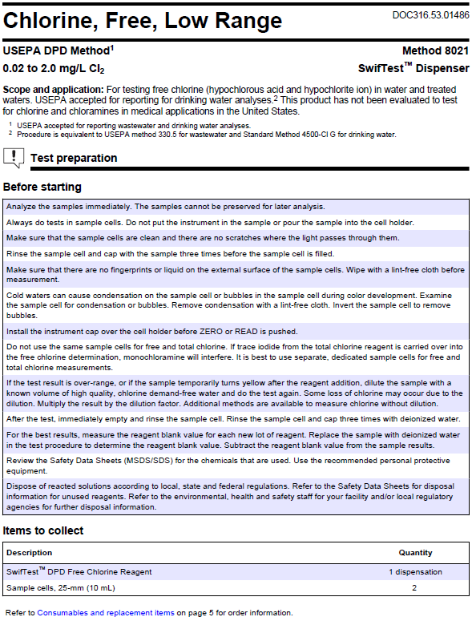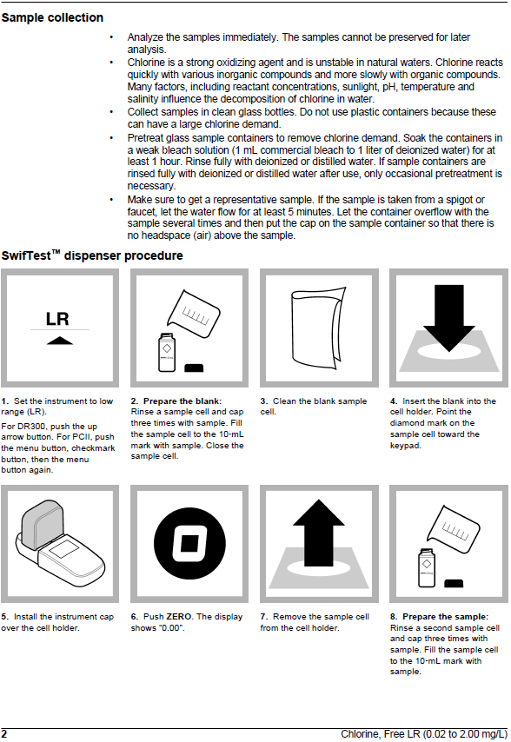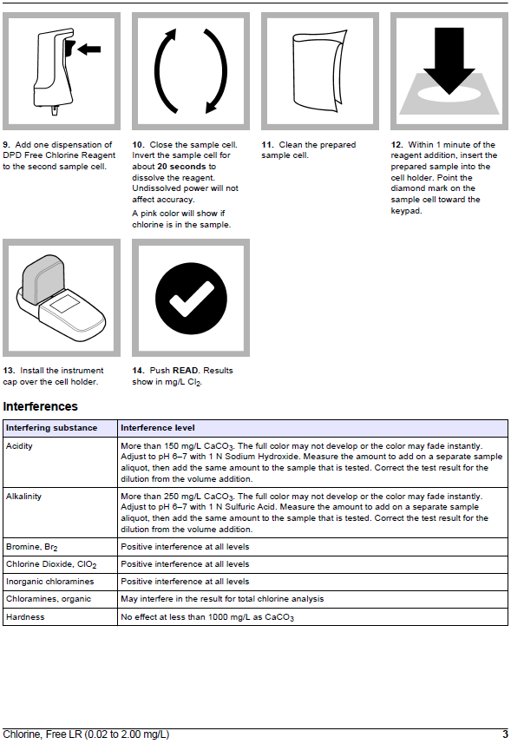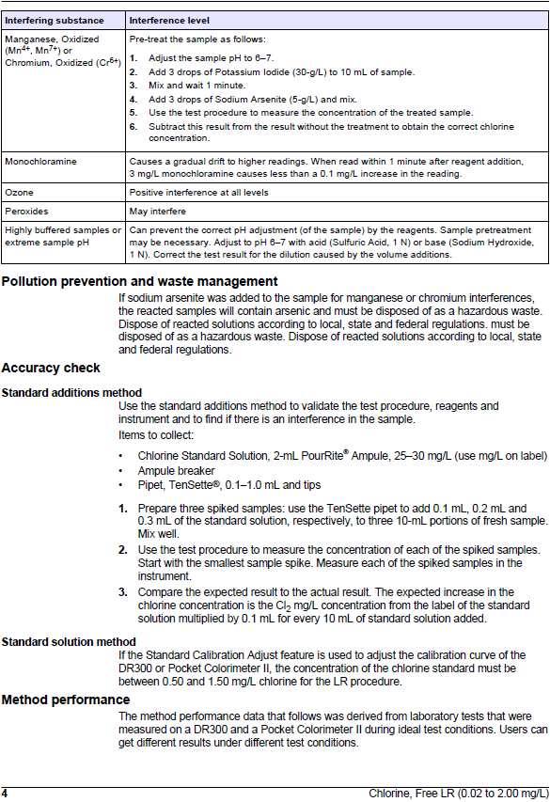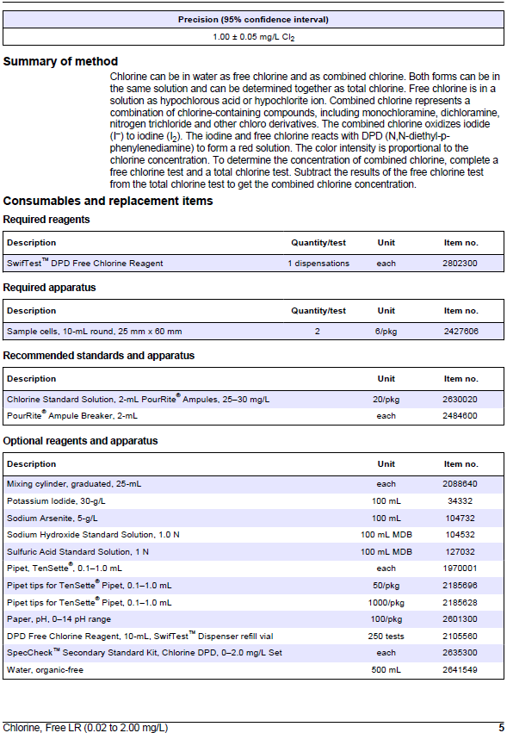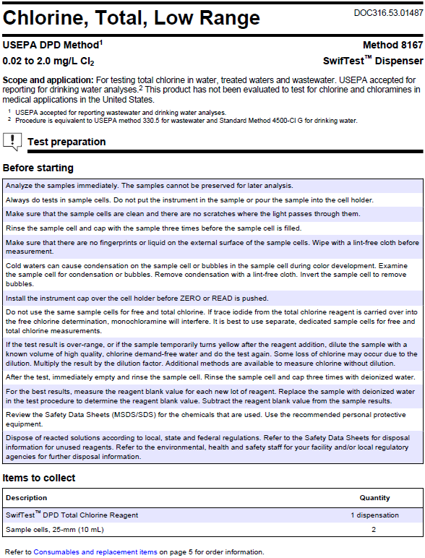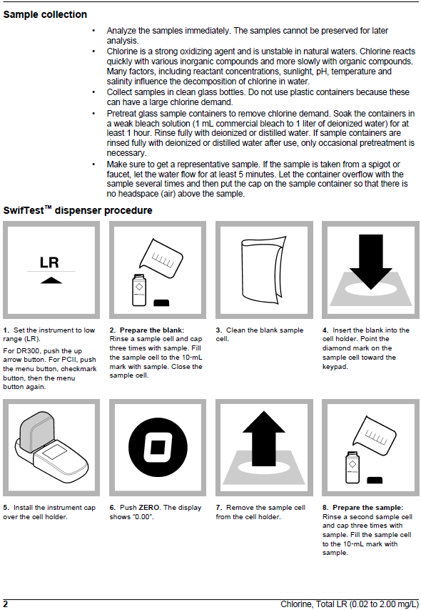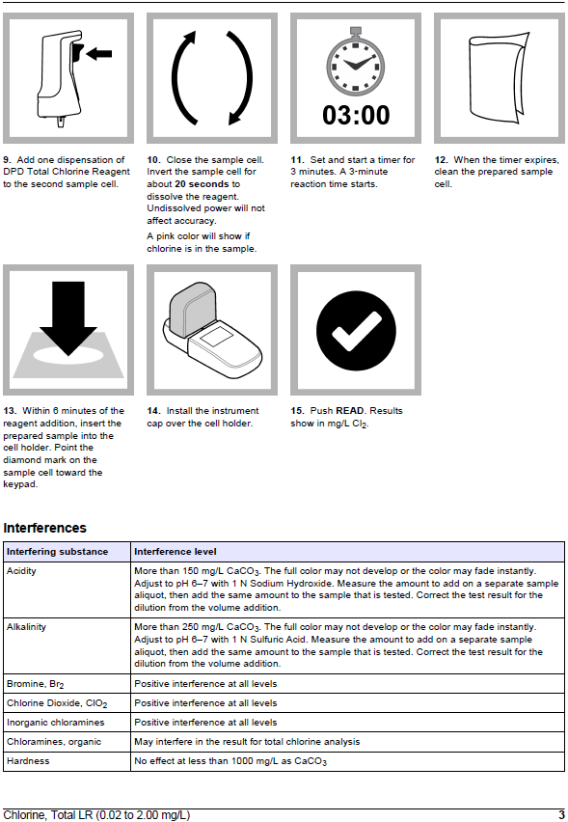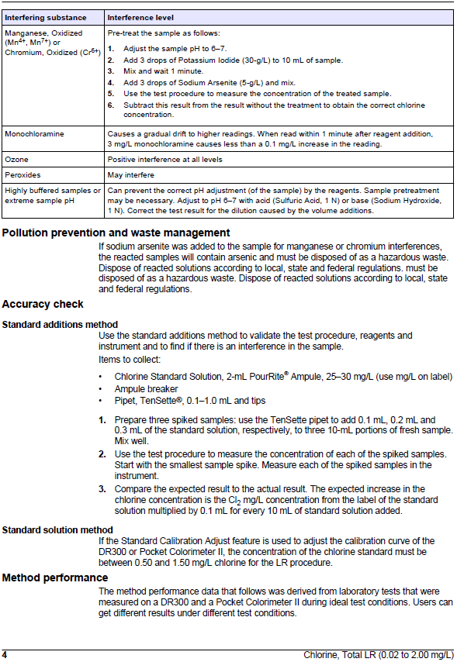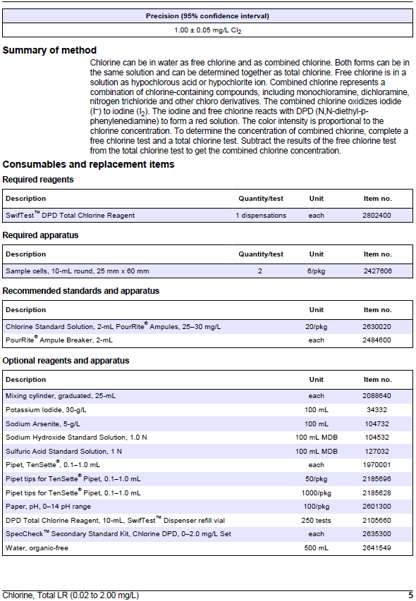

Appendix C

Sewage Lagoon Decant

Workflow:

- In the spring allow a fair amount of ice to thaw from the sewage lagoon. Generally late June or early July and time it with the monthly charter flight.
- Collect a sample from EUR-3 as outlined in Section 6.3.3.
- Prepare the sample for transport to laboratory for toxicity analysis.
- Allow the lab sufficient time to conduct their test. Generally about 10 business days.
- After 10 business days request a copy of the analysis from the lab even if it is still only preliminary. The final should arrive a few days later.
- Forward the results to CSFB. CSFB will forward the results to the CIRNAC Inspector for approval to decant the lagoon. This could take 10 business days.
- Only after approval is granted by CIRNAC can the lagoon be decanted.
- The quantity of discharge needs to be measured and recorded.
  - Set up the flow meter between the pump and discharge hose.
  - Record the date, time and meter reading before engaging the pump.
  - Decant the lagoon until there is only minimal sewage and ice remaining.
  - Stop the pump and record the date, time and meter reading again.
- Allow the remainder of the ice to thaw. Repeat the process for each month of open water conditions (June, July and August).
- The final August decant prepares the lagoon to survive the winter without a spill.

