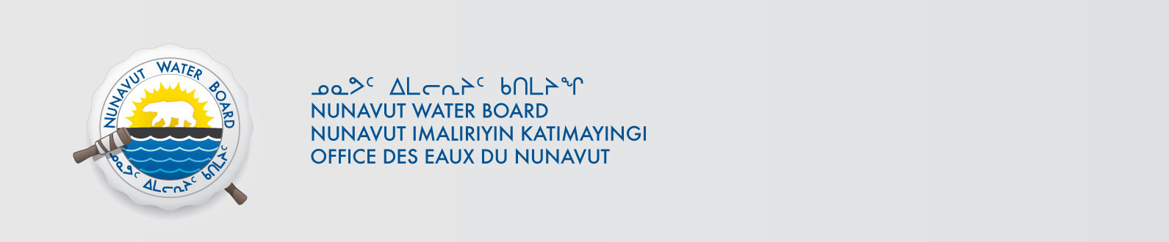

June 10, 2016 File No: 3BC-EUR1116NWB2MEL01--

Jean-Philippe Cloutier-Dussault
Environment Canada
Government of Canada
Email: jean-philippe.cloutier-dussault@canada.ca
Telephone (514) 283-4045

Subject: Environment Canada – WMC International Limited Eureka High Arctic Weather Station – Amendment Renewal – Type “B”, Qikiqtani Region

Dear Jean-Philippe:

The Nunavut Water Board (NWB) provides notice that, on June 7, 2016, an amendment/renewal an application for a licence renewalapplication for a Type “B” water license January 5, 2001for water use and/or waste disposal associated with exploratory drillingactivities in the Qikiqtani region of Nunavut was filed by Environment and Climate Change Canada in addition to the amendment application submitted on July 14, 2015. By way of this correspondence, the Board invites parties to provide the NWB with their comments with respect to the application as outlined below.
The application can be obtained from our ftp site at the following link:
ftp://ftp.nwb-oen.ca/1%20PRUC%20PUBLIC%20REGISTRY/3%20MUNICIPAL/3B/3BC%20-%20Camp/3BC-EUR1116%20(EC%20Eureka)/1%20APPLICATION/2015%20Amend%201/

Under the Nunavut Land Claims Agreement (NLCA), Article 11, Section 11.5.9 and s. 76 (1) of Nunavut Planning and Project Assessment Act (NuPPAA), the proponent of a project proposal governed by the NLCA and NuPPAA that requires a water licence is required to submit a project proposal document (which may include the water licence application) directly to the Nunavut Planning Commission (NPC or Commission). The NPC then reviews the project proposal and makes a determination regarding the applicable land use planning requirements and/or provides direction regarding whether the project proposal is subject to screening by the Nunavut Impact Review Board (NIRB). Under Articles 11, 12 and 13 of the NLCA, NuPPAA and Part 3 of the Nunavut Waters and Nunavut Surface Rights Tribunal Act (NWNSRTA), until the project proposal has concluded the applicable land use planning and assessment process required by the NPC and the NIRB, the NWB cannot issue a water licence.

On this basis, the NWB, while previously acknowledging the receipt of the application, waited for the Commission’s determination and recommendations before proceeding to the next steps in the NWB’s processing of the application. Please be advised that on September 4, 2015 the NWB received the required NIRB’s determination in respect of the project proposal associated with the water licence application. NIRB Screening letter dated September 2, 2015 mentions that NPC completed their conformity determination on June 29, 2015. On April 14, 2016 NPC provided a completed conformity determination with respect to the renewal water licence.

The NWB is inviting interested parties to make representations about the amendment/renewal application, including information requests, identifying issues of water user compensation and providing technical review comments directly to the NWB on or before June 27, 2016.

After the NWB receives and reviews the comments received, the Board may provide additional procedural instructions regarding the next steps in the Board’s processing of the application. Please note that throughout the Board’s consideration of the application, the NWB retains the right to request additional information and studies, as set out under ss. 48(1)-(3) of the NWNSRTA. If additional information will be requested, the NWB’s technical staff will contact the applicant to discuss the Board’s request in detail.

If the applicant or parties have any questions regarding this matter, please contact the Technical Department at Technical@nwb-oen.ca

Sincerely,

Ida Porter
Licensing Administrative Assistant

Enclosure: Notice of Application

Cc: Distribution List – Qikiqtani

