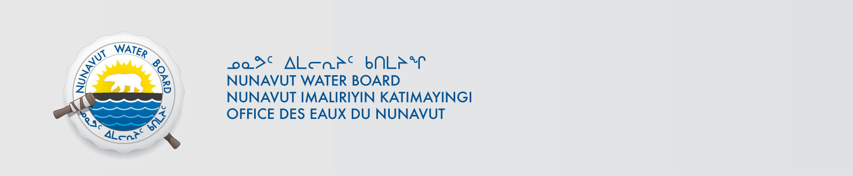

June 15, 2018 NWB File No: 8BC-EUR1621

Mr. Jean Philippe Cloutier
Property Management Division
Environment Canada (ECCC)
335 River Road Ottawa, ON, K1V 1C7
E-mail: jeanphilippe.cloutierdussault@canada.ca

Subject: Application for Amendment to Water Licence 8BC-EUR1621

Dear Mr. Cloutier-Dussault:

The Nunavut Water Board (“NWB”) acknowledges receipt on June 14, 2018 of your amendment water licence application, for the High Arctic Weather Station. This application has been assigned file number 8BC-EUR1621. Please refer to this number on future submissions. Application documents received are as follows:

180614 8BC-EUR1621 Summary English
180614 8BC-EUR1621 Summary French
180614 8BC-EUR1621 Summary Inuktitut
180614 8BC-EUR1621 West Remus Quarry Maps
180614 8BC-EUR1621 West Remus Quarry NTS Maps
180614 8BC-EUR1621 Signed Amendment Application

Please be advised that under the Agreement Between the Inuit of the Nunavut Settlement Area and Her Majesty the Queen in Right of Canada (Nunavut Agreement) Article 11, Section 11.5.9 and s. 76 (1) of Nunavut Planning and Project Assessment Act (NuPPAA), the proponent of a project governed by NuPPAA is also required to submit a project proposal document directly to the Nunavut Planning Commission (NPC or Commission) for the NPC’s determination regarding the applicable land use planning requirements and/or directions regarding whether the project is subject to screening by the Nunavut Impact Review Board. In particular, please note that as established under Articles 11, 12 and 13 of the Nunavut Agreement, NuPPAA and Part 3 of the Nunavut Waters and Nunavut Surface Rights Tribunal Act, until the project has completed the applicable land use planning and assessment process required by the NPC and the NIRB, the NWB cannot issue a water licence/approval.

The NWB confirms receipt of NPC conformity under NuPPAA on June 6, 2018 and NIRB determination through NPC under NuPPAA on June 14, 2018. This application is now ready for review and comments. Deadline for submissions is June 29, 2018.

Please call the undersigned at (867) 360-6338 or email to licensing@nwb-oen.ca if you have any questions.

Sincerely,

Richard Dwyer
Manager Licensing

