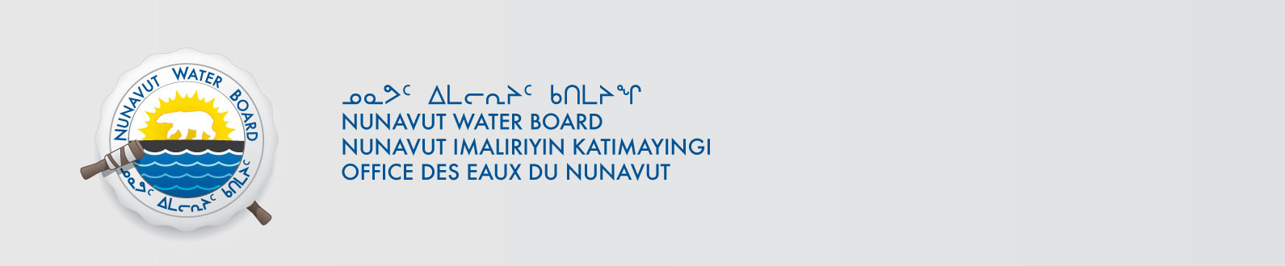

June 18, 2021 NWB File No: 8BC-EUR1621

Asif Mohammed
Real Property Management Division,
Environment Climate Change Canada
867 Lakeshore Road Ground Office L123
Burlington ON L7S 1A1
E-mail: asif.mohammed@canada.ca

Subject: Application Acknowledgement for Eureka High Arctic Weather Station

Dear Asif Mohammed

The Nunavut Water Board (“NWB”) acknowledges receipt on June 18, 2021 of water licence renewal application, for the Eureka High Arctic Weather Station. This application has been assigned file number 8BC-EUR1621. Please refer to this number on future submissions. Application documents received are as follows:

Water Licence Renewal Application
Appendix A Topographical Map
Appendix B English Summary of Renewal Application
Appendix C Inuktitut Summary of Renewal Application
Appendix D Emergency Plan for Petroleum and Allied Petroleum Products
Appendix E Summary of Operations and Maintenance Procedures for Drinking Water, Sewage, Solid Waste Disposal and Waste Treatment Facilities
Appendix F Interim Abandonment & Restoration Plan
Appendix H Letter to CIRNAC regarding the Contaminated Soils Stockpile
Appendix I CIRNAC Quarry Permit Application & Revised Quarry Operations Plan
Appendix J Waste Burn Request
Appendix K Fisheries and Oceans Canada Request for Review as part of Eureka HAWS two Temporary Crossings

Please be advised that under the Agreement Between the Inuit of the Nunavut Settlement Area and Her Majesty the Queen in Right of Canada (Nunavut Agreement) Article 11, Section 11.5.9 and s. 76 (1) of Nunavut Planning and Project Assessment Act (NuPPAA), the proponent of a project governed by NuPPAA is also required to submit a project proposal document directly to the Nunavut Planning Commission (NPC or Commission) for the NPC’s determination regarding the applicable land use planning requirements and/or directions regarding whether the project is subject to screening by the Nunavut Impact Review Board. In particular, please note that as established under Articles 11, 12 and 13 of the Nunavut Agreement, NuPPAA and Part 3 of the Nunavut Waters and Nunavut Surface Rights Tribunal Act, until the project has completed the applicable land use planning and assessment process required by the NPC and the NIRB, the NWB cannot issue a water licence/approval.

The NWB confirms receipt of NPC conformity under NuPPAA on February 22, 2021 and NIRB determination through NPC under NuPPAA on May 13, 2021. This application is now ready for review and comments. Deadline for submissions is July 9, 2021.

Please call the undersigned at (867) 360-6338 or email to licensing@nwb-oen.ca if you have any questions.

Sincerely,

Richard Dwyer

Copy Qikiqtani Distribution List

