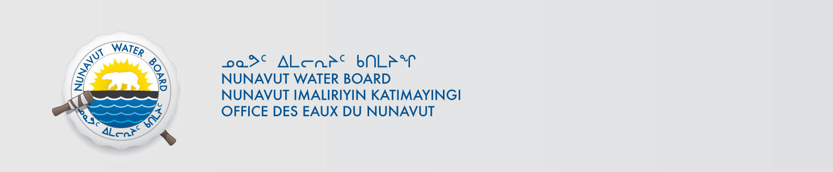

File No: NWB2ATU9899 8BC-EUR1621

June 15, 2018

To: Hamlet, CLARC, HTO, RIA, Coop, and NorthernLocal Organizations – Request to Post Notices

The Nunavut Water Board requests that you post on a bulletin board, until April 10, 2000June 29, 2018, the attached notice (in English), where it can be viewed by the public. The attached letter is for your information only and does not require posting.

Your time and effort is greatly appreciated.

Sincerely,

Richard Dwyer
Manager Licensing

Cc: Hamlet of Resolute Bay (867) 252-3749
Mayor of Resolute Bay (867) 252-3749
Qikiqtani-IA (867) 252-3129
Resolute Bay HTO (867) 252-3800
Tadjaat Co-op (867) 252-3618

