2014 Annual Nunavut Water Board Report for BAF-3
FOR THE
North Warning System

Contract # W8485-100224/001/NX
CDRL 16.F.5.d

Document Number
FM-EHS-13, Rev 1, 16-Mar-2015

Prepared for

North Warning System & Assoc. Projects
Aerospace Equipment Program Directorate
455 Blvd de la Carrière
11th floor
Gatineau, Québec
K1A 0K2

Prepared by


400 Cooper Street
Suite 3000
Ottawa, ON, K2P 2H8

Warning: Information Subject to Export Control Laws — This document (and/or software, if applicable) may contain export-restricted data whose export/transfer/disclosure is restricted by U.S. and Canadian law. Dissemination to non U.S. persons whether in United States or abroad requires an export license or other authorizations from the United States and Canadian Governments.
CHANGE HISTORY
This sheet is a record of each issue of this document. When the revised document is issued, the previous issue is automatically superseded.
Version | Date | Configuration Management | Pages Changed | Reason for Change
1 | 16-Mar-2015 | - | - | Initial Document Release.
Document Title: 2014 Annual Nunavut Water Board Report for  BAF-3 |  |  |  | Document Number: FM-EHS-13

EXECUTIVE SUMMARY
This 2014 Annual Report for the Nunavut Water Board (NWB) has been prepared by Raytheon Canada Limited (RCL) for the Department of National Defence in order to meet the requirements of the licence issued 10 September 2009 3BC-BAF0919 – Type “B”, Part B. General Conditions, paragraph 1. This report covers the period from 01 January to 31 December 2014.
The Operation and Maintenance (O&M) Contractor for the North Warning System (NWS) changed in 2014. Nasittuq was the O&M Contractor of the NWS from 01 January to 31 July 2014 and had Care, Custody, and Control (CC&C) of the site. On 01 August 2014, RCL became the O&M Contractor and took over CC&C of the NWS sites, including the BAF-3 Long Range Radar site.
BAF-3 is an unattended (unmanned) North Warning System radar site located on Brevoort Island, Nunavut. The site is visited quarterly for preventive maintenance inspections and as required for other work by O&M Contractor staff based out of the Logistics Support Site – Iqaluit (LSS-Q), Iqaluit, Nunavut.
A total of 45.9 cubic meters was drawn from the water supply lake. This is below the annual maximum of 1,750 cubic meters allowed by the current licence.
There is no analysis of effluent from bermed fuel storage facilities (berm water) because there are no longer bermed fuel storage facilities on-site. The beach tanks which were in a berm were demolished in 2012. The summit tanks which were in a berm were demolished in 2013.
No hazardous waste and waste oil were disposed of in 2014.
Non-hazardous domestic solid waste was flown out to the Logistics Support Site – Iqaluit and disposed of at Iqaluit’s landfill. RCL has documented authorization from the community for receiving the waste.
Two outdoor spills occurred. The spill were:
- NT-NU Spill Line Report # 14-355. On 01 October 2014, RCL Bulk Fuel Technicians discovered two leaking valve stems. It was determined that the cause of the leak was loose valve packing in the valves. The valve packing was tightened and the leaking stopped. Technicians attempted to clean up the spilled fuel, but the ground was frozen solid. Any remaining impacted soil will be removed in the spring, once the soil thaws.
- NT-NU Spill Line Report # 14-357. On 03 October 2014 Bulk Fuel Technicians were on site and had completed the fuel transfer from the beach tanks to the summit tanks. The technicians were draining the beach to summit line when the temporary hose connecting the pumphouse to the beach tanks came apart. Valves were immediately closed, stopping the spill. The spill was cleaned-up as much as possible. Any remaining impacted soil will be removed in the spring, once the soil thaws.
The Spill Contingency Plan was revised. The table of fuel tanks (Appendix 8) was updated.
2014 was Year 8 of the remediation and monitoring of the January 2007 Jet A1 fuel spill (reported in the 2007 Annual Report). Bad weather prevented Stantec Consulting Limited from flying to the site in July to conduct a monitoring visit.

ᓇᐃᒡᓕᑎᒋᐊᖅᓯᒪᔪᖅ
ᑖᓐᓇ 2014ᒧᑦ ᐊᕐᕌᒍᑕᒫᖅᓯᐅᑎ ᐅᓂᒃᑳᖅ ᓄᓇᕗᒻᒥ ᐃᒪᓕᕆᔨᒃᑯᓐᓄᑦ ᐋᖅᑭᒃᓱᖅᑕᐅᕗᖅ ᕋᐃᑎᐊᓐ ᑲᓇᑕ ᓕᒥᑎᑦᑯᓐᓂᑦ ᑐᕌᖅᖢᒍ ᑲᓇᑕᒥ ᐅᓇᑕᖅᑐᒃᓴᓕᕆᔨᒃᑯᓐᓄᑦ ᑎᑭᐅᑎᓯᒪᔪᒪᒧᑦ ᐱᔭᕆᐊᖃᖅᑎᑕᓂᒃ ᐱᓕᕆᐊᖃᕈᓐᓇᐅᑎᑖᕆᔭᐅᓚᐅᖅᑐᒧᑦ ᓯᑎᐱᕆ 10, 2009 ᓇᐃᓴᐅᑖ 3BC-BAF0919 – ᖃᓄᐃᑦᑑᓂᖓ “B”, ᐃᓚᖓ B. ᐊᑐᖅᑕᐅᔭᕆᐊᓖᑦ, ᑎᑎᕋᖅᓯᒪᓂᖅ 1. ᑖᓐᓇ ᐅᓂᒃᑳᖅ ᐅ.ᓂᒃᑲᓯᖃᖅᐳᖅ ᖃᓄᐃᓐᓂᑯᓂᒃ ᔭᓄᐊᕆ 1ᒥᑦ ᑎᓯᐱᕆ 31ᒧᑦ 2014.
ᐊᐅᓚᑦᑎᓂᕐᒧᑦ ᒥᐊᓂᕆᔭᖃᖅᓂᕐᒧᓪᓗ ᑳᓐᑐᓛᖃᖅᑎᐅᔪᑦ ᐅᓇᑕᖅᑐᒃᓴᐃᑦ ᐅᑭᐅᖅᑕᖅᑐᒥ ᓈᓚᒃᑎᖏᓐᓄᑦᐊᓯᔾᔨᓚᐅᕐᒪᑦ 2014ᒥ. ᓇᓯᑦᑐᖅ ᐊᐅᓚᑦᑎᓂᕐᒧᑦ ᒥᐊᓂᕆᔭᖃᖅᓂᕐᒧᓪᓗ ᑳᓐᑐᓛᖃᖅᑎᐅᓚᐅᕐᒪᑦ ᐅᓇᑕᖅᑐᒃᓴᐃᑦ ᐅᑭᐅᖅᑕᖅᑐᒥ ᓈᓚᒃᑎᖏᓐᓄᑦ ᔭᓄᐊᕆ 01ᒥᑦ ᔪᓚᐃ 31ᒧᑦ 2014 ᑲᒪᒋᔭᖃᖅᑎᐅᓚᐅᖅᐳᑦ ᑎᒍᒻᒥᔨᐅᓚᐅᖅᐳᑦ ᐊᐅᓚᑦᑎᔨᐅᓪᓗᑎᒡᓗ ᓈᓚᒡᕕᖃᕐᕕᐅᔪᒥᒃ. .ᐊᒐᔅᑦ 01 2014ᒥ, ᕋᐃᑎᐊᓐ ᑲᓇᑕ ᓕᒥᑎᑦᑯᑦ ᐊᐅᓚᑦᑎᓂᕐᒧᑦ ᒥᐊᓂᕆᔭᖃᖅᓂᕐᒧᓪᓗ ᑳᓐᑐᓛᖃᖅᑎᐅᓕᓚᐅᕐᒪᑦ ᑲᒪᒋᔭᖃᓕᖅᖢᓂ ᐅᓇᑕᖅᑐᒃᓴᐃᑦ ᐅᑭᐅᖅᑕᖅᑐᒥ ᓈᓚᒃᑎᖏᓐᓄᑦ ᐃᓂᒋᔭᓂᒃ, ᐃᓚᒋᔭᐅᓪᓗᓂ BAF-3 ᐅᖓᓯᒃᑐᒃᑯᑦ ᓈᓚᒡᕕᖃᕐᕕᒃ.
BAF-3 ᓇᔪᖅᑕᐅᓇᓂ ᐅᓇᑕᖅᑐᒃᓴᐃᑦ ᐅᑭᐅᖅᑕᖅᑐᒥ ᓈᓚᒃᑎᖏᓐᓄᑦ ᓈᓚᒡᕕᖃᕐᕕᐅᕗᖅ ᐳᕋᕗᑦ ᕿᑭᑦᑕᖓᓂ, ᓄᓇᕗᒻᒥ. ᐃᓂᐅᔪᖅ ᐅᐸᒃᑕᐅᓲᖑᕗᖅ ᐊᕐᕌᒍ ᑎᓴᒪᐃᖅᓱᖅᖢᒍ ᖃᓄᐃᑦᑕᐃᓕᒪᑎᑦᑎᓇᓱᒪᑦ ᓇᐅᑦᑎᖅᓱᓂᖃᕐᓂᕐᒧᑦ ᕿᒥᕐᕈᓇᒃᑕᐅᔭᖅᑐᖅᖢᓂ ᑕᐃᒪᑦᑕᕆᐊᖃᕌᒥᒡᓗ ᐊᓯᖏᓐᓂᒃ ᐊᐅᓚᑦᑎᓂᕐᒧᑦ ᒥᐊᓂᕆᔭᖃᖅᓂᕐᒧᓪᓗ ᐃᖅᑲᓇᐃᔭᖅᑎᑦ ᐱᓕᕆᕙᒃᖢᑎᒃ ᖃᓄᐃᓕᐅᕆᐊᖃᖅᑕᖃᕐᕕᖕᒥᑦ ᐃᖃᓗᐃᑦ ᓄᓇᕗᒻᒥᑦ.
45.9 ᒦᑕᑲᓪᓚᐅᑉ ᐃᓗᑐᓂᖓᓂᒃ ᐃᒥᖅᑕᕐᕕᖕᒥᑦ ᐱᓚᐅᖅᐳᑦ. ᑕᒪᓐᓇ ᑎᑭᐅᒪᑦᑎᙱᓚᖅ ᒫᓐᓇᐅᔪᒃᑯᑦ ᐊᑐᖅᑕᖃᕈᓐᓇᐅᑎᒋᑎᑕᒧᑦ ᑭᒡᓕᒋᑎᑕᒥᑦ 1,750 ᒦᑕᑲᓪᓚᐅᑉ ᐃᓗᑐᓂᖓᓂᒃ.
ᖃᐅᔨᓴᕐᓂᖅᑕᖃᙱᓚᖅ ᑯᕕᖅᑕᖅᑕᐅᔪᒃᓴᒥᑦ ᒪᓂᖅᑲᒧᐊᖅᑎᑦᑎᑦᑕᐃᓕᒪᔾᔪᑎᒥᙶᖅᑐᒥᒃ ᖃᑦᑕᐅᔭᕐᔪᐊᓂᒃ ᐊᕙᓗᓯᓯᒪᔪᒥᑦ ᒪᓂᖅᑲᒧᐊᖅᑎᑦᑎᑦᑕᐃᓕᒪᔾᔪᑎᓕᖅᓱᖅᓯᒪᔪᓂᒃ ᖃᑦᑕᐅᔭᕐᔪᐊᖅᑕᖃᔮᕈᓐᓃᕐᒪ ᑕᕝᕙᓂ ᓈᓚᒡᕕᖃᕐᕕᖕᒥ. ᖃᑦᑕᐅᔭᕐᔪᐊᑦ ᓯᒡᔭᒦᑦᑐᑦ ᒪᓂᖅᑲᒧᐊᖅᑎᑦᑎᑦᑕᐃᓕᒪᔾᔪᑎᒧᑦ ᐊᕙᓗᔭᐅᓯᒪᔪᑦ ᐃᒍᑦᑎᖅᑕᐅᓚᐅᖅᓯᒪᖕᒪᑕ 2012ᒥᑦ. ᖃᕝᕙᓯᒃᑐᒦᑦᑐᑦ ᒪᓂᖅᑲᒧᐊᖅᑎᑦᑎᑦᑕᐃᓕᒪᔾᔪᑎᒧᑦ ᐊᕙᓗᔭᐅᓯᒪᔪᑦ ᐃᒍᑦᑎᖅᑕᐅᓚᐅᖅᓯᒪᓪᓗᑎᒃ 2013ᒥ.
ᓱᕈᕐᓇᖅᑐᓂᒃ ᐊᒃᑕᑯᑕᖃᓚᐅᙱᓚᖅ ᐅᖅᓱᐊᓗᒃᕕᓂᖅᑕᖃᕋᓂᓗ 2014ᒥ
ᓱᕈᕐᓇᙱᑦᑐᑦ ᐊᒃᑕᑯᑐᐃᓐᓇᐃᑦ ᖃᖓᑕᓂᒃᑯᑦ ᐱᓕᕆᐊᖃᕐᕕᓕᐊᕈᔾᔭᐅᓚᐅᖅᐳᖅ ᐃᖃᓗᖕᓂ – ᐊᒃᑕᖅᑕᐅᓚᐅᖅᐳᑦ ᐃᖃᓗᐃᑦ ᐊᒃᑕᕐᕕᖁᑎᖓᓐᓄᑦ.
ᒪᕐᕉᖕᓂᒃ ᓯᓚᒃᑯᑦ ᑯᕕᖅᑕᖃᓚᐅᖅᐳᖅ. ᑯᕕᓃᒃ ᐅᑯᐊᖑᓚᐅᖅᐴᒃ:
- ᓄᓇᑦᓯᐊᖅ-ᓄᓇᕗᑦ ᑯᕕᓂᕐᒧᑦ ᐅᓂᒃᑳᓕᐊᖅ ᓈᓴᐅᑖ 14-355. ᐊᒃᑑᐸ 01 2014, ᕋᐃᑎᐊᓐ ᑲᓇᑕ ᓕᒥᑎᑦᑯᓐᓄᑦ ᐅᖅᓱᐊᓗᓕᕆᔨᖁᑦᒋᔭᑦ ᖃᐅᔨᓚᐅᕐᒪᑕ ᒪᕐᕉᖕᓂᒃ ᕿᔾᔭᓪᓗᒑᖕᓂᒃ ᕿᕐᓛᖅᑑᖕᓂᒃ. ᐃᓱᒪᒋᔭᐅᓚᐅᖅᐳᖅ ᕿᔾᔭᓪᓗᕈᓐᓇᖅᑎᑦᑎᔪᒧᑦ ᐃᒻᒧᑎᒋᔭᖅ ᖃᓱᖓᓇᓱᒋᔭᐅᓪᓗᓂ. ᕿᔾᔭᓪᓗᕈᓐᓇᖅᑎᑦᑎᔪᒧᑦ ᐃᒻᒧᑎᒋᔭᖅ ᓱᑲᑕᐅᖕᒪᑦ ᑯᑐᒍᓐᓃᖅᖢᓂ. ᐅᖅᓱᐊᓗᓕᕆᔨᖁᑎᒋᔭᑦ ᓴᓗᒻᒪᖅᓴᐃᓇᓱᓚᐅᕋᓗᐊᖅᖢᑎᒃ ᑯᕕᔪᒥᒃ ᒪᓂᕋᖅ ᕿᖁᒪᓗᐊᓚᐅᕐᒪᑦ. ᐃᔅᓴᒃᑕᐅᓯᒪᔪᑦ ᐅᖅᓱᐊᓗᖕᒧᑦ ᓴᓗᒻᒪᖅᓴᖅᑕᐅᔪᒫᕐᓂᐊᖅᓯᒪᔪᑦ ᐅᐱᕐᖔᖅ ᒪᓂᕋᖅ ᕿᖁᒪᔪᓐᓃᖅᐸᑦ..
- ᓄᓇᑦᓯᐊᖅ-ᓄᓇᕗᑦ ᑯᕕᓂᕐᒧᑦ ᐅᓂᒃᑳᓕᐊᖅ ᓈᓴᐅᑖ 14-357. ᐊᒃᑑᐸ 03 2014 ᐅᖅᓱᐊᓗᓕᕆᔨᖁᑦᒋᔭᑦ ᓈᓚᖕᕕᖃᕐᕕᓕᐊᖅᓯᒪᓚᐅᖅᐳᑦ ᐅᖅᓱᐊᓗᖕᒥᒃ ᓅᑎᕆᔭᖅᑐᖅᓯᒪᓪᓗᑎᒃ ᓯᒡᔭᒦᑦᑐᓂᑦ ᖃᕝᕙᓯᒃᑐᒦᑦᑐᓄᑦ. ᐅᖅᓱᐊᓗᓕᕆᔨᖁᑦᒋᔭᑦ ᐃᒪᐃᖅᑎᑦᑎᓕᖅᑎᓪᓗᒋᑦ ᓯᒡᔭᒦᑦᑐᒥᑦ ᖃᕝᕙᓯᒃᑐᒦᑦᑐᒧᑦ ᓱᓪᓗᓕᒋᑎᑕᐅᑲᐃᓐᓇᖅᑐᖅ ᐃᒍᒥᑎᓪᓗᒍ. ᐃᕐᖐᓐᓇᖅ ᓱᑲᑎᖅᑕᐅᓪᓗᑎᒃ ᑯᕕᔪᓐᓃᖅᑎᑕᐅᓪᓗᓂ. ᓴᓗᒻᒪᖅᓴᐃᓇᓱᒍᓐᓇᕐᓂᓕᒫᕐᒥᓂᒃ ᓴᓗᒻᒪᖅᓴᖅᑕᐅᒐᓗᐊᖅᖢᓂ. ᐃᔅᓴᒃᑕᐅᓯᒪᔪᑦ ᐅᖅᓱᐊᓗᖕᒧᑦ ᓴᓗᒻᒪᖅᓴᖅᑕᐅᔪᒫᕐᓂᐊᖅᓯᒪᔪᑦ ᐅᐱᕐᖔᖅ ᒪᓂᕋᖅ ᕿᖁᒪᔪᓐᓃᖅᐸᑦ.
ᑯᕕᔪᖃᕋᔭᕐᓂᖅᐸᑦ ᐸᕐᓇᐅᑎᑦ ᖃᓄᐃᓕᐅᕈᑎᖃᕆᐊᖃᕐᓂᕐᒧᑦ ᓄᑖᙳᖅᑎᕆᐊᖅᑕᐅᓚᐅᖅᐳᖅ. ᑎᑎᕋᐅᓯᕆᓯᒪᔭᑦ ᐅᖅᓱᐊᓗᖃᐅᑎᓅᖓᔪᖅ (ᐅᐃᒍ 8) ᐅᓪᓗᒥᓕᓴᙳᕆᐊᖅᑕᐅᓚᐅᖅᐳᖅ.
2014 ᐊᕐᕌᒍ 8ᒋᔭᐅᓕᖅᐳᖅ ᐋᖅᑭᒃᓯᒋᐊᕐᓂᕆᔭᐅᓚᐅᖅᑐᒧᑦ ᓇᐅᑦᑎᖅᓱᐊᖃᕐᓂᕆᔭᒧᓪᓗ ᔭᓄᐊᕆ 2007ᖑᑎᓪᓗᒍ Jet A1 ᐅᖅᓱᐊᓗᖕᒥᒃ ᑯᕕᔪᖃᓚᐅᖅᓯᒪᑎᓪᓗᒍ (ᐅᓂᒃᑲᐅᓯᐅᓂᑯ 2007 ᐊᕐᕌᒍᑕᒫᑦ ᐅᓂᒃᑳᓕᐊᖏᓐᓂ). ᓯᓚᕐᓂᕐᓗᖕᒧᑦ ᔅᑕᓐᑕᒃ ᐅᖃᐅᔾᔨᔨᑦ ᓕᒥᑦ (Stantec Consulting Limited) ᖃᖓᑕᓲᒃᑯᑦ ᑎᑭᑦᑐᓐᓇᖅᓯᓚᐅᙱᒻᒪᑕ ᓇᐅᑦᑎᖅᓱᐃᓂᕐᒧᑦ ᑕᑯᓇᒋᐊᖅᑐᕐᓗᑎᒃ.

TABLE OF CONTENTS
1.0 Introduction 1
1.1 Report Details 1
2.0 Water Use 1
3.0 Hazardous Waste and Waste Oil Disposal 2
4.0 Non-hazardous Solid Waste Disposal 3
5.0 Monitoring Program 3
6.0 Spills (Unauthorized Discharges) 4
7.0 Revisions to the Spill Contingency Plan 4
8.0 Progressive reclamation work undertaken 5
9.0 Acronyms 5
Annex A – Hazardous Waste and Waste Oil Disposal in 2014 6
Annex B - BAF-3 - Location of Landfill with Co-ordinates 7
Annex C - BAF-3 - Sewage Outfall Location (BAF-2) with Co-ordinates 8
Annex D - BAF-3 - Analysis of Sewage Effluent 9
Annex E - BAF-3 - Bermed Fuel Storage Facilities with Co-ordinates 10
Annex F - BAF-3 - Analysis of Berm Water (Effluent from Bermed Fuel Storage Facilities) 11
Annex G - BAF-3 - Monitoring Activities of 2007 Jet A1 Fuel Spill 12

TABLES
Table 2-1 Monthly Raw Water Usage at BAF-3 in 2014 2
Table 3-1 Hazardous Waste and Waste Oil Sent for Disposal from BAF-3 in 2014 2
Table 4-1 Non-hazardous Domestic Solid Waste Sent for Disposal from BAF-3 in 2014 3
Table 7-1 Outdoor Spills Reported at BAF-3 in 2014 4

Introduction
This 2014 Annual Report for the Nunavut Water Board (NWB) has been prepared by Raytheon Canada Limited (RCL) for the Department of National Defence in order to meet the requirements of the licence issued 10 September 2009 3BC-BAF0919 – Type “B”, Part B. General Conditions, paragraph 1. This report covers the period from 01 January to 31 December 2014.
The Operation and Maintenance (O&M) Contractor for the North Warning System (NWS) changed in 2014. Nasittuq was the O&M Contractor of the NWS from 01 January to 31 July 2014 and had Care, Custody, and Control (CC&C) of the site. On 01 August 2014, RCL became the O&M Contractor and took over CC&C of the NWS sites, including the BAF-3 Long Range Radar site.
BAF-3 is an unattended (unmanned) North Warning System radar site located on Brevoort Island, Nunavut. The site is visited quarterly for preventive maintenance inspections and as required for other work by O&M Contractor staff based out of the Logistics Support Site – Iqaluit (LSS-Q), Iqaluit, Nunavut.

Report Details
Licensee: Department of National Defence, Government of Canada
Licence: 3BC-BAF0919 – Type “B”
Location: BAF-3 North Warning System Site,
Brevoort Island, Qikiqtani Region, Nunavut
Report prepared by: Raytheon Canada Limited, 16-Mar-2015
Time Period Covered: 01 January to 31 December 2014

Water Use
A total of 45.9 cubic meters was drawn from the water supply lake. This is below the annual maximum of 1,750 cubic meters allowed by the current licence. See Table 2-1 for the volume of raw water drawn.

Table 2-1 Monthly Raw Water Usage at BAF-3 in 2014
Month |  | Raw water drawn in cubic meters (m³) | Company with CC&C of the site
January | 0 |  | Nasittuq Corporation
February | 0 |  | Nasittuq Corporation
March | 0 |  | Nasittuq Corporation
April | 0 |  | Nasittuq Corporation
May | 0 |  | Nasittuq Corporation
June | 29.5 |  | Nasittuq Corporation
July | 0 |  | Nasittuq Corporation
August | 16.4 |  | RCL
September | 0 |  | RCL
October | 0 |  | RCL
November | 0 |  | RCL
December | 0 |  | RCL
Total | 45.9

Hazardous Waste and Waste Oil Disposal
No hazardous waste and waste oil were disposed of in 2014. Therefore Table 3-1 is blank and Annex A for the shipping documents is blank. (Shipping documents include the completed movement documents for waste regulated under the Transportation of Dangerous Goods Regulations (TDGR) and Manifests for non-regulated waste).
Table 3-1 Hazardous Waste and Waste Oil Sent for Disposal from BAF-3 in 2014
Site |  | Description, TDG shipping name | Quantity | Movement Document or Manifest #
BAF-3 | No hazardous waste or waste oil was disposed of in 2014. |  | 0 | N/A

Non-hazardous Solid Waste Disposal
Non-hazardous domestic solid waste was flown out to the Logistics Support Site – Iqaluit and disposed of at Iqaluit’s landfill. RCL has documented authorization from the community for receiving the waste. See Table 4-1 for the quantity of waste generated.
Table 4-1 Non-hazardous Domestic Solid Waste Sent for Disposal from BAF-3 in 2014
Month |  | Waste Generated (kg) | Company with CC&C of the site
January | 21 |  | Nasittuq Corporation
February | 0 |  | Nasittuq Corporation
March | 77 |  | Nasittuq Corporation
April | 58 |  | Nasittuq Corporation
May | 12 |  | Nasittuq Corporation
June | 26 |  | Nasittuq Corporation
July | 0 |  | Nasittuq Corporation
August | 635 |  | RCL
September | 0 |  | RCL
October | 0 |  | RCL
November | 544 |  | RCL
December | 0 |  | RCL
Total | 1,373

Monitoring Program
See Annex C for the location of the sewage effluent outfall, BAF-2, with co-ordinates. A sump for the sewage outfall was built in 2010.
Annex D is blank. The sump for the sewage outfall was not pumped out therefore no samples were taken for laboratory analysis.
Annex E lists the bermed fuel storage facilities, Monitoring Station # BAF-4 with co-ordinates that used to exist on-site. Fuel tanks within the berms were demolished in 2012 and 2013, therefore no effluent (berm water) samples were taken in 2014.
Annex F is blank. There was no analysis of effluent from bermed fuel storage facilities at BAF-3 in 2014.
Annex G is blank. Bad weather prevented Stantec Consulting Limited from flying to the site in July to conduct monitoring visit #1. Therefore no samples were taken of untreated effluent from the mid-site biopiles, the final discharge point from the landfarm (Monitoring Station # BAF-3), and from the biopile monitoring wells (Monitoring Station # BAF-5).

Spills (Unauthorized Discharges)
Two outdoor spills occurred. See Table 6-1 for details.
Table 6-1 Outdoor Spills Reported at BAF-3 in 2014
Date,  Spill # |  | Product | Quantity | Cause and follow-up action | Location at BAF-3
01 Oct 2014  NT-NU Spill # 14-355 | Jet A1 fuel |  | Unknown | On 01 October 2014, RCL Bulk Fuel Technicians discovered two leaking valve stems. It was determined that the cause of the leak was loose valve packing in the valves. The valve packing was tightened and the leaking stopped. Technicians attempted to clean up the spilled fuel, but the ground was frozen solid. The surface of the spill was cleaned as much as possible.  The remaining contaminated soil will be removed in the spring, once the soil thaws. | Summit, pipeline near pumphouse
03 Oct 2014  NT-NU Spill # 14-357 | Jet A1 fuel |  | 300 litres | On 03 October 2014 Bulk Fuel Technicians were on site and had completed the fuel transfer from the beach tanks to the summit tanks. The technicians were draining the beach to summit line when the temporary hose connecting the pumphouse to the beach tanks came apart. Valves were immediately closed, stopping the spill. Much of the spill was contained in the port-a-berm that had been placed under the connection point, but fuel overfilled the berm. Fuel contaminated snow and ice were placed in drums. Fuel was soaked up using sorbents and the sorbents were also placed in drums. It was determined that the temporary pipe came apart because the overfill protection in the tanks was jammed closed.  The remaining contaminated soil will be removed in the spring, once the soil thaws. | Next to beach pump house

Revisions to the Spill Contingency Plan
The Spill Contingency Plan was revised. The table of fuel tanks (Appendix 8) was updated.

Progressive reclamation work undertaken
2014 was Year 8 of the remediation and monitoring of the January 2007 Jet A1 fuel spill (reported in the 2007 Annual Report).
Bad weather prevented Stantec Consulting Limited from flying to the site in July to conduct a monitoring visit.

Acronyms
Acronym | Definition
CC&C | Care, Custody, and Control
DEG | Diesel Engine Generator
DND | Department of National Defence
NWB | Nunavut Water Board
NWS | North Warning System
NWSO | North Warning System Office
O&M | Operations and Maintenance
PCB | Polychlorinated Biphenyl
RCL | Raytheon Canada Limited
TDGR | Transportation of Dangerous Goods Regulations

Annex A – Hazardous Waste and Waste Oil Disposal in 2014
This annex has been left blank as no hazardous waste or waste oil were disposed of in 2014. Therefore there are no shipping documents for Annex A.

Annex B - BAF-3 - Location of Landfill with Co-ordinates
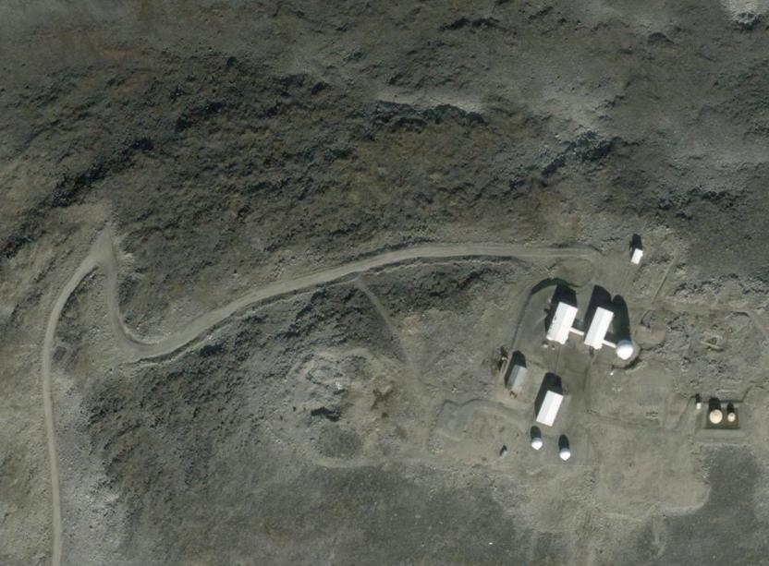
Coordinates of Landfill Location:
63° 20’ 30.00”N,
64° 10’ 02.00”W

Coordinates of Landfill Location: 63° 20’ 30.00”N, 64° 10’ 02.00”W

Annex C - BAF-3 - Sewage Outfall Location (BAF-2) with
Co-ordinates
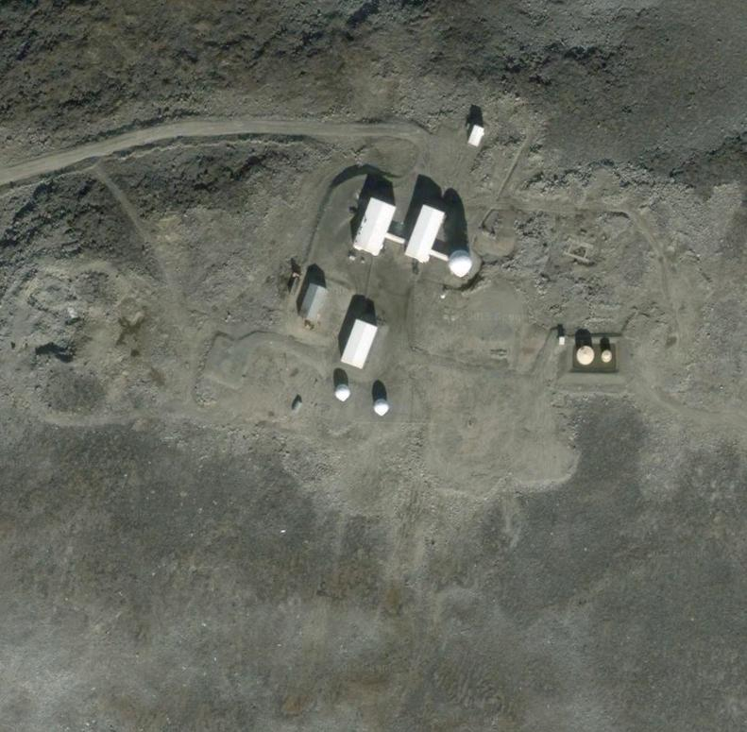
Coordinates of Sewage Outfall Location (BAF-2): 63° 20’ 21.40”N,
64° 09’ 26.63”W
Coordinates of Sewage Outfall Location (BAF-2): 63° 20’ 21.40”N, 64° 09’ 26.63”W

Annex D - BAF-3 - Analysis of Sewage Effluent
The sump of the sewage outfall was not pumped out therefore no samples were taken for laboratory analysis. This Annex has been left blank because there are no results to report.

Annex E - BAF-3 - Bermed Fuel Storage Facilities with
Co-ordinates
Licence | Location | Monitoring Station #  (Final discharge point of bermed fuel storage facility) | Berm’s location on-site | Berm’s  co-ordinates
3BC-BAF0919 Type “B” | BAF-3 North Warning System Site,  Brevoort Island, Qikiqtani Region, Nunavut | BAF-4 | Summit, berm of former tanks W22A and W22B.  Note: Tanks W22A and W22B were demolished in 2013 and the berm was breached with an engineered breech. | 63° 20’ 23” N  64° 09’ 18” W
3BC-BAF0919 Type “B” |  | BAF-4 | Beach, berm of former tanks W22C and W22D.  Note: Tanks W22C and W22D were demolished in 2012 and the berm was left intact. | 63° 19’ 52” N  64° 10’ 40” W

Annex F - BAF-3 - Analysis of Berm Water (Effluent from Bermed Fuel Storage Facilities)
There is no analysis of effluent from bermed fuel storage facilities (berm water) because there are no longer bermed fuel storage facilities on-site. The beach tanks which were in a berm were demolished in 2012. The summit tanks which were in a berm were demolished in 2013.

As there are no berms that contain fuel tanks at BAF-3, this annex has been intentionally left blank.

Annex G - BAF-3 - Monitoring Activities of 2007 Jet A1 Fuel Spill
2014 (Year 8) Remediation and Monitoring Activities of 2007 Jet A1 Fuel Spill. Bad weather prevented Stantec Consulting Limited from flying to the site in July to conduct monitoring visit #1.
As no monitoring activities were completed, this annex has been left blank.

