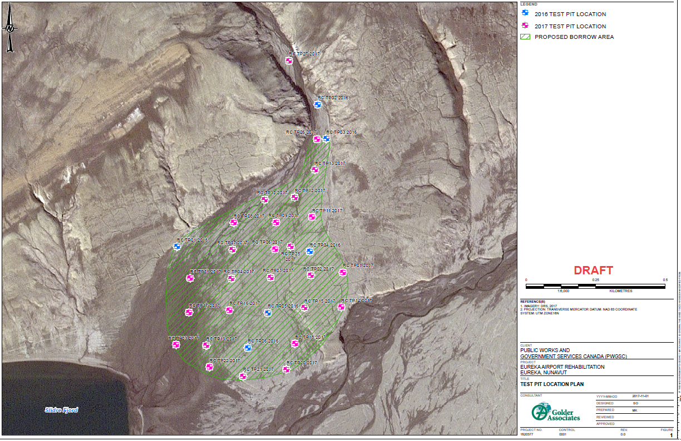
Figure 1 – Quarry Layout
Temporary Camp and Fuel Storage Area
Access Road

Figure 2 - NRC Map at 1:50,000

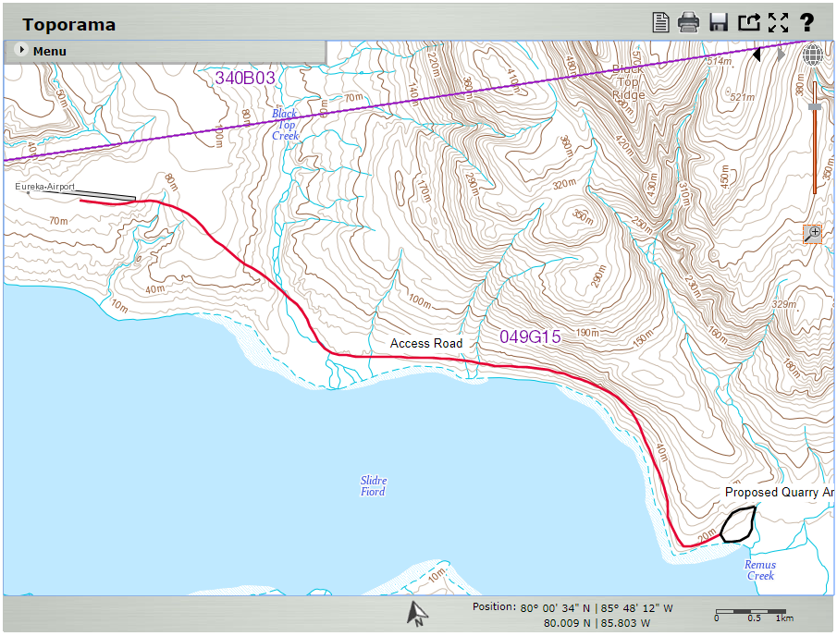

Figure 3 – NTS Map at 1:5000

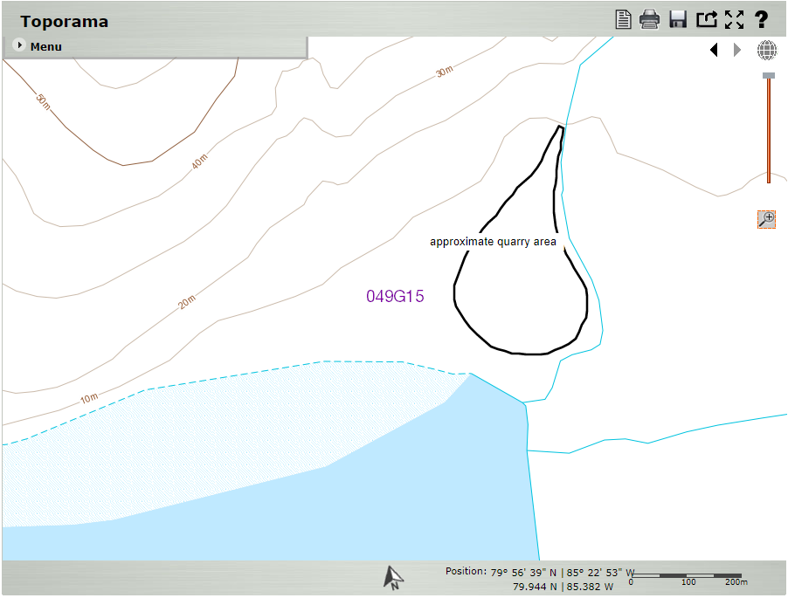

Figure 4 - Quarry Limit Coordinates

