Response to Comments for CAM-3 Water Licence Amendment 2025

- Potential for Washouts and Erosion

Comment:
The Inspector was notified during an inspection in 2022 that the Licensee was withdrawing water from another source (the proposed water source in the current application) due to washouts of the water lake road. The Licensee later clarified that water withdrawals from the other source were discontinued, and plans were in place to install new culverts.

CIRNAC is seeking clarification if other areas are prone to washouts and erosion, particularly those within the vicinity of the proposed water source.

Recommendation:
(R-01) CIRNAC recommends that the Licensee clarify if other areas near the proposed water source are prone to washouts and erosion and describe sediment and erosion controls that will be used to minimize damage to watercourses.

Response:
Nasittuq inspected the road to the new proposed water lake and has found no evidence of washouts and erosion. If this were to occur, we would follow the North Warning System (NWS) Environmental Protection Plan (EPP) Section 9: Roads Grounds and Helipads, which outlines requirements for silt fences, etc. Nasittuq also has a Gravel Plan and Erosion Control Plan to address these issues.

The EPP Section 9 includes the following:

Roads, gravel pads, and improved grounds will be:
- designed to minimize impact on surface drainage;
- monitored for any signs of erosion, and remedial action will be taken where identified;
- repaired and proper drainage and erosion control structures will be maintained to minimize ponding and erosion.
- Ditches and culverts will be kept free of debris and checked for ice.
- Gravel fill will be compacted to prevent terrain damage. No ice-rich or otherwise unsuitable materials will be used for road fill. Sufficient suitable granular materials will be stockpiled for repair and protection of unstable areas.
- Traffic will be suspended if the road surface becomes soft and rutted. Ruts act as drainage channels and flowing water may thaw underlying permafrost.
Where fish habitat is known or suspected, special efforts, such as the erection of silt barriers, will be made to protect spawning habitat during road/culvert maintenance activities. Material from earthworks must be deposited more than thirty-one meters from any water body.

Note: None of the water bodies in question have been identified as fish bearing.

- Berm Water Sampling Procedures

Comment:
CIRNAC notes that the document titled "SP-52 Berm Water Sampling Standard Procedure" has some inconsistencies relative to plan that was approved by the Board (dated July 16, 2021). Table 3 below provides a comparison of each document.
Table 3: Comparison of lab sampling protocols in the approved and new plans (see Table 3-1 in the approved plan and Table 2.4-1 in the new plan).

Parameter | Bottle |  |  | Preservative |  | Sampling |  | Hold Time
 | Approved |  | New | Approved | New | Approved | New | Approved | New
Dissolved | 125 mL |  | 1 x 80 mL | nitric acid | NA | Field filtered. | Filter using the | 28 days | Keep cool.
Metals | plastic |  | plastic with | (may be |  | No rinse (do | syringe and |  | Hold time is 6
(dissolved |  |  | HNO3 acid | marked as |  | not discard | filter |  | months.
lead) |  |  |  | HNO3) |  | the | attachment. Fill
 |  |  |  |  |  | preservative*) | to neck. Do not
 |  |  |  |  |  | Note: Cross | discard

 |  |  |  |  | out “Metals”  and write “Lead”. | preservative  liquid. Do not dip into berm.
BTE | 2 x 40 mL | 2 x 40 mL | May contain | NA | Fill slowly and | Fill slowly and | 7 days | Keep cool.
 | VOC glass | VOC vials | a |  | completely – | completely – |  | Holding time
 | vials |  | preservative |  | no | no air bubbles |  | is 14 days.
 |  |  | tablet such |  | headspace. | present. Do not
 |  |  | as sodium |  | No rinse (do | discard
 |  |  | bicarbonate |  | not discard | preservative
 |  |  |  |  | the | tablet. Do not
 |  |  |  |  | preservative | dip into berm
 |  |  |  |  | tablet). | (fill by pouring
 |  |  |  |  |  | from the 250
 |  |  |  |  |  | mL bottle).
pH | 250-1000 | 1 x 250 mL | None | NA | Grab, fill | Fill to neck | 14 days | Keep cool.
 | mL | plastic bottle |  |  | bottle to top |  |  | Hold time
 |  |  |  |  | with water. |  |  | extremely
 |  |  |  |  |  |  |  | short Use pH
 |  |  |  |  |  |  |  | strips to
 |  |  |  |  |  |  |  | supplement
 |  |  |  |  |  |  |  | analysis.
Oil & | 1 L amber | 2 x 250 mL | None | NA | Grab, Fill | Grab | 14 days | Keep cool.
Grease | glass | Amber Glass |  |  | bottle to the |  |  | Return to the
(total) | bottle | bottles (no |  |  | top with |  |  | laboratory
 |  | preservative) |  |  | water. |  |  | within 7 days
 |  |  |  |  |  |  |  | of sampling.

It is unclear to CIRNAC why there is a large discrepancy between hold times, given the similarities in collection and sampling. CIRNAC also notes that Section 2.5.3 in the new plan may benefit from revisions. For example, the first step in collecting dissolved metals states: “Locate the bottle for Dissolved Metals (125 ml with acid preservative) and have it within arms reach.”, which may create confusion for personnel in the field when they are planning to use 80 mL bottles. Lastly, the sampling decision tree in Appendix B of the new plan does not include notifying the Inspector 10 days before discharging berm water (this information was included in the approved plan). CIRNAC understands that this remains an ongoing requirement of the water licence (Part D, Item 19).

Recommendation:
(R-02) CIRNAC recommends that the Licensee clarify why the hold times are different, including whether longer hold times will impact the validity of laboratory measurements, and update Section 2.5.3 and Appendix B of the new plan.

Response:
Nasittuq has reworked this plan. Section D-2.5.3 (now in Appendix D) has been clarified to note current laboratory requirements as per ISO/IEC Standard 17025 are to be used for bottles, preservatives and hold times. Section D-2.4 (now in Appendix D) has been updated to clarify samples are to be shipped ASAP. Reference to specific hold times for each parameter were removed as the approach to check with the laboratory will ensure most up to date requirements are followed (typically 14 days). A notification to the Inspector 10 days prior to discharging berm water has been added to the sampling decision tree.

- Water Source Characteristics

Comment:
The Licensee is proposing to use an additional lake as a water source to support camp operations and melted snow as an alternate water source if designated lakes freeze to the bottom during the winter. In its review, CIRNAC was unable to identify detailed information about the proposed new lake in the documents listed in Table 2, including the status of the existing aquatic habitat (e.g., water quality, species composition, etc.), or how any future water withdrawals would impact the lake environment CIRNAC is also seeking clarification on which factors may be contributing to the complete freezing of the water lake. Freezing was reported to have occurred during the winter of 2022-2023, but this observation was not recorded in previous annual reports submitted by the Licensee. CIRNAC is aware that changes in climatic conditions (e.g., colder temperatures, reduced mixing by wind) are expected to affect freezing conditions in the lake, but notes other factors may be relevant, including changes in site hydrology, lake water quality, and water withdrawal rates. CIRNAC understands that the withdrawal rates reported in the annual reports are below the requirements of the water licence, but notes that lake withdrawals, potentially combined with other factors, have the potential to contribute to lake drawdown. Part C, Item 4 of the water licence provides direction on drawdowns:

“Where the use of Water is of a sufficient volume that the source Water body may be drawn down, the Licensee shall submit, for approval of the Board in writing, the following information: the volume required, a hydrological overview of the water body, details of impacts, and proposed mitigation measures.”

Recommendation:
(R-03) CIRNAC recommends that the Licensee provide further information on the proposed lake, demonstrating that it is suitable as a water source, and describe factors that may be contributing to the freezing of the designated lake, including the potential impacts of water withdrawal on lake drawdown.

Response:
Under the new North Warning System Operations and Maintenance Contract awarded in 2022, Northern Long Range Radar sites like CAM 3, were transitioned from an unattended or remote operation mode, to a fully attended, 24/7/365 operation model. The fully attended sites now require a reliable source of potable water throughout the year.

Under the previous two contracts, the sites were only subject to quarterly maintenance visits by NWS personnel. The potable water tanks on site would be filled in the fall and they held enough water to supply the maintenance crews that periodically occupied the site during winter months. No water was drawn from the lakes during maximum freeze as no water was required.

A review of historical drawings from when the sites were originally built and fully attended in the 1950’s indicates that the subject matter lakes were termed as the “summer water lake” for the current lake, and “winter water lake” for the proposed lake. Site conditions appear to have remained consistent over the decades as we have found that the summer lake freeze’s completely in the winter whereas the winter lake provides water much later into the season.

Hydrogeological information:

The attachment A1 “Cam-3 Biophysical Environment” describes the geology (section 3.2) and hydrology (section 3.3) of the Shepherd Bay area.

To supplement this information, in 2021, the NWS retained a consultant to perform an assessment to evaluate the viability of lakes in vicinity of CAM-3 and indicated that the proposed lake (the historic “winter water lake”) was the most viable lake for water supply.

The consultant performed a bathymetry survey and analyzed climatic models. They concluded that (in the middle of winter) the lake’s ice depth exceeds the depth of the lake. Though the lake freezes to the bottom, it would still be the most viable lake as it was the lake that would freeze to the bottom latest in the season compared to other lakes in the area. In the middle of winter when the lake freezes to the bottom, Nasittuq would rely on existing water in storage tanks, and/or snow melting to provide water in mid-winter.

The consultant looked for presence of fish during the survey and found none.

Bathymetric Survey 2021-09-11
High water level = 38.47 masl
Volume available = 703,090 cubic metres (at high water mark)
Maximum depth observed: 2.794 m
Volume required: 299 cubic metres per day / 3000 cubic metres per year.

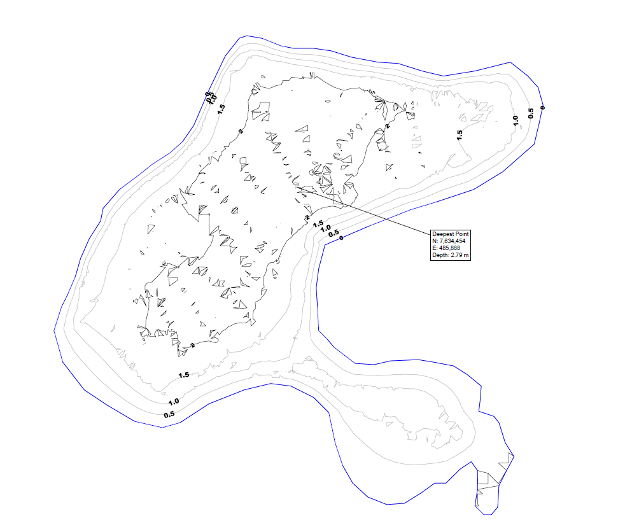
Figure 0-1 Bathymetry of the proposed lake, as surveyed in 2021
General Area Topography and Surface Water Flow

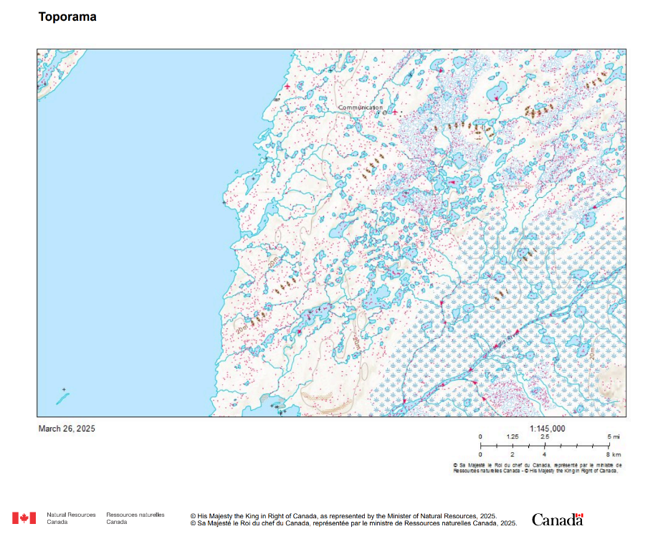
Inglis River
CAM-3
Proposed Lake
Figure 0-2. Regional topography and surface water flow

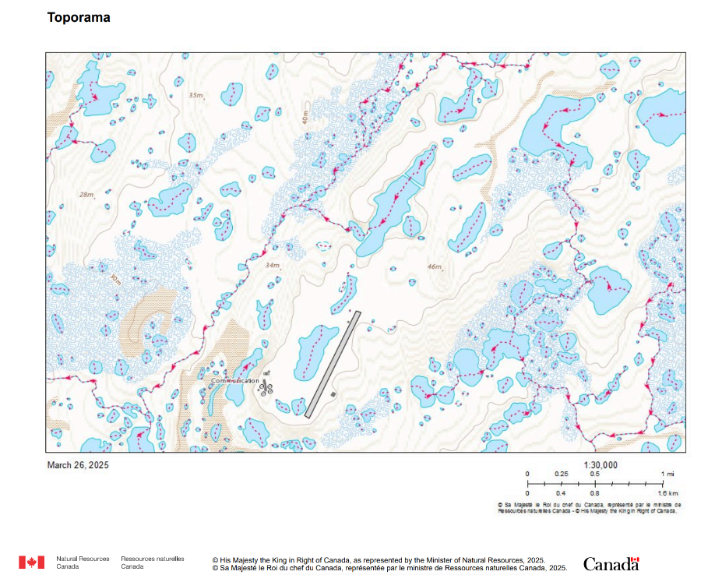
Proposed Lake
CAM-3
Figure 0-3. Topography and surface water flow surrounding CAM-3
Effects of Draw-Down
NWS protocols dictate that if the lake starts to become drawn-down pumping operations must cease.

DFO Comments

The Amendment to Water Licence Application, for the CAM-3, North Warning System Long Range Radar Site, Shepherd Bay, file number: 8BC-SHE1929, discusses water withdrawal activities for the duration of the project, which have the potential to impact fish and fish habitat.

Direct fish mortality can occur during water withdrawal activities through entrainment/impingement. Entrainment occurs when a fish is drawn into a water intake and cannot escape. Impingement occurs when a fish is held in contact with the intake screen and is unable to free itself. Excessive amounts of water withdrawn from ice- covered waterbodies can impact fish through oxygen depletion, loss of over-wintering habitat and/or reductions in littoral habitat.

Recommendation:
In order to comply with the Fisheries Act, it is recommended that the Proponent follow DFO’s protective measures for fish and fish habitat and standard codes of practice which can be found on DFO’s website ( https://www.dfo-mpo.gc.ca/pnw-ppe/measures- mesures-eng.html and https://www.dfo-mpo.gc.ca/pnw-ppe/practice-practique-eng.html).

Proponents are also asked to respect the NU in-water works restricted activity timing windows (Projects Near Water - Nunavut Restricted Activity Timing Windows for the Protection of Fish and Fish Habitat (dfo-mpo.gc.ca) to protect fish during spawning and incubation periods when spawning fish, eggs and fry are vulnerable to disturbance or sediment.

The proponent should refer to DFO’s Interim code of practice: End-of-pipe fish protection screens for small water intakes in freshwater available at https://www.dfo- mpo.gc.ca/pnw-ppe/codes/screen-ecran-eng.html when using fish screens and if the water intake flow is up to 0.150 m3/s, or 150 liters per second (L/s).

In addition, the proponent should follow the DFO Protocol for Winter Water Withdrawal in the NWT (2010) and not withdrawal more than 10% of under-ice water volumes (Attachment 1: DFO Winter Water Withdrawal Protocol (2010)).

If the proposal meets the criteria for a site specific review, as described on DFO’s website (https://www.dfo-mpo.gc.ca/pnw-ppe/reviews-revues/request-review-demande-d- examen-003-eng.html), they should complete and submit the request for review form available on the website (https://www.dfo-mpo.gc.ca/pnw-ppe/reviews-revues/request- review-demande-d-examen-004-eng.html

It is also the proponent’s Duty to Notify DFO if they have caused, or are about to cause, the death of fish by means other than fishing and/or the harmful alteration, disruption, or the destruction of fish habitat. Such notification should be directed to DFO.ARCEMTriage-TriageGEARC.MPO@dfo-mpo.gc.ca

Response
Nasittuq has reviewed the documents in DFO’s recommendations and confirms that applicable requirements are integrated into NWS Standard Procedures. Though the proposed lake freezes to the bottom and likely does not contain any fish, for a conservative approach, Nasittuq employs end-of-pipe fish protection screens.

