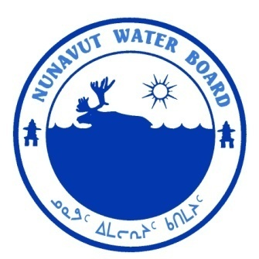  P.O. Box 119 | kNK5 wmoEp5 vtmp5
Gjoa Haven, NU X0B 1J0 | NUNAVUT WATER BOARD
Tel: (867) 360-6338 | NUNAVUT IMALIRIYIN KATIMAYIT
Fax: (867) 360-6369 | OFFICE DES EAUX DU NUNAVUT

File No.: 3BC-SHE0919/TR/B1
July 20, 2011

Kim Kalen
Environmental Officer
North Warning System Office
c/o National Defence Headquaters
101 Colonel By Drive
Ottawa, ON K1A 0K2

E-mail: nippernips@sympatico.ca

RE: Licence 3BC-SHE0919, “CAM-3 North Warning System Site, Shepherd Bay” Kitikmeot Region, Nunavut; Submissions of the 2010 Annual Report

Dear Mr. Kalen:

The Nunavut Water Board (“NWB”) received on March 30, 2011 the 2010 Annual Report for the above mentioned project.

The annual report is found to be complete and meeting the reporting requirements of licence 3BC-SHE0919.

The Licensee is reminded that in accordance with the terms and conditions Part D, Item 1 and Part E, Item 1 of the current licence the Licensee is required to submit for Board approval a revised Sewage Disposal Update and an Operation & Maintenance Plan for Landfill, respectively.

Should you have any questions, please feel free to contact the undersigned at 867-360-6338 ext. 30 or by email at k.kharatyan@nunavutwaterboard.org.

Yours truly,

Original Signed by:

Karén Kharatyan

Technical Advisor

Cc: Distribution List – Kitikmeot Region

