 |  | Submittals |  |  | No. : 78  Rev. : 01  Date : January 22, 2014
Project :  Subject : | CLYDE RIVER HARBOUR DEVELOPMENT Project No. : 2022-034  DFO ETO-025-222050  2024 Annual report for the Nunavut Water Board rev-01
Submitted to : | CBCL Limited David Parsons  1505 Barrington St davidp@cbcl.ca  Halifax, NS, B3J 3K5 506-633-6650 ext 3233
Copy to : | Kenton Thiesson kenton.thiessen@pwgsc-tpsgc.gc.ca  PSPC 204-229-6375
Speciality : |  |  |  | Submitted for : review
Specification section : |  |  |  | Revision required by : February 1, 2014
Drawing reference : |  |  |  | Color choice required :
Submited as : |  |  |  | Total Page incl. cover : 152
Subcontractor or supplier :

Manufacturer :
Description :

Supplier No : Comments :
Revised and submitted by :  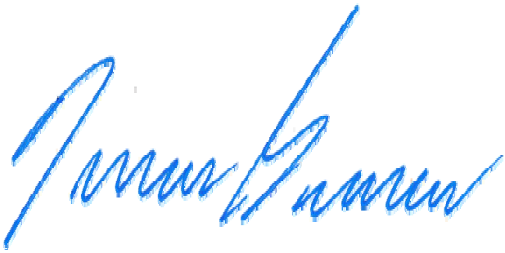  François Bourassa, P.Eng. Pilitak Enterprises Ltd.  1519 Federal Road Iqaluit  418-781-6114 ext 213  fbourassa@pilitak.biz |  |  | Review by the consultant or the client :


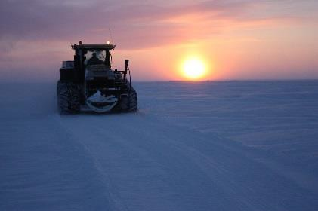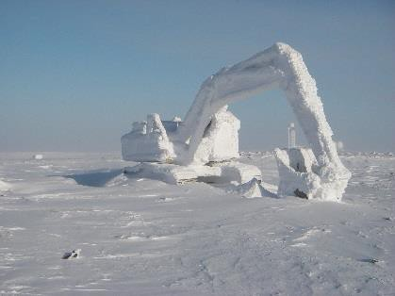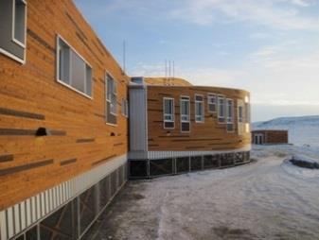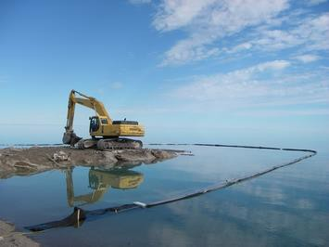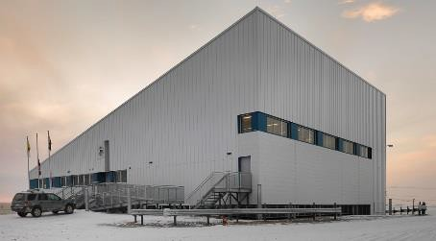


NUNAVUT WATER BOARD (NWB)
ANNUAL REPORT
Permit no. 8BC-CLY2225 Clyde River Harbour Development

DFO ET025-222050/A

Submitted to:

Public Services and Procurement Canada
Revision-01: January 2024

Clyde River Harbour Development

NUNAVUT WATER BOARD (NWB) ANNUAL REPORT FOR PROJECT ACTIVITIES
EXECUTIVE SUMMARY

This report addressed to the Nunavut Water Board (NWB) has been prepared to summarize the 2023 project activities that were carried on under the Type ‘B’ Licence -8BC-CLY2225 issued to the Department of Fisheries and Oceans Canada -Small Craft Harbour (DFO-SCH). The Clyde River Small Craft Harbour Construction’s project was awarded to Pilitak Enterprises Ltd in May 2022 by Public Services and Procurement Canada (PSPC) for DFO-SCH.

2023 PROJECT ACTIVITIES
The 2023 construction season started on May 15 and ended on November 2nd. Granular material and rocks were prepared at the quarry where about 67,500 cubic meters of bedrock were drilled and blasted. A total of 87,000 tones of rocks and gravel was transported from the quarry to the construction site, which represents about 4,200 truck loads who transited through the Hamlet of Clyde River. The transported material was used mainly for the construction of the southwest breakwater, which was completed to about 70%. Some material was used for the upland regrades and for the beginning of the construction of the northeast breakwater. The mooring bollard and the tie back fixed wharf wall were installed. Some minor dredging works were done along a section of the southwest breakwater.
WATER USAGE AND QUALITY MONITORING
Approximately 304 m³ of potable water were delivered by the Hamlet during the 2023’s operations which represents an average domestic water consumption of 2.4 cubic m³/day. A total of 190 m³ of water withdrawn from the Clyde River was used for dust control. At no time more than 30 m³/day of water was used for the dust control. The total daily water consumption has never exceeded the licence’s maximum daily allowance of 36 m³/day. No unauthorized discharge occurred during this construction season. The surface runoff or discharges impacted by construction activities associated with the Project, where flow may directly or indirectly enter water were monitored for the total suspended solids (TSS), the presence of visible oil and grease and the pH. Two monitoring stations were established and at no times the collected measurements exceeded the parameters thresholds indicated in the Water Licence.

WASTE MANAGEMENT
The total volume of waste generated during the 2023’s construction season is estimated to 110.6 m³. From this volume, about 46 m³ of used wood and pallets were salvaged by the community and 12.3 m³ of waste were shipped off-site for disposal or recycling. The diverted waste from the community disposal facility represents 53% of the total volume of waste generated.

SPILL
A total of 5 spills of diesel and hydraulic oil, each less than 100 L, occurred during the 2023 construction season.

ᑲᖏᖅᑐᒑᐱᒻᒥ ᐅᒥᐊᑦ ᐅᖅᑯᐃᕝᕕᖓᓂᑦ ᓴᓇᕙᓪᓕᐊᓂᖅ
ᓄᓇᕘᑉ ᐃᒪᓕᕆᔨᖏᑕ ᑲᑎᒪᔨᖏᓄᑦ ( NWB) ᐊᕐᕌᒍᑕᒫᖅᓯᐅᑦ ᐅᓂᒃᑳᓕᐊᖓ ᐱᔭᒃᓴᕆᔭᓄᑦ ᑲᒪᒋᔭᐅᔪᓄᑦ
ᓇᐃᒡᓕᒋᐊᖓᔪᖅ ᐅᓂᒃᑳᓕᐊᖅ

ᐅᓇ ᐅᓂᒃᑳᓕᐊᖅ ᓵᖓᔭᖃᖅᑐᖅ ᓄᓇᕘᑉ ᐃᒪᓕᕆᔨᖏᑕ ᑲᑎᒪᔨᖏᓄᑦ (NWB) ᐸᕐᓈᖑᓯᒪᔪᖅ ᐅᓂᒃᑳᓕᐅᕆᔾᔪᑕᐅᓪᓗᓂ
ᑖᒃᑯᐊ 2023ᒥ ᐱᔭᒃᓴᓕᐊᕆᔭᑦ ᑲᒪᒋᔭᐅᓯᒪᔪᑦ ᐊᑐᖅᖢᑎᒃ ᐃᓕᖅᑯᓯᓕᒃ “ᐅ” ᓚᐄᓴᓐᓯᐊᓂᒃ - 8BC-CLY2225 ᑐᓂᔭᐊᓂᑰᔪᖅ ᑲᓇᑕᐅᑉ ᐱᓕᕆᕝᕕᐊᑕ ᐃᒪᕐᒥᐅᑕᓕᕆᔨᒃᑯᑦ ᑲᓇᑕᒧᑦ - ᐅᒥᐋᕋᓛᖑᓂᖅᓴᓄᑦ ᐅᖅᑯᐃᕝᕖᑦ (DFO-SCH). ᑖᓐᓇ ᑲᖏᖅᑐᒑᐱᒻᒥ ᐅᒥᐋᕋᓛᓄᑦ ᐅᖅᑯᐃᕝᕕᐅᑉ ᓴᓇᔭᐅᓂᒃᓵ ᑐᓐᓂᕆᔭᐅᓪᓗᓂ ᑖᒃᑯᓄᖓ ᐱᓕᑕᒃ ᑕᑯᒃᓴᕈᐃᔨᑦᑎ ᑎᒥᖓᓄᑦ ᒪᐃ 2022ᒥ
ᑖᒃᑯᓄᖓ ᑭᒃᑯᓕᒫᓄᑦ ᐱᔨᑦᑎᐅᑎᑦ ᓂᐅᕕᕋᖅᑕᓄᓪᓗ ᑲᓇᑕᒥ (PSPC) ᑖᒃᑯᓄᖓ DFO-SCH.

2023 ᐱᔭᒃᓴᕆᔭᓄᑦ ᑲᒪᒋᔭᐅᓚᐅᖅᑐᑦ
ᑖᓐᓇ 2023 ᓴᓇᔪᓕᕆᓂᐊ ᑕᖅᑭᒋᔭᖏᒃ ᐱᒋᐊᓚᐅᖅᑐᑦ ᒪᐃ 15ᒥ ᐃᓱᓕᖢᓂᓗ ᓄᕕᐱᕆ 2ᒥ. ᑐᐊᐸᓕᐊᑦ ᕿᒡᒍᓕᐊᓪᓗ ᐸᕐᓈᖑᓪᓗᑎᒃ ᑐᐊᐸᒃᑕᕝᕕᒻᒥ ᐃᒻᒪᖄ ᑕᐃᑲᓂ 67,500 ᒦᑕᒃ ᑭᑉᐹᕆᖓᔪᑦ ᓂᐅᖅᑐᖅᑕᐅᓪᓗᑎᒃ ᐊᓱᐃᓛᒃ ᖄᖅᑎᑕᐅᕋᖅᖢᑎᒃ. ᑲᑎᓕᒫᖅᖢᒍ 87,000 ᑕᓐᓯᓂᒃ ᐅᔭᕋᓂᒃ ᑐᐊᐸᓂᓪᓗ ᐅᓯᑲᖅᑕᓚᐅᖅᑐᑦ ᑕᐃᑲᙵᑦ ᐅᔭᕋᒃᑕᕝᕕᐊᓂ ᑕᐃᑯᖓ ᓴᓇᔭᐅᕝᕕᐊᑕ ᐃᓂᖓᓄᑦ, ᑭᒡᒐᖅᑐᐃᔪᖅ ᐃᒻᒪᖄ 4,200 ᐅᓯᑲᖅᑕᐅᑎᒧᑦ ᐅᓯᔭᐅᔪᑦ ᐊᖅᑯᑖᒍᑦ ᕼᐋᒻᒪᓚᖓᑕ ᑲᖏᖅᑐᒑᐱᐅᑉ ᓴᓇᕝᕕᖓᓄᑦ. ᑕᒪᓐᓇ ᐅᓯᑲᖅᑕᖅᑕᐅᔪᖅ ᐊᑐᖅᑕᐅᓪᓗᐊᑕᖅᖢᓂ ᓴᓇᔭᐅᓂᐊᓄᑦ ᐅᖅᑯᐋᒍᑦ ᓯᕿᖅᑕᖅᑕᐅᕝᕕᐊᓂ, ᐱᔭᕇᖅᑕᐅᓪᓗᓂ ᐃᒻᒪᖄ ᑎᑭᖢᒍ 70%. ᐃᓚᖓ ᐊᑐᖅᑕᐅᒋᓪᓗᓂ ᓄᑖᕈᐃᔾᔪᑕᐅᓪᓗᓂ ᑎᒫᒍᑦ ᒪᓂᖅᑭᑎᐱᓂᒻᒥᒃ ᓴᓇᔭᐅᕙᓪᓕᐊᓂᐊᑕᓗ ᐊᖅᑯᑖᓄᑦ
ᐅᐊᖕᓈᒍᑦ ᓯᕿᖅᑕᖅᑕᐅᕝᕕᒃᓵᑕ. ᑖᓐᓇ ᑭᓴᖅᑕᐅᕝᕕᐊᑕ ᐃᐱᕝᕕᐊ ᐊᒻᒪᓗ ᓇᐸᔪᖅ ᐊᑭᙵᕆᔭᖅ ᐃᐱᖅᓯᒪᕝᕕᖓ ᐃᓕᔭᐅᓪᓗᓂ ᐊᑐᐃᓐᓇᐅᓕᖅᖢᓂ. ᐃᓚᖓ ᐃᖅᑲᖓ ᐊᒡᒐᒃᑕᐅᓪᓗᓂ ᐃᒃᑲᓗᐊᖅᑐᓕᑦ ᑕᐅᕙᓂ ᐅᖅᑯᖔᖔᑕ ᓯᕿᖅᑕᕝᕕᓕᐊᑉ ᓵᖓᒍᑦ.

ᐃᒥᕐᒥᒃ ᐊᑐᖅᑕᓐᓂᖏᑦ ᐊᒻᒪ ᐃᒥᑦᑎᐊᕙᐅᓂᐊᑕ ᖃᐅᔨᓵᕆᔭᐅᓂᖏᓄᑦ
ᐃᒻᒪᖄ ᑲᑎᓕᒫᖅᖢᒍ 304 ᒦᑕᑦ ᑭᑉᐹᕆᖓᔪᑦ ᐃᒥᑦᑎᐊᕙᒻᒥᒃ ᐅᓯᑲᖅᑕᕝᕕᐅᓚᐅᖅᑐᒍᑦ ᕼᐋᒻᒪᓚᒃᑯᓐᓄᑦ 2023 ᓴᓇᕝᕕᐅᑉ ᑕᖅᑭᖏᒍᑦ ᐃᒻᒪᖄ ᑭᒡᒐᖅᑐᐃᔪᖅ ᕿᑎᕋᖅᑐᒥᒃ ᓄᓇᓕᒻᒥ ᐃᒪᖅᑐᓐᓂᒻᒥᒃ 2.4 ᑭᑉᐹᕆᖓᔪᑦ ᒦᑕᑦ /ᖃᐅᑕᒫᖅ. ᑲᑎᖢᒍ 190 ᒦᑕᑦ ᑭᑉᐹᕆᖓᔪᑦ ᐊᑐᖅᑕᐅᓚᐅᕆᕗᖅ ᑲᖏᖅᑐᒑᐱᐅᑉ ᐃᒪᖃᕝᕕᐊᓂᒃ ᐳᔫᓗᐊᖁᓇᒍ ᐊᖅᑯᑎᒋᔭᕗᑦ ᐊᑐᖅᑕᐅᓕᕌᖓᑦ.
ᑕᐃᒪᖓᓕᒫᖅ ᓴᓇᑎᓪᓗᑕ ᐅᖓᑕᐆᔾᔨᓚᐅᓐᓇᑕ 30 ᑭᑉᐹᕆᖓᔪᑦ ᒦᑕᑦ /ᖃᐅᑕᒫ ᐳᔫᖅᑐᒧᑦ ᓴᓇᕝᕕᑦᑎᓐᓂ. ᑖᓐᓇ ᑲᑎᓕᒫᖅᖢᒍ ᖃᐅᑕᒫᑦ ᐃᒪᖅᑐᓐᓂᕗᑦ ᐅᖓᑕᐅᔾᔨᓚᐅᖅᓯᒪᓇᓂ ᓚᐄᓴᓐᓯᐅᑉ ᐳᖅᑐᓛᖑᓂᕋᖅᑖᑕ 36 ᑭᑉᐹᕆᖓᔪᑦ ᒦᑕᑦ
/ᖃᐅᑕᒫ. ᐊᖏᖅᑕᐅᓯᒪᖏᑦᑐᑦ ᑯᕕᔭᐅᔪᓂᒃ ᐱᑕᖃᓚᐅᓐᓇᓂ ᓴᓇᔭᐅᕙᓪᓕᐊᑎᓪᓗᒍ ᑖᓐᓇ ᑕᖅᑭᖁᑎᑦᑎᒍᑦ. ᓄᓇᖓᓂ ᑰᒍᑎᔪᑦ ᐅᕝᕙᓘᓐᓃᑦ ᖄᒥᑦᑎᔪᑦ ᐊᒃᑐᐊᔪᑦ ᓴᓇᔭᑦᑕ ᐱᓕᕆᐋᖏᓐᓄᑦ ᐱᔭᒃᓴᓕᐊᖑᔪᒧᑦ, ᑖᒃᑯᐊ ᑰᓐᓂᖏᑦ ᐃᓗᓪᓚᕆᐊᓄᑦ ᐅᕝᕙᓗ ᓴᓂᕌᓂ ᐃᓯᒐᓛᓲᑦ ᐃᒪᖏᑦ ᖃᐅᔨᓵᖑᓪᓗᑎᒃ ᑲᑎᓕᒫᖅᖢᒍ ᐊᐅᒍᑎᓯᒪᔪᑦ ᐃᓗᐊᑦᑐᕕᓃᑦ (TSS), ᐱᑕᖃᒻᒪᖔᑦ
ᑕᑯᒃᑕᐅᔪᒥᑦ ᐃᔨᒧᑦ ᐅᖅᓱᐋᓗᒥᒃ ᑭᓂᖅᑐᒥᓪᓗ ᐊᒻᒪᓗ ᐃᒪᐅᑉ ᓂᕈᒥᓐᓂᖓᒍᑦ. ᒪᕐᕉᒃ ᖃᐅᔨᓴᐃᕝᕖᒃ ᓴᖅᑭᑕᐅᓪᓗᑎᒃ ᐃᒪᖓᓄᑦ ᑕᐃᒪᙵᓪᓗ ᑲᑎᖅᓱᒐᐅᓲᑦ ᖃᐅᔨᓴᕈᑏᑦ ᐃᒪᖓᓄᑦ ᖄᖏᖅᓯᓚᐅᓐᓇᑎᒃ ᑭᒡᓕᓯᓂᐊᕈᑕᐅᔪᓄᑦ ᑎᑎᕋᖅᓯᒪᔭᑦ ᐃᓗᐊᒍᑦ ᐃᒪᕐᒧᑦ ᓚᐄᓴᓐᓯᐅᑉ.

ᐊᒃᑕᑯᒃᓴᑦ ᑲᒪᒋᔭᐅᓂᒃᓴᖏᑦ
ᑲᑎᓕᒫᖅᖢᒍ ᐊᒃᑎᒋᓂᖓ ᐊᒃᑕᑯᒃᓴᑦ ᑲᒪᒋᔭᑦᑎᒍᑦ ᑕᑯᒃᓴᕈᖅᑐᑦ ᐃᓗᐊᒍᑦ 2023 ᐱᔭᒃᓴᓕᐊᑦᑕ ᐱᓕᕆᐋᖏᒍᑦ ᓇᓚᐅᑦᑖᒃᑯᑦ ᑎᑭᓚᐅᖅᑐᖅ 110.6 ᒦᑕᑦ ᑭᑉᐹᕆᖓᔪᓄᑦ. ᑖᒃᑯᓇᖓᑦ, ᐃᒻᒪᖄ 46 ᒦᑕᑦ ᑭᑉᐹᕆᖓᔪᑦ ᕿᔪᕕᓃᑦ ᐅᓯᔭᐅᔾᔪᑎᖏᓪᓗ ᓄᓇᓕᒻᒧᑦ ᓇᒡᕚᖅᑕᐅᓪᓗᑎᒃ ᐊᒻᒪᓗ 12.3 ᒦᑕᑦ ᑭᑉᐹᕆᖓᔪᒃ ᐃᒋᑕᒃᓴᑦᑎᓐᓂ ᓇᒃᓯᐅᔾᔭᐅᓪᓗᑎᒃ ᐊᓯᖏᓄᑦ ᓄᓇᓄᑦ
ᐃᒋᑦᑎᕕᑦ ᐅᕝᕙᓗ ᓴᓗᒻᒪᓚᐅᖅᖢᑎᒃ ᐊᑐᒃᑲᓐᓂᒐᒃᓴᓕᕆᔨᓄᑦ. ᑖᒃᑯᐊ ᓇᒡᕚᖅᑕᐅᔪᕕᓃᑦ ᐃᒋᑕᕗᑦ ᓄᓇᓕᒻᒥᐅᓄᑦ ᐊᒃᑕᕝᕕᖓᓂᒃ ᑭᒡᒐᖅᑐᐃᔪᖅ ᐃᒻᒪᖄ 53% ᑲᑎᓕᒫᖅᑕᑦᑕ ᐃᒋᑕᒃᓴᓕᐊᕕᓂᑦᑎᓐᓂᒃ ᐱᓕᕆᐋᕆᔭᑦᑎᒍᑦ.

ᑯᕕᓂᑯᑦ
ᑲᑎᓕᒫᖅᖢᒋᑦ ᑕᓪᓕᒪᑦ ᑯᕕᔪᑦ ᐃᒐᓯᐅᑎᒥᒃ ᐅᖁᒪᐃᑦᑐᓕᕆᔨᓪᓗ ᑭᓂᖅᑐᒋᓲᖏᑦ, ᐊᑐᓂᑦ ᒥᑭᓐᓂᖅᓴᐃᓐᓇᑦ ᑯᕕᔭᖅ 100 ᓖᑕᒥᒃ, ᓴᖅᑭᓚᐅᖅᑐᑦ ᐃᓗᐊᒍᑦ 2023 ᓴᓇᔪᓕᕆᓂᐅᑉ ᑕᖅᑭᖁᑎᖏᒍᑦ.

ii

TABLE OF CONTENTS

PAGE
- DESCRIPTION OF PROGRESS 1
  - ACTIVITIES UNDERTAKEN DURING 2023 1
- WATER USE ACTIVITIES 15
  - DOMESTIC WATER USE 15
  - WATER FOR DUST CONTROL AND/OR CONSTRUCTION ACTIVITIES 15
  - TOTAL WATER USE 17
  - UNAUTHORIZED DISCHARGE 18
  - RIVER CROSSING 18
- REPORTS AND PROGRAMS 19
  - WASTE MANAGEMENT 19
  - SPILLS 20
  - QUARRY DEVELOPMENT 21
  - EROSION AND SEDIMENT CONTROL 22
  - WATER QUALITY MONITORING 24

Appendices
APPENDIX 1: SPILL PREVENTION & RESPONSE PLAN REV-02 APPENDIX 2: EROSION AND SEDIMENT CONTROL PLAN REV-03 APPENDIX 3: SPILL REPORTS AND SOIL DISPOSAL
APPENDIX 4: NWB ANNUAL REPORTING FORM

DESCRIPTION OF PROGRESS
This report addressed to the Nunavut Water Board (NWB) has been prepared to summarize the 2023 project activities that were carried on under the Type ‘B’ Licence -8BC-CLY2225 issued to the Department of Fisheries and Oceans Canada -Small Craft Harbour (DFO-SCH). The construction project was awarded to Pilitak Enterprises Ltd (PEL) in May 2022 by Public Services and Procurement Canada (PSPC) for the Department of Fisheries and Ocean (DFO).

1.1 ACTIVITIES UNDERTAKEN DURING 2023

Our first crew was mobilized to Clyde River on May 15th, 2023, to open the camp, remove snow at the different sites and de-winterizing our equipment. The constructions activities started at the beginning of June 2023 and were ended at mid-October 2023. The following main activities were performed:

  - Drilling and blasting: About 67,500 cubic meters of rock were blasted from the existing quarry.
  - Road upgrades: Road from the quarry to the airport road was upgraded. Gravel and rocks were placed to increase the bearing capacity of the road. The drainage was improved by adding culverts and the existing ditches were improved in some sections. Sediment and erosion protection measures were implemented.
  - Road maintenance: Roads from the harbour site to the quarry were maintained frequently to keep them in good condition. The reshaping of the surface was done with a grader and gravel was added on some road sections. Dust control was done by spreading calcium chloride and water on the road.
  - Material preparation for the project: The rip rap plant, the screener plant and the rock crusher plant were used to produce gravel and rocks of variable sizes for the project.
  - Gravel and rock transportation to harbour site: A total of 87,000 tonnes of rocks and gravel was transported between the quarry and the site.
  - Upland upgrades: Shot rock was transported and placed in front of the harbour site (uplands).
  - The southwest breakwater was constructed with corestones, filterstones and armourstone. The breakwater was built to the full length. Filterstone and armourstone will still need to be installed in some sections during the next summer. The southwest breakwater construction is completed to approximately 70%.
  - The dredge spoil storage area was developed on the west side of the existing tankfarm. Berms and a decantation basin were built to collect the sediment from the dredged dewatering.
  - Dredging: Minor dredging was done along the east side of the southwest breakwater. A total of 549 cubic meter was excavated and transported to the dredge spoil storage area.
  - Sealift delivery: Steel sheet piles, floating wharfs and other supplies and equipment were delivered to Clyde River by sealift.
  - Mooring bollard: A new mooring bollard was installed on the uplands, in front of the southwest breakwater.
  - Fixed wharf construction: The tie back wall of the fixed wharf was installed into the core of the southwest breakwater. A total of 21 pairs of steel sheet piles were installed with a crane equipped with a vibro hammer down to an elevation of -4.5 meters.
  - Winterization of the equipment and facilities.

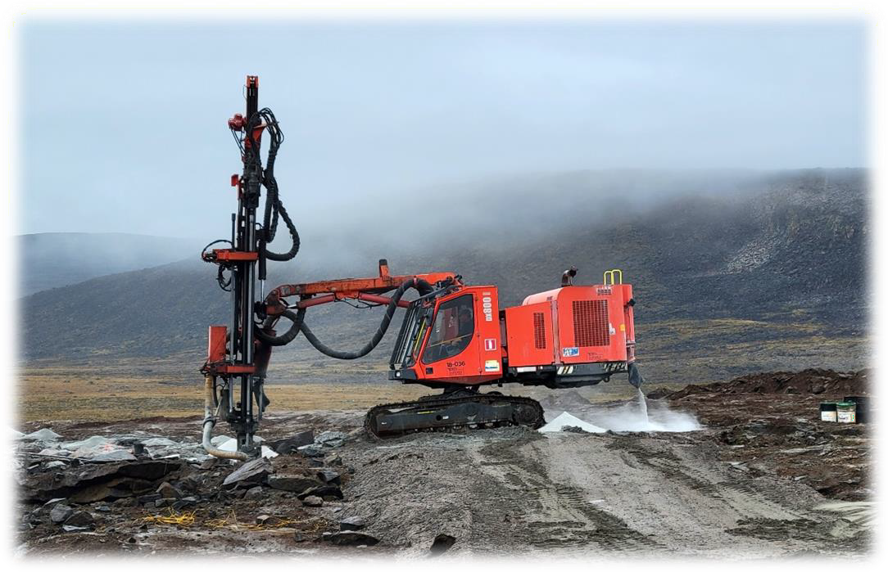

Drilling at the Quarry
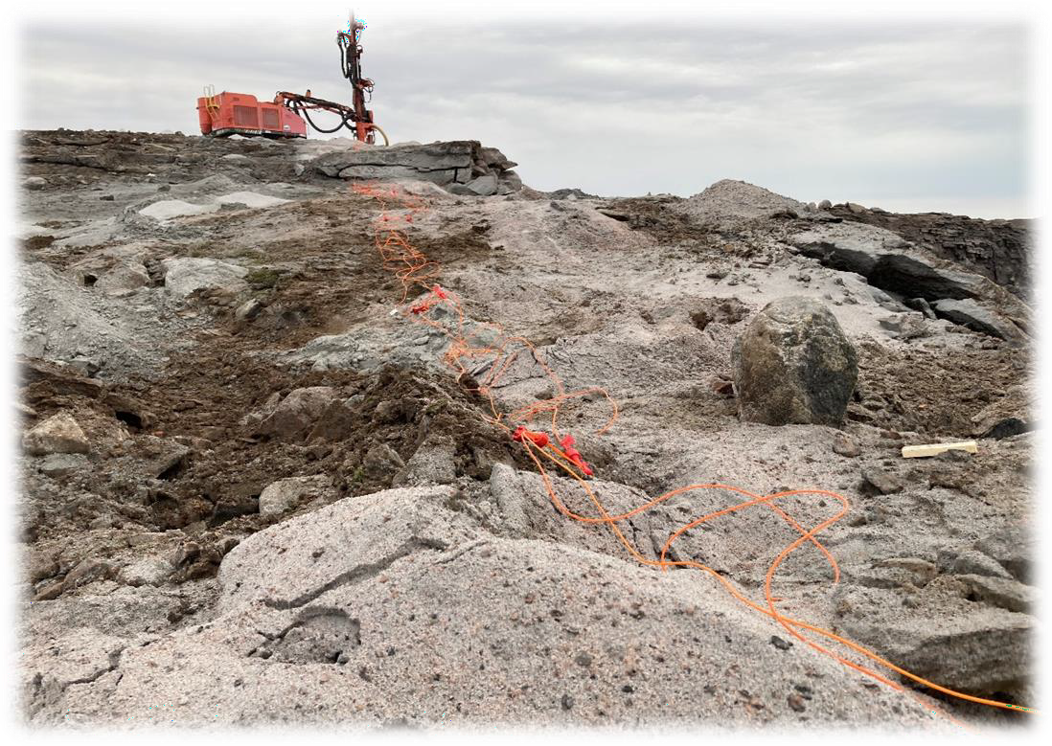
Blasting Preparation

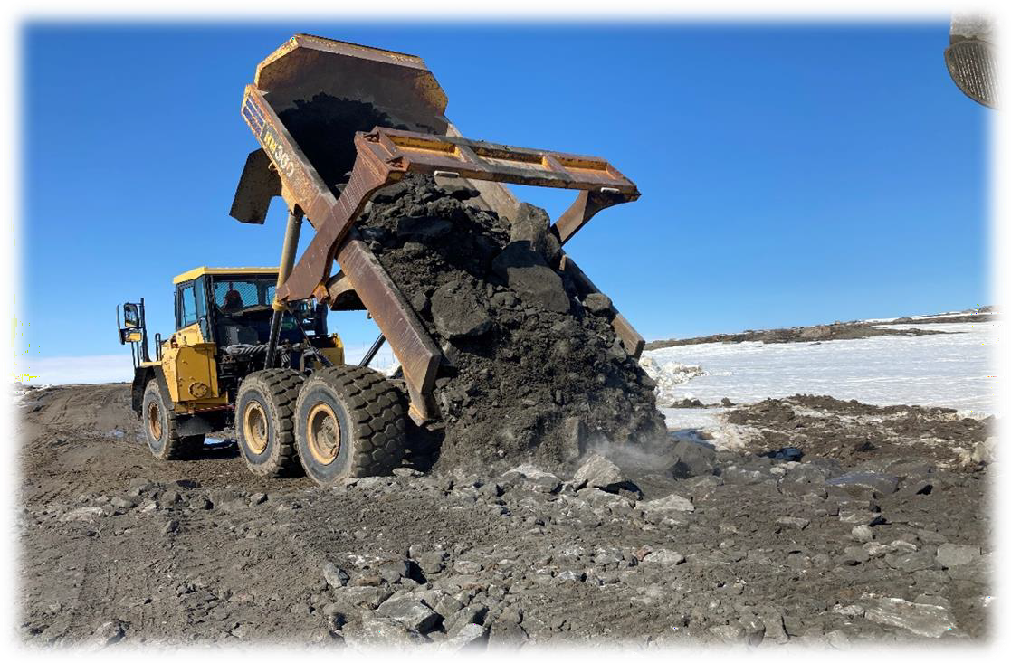
Road Upgrade

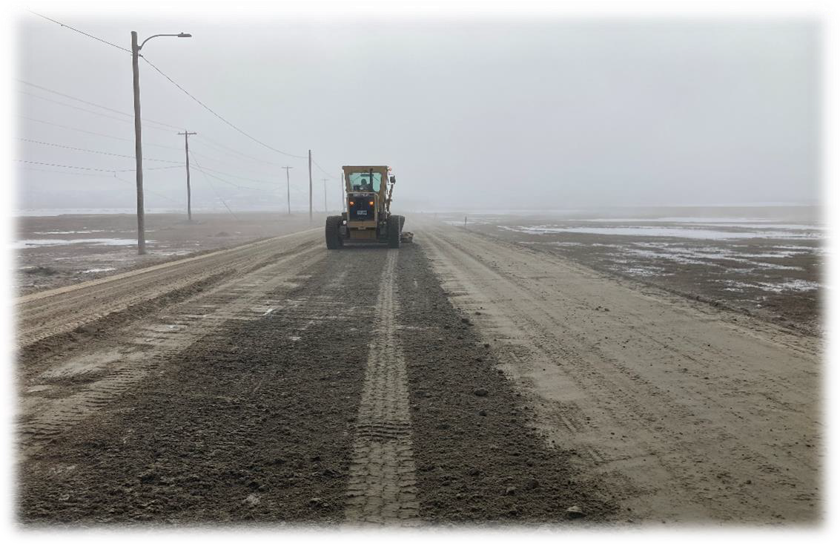
Road Maintenance

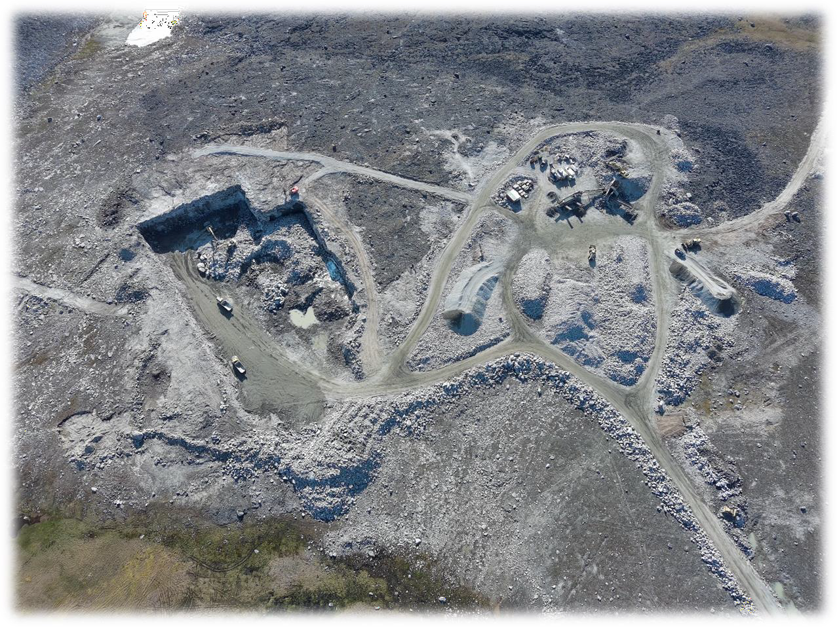

Quarry and Material Processing Area
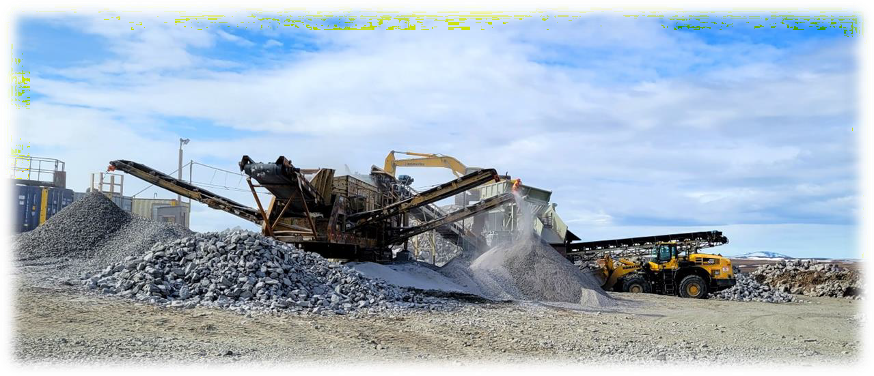

Rip Rap and Screener Plants


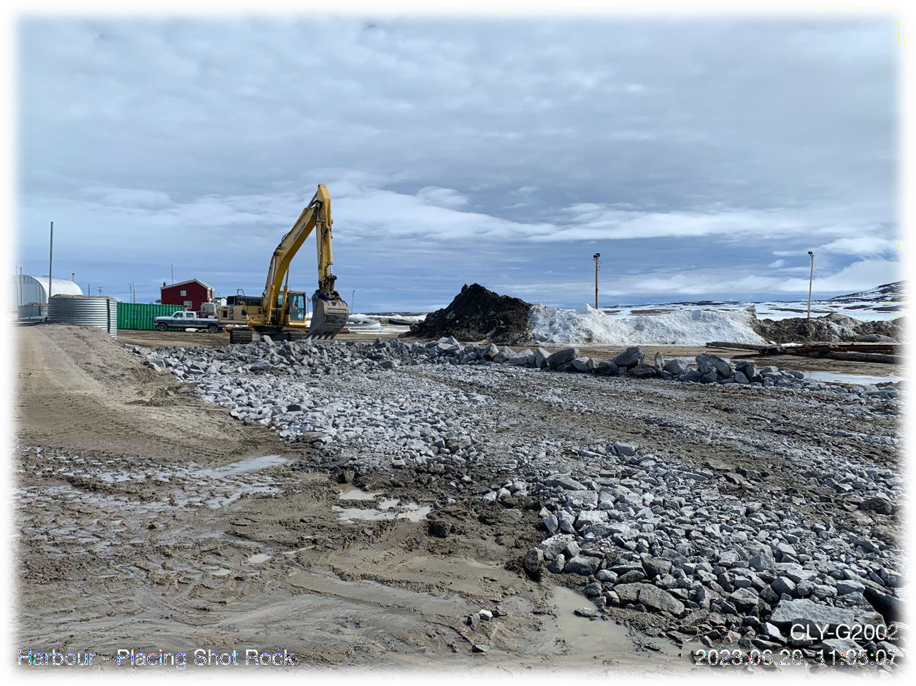
Material Transportation from the Quarry to the Harbour Site
Placing Shot Rock on the Upland Area (in Front of the Harbour)

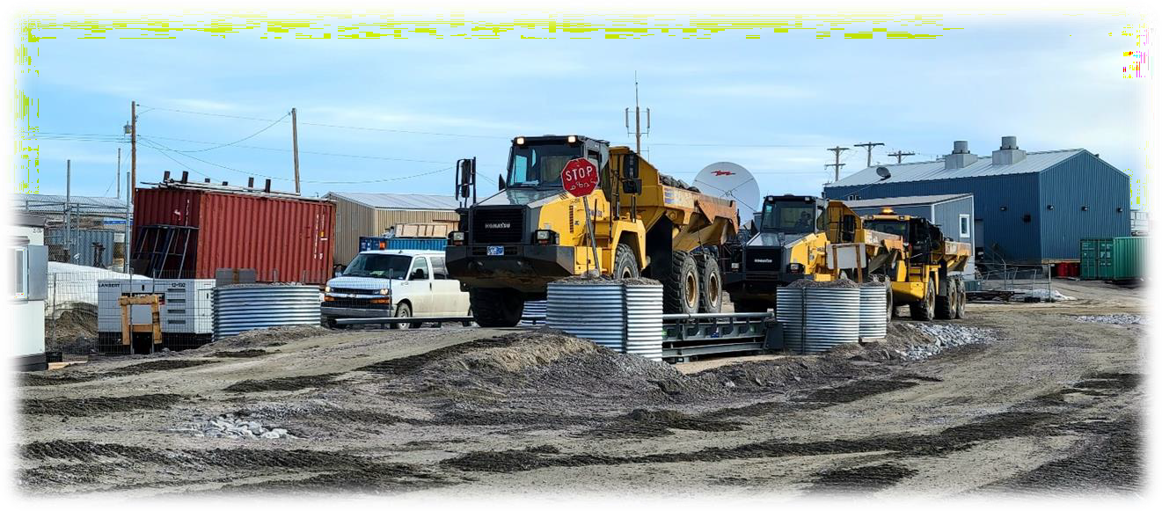
Trucks at the Scale Station

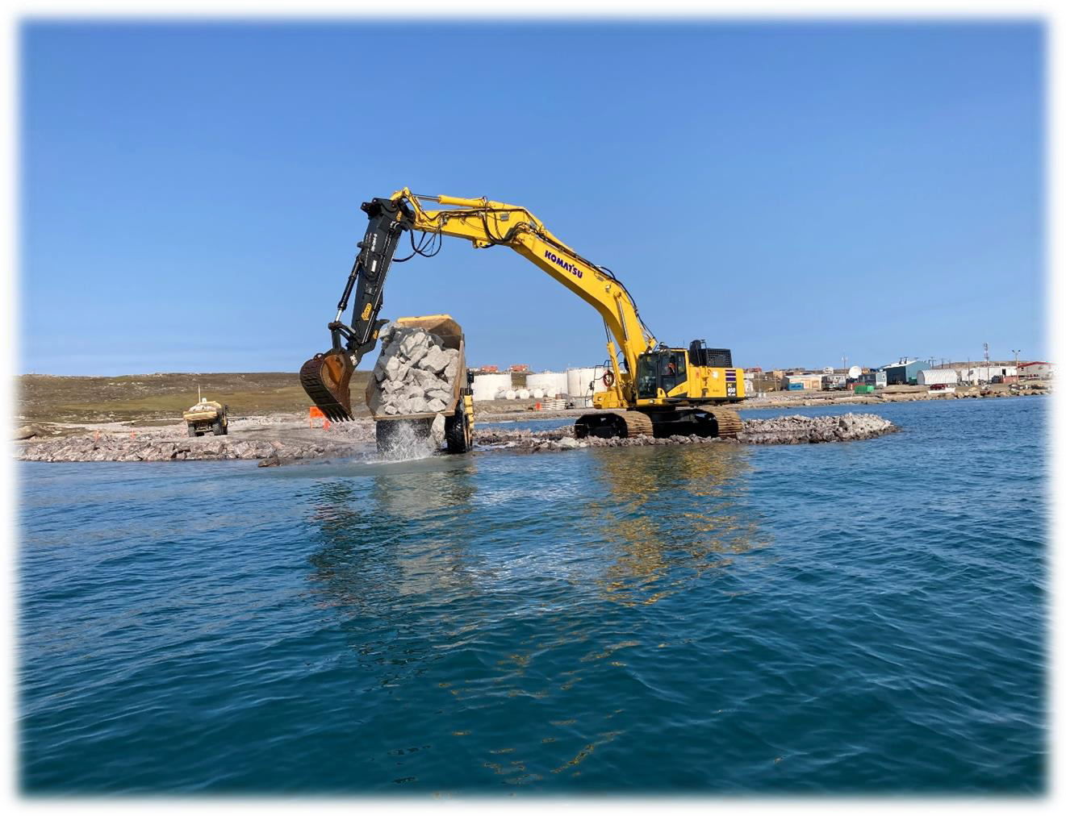
Southwest Breakwater Construction

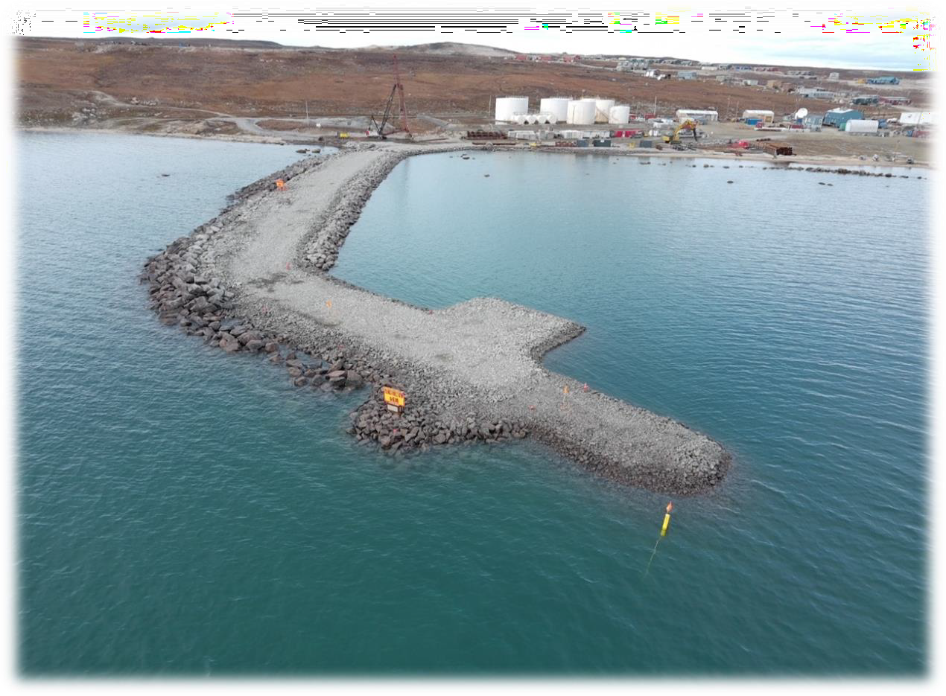

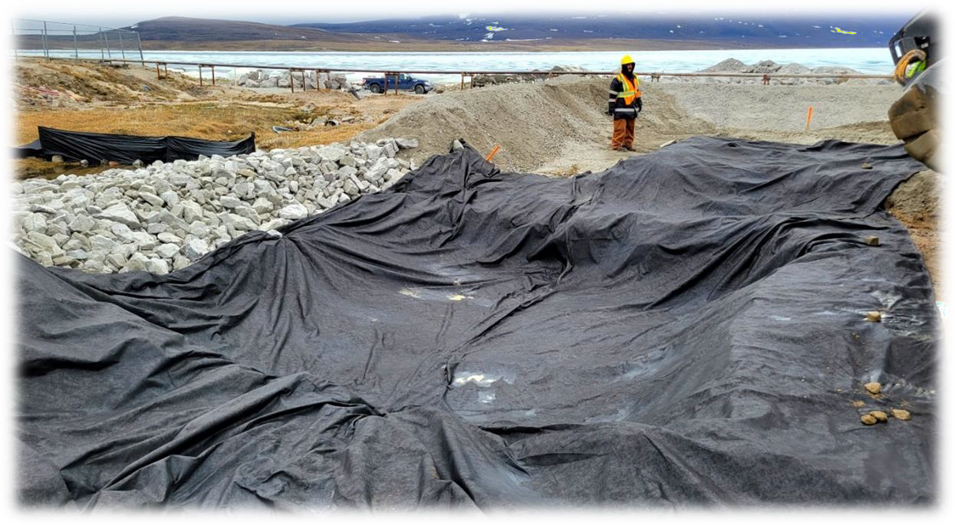
Southwest Breakwater Construction
Dredge Spoil Storage Area Preparation

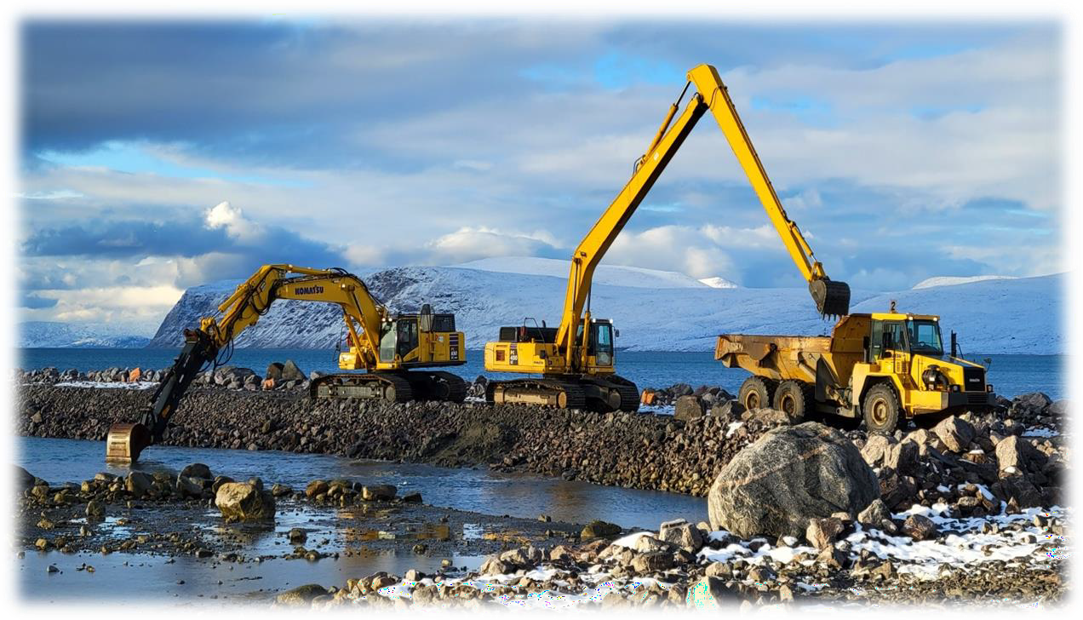

Dredging Along the Southwest Breakwater

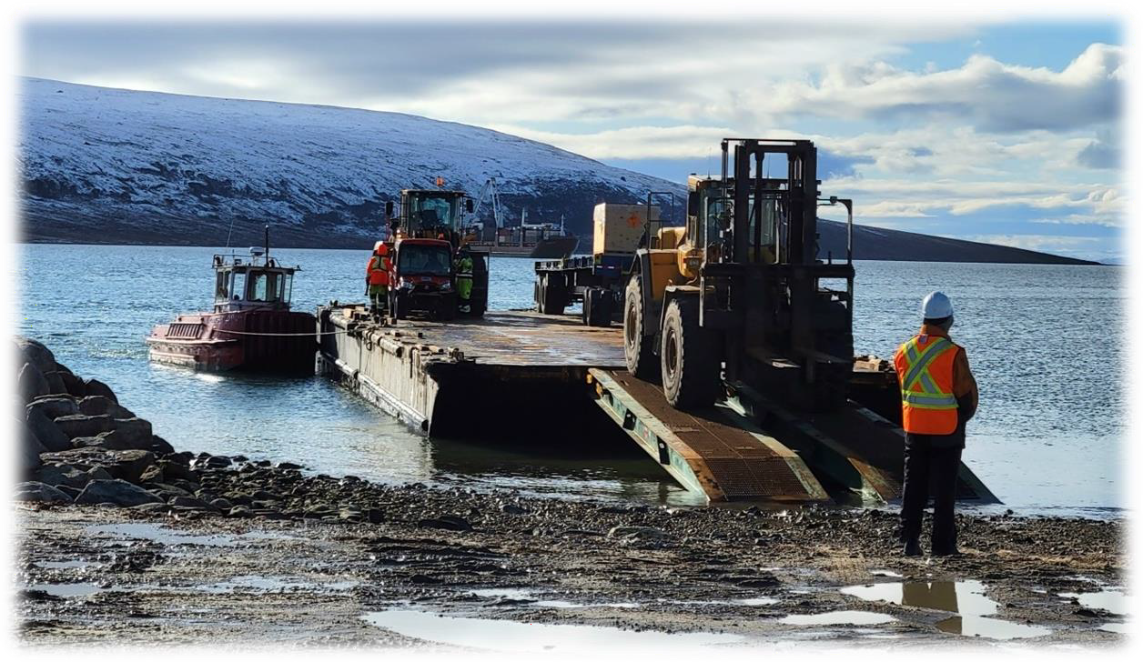
Sealift Unloading

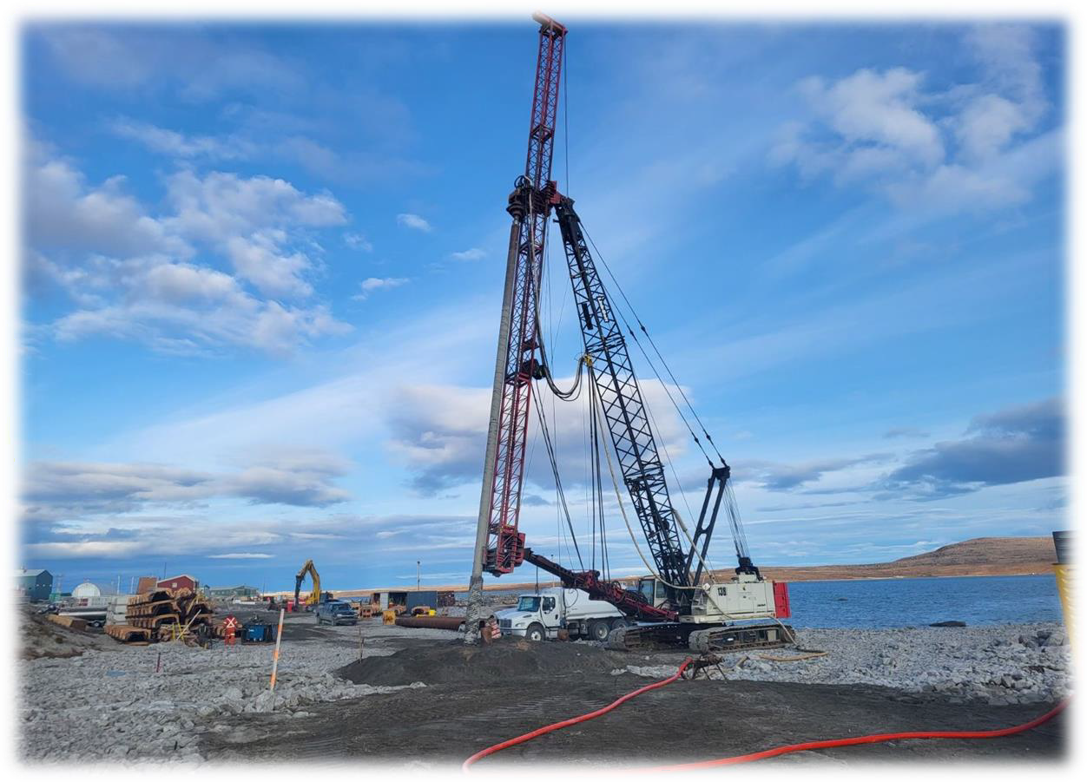
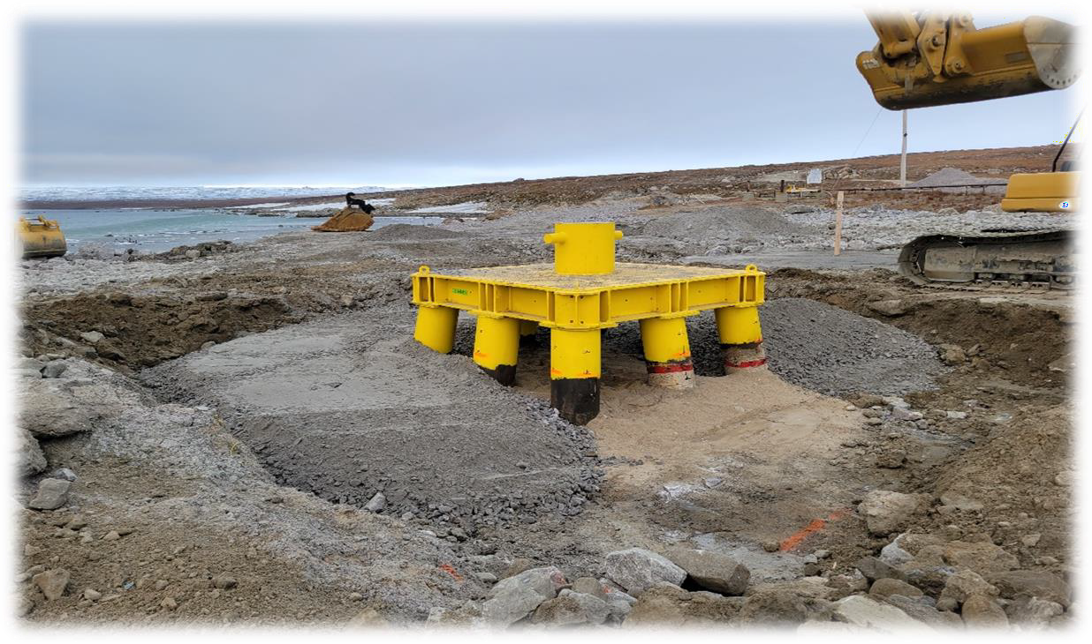
Drilling for the Mooring Bollard Installation
Mooring Bollard Installation Completed

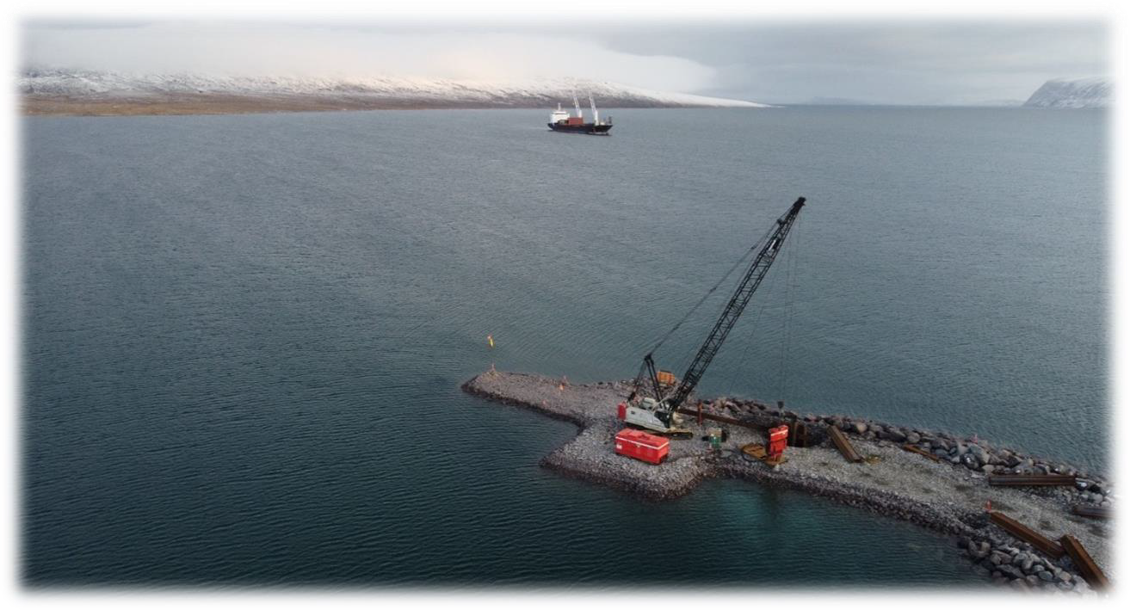

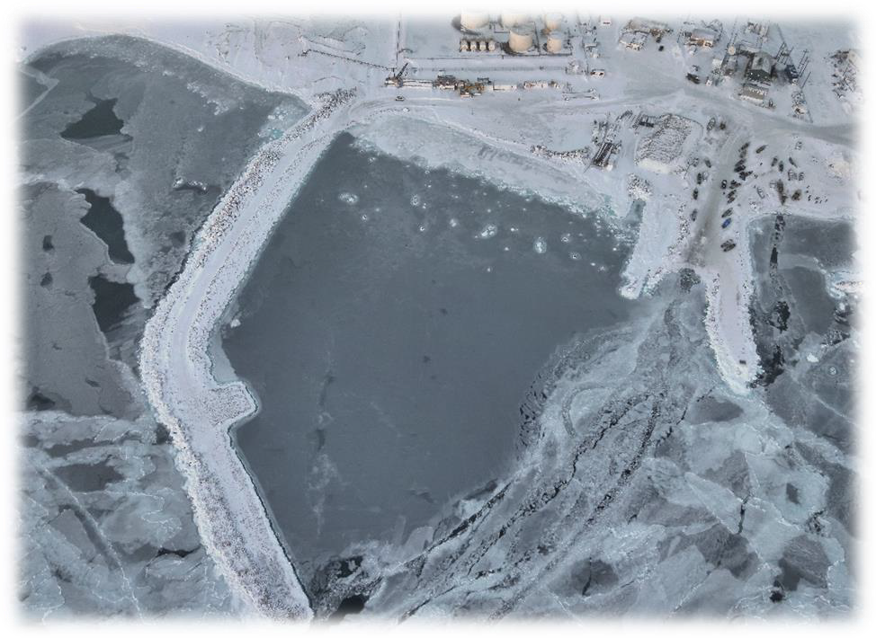
Steel Sheet Piling Installation at the Southwest Breakwater

Southwest Breakwater at the End of the 2023’s Construction Season

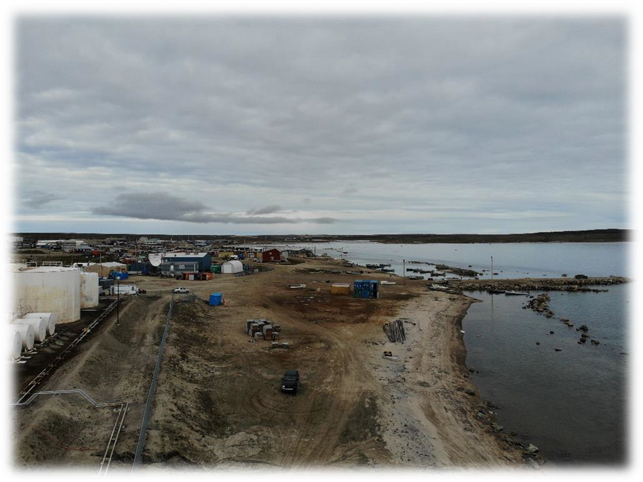
Construction site before beginning of work -August 2022
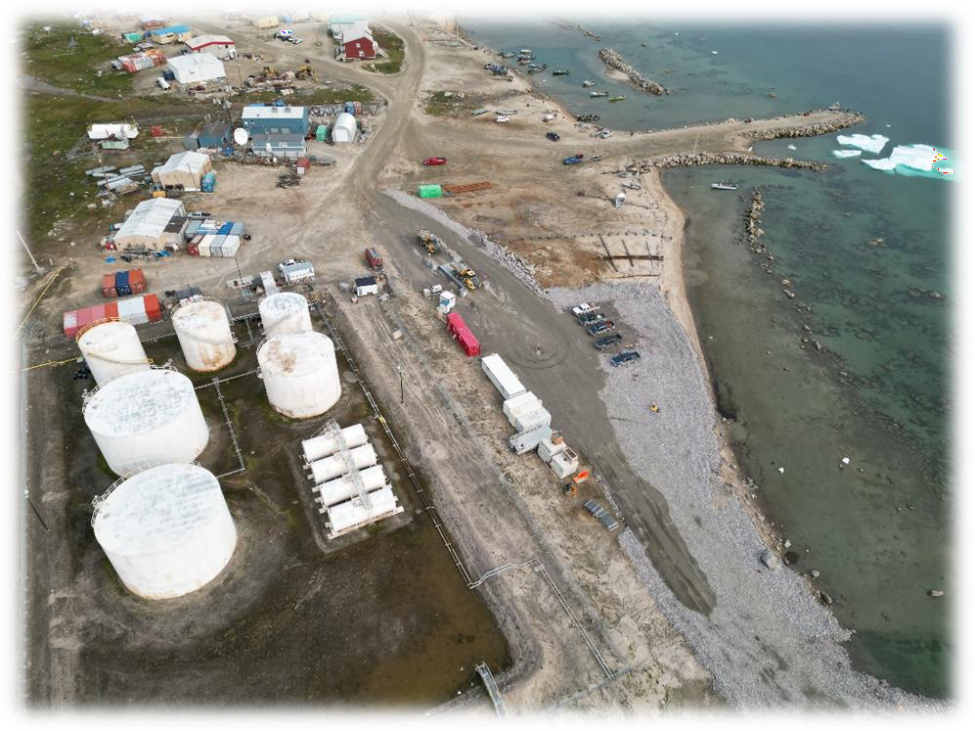
Construction site -August 2023

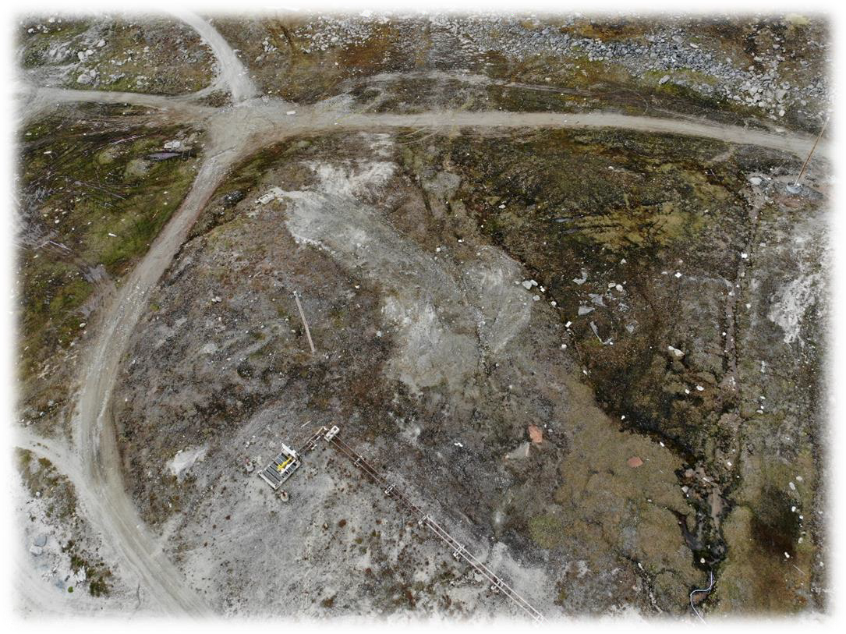
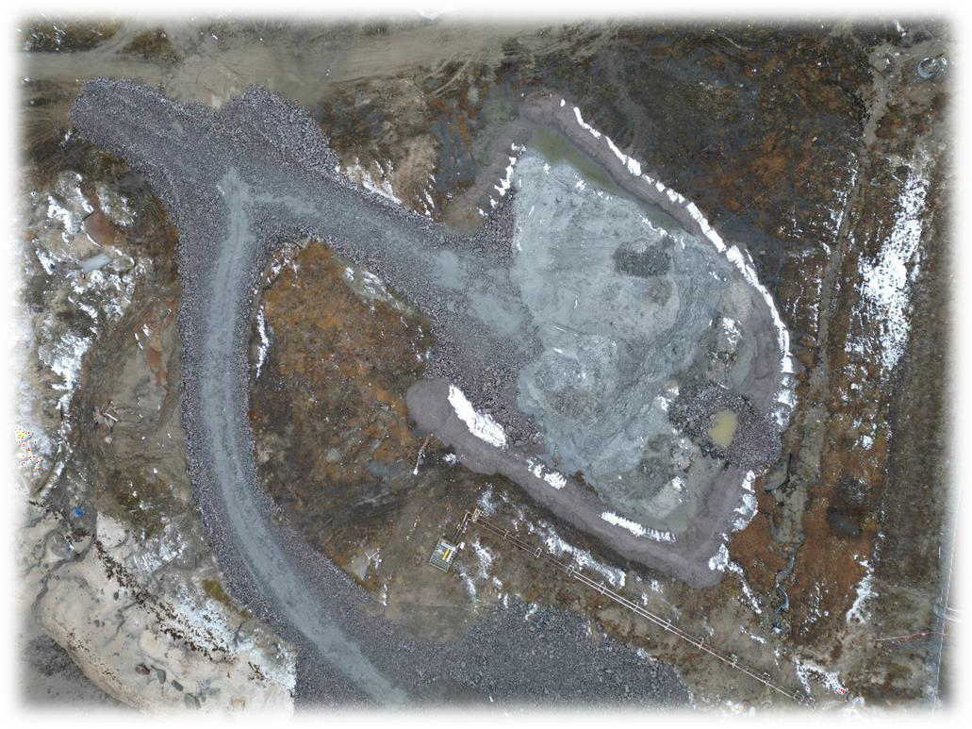
Dredge spoil dewatering area before beginning of work -August 2022
Dredge spoil dewatering area -August 2022

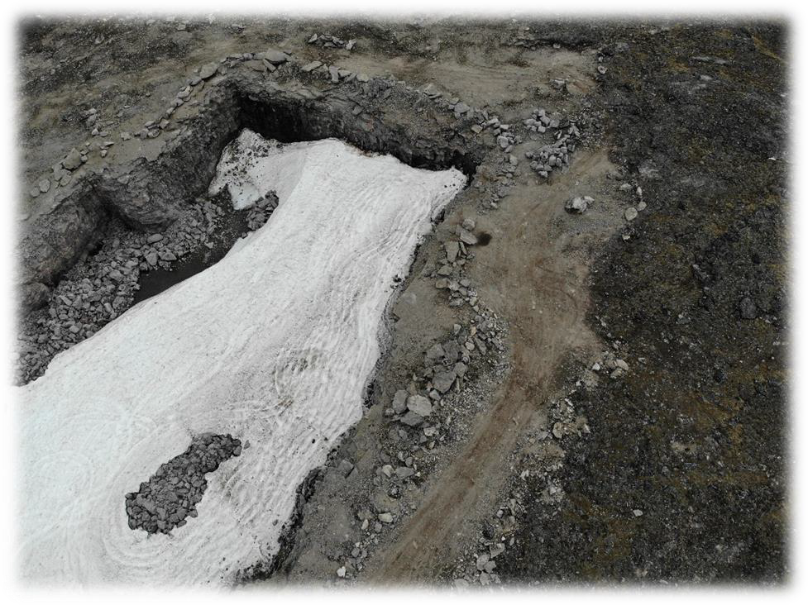
Existing quarry before beginning of work -August 2022
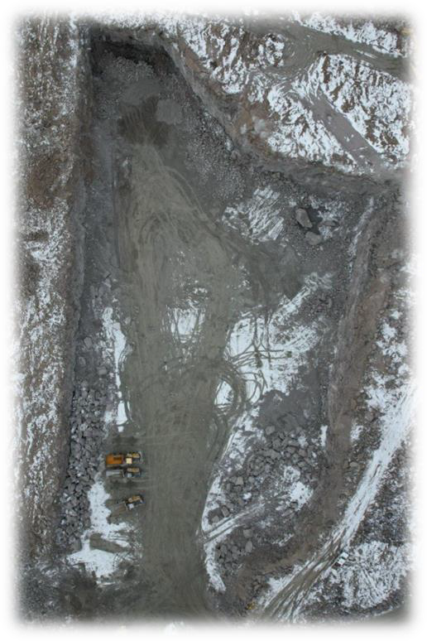
Quarry development -October 2023

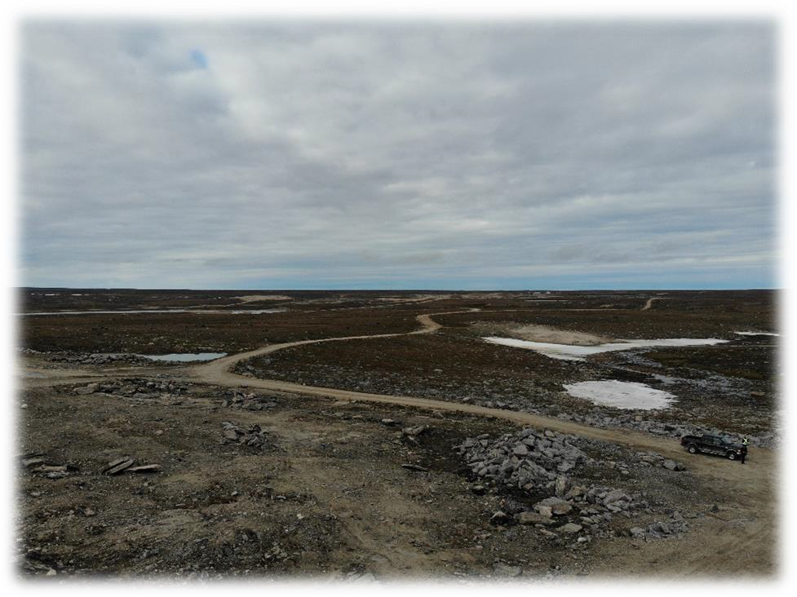
Existing road to quarry beginning of work -August 2022
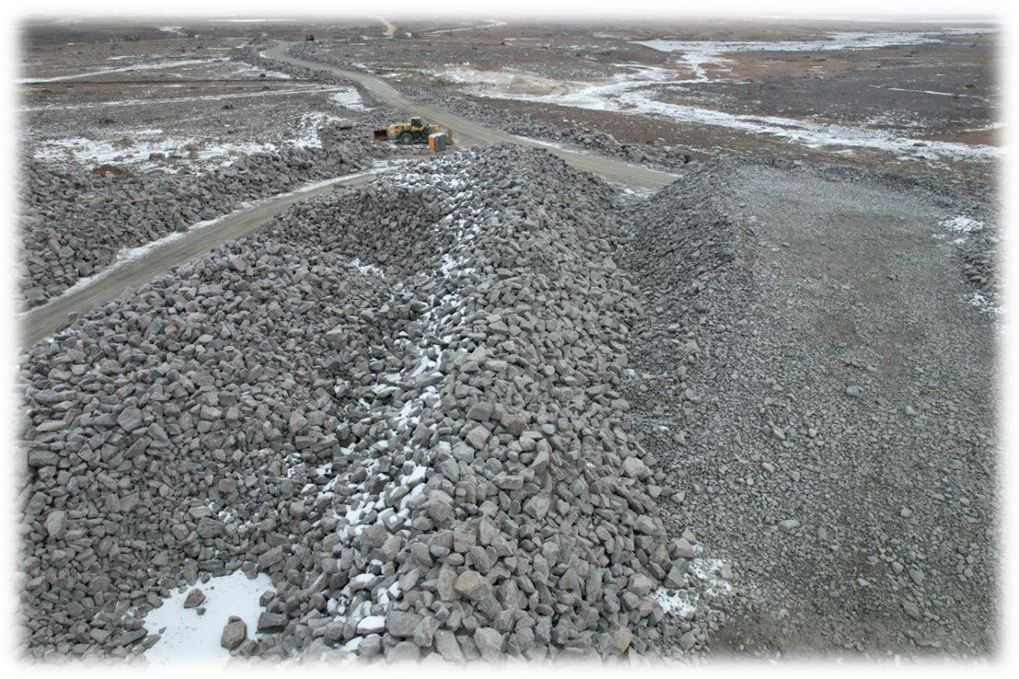
Road to quarry -October 2023

WATER USE ACTIVITIES
The type B water licence issued for this project is for the usage of a maximum 36 m³/day of water supplied by the Hamlet of Clyde River from their domestic water delivery system. The licence was amended to include the withdraw of a maximum 30 m³/day of water directly from the Clyde River, for dust suppression. The maximum daily water consumption remains the same, at 36 m³/day.

2.1 DOMESTIC WATER USE

Domestic water was used at our 2 houses in Clyde River and at our construction camp. The potable water was delivered by the hamlet water truck. The sewage water was collected by the hamlet sewage truck and disposed at their sewage lagoon facility. Our operations started in mid- May with a crew of 10 people and ramped up to an average of 18 people from mid-June up to the beginning of November. Approximately 304,000 litres of potable water were delivered by the hamlet for the entire duration of our 2023’s operations. This represents and average domestic water consumption of 2.4 m³/day.

2.2 WATER FOR DUST CONTROL AND/OR CONSTRUCTION ACTIVITIES

Dust control measures were needed only on a few occasions during the months of July and August 2023, as summarized in the Table 1. Water was poured on the roads with our water truck and calcium chloride was spread with a 2 tonnes spreader installed at the back of a pickup truck.

The water for the dust suppression was pumped out from the Clyde River except on July 1st, where the Hamlet truck filled with domestic water was used for this purpose. Our water truck, equipped with is own suction pump, was used to withdraw water directly from the Clyde River. The pump that was used have a maximum capacity of 264 GPM or 0.0166 m3/s, which is lower than the maximum allowable flow rate of 0.025 m³/s, stipulated within the license amendment. A screen was installed at the end of the intake hose, to ensure that fish are not entrained during the pumping operations. At no time during the water pumping dead or injured fishes have been observed. The water was pumped out from the Clyde River on the southwest side of the bridge located nearby our construction camp, about 800 m northeast of the airport terminal, as indicated in Figure 1.

Table 1: Dust Control Measures

Date | Dust Control Measures
Date | Water Spreading on Roads | Calcium Chloride Spreading on Roads
July 1st,  2023 | 20 m3 of water (from hamlet) spread on the harbour site to quarry | 700 Kg spread on roads from harbour site to quarry (5 km)
July 28th, 2023 | 30 m3 of water pumped from the river and spread on roads from the harbour site to  quarry | 1,000 Kg spread on roads from harbour site to quarry (5 km)
July 29th, 2023 | 30 m3 of water pumped from the river and spread on roads from the harbour site to  quarry | --
Aug. 2nd, 2023 | 30 m3 of water pumped from the river and spread on roads from the harbour site to  quarry | --
Aug. 4th, 2023 | 30 m3 of water pumped from the river and spread on roads from the harbour site to  quarry | --
Aug. 5th, 2023 | 30 m3 of water pumped from the river and spread on roads from the harbour site to  quarry | --
Aug. 10th, 2023 | 20 m3 of water pumped from the river and spread on roads from the harbour site to  quarry | --
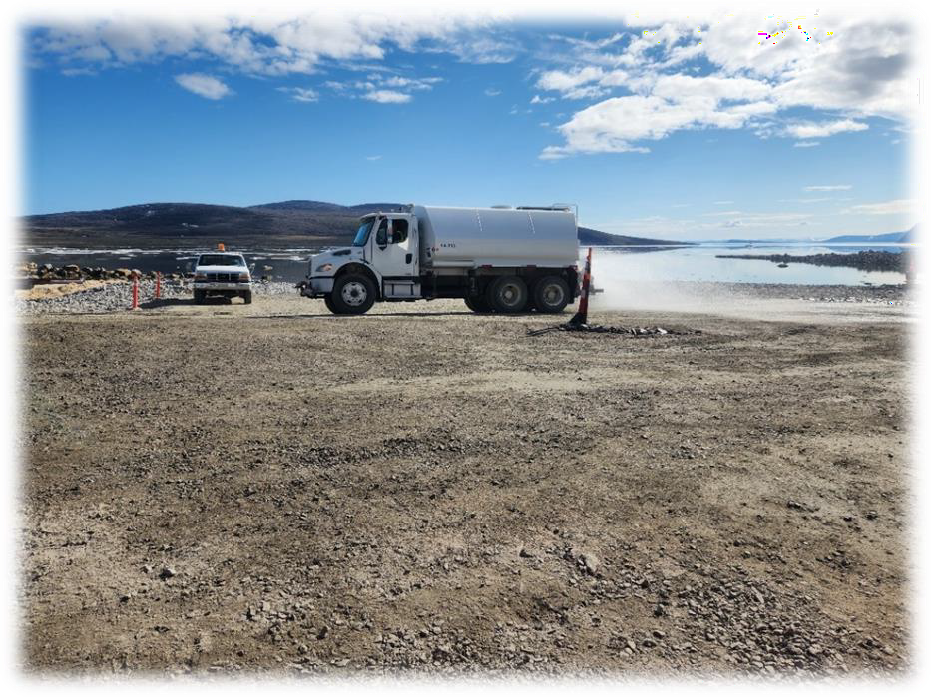
Water Spreading on the Road for Dust Control

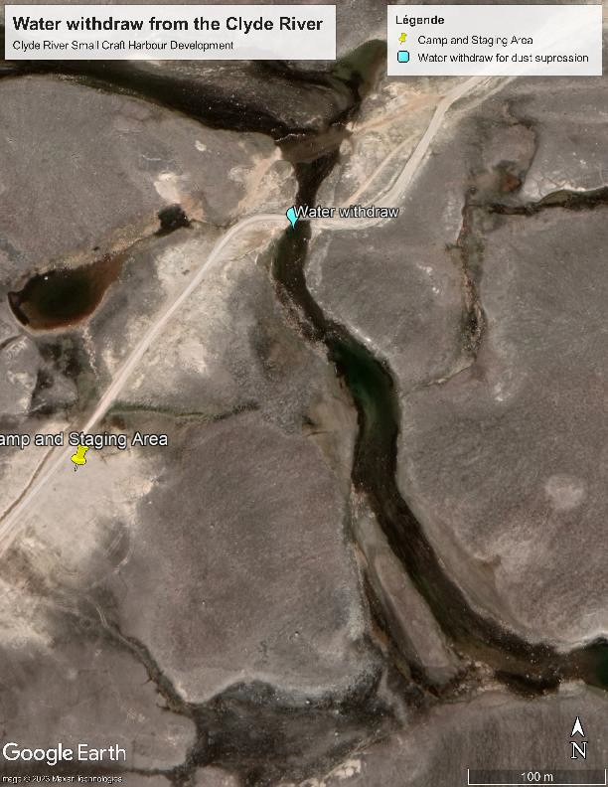
Figure 1: Location of the Water Withdrawn from the Clyde River

2.3 TOTAL WATER USE

The total daily water consumption, including the domestic water and the water used for the dust control, has never exceed the licence’s maximum daily allowance of 36 m³/day.

2.4 UNAUTHORIZED DISCHARGE

Except for 5 minor hydraulic oil or diesel spills on land, no unauthorized discharge occurred during this construction season.

2.5 RIVER CROSSING

No Ford crossing in the river Clyde occurred during the 2023 construction season. On May 31st, 2023, one excavator crossed on the frozen river to access the other side. The renovated bridge has been used for all other equipment movements and material transportation. At no time during these operations dead or injured fish were observed.

REPORTS AND PROGRAMS
The following management plans, in relation with the water licence, were issued for the project. As indicated in Table 2, some of these plans were revised. The updated plans are presented in Appendix.

Table 2: Plans Submitted in Relation with the Water Licence

Management Plans | Included within the 2022 NWB annual report | Updated version attached to this document
Waste Management Plan | Rev-02 | --
Spill Prevention and Response Plan | Rev-01 | Rev-02
Quarry Development and Blasting Management  Plan | Rev-01 | --
Water Quality Monitoring Plan (Included in the  Sediment and Erosion Control Plan) | -- | --
Sediment and Erosion Control Plan | Rev-00 | Rev-03
Closure and Reclamation Plan for the Quarry  Site (included in the Quarry Development and Blasting Management Plan | -- | --

3.1 WASTE MANAGEMENT

The waste management for the 2023’s construction season is summarized in Table 3. A considerable volume of used wood coming from the crates and pallets that were emptied after the sealift arrival were offered to the community for salvage. Waste batteries, scrap metals, used oils et used oil filters, empty gas cylinders and some mechanical parts were shipped by sealift to different southern facilities for reusing, recycling or retrofit. As presented within the following section, some hydrocarbon contaminated soils were shipped on the sealift for disposal into a licence facility in the province of Quebec. The largest volume of waste delivered to the local landfill was domestic garbage coming from the camp operation. The total volume of waste generated during the 2023’s construction season is estimated to 110.6 m³. From this volume, about 46 m³ of used wood and pallets were salvaged by the community and 12.3 m³ of waste were shipped off-site for disposal or recycling. The diverted waste from the community disposal facility represents 53% of the total volume of waste generated.

Table 3: 2023 Waste Management

 | May | June | July | Aug. | Sept. | Oct.
Streams Contributing to Credit
Wood Crate or Wood Pallets or Wood to be Reused |  |  | 2 | 1 | 43
Metal Strapping and other Scrap Metals |  |  |  |  | 3
Waste Oil and Waste Filters & Grease Container |  |  |  |  | 2,6
Waste Batteries |  |  |  |  | 0,2
Waste Tires |  |  |  |  | 4,5
Mechanical Parts Sent for Retrofit |  |  |  |  | 2
Streams not Contributing to Credit
Misc. Camp waste |  | 23 | 8,25 | 10,5 | 6 | 4,5
Total Diverted Waste | 58,3 | m3
Total Waste | 111 | m3
Percentage Diverted | 53%

3.2 SPILLS

A spill prevention & response plan was submitted to PSPC and to the consultant at the end of June 2022. One revised version (rev-01) was issued in order to includes the comments from all parties. This version was included within the 2022 annual report presented to the Nunavut Water Board. No modifications to the Plan have been done since that time.

A total of 5 spills occurred during the 2023’s construction season, as summarized in Table 4. Spill reports were sent to the Nunavut Spill Line for the spills that occurred on July 4th, 2023, and September 14th, 2023. These spills were under 100 litres but considering that they happened nearby the water, the Nunavut spill line was contacted. No corrective action was instructed by the Nunavut Spill Line authorities. The contaminated soil placed into Quatrex bags were loaded into a marine container and shipped by sealift to Bécancour (QC). The contaminated soils were transported to the licenced disposal facility SolNeuf on October 20th, 2023. The spill reports and the soil disposal documentation are presented in Appendix 3.

Table 4: Spill Log

Date of Spill | Location | Source | Quantity & Product | Contingency Measures
June 28th, 2023 | Screener site, nearby quarry | Broken hose on fuel tanker | 70 liters of diesel | Absorbent pads and granular absorbent were used to remove the product from the surface. Contaminated soils were excavated  and placed into the Quatrex bag no.1 for off-site disposal
July 4th, 2023 | Southwest  breakwater, nearby beach | Excavator broken hydraulic hose | 40 liters of  biodegradable hydraulic oil | Stained rocks were collected and  placed into Quatrex bag no.2 for off-site disposal
Aug. 16th, 2023 | Beside rip rap plant | Broken hose on fuel tanker | 81 liters of diesel | Contaminated soils were excavated and placed into one Quatrex bag no.3 for off-site disposal
Aug. 16th, 2023 | Quarry road, north of the rip rap plant | Broken hose on fuel tanker | 20 liters of diesel | Contaminated soils were excavated and placed into one Quatrex bag  no.3 for off-site disposal
Sept. 14th, 2023 | Southwest breakwater, fixed wharf location | Broken hydraulic hose on the power pack for the vibro  hammer | 10 liters of biodegradable hydraulic oil | Stained rocks were wiped out with absorbent pads

3.3 QUARRY DEVELOPMENT

A total of 17 blasts was done at the quarry from June 10th, 2023, to September 13th. About 67,500 cubic meters of rock was extracted to produce a part of the material required for the project. The Figure 2 shows the quarry expansion limits, the original quarry perimeter before the project starts and the quarry perimeter at the end of the 2023 construction season. The quarry will still be in development in 2024. The reclamation works will be done in 2025.

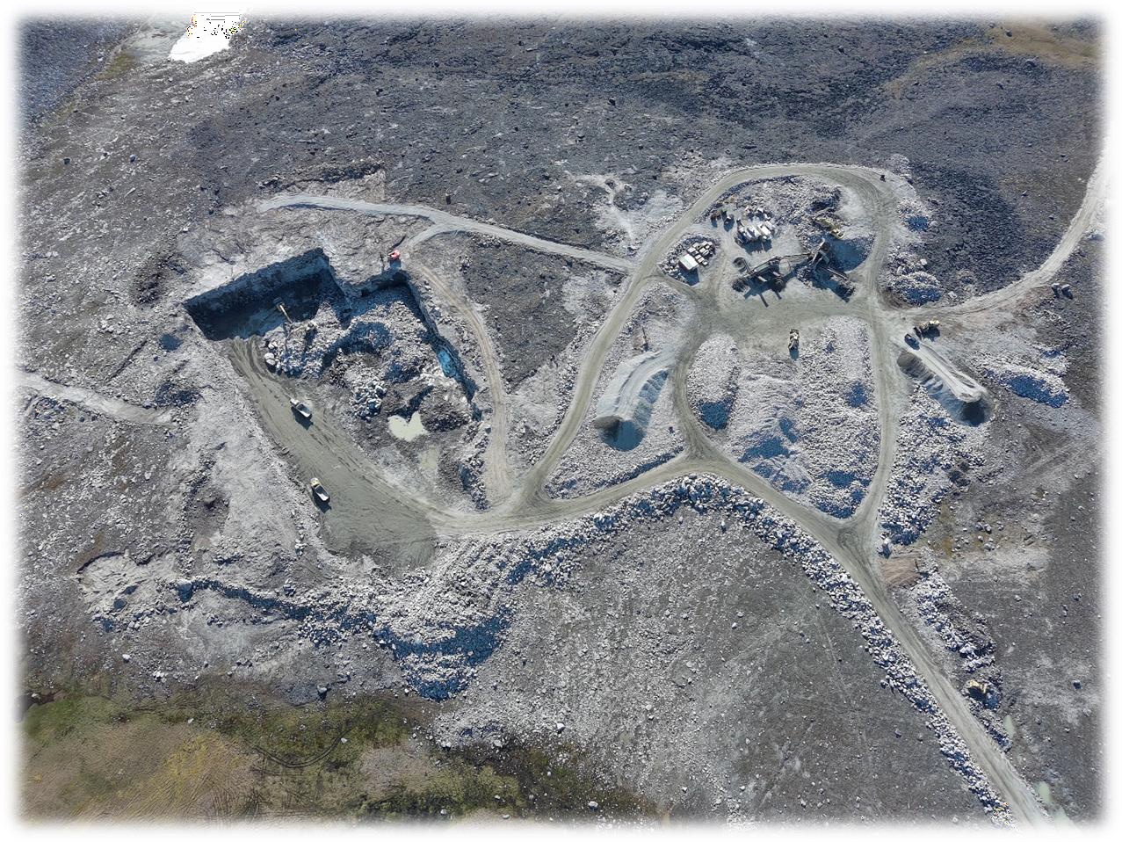
Quarry perimeter before the project
Quarry perimeter end of 2023 construction
Quarry expansion limits
Figure 2: Quarry Expansion Limits and Progress

3.4 EROSION AND SEDIMENT CONTROL

Erosion was monitored at the different working sites, during the snow melting and during rain episodes. Erosion and sediment control measures were installed at the harbour site and along the haul road, from the quarry to the airport road. At the harbour site, a dredge spoil dewatering area was built. A decantation basin was dug, and a filter berm was built with geotextile. The upgradient drainage was improved by adding a ditch along the north end of the dewatering area. A culvert was installed, as per contract, under the access road to the dewatering area.

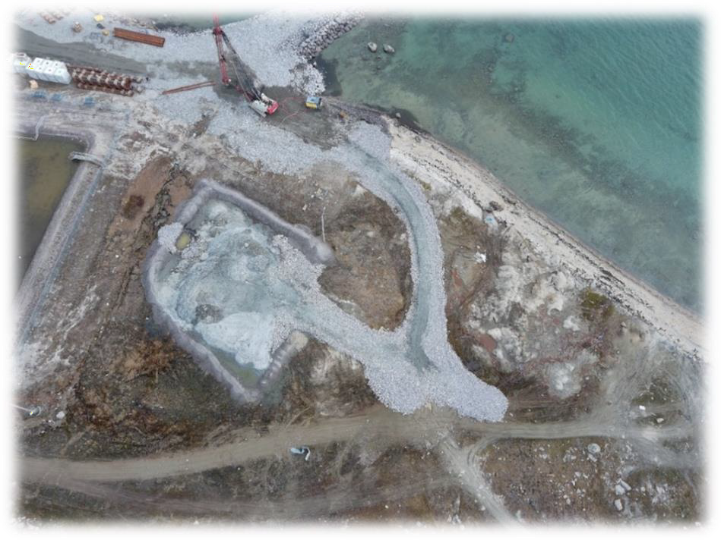

Dredge Spoil Dewatering Area

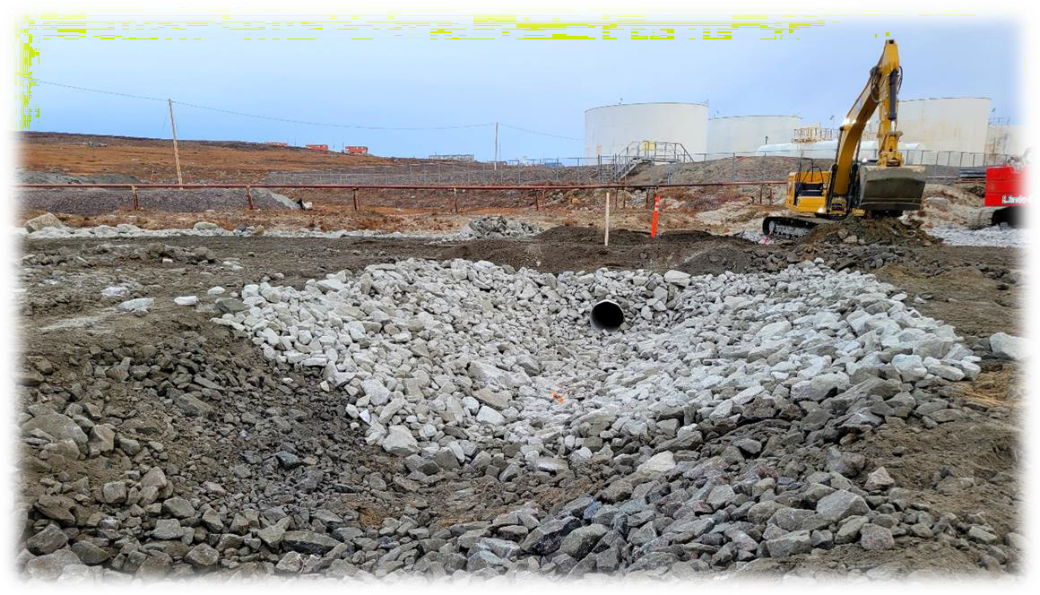

New Culvert and Erosion Protection Installed Under Access Road to Dewatering Area

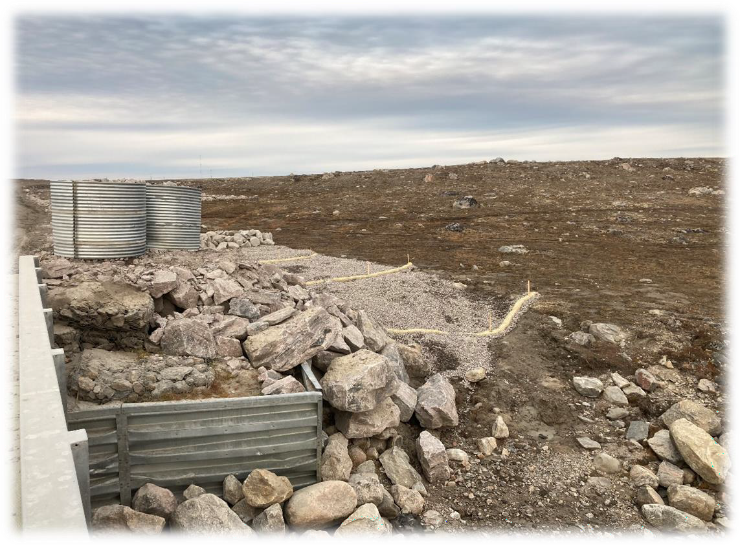

Erosion Protection Installed on the East Side of the Bridge to the Quarry Only preparation works were done this year. According to the site conditions, silt fences were installed at some specific locations to prevent the migration of fine material into adjacent waterbodies.

The existing bridge was renovated in Fall 2022. No culverts were installed to cross the river.

3.5 WATER QUALITY MONITORING

According to the water licence, all surface runoff or discharges impacted by construction activities associated with the Project, where flow may directly or indirectly enter Water, shall be monitored for the following parameters:
  - Total Suspended Solids (TSS)
  - Visible oil and grease
  - pH

The TSS was measured with a portable Hach turbidity meter LXV322 and the pH with a portable pH meter Hanna pHeP 4. Two locations, where runoff from construction activities enter water body, were monitored, as presented on the Pictures 1 and 2. The monitoring Station 01 was

located on the southwest side of the bridge to the quarry. The runoff coming out of the rock and granular material processing area is following the existing haul road’s ditch that reaches the Clyde River.

The monitoring Station 02 is located in front of the southwest breakwater, at the water discharge point of the dredge spoil disposal area. A sedimentation pond and a filtration berm were built at the drainage exit area. The water that is coming out the filtration berm discharges into an existing ditch that drains the area located north of the community tank farm.

Picture 1: Picture 2:
Runoff from the Material Rock and Runoff Water from the Dredge Spoil
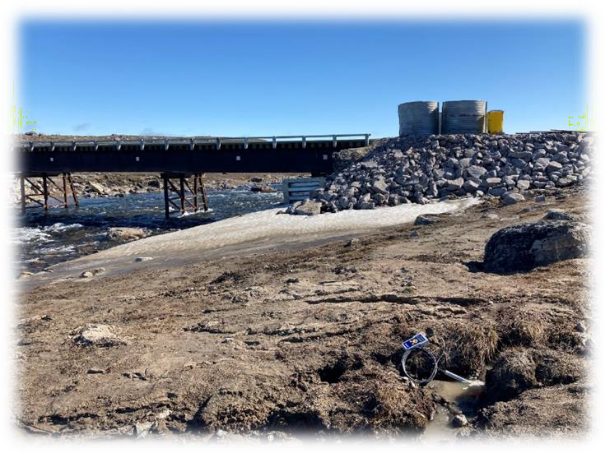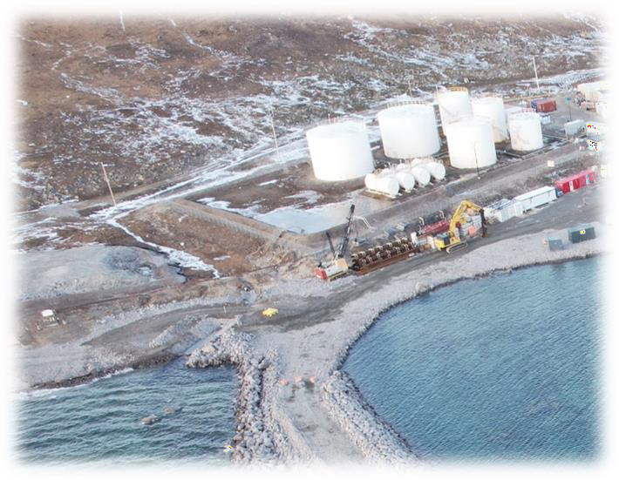Granular Material Processing Area Dewatering Area
Runoff Monitoring Station 01
Runoff Monitoring Station 02

The results are presented into the Tables 3 and 4 below. No exceedance of the TSS was measured at both monitoring points and no hydrocarbon sheen was observed. The measured pH values were all around 7.

TABLE 3: MONITORING STATION 01 (SOUTHWEST SIDE OF THE QUARRY BRIDGE)
Date | Total Suspended Solids Max average 50 mg/L Max grab sample 100 mg/L | Oil and Grease  No visible sheen | pH  Between 6.0 & 9.5
July 15th,2023 | 50 mg/L | No visible sheen | 7.0
July 15th,2023  In river, downstream | 20 mg/L | No visible sheen | 7.1
Aug 10th,2023 | 30 mg/L | No visible sheen | 7.0
Aug 24th, 2023 | 10 mg/L | No visible sheen | 7.0

Table 4: MONITORING STATION 02 (DREDGE SPOIL STORAGE AREA)
Date | Total suspended solids Max average 50 mg/L Max grab sample 100 mg/L | Oil and Grease  No visible sheen | pH  Between 6.0 & 9.5
July 12th, 2023 | 20 mg/L | No visible sheen | 7.1
July 20th, 2023 | 20 mg/L | No visible sheen | 7.1
Aug 10th, 2023 | 10 mg/L | No visible sheen | 7.0
Aug 24th, 2023 | 41 mg/L | No visible sheen | 7.2
Aug 24th, 2023  In river, downstream | 26 mg/L | No visible sheen | 7.1

APPENDIX 1
CLYDE RIVER HARBOUR CONSTRUCTION

APPENDIX 1

SPILL PREVENTION AND RESPONSE PLAN (rev-02)


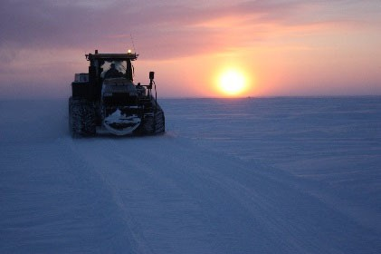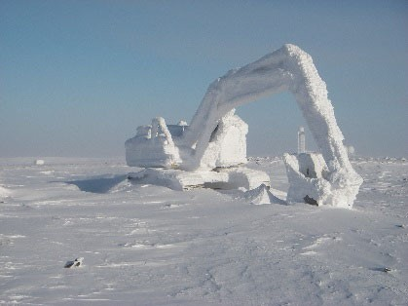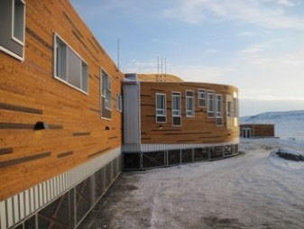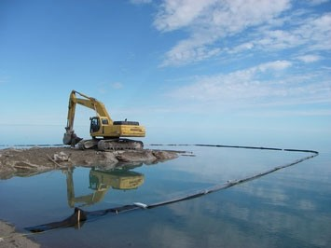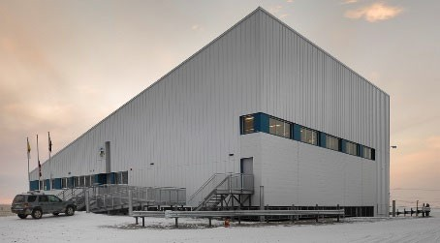



SPILL PREVENTION & RESPONSE PLAN

Clyde River Harbour Development

DFO ET025-222050/A

Submitted to:

Public Services and Procurement Canada
Rev-02: March 2023

TABLE OF CONTENTS

PAGE
- INTRODUCTION 1
- CONSUMMABLES ON SITE 2
  - DIESEL FUEL / JET FUEL 2
  - GASOLINE 3
  - HYDRAULIC OIL 4
  - LUBE OIL 5
- STORAGE AND REFILLING 6
  - STORAGE 6
    - Diesel (motive or P-50) /jet fuel 6
    - Gasoline 6
    - Lubricants and antifreeze 6
  - REFILLING VEHICLES AND EQUIPMENT 7
    - Diesel /jet fuel 7
    - Gasoline 8
- PROCEDURES IN CASE OF SPILL 9
  - LINE OF COMMUNCATION 9
  - EM 9
  - ERGENCY PHONE NUMBERS 10
  - SPILL RESPONSE MATERIAL 10
  - GENERAL PROCEDURES 12
  - SPECIFIC PROCEDURES FOR DIFFERENT ENVIRONMENTS 13
    - Spill on land 13
    - Spill in water 13
    - Spill in rivers and streams 13
    - Spill on ice and snow 14
  - COLLECTION AND DISOSAL OF CONTAMINATED SOIL AND MATERIAL 14
  - COLLECTION AND DISPOSAL OF LIQUIDS 15
  - REPORTING 15
- SPILL PREVENTION 17
  - SAFE STORAGE 17
  - SAFE HANDLING 17
  - MAINTENANCE OF EQUIPMENT 17
  - SAFE OPERATION OF VEHICLE AND EQUIPMENT 18
- TRAINING 19
  - SPILL RESPONSE 19

APPENDICES
1: Safety Data Sheets
2: NT-NU Spill Report Form

i

INTRODUCTION
The purpose of this document is to present the spill response and spill prevention plan in detail for the construction project of the new harbour in Clyde River, Nunavut. Clyde River, which is located within the Qikiqtaaluk Region, in the North Baffin region.

The construction project was awarded to Pilitak Enterprises Ltd (PEL) in May 2022 by Public Services and Procurement Canada (PSPC) for the Department of Fisheries and Ocean (DFO). At the end of August 2022, heavy equipment, camp facilities and material were delivered by sealift to Clyde River. The project consists mainly of the construction of two large breakwaters, a fixed wharf structure, two lines of float wharf modules, a retrofit of the existing sealift ramp and the improvements of the uplands. The new marine infrastructure will be constructed during the summers of 2023, 2024 and 2025 while preparation was carried out during the fall of 2022.

This spill response and prevention plan for this project includes the description, the safe storage, the handling of the various consumables to be used (diesel, jet fuel, gasoline and lubricants) as well as the procedures to be taken in case of any spill within the different environments. This plan is in effect from May 2023 and will be updated accordingly, as needed.

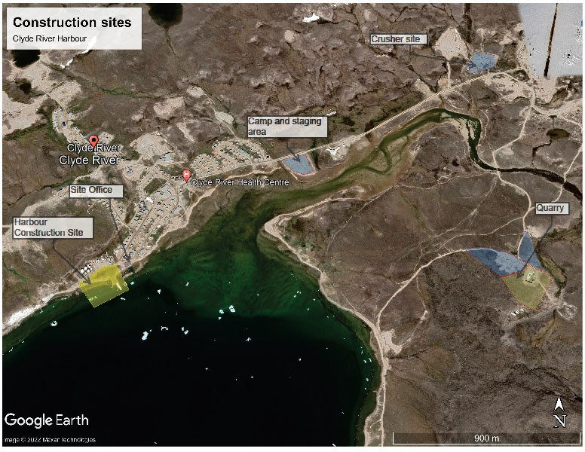

CONSUMMABLES ON SITE
This section describes the consumables to be used on-site. Only a brief explanation of the products is presented here. For a more in-depth, complete description, refer to the safety data sheets found in Appendix 1.

2.1 DIESEL FUEL / JET FUEL

Typical Physical and Chemical Properties:
  - Appearance: Clear, yellow, or red
  - Flashpoint: 40°C (diesel), -25°C (jet)
  - Odour: Petroleum
  - Pour point: -50°C to -6°C
  - Solubility: Insoluble
  - Viscosity: Not viscous
  - Vapour: Will sink to ground levels
  - Specific gravity: Floats on water (0.8 to 0.9)

Safety Measures/Warnings:
  - Vapours are heavier than air and form easily at high temperatures
  - Empty containers can contain explosive vapours
  - Toxic gases form upon combustion
  - Eye contact causes irritation
  - Material can accumulate static charges
  - Inhalation of vapours can cause irritation of the respiratory tract, headache, vomiting, and unconsciousness

Personal Protection:
  - Always wear impervious, chemical-resistant clothing, gloves, footwear, and goggles such as Nitrile, PVC, and Viton which are suitable materials
  - Do not use natural rubber or Neoprene
  - Wear a full-face organic vapour cartridge respirator where oxygen is adequate; otherwise wear a positive-pressure SCBA

Precautions:
  - Monitor for explosive atmosphere

  - Avoid contact with strong oxidizers (e.g., nitric acid, sulphuric acid, chlorine, ozone, peroxides) and eliminate ignition sources
  - Restrict access and work upwind of spill

2.2 GASOLINE

Typical Physical and Chemical Properties:
  - Appearance: colorless
  - Flashpoint: -50 °C
  - Odour: Petroleum
  - Freezing point: -60°C
  - Solubility: Insoluble
  - Viscosity: Not viscous
  - Vapour: Will sink to ground level
  - Specific gravity: Floats on water (0.7-0.8)

Safety Measures/Warnings:
  - Vapours form instantaneously and are heavier than air
  - Empty containers can contain explosive vapours
  - Vapours can travel to distant sources of ignition and flash back
  - Eye contact causes irritation
  - Material can accumulate static charges
  - Inhalation of vapours can cause irritation of the respiratory tract, headache, vomiting, and unconsciousness

Personal Protection:
  - Always wear impervious, chemical-resistant clothing, gloves, footwear, and goggles Nitrile, PVC, and Viton are suitable materials
  - Do not use natural rubber or Neoprene Precaution:
  - Monitor for explosive atmosphere
  - Eliminate ignition sources
  - Restrict access and work upwind of spill
  - Avoid contact with strong oxidizers (e.g., nitric acid, sulphuric acid, chlorine, ozone, peroxides)

2.3 HYDRAULIC OIL

The heavy equipment used for works in the water will function with a bio-hydraulic fluid (Panolin HLP Synth). Other equipment will use regular hydraulic oil (T04 10W). The procedures in case of spill remain the same.

Typical Physical and Chemical Properties:
  - Appearance: Straw yellow liquid
  - Flashpoint: 215°C
  - Odour: Petroleum
  - Pour point: -25°C
  - Solubility: Generally Insoluble
  - Viscosity: Medium
  - Vapour: Few vapours emitted
  - Specific gravity: Floats on water (0.9)

Safety Measures/Warnings:
  - Vapours are heavier than air but are unlikely to form
  - Toxic gases can form in fire and at high temperatures
  - CO, CO2 and dense smoke are produced upon combustion
  - Oil mist or vapour from hot oil can cause irritation of the eyes, nose, throat and lungs

Personal Protection:
  - Always wear impervious, chemical-resistant clothing, gloves, footwear, and goggles Nitrile, PVC, and Viton are suitable materials
  - Do not use natural rubber or Neoprene Precaution:
  - Avoid excessive heat, which can cause formation of vapours
  - Avoid contact with strong oxidizers (e.g., nitric acid, sulphuric acid, chlorine, ozone, peroxides)
  - Eliminate ignition sources
  - Restrict access and work upwind of spill

2.4 LUBE OIL

Typical Physical and Chemical Properties:
  - Appearance: amber liquid
  - Flashpoint: 190°C - 220°C
  - Odour: Petroleum
  - Pour point: -35°C - -40°C
  - Solubility: Generally Insoluble
  - Viscosity: Medium
  - Vapour: Few vapours emitted
  - Specific gravity: Floats on water (0.9)

Safety Measures/Warnings:
  - Vapours are heavier than air but are unlikely to form
  - Toxic gases can form in fire and at high temperatures
  - CO, CO2 and dense smoke are produced upon combustion
  - Oil mist or vapour from hot oil can cause irritation of the eyes, nose, throat and lungs

Personal Protection:
  - Always wear impervious, chemical-resistant clothing, gloves, footwear, and goggles Nitrile, PVC, and Viton are suitable materials
  - Do not use natural rubber or Neoprene Precaution:
  - Avoid excessive heat, which can cause formation of vapours
  - Avoid contact with strong oxidizers (e.g., nitric acid, sulphuric acid, chlorine, ozone, peroxides)
  - Eliminate ignition sources
  - Restrict access and work upwind of spill

STORAGE AND REFILLING
All fuel / Jet fuel and gasoline for the entire project will be supplied by Petroleum Product Division (PPD) from the tank farm facility located at the west end of the hamlet, in front of where the harbour will be constructed. The gasoline and the fuel distribution are managed by the local PPD’s agent Aqunik Enterprises.

3.1 STORAGE

- Diesel (motive or P-50) /jet fuel

According to what will be available from PPD, diesel or downgraded jet fuel or a blend of both products will be used for heavy equipment and for heating our camp facility.

One aboveground horizontal dyke tanks CAN/ULC S653 of a capacity of 4,633 litres is installed at the quarry for refilling heavy equipment as a backup.

One aboveground horizontal dyke tanks CAN/ULC S653 of a capacity of 2,359 litres is installed at the camp to feed the backup generator and the heating system.

All tanks comply with CEPA storage tank systems for petroleum products regulations and applicable territorial regulation for temporary fuel tanks. They are also registered with Environment Canada Federal Identification Registry for Storage Tank Systems.

- Gasoline

All gasoline for the entire project will be supplied by PPD, from the exiting hamlet’s gas station. Minor quantities of gasoline for small equipment and the boat’s motor will be stored into 5 gallons jerricans.

- Lubricants and antifreeze

All the lubricants and the antifreeze for the equipment will be sent in 205L drums. Lubricant and antifreeze drums are stored into a marine container located beside the maintenance garage.

3.2 REFILLING VEHICLES AND EQUIPMENT

  - Diesel /jet fuel

The heavy equipment and vehicles using diesel fuel (or downgraded jet fuel) will be refueled by our fuel truck having a capacity of 16,000 L. The fuel truck will be refilled directly at the tank farm as per PPD’s procedures.

A 995 L capacity fuel tank will be installed at the back of a pickup truck for refilling heavy equipment when the fuel truck is not available, or the equipment’s location would be too difficult to access by the fuel truck.

Both vehicles used for fuel delivery are equipped with their own spill kit.

Only the authorized and trained employees can use the fuel truck. The below procedure shall be followed when refueling vehicles or equipment:

- Before starting a fuel truck run, make sure to do the truck routine inspection.
- Verify the fuel level in both front and rear tanks.
- Verify under the vehicle for the presence of fuel leak.
- Male sure that the spill kit is on the vehicle.
- Turn on the battery disconnect switch.
- Drive close to equipment to be fuelled and make sure to be parked on stable ground.
- Put the truck on neutral and activate the parking brake.
- Put the clutch on and engage the PTO. Once the PTO is correctly engaged, a sound alarm can be heard, and a bleeping light can be seen below the driver’s sun visor.
- LEAVE THE ENGINE RUNNING ON HIDLE. DO NOT INCREASE THE MOTOR RPM.
- Weare your PPE (hard hat, safety glasses, safety boots and work gloves) before exiting the fuel truck.
- Do not smoke when fueling vehicles, equipment, and containers.
- The engine of the equipment or vehicle to be refueled must be turned off.
- Beside the hose dispenser, select the front or the rear tank. ALWAYS USE THE REAR THANK FIRST UNTIL IT IS EMPTY BEFORE SWITCHING TO THE FRONT TANK
- Unroll the hose to reach out the vehicle fuel tank to be refilled.
- Remove fuel cap, insert nozzle and squeeze trigger, wait till tank is full release trigger. KEEP YOUR HAND ON THE HANDLE AT ALL TIME. BE AWARE OF ANY UNUSUAL NOISE.
- Make sure that no fuel remains in the nozzle and wipe out with a rag if needed.
- Turn-off the PTO

- Roll back the hose on the dispenser. Make sure that the hose is not stuck, and no sharp objects could damage the hose before engaging the hose reel.
- BEFORE MOVING THE TRUCK, MAKE SURE THAT THE PTO IS OFF.
- TWO EMERGENCY SHUTT-OFF BUTTON ARE LOCATED AT THE BACK THE TRUCK, ONE ON EACH SIDE OF THE HOSE DISPENSER.
- A spill kit is located inside the close truck box located on the driver side and identified with a yellow sticker “Spill Kit’’
- At the end of the fuel run, park the truck at the same location, beside the camp water tank. Verify under the vehicle for the presence of fuel leak. Turn off the battery disconnect switch.

  - Gasoline
All gasoline vehicles will be refilled directly at the hamlet gas station located at the tank farm facility. The refilling is done by the gas station employees according to PPD’s regulations.

PROCEDURES IN CASE OF SPILL
Spills have the potential to cause severe environmental damage. Workers must ensure that any spills are treated with great care, and dealt with promptly, to minimize the possibility of any of them becoming a major issue.

4.1 LINE OF COMMUNCATION

No matter the size of the spill, it must be reported as soon as possible to the site superintendent and the environment monitor who will be in charge of the spill response team. The following line of communication must be applied:

Project Manager (PSPC)

Nunavut Spill Report Line and NWB inspector if spill is greater than 100L

Site Representative (CBCL-Canadrill)

Project Manager (PEL)

Spill Response Team (PEL)
Spill discovered Contact Superintendent (PEL)

Spills of other products shall also be reported. Refer to the table “Schedule 1 – Reportable Quantities for NT–NU Spills” included in the Appendix 2 for reportable products. Diesel/oil spill on land greater than 100L must me reported to the Nunavut Spill Report Line and to the NWB inspector. Any spill near or into a water body, regardless of the quantity of releases of harmful substances, must be reported immediately to the same authorities.

4.2 EM

4.3 ERGENCY PHONE NUMBERS

Pilitak Enterprises Ltd | Business hours | After hours
Site superintendent | To be confirmed
Jean-Marc Ballard, EM | (418) 717-4605
François Bourassa, Project Manager | (418) 930-0850 | (418) 930-0850
Site Office, Clyde River | (514) 632-6324
PSPC
Kenton Thiessen, project manager | (204) 229-6375
Michael Steinborn | (431) 229-6375
CBCL-Canadrill
David Parsons, project manager | (506) 651-1812
Jason Smith | (867) 222-0184
Corey Heffernan | (902)293-4554
Hamlet of Clyde River
Philip Sanguya, Forman | (867) 924-6342
Aqunik Enterprises (PPD local agent)
Jonathan Palluk | (867) 924-6506
Environment
Nunavut Spill Report Line | (867) 920-8130.
GN environmental protection | (867) 975-7726
NWB Inspector | (867) 975-4284
Environment Canada | (867) 975-4644

4.4 SPILL RESPONSE MATERIAL

Complete emergency spill kits will be installed at every working site listed below:
  - Quarry
  - River crossing
  - Crusher site
  - Camp site
  - Construction site

Each kit is made of the following items and is stored in pre-identified 45-gallon drums:

  - 3 Tyveck coveralls
  - 10 pairs of disposable gloves
  - 1 pair of protective goggles
  - 2 x 100 absorbent pad packs
  - 1 x 20kg granular absorbent bag
  - 4 x 10’”x 2’’ diam. floating absorbent booms
  - 10 yellow storage bags
  - One spade
  - One broad nose shovel
  - One broom
  - Rags

The fuel truck is equipped with is own spill kit, including the same material as above described.

All environmental supplies for the entire project, including a large inventory of hydrocarbon absorbents and emergency spill material, are stored in the marine container # 203387-0 located beside the site office, as indicated below.

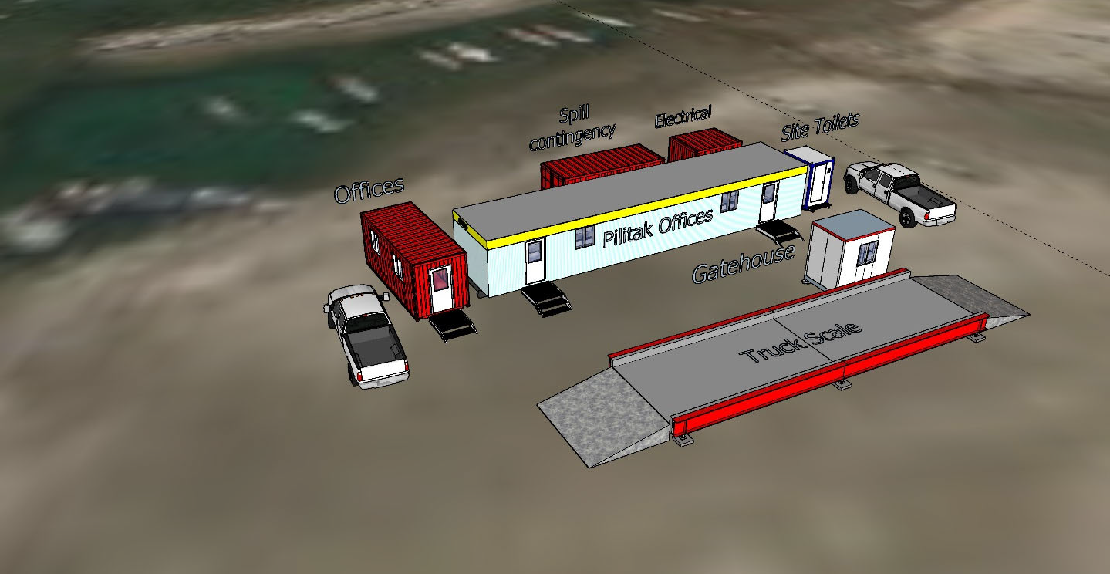Figure 5.3: Location of the spill response marine container
Spill Response material
Marine container no. 203387-0

The emergency boat, which is a 26’ x 10’ pontoon equipped with a 70 HP motor, will be parked at the existing small craft harbour. A spill kit in a 205 drum will be installed on the boat for the duration of the construction season. Additional spill contingency material is located nearby the office, as described above. The spill kit installed on the boat will include the following material:

  - 2 nylon rope 100’

  - 1 telescoping boat hook
  - 10 pairs of disposable gloves
  - 1 pair of protective goggles
  - 2 x 100 absorbent pad packs
  - 6 absorbent socks
  - 1 bag of peat moss
  - 10 x 10’x 2’’ diam. floating absorbent booms
  - 10 yellow storage bags
  - 6 grapnel anchors

4.5 GENERAL PROCEDURES

This general procedure is to be followed in the event of a spill. Steps are listed in the order of importance; however, depending on the circumstances, conditions, and potential injuries, this order may need to be altered to meet specific needs.

- Identify the product spilled and call for help:

Petroleum products to be used on site are arctic diesel, jet fuel, gasoline and lubricants. As soon as possible, advise the site superintendent and call for help when needed.

- Assessment of dangers and hazards:

An immediate determination must be made about the direction of the spill’s progress, whether downhill, on the ice, towards the water, or already in the water. As well, careful attention will be paid to the full nature of the incident; is this solely a surface contaminant, or are fumes an additional factor; are there any injuries current or possible.

- Stop the flow at source:

Has the flow been stopped or is it still leaking? Is there an emergency Shut-off valve? Have holes in the container been patched? Is the container empty? PRECAUTION: ONLY ATTEMPT TO STOP THE FLOW IF IT IS SAFE TO DO SO.

- Take actions to contain the spill:

Prompt containment can reduce environmental exposure and risk. Containment measures may be land or water based. Land based measures include application of sorbents, construction of

berms and diversion/collection trenches. Water based measures could include dams, dykes, and floating booms.

4.6 SPECIFIC PROCEDURES FOR DIFFERENT ENVIRONMENTS

Spill on land

      - Do not flush into ditches or drainage systems.
      - Block entry into waterways and contain with earth, snow or other barriers.
      - Remove small spills with sorbent pads.
      - On tundra, collect as much contamination as possible ensuring to the maximum, yet reasonably practicable extent, to minimize destruction of the root zone of the tundra grasses.

Spill in water

      - Contain spill as close to release point as possible.
      - Use spill containment boom to concentrate slicks for recovery.
      - On small spills, use sorbent pads to pick up contained oil.
      - On larger spills, use skimmer on contained slicks.

The following strategies can be used to contain spills on slow moving or calm water: Contain spills on open water immediately to restrict the size and extent of the spill. Fuel and petroleum products that float on water may be contained through the use of booms, absorbent materials, skimming, or the erection of culverts. Deploy containment booms to minimize spill area; the effectiveness of booms may be limited by wind, waves, and other factors. Use absorbent booms to slowly encircle and absorb spilled material. These absorbents are hydrophobic (they absorb hydrocarbons and repel water). Once booms are secured, use skimmers to draw in hydrocarbons and minimal amounts of water. Skimmed material can be pumped through hoses to empty fuel tanks and/or drums. Recognize that culverts permit water flow and can allow fuel to be captured and collected along the surface with absorbent materials. Use absorbent pads and similar materials to capture small spills and/or oily residue on water. Determining the best possible strategy for containment will depend on a number of factors, such as: speed of slick travel, location of possible containment sites, availability of personnel and equipment, location of sensitive areas and safety of operations. Booming with either absorbent or non-absorbent booms is another effective means of containing spills on slow-moving waters and in lakes.

Spill in rivers and streams

      - Prevent entry into water, if possible, by building berms or trenches.

      - Intercept moving slicks in quiet areas using (sorbent) booms.
      - Do not use sorbent booms/pads in fast currents and turbulent water.

Effective containment using conventional booming techniques is very difficult in streams or rivers where currents exceed 0.7 knots (0.4 m/s). At these speeds, oil becomes entrained in the water flowing under the boom, resulting in significant losses. Some improvement can be achieved in waters flowing at 1-2 knots (0.5 m/s to 1 m/s), particularly if the boom is deployed at an angle of less than 90° to the direction of flow. Absorbent booms or socks can also be used to provide a barrier to floating oil. These types of booms should be checked regularly, to ensure that they do not become saturated with either water or oil, as they tend to float very low in the water or even sink and release oil downstream.

Spill on ice and snow

      - Block entry into waterways and contain with snow or another barrier.
      - Remove minor spills with sorbent pads and/or snow.
      - Use ice augers and pump to recover diesel under ice.
      - Slots in ice can be cut over slow moving water to contain oil.
      - Recover all remaining spilled product with absorbent pads.

4.7 COLLECTION AND DISOSAL OF CONTAMINATED SOIL AND MATERIAL

Once the source of the spill has been stopped and the spill response material have been installed and the spill secured, the cleanup operation needs to be initiated. Any contaminated soil will be removed and placed into Quatrex 27 bulk bags. Empty Quatrex bulkbags are available in the environmental supply container located nearby the site office. For small spills, 2 Quatrex bags will be installed beside the maintenance garage, one for soil contaminated by oil and the other one for the soil contaminated with diesel/jet fuel or gasoline. Small spills or stained soil will be collected manually with a shovel, placed into a pale and transferred into one of the two storage bags located beside the maintenance garage. If a bag is getting filled, it will be closed, palletized, and labelled according to TDG for off-site / off-territory disposal into a licenced facility. For larger spills, the excavator will be used to remove the contaminated soil. For small to medium size spills, Quatrex bags will be loaded with contaminated soil directly beside the excavation. For larger spills, the contaminated soil will be loaded into a dump truck and transported to a temporary processing area where the it will be placed in stockpiles of less than 20 cubic meters. Each stockpile will be protected with polyethylene tarps. The location of a temporary storage area will be discussed with the hamlet. A soil sample will be collected from each of the 20 cubic meter stockpile and sent to the analytical laboratory to be tested. According to the analytical results,

the soil could be disposed at the local solid waste facility as daily cover or loaded in to Quatrex
bags for off-site / off-territory disposal into a licenced facility.

The dirty spill response material, including used PE, used absorbents and rags, will be collected and placed into an assigned bulk bags for off-site / off-territory disposal into a licenced facility. A bulk bag for dirty spill response material will be installed and identified properly beside the maintenance garage.

4.8 COLLECTION AND DISPOSAL OF LIQUIDS

Any product collected from a spill will be pumped into empty drum (s). A cubic meter tote tank could used as a water separator if needed. Collected product, according to their type, could be reused for heating the maintenance garage (diesel and jet fuel only) or ship off-site off-territory for disposal into a licenced facility. Any drums containing spilled product will be clearly identified, transported, and placed in the hazardous waste temporary storage (HWTSA) located beside the maintenance garage. The HWTSA will be located at a minimum of 31 meters away from the any water body and will be clearly identified. The inventory of hazardous material will be kept to date by the environmental monitor and daily inspections of the HWTSA will be done to ensure that no accidental release could possibly makes its way into a water body. The hazardous material will be shipped off-site by sealift at the end of each working season. The proper waste manifest and transportation documents will be prepared by the environmental monitor.

The potential contaminated or hazardous water will be collected and temporary stored into drums or bigger devices, according to the volume involved. For larger quantities, a temporary basin made of RPE liner could be built. The water will be tested to evaluate the residual concentrations of the spilled product. According to the analytical results, the collected water will be containerized into drums for off-site disposal, treated on-site or release if it meets the applicable criteria. Drums containing contaminated or hazardous water will be stored into the HWTSA before being shipped off-site.

4.9 REPORTING

Spills of other products shall also be reported. Refer to the table “Schedule 1 – Reportable Quantities for NT–NU Spills” included in the Appendix 2 for reportable products.

For every spill, pictures must be taken during and after the cleanup process. The GPS coordinates of the spill location must be recorded. All collected information and pictures will be used for the spill report. Spills of 100 litres and less will be recorded on the Site Spill Log, reported in the

weekly report and within the annual license reporting. Any spill grater than 100 litres must be reported to the Nunavut 24-hour spill report line (see the attached from in Appendix 2). The person reporting the spill must provide as much of the following information as possible. Please note that the operators at the Hotline are NOT spill management experts. They can only relay information to the appropriate authorities/protection agencies. Reportable information includes but is not limited to the following:

- Date and time of spill;
- Direction spill is moving (or if it has stopped);
- Name and phone number of persons close to the location of the spill;
- Type of contaminant spilled and quantity spilled;
- Cause of spill;
- Whether the spill is continuing or has stopped;
- Description of the existing containment;
- Actions taken to recover, clean-up and dispose of spilled contaminant;
- Name, address and phone number of person reporting the spill;
- Name of person in charge of management or control at time of spill;

The spill report must be filled and sent to the NT-Nu spill Report email address spills@gov.nt.ca with a copy to the following individuals:
  - PSPC, Kenton Thiessen: kenton.thiessen@pwgsctpsgc.gc.ca
  - CBCL-Canadrill. David Parsons: davidp@cbcl.ca

SPILL PREVENTION
The prevention is the first and the most effective measure to avoid potential spills and it should be a priority for everyone.

5.1 SAFE STORAGE

All liquid that could be potentially spill should be stored in a way to have a double containment, as per applicable regulations. Diesel storage tank installed on site are dyke tanks CAN/ULC S653. Oil and antifreeze drums are stored into a marine container. When drums are temporary stored outside, they should be installed on wooden pallet. Liquid storage should be done at least 31 meters away from any water body. The proper product must be stored into the proper container with the applicable identification. Gas and diesel jerricans shall be stored in lockable and vented area.

5.2 SAFE HANDLING

Simple measures could help to prevent spills, especially when handling diesel and gasoline. When using the dyke tank to refuel a vehicle, the following procedure shall apply:
- Park the vehicle adequately and turn off the engine;
- Turn on the power switch to activate the fuel pump;
- Remove the nozzle from the tray and place it into the filling device of the vehicle;
- Push the handle’s lever and monitor often the fuel level in the tank;
- Stay beside the handle during the entire refueling operation;
- When refueling is completed, place the nozzle slowly back in the tray to avoid fuel dropping;
- Turn-off the power

Only the authorized and trained drivers can operate the fuel truck. Any refueling activities shall be done at least 31 meters away from any water body. At the end of the working shift, the fuel truck shall be parked beside the maintenance garage.

5.3 MAINTENANCE OF EQUIPMENT

A good preventive maintenance of vehicles and equipment will help to prevent potential spills. Any signs of malfunctioning equipment, including a small liquid leak, shall be immediately reported to the head mechanic. When a small leak cannot be repaired immediately, the vehicle must be parked over a spill tray.

5.4 SAFE OPERATION OF VEHICLE AND EQUIPMENT

The safe operation of the vehicles and the equipment will prevent potential incident and/or accident that can lead to a spill. The traffic control plan, including the speed limits, must be followed by everyone. Considering that we will be doing work in or nearby water, the equipment operators shall be more careful and more attentive when handling rocks or material that could damage hydraulic hoses. In the case where a oil leak is observed on any components of the equipment, work must cease immediately and the source of the leak shall be found and repaired.

6.1 SPILL RESPONSE
6. TRAINING

All employees working on the project will have to attend the worker orientation seminar. Through this seminar, the spill response plan will be reviewed and explained to everyone. The employees will be trained in the safe operation of all machinery and tools, as well as in the handling of materials to help prevent and respond to spills safely, in a timely and effective manner. The content of a spill kit will be showed to the workers and a demonstration will be done for explaining how to use the equipment. Training will also include initial spill response in the event of a spill. The spill response team will be also determined and the member list will be posted.

APPENDIX 1
CLYDE RIVER HARBOUR CONSTRUCTION

APPENDIX 1

SAFETY DATA SHEETS
Updated SDS binder will be posted at the site office


Material Safety Data Sheet
DIESEL FUEL

I 1 . Product and company identification

Product name Synonym

Code Material uses

Manufacturer

In case of emergency
DIESEL FUEL
Seasonal Diesel, #1 Diesel, #2 Heating Oil, #1 Heating Oil, D50, D60, P40, P50, Arctic Diesel, Farm Diesel, Marine Diesel, Low Sulphur Diesel, LSD, Ultra Low Sulphur Diesel, ULSD, Mining Diesel, Naval Distillate, Dyed Diesel, Marked Diesel, Coloured Diesel, Furnace special, Biodiesel blend, B1, B2, B5, Diesel Low Cloud (LC), Marine Gas Oil.
W104, W293
Diesel fuels are distillate fuels suitable for use in high and medium speed internal combustion engines of the compression ignition type. Mining diesels, marine diesels, MDO and naval distillates may have a higher flash point requirement.
PETRO-CANADA
P.O. Box 2844
150 - 6th Avenue South-West Calgary, Alberta
T2P 3E3
Petro-Canada: 403-296-3000
Canutec Transportation: 613-996-6666
Poison Control Centre: Consult local telephone directory for emergency number(s) .

I 2 . Hazards identification

Physical state Odour
WHMIS (Canada)

OSHA/HCS status Emergency overview

Routes of entry
Potential acute health effects Inhalation

Ingestion

Skin Eyes
Potential chronic health effects Chronic effects Carcinogenicity
Mutagenicity Teratogenicity
Bright oily liquid.
Mild petroleum oil like.
••

Class B-3: Combustible liquid with a flash point between 37.8°C (100°F) and 93.3°C (200°F).
Class D-2A: Material causing other toxic effects (Very toxic). Class D-2B: Material causing other toxic effects (Toxic).
This material is considered hazardous by the OSHA Hazard Communication Standard (29 CFR 1910.1200).
WARNING!
COMBUSTIBLE LIQUID AND VAPOUR. CAUSES EYE AND SKIN IRRITATION.
Combustible liquid. Severely irritating to the skin. Irritating to eyes. Keep away from heat, sparks and flame. Do not get in eyes. Avoid breathing vapour or mist. Avoid contact with skin and clothing. Use only with adequate ventilation. Wash thoroughly after handling.
Dermal contact. Eye contact. Inhalation. Ingestion.

Inhalation of this product may cause respiratory tract irritation and Central Nervous System (CNS) Depression, symptoms of which may include; weakness, dizziness, slurred speech, drowsiness, unconsciousness and in cases of severe overexposure; coma and death.
Ingestion of this product may cause gastro-intestinal irritation. Aspiration of this product may result in severe irritation or burns to the respiratory tract.
Severely irritating to the skin. Irritating to eyes.

No known significant effects or critical hazards.
Diesel engine exhaust particulate is probably carcinogenic to humans (IARC Group 2A). No known significant effects or critical hazards.
No known significant effects or critical hazards.

Developmental effects Fertility effects
Medical conditions aggravated by over- exposure
No known significant effects or critical hazards. No known significant effects or critical hazards.
Avoid prolonged or repeated skin contact to diesel fuels which can lead to dermal irritation and may be associated with an increased risk of skin cancer.

See toxicological information (Section 11)

. Composition/information on ingredients
Name | CAS number | %
Hydrotreated Renewable Diesel/ Fuels, diesel/ Fuel Oil No. 1/ Fuel Oil No. 2 | 64742-81-0/ | 95 - 100
 | 68334-30-5/
 | 8008-20-6/
 | 68476-30-2
Alkanes, C10 - 20 Branched and Linear (R100) | 928771-01-1 | 10 - 20
Fatty acids methyl esters | 61788-61-2 /  67784-80-9 I | 0-5
 | 73891-99-3
There are no additional ingredients present which, within the current knowledge of the supplier and in the concentrations applicable, are classified as hazardous to health or the environment and hence require reporting in this section.

. First-aid measures

Eye contact

Skin contact

Inhalation

Ingestion

Protection of first-aiders Notes to physician
Check for and remove any contact lenses. Immediately flush eyes with plenty of water for at least 15 minutes, occasionally lifting the upper and lower eyelids. Get medical attention immediately.
In case of contact, immediately flush skin with plenty of water for at least 15 minutes while removing contaminated clothing and shoes. Wash skin thoroughly with soap and water or use recognised skin cleanser. Wash clothing before reuse. Clean shoes thoroughly before reuse. Get medical attention immediately.
Move exposed person to fresh air. If not breathing, if breathing is irregular or if respiratory arrest occurs, provide artificial respiration or oxygen by trained personnel. Loosen tight clothing such as a collar, tie, belt or waistband. Get medical attention immediately.
Wash out mouth with water. Do not induce vomiting unless directed to do so by medical personnel. Never give anything by mouth to an unconscious person. Get medical attention immediately.
No action shall be taken involving any personal risk or without suitable training. It may be dangerous to the person providing aid to give mouth-to-mouth resuscitation.
No specific treatment. Treat symptomatically. Contact poison treatment specialist immediately if large quantities have been ingested or inhaled.

1 s . Fire-fighting measures

Flammability of the product Extinguishing media
Suitable Not suitable
Special exposure hazards

Products of combustion

Special protective equipment for fire-fighters
Combustible liquid

Use dry chemical, CO2, water spray (fog) or foam. Do not use water jet.
Promptly isolate the scene by removing all persons from the vicinity of the incident if there is a fire. No action shall be taken involving any personal risk or without suitable training. Move containers from fire area if this can be done without risk. Use water spray to keep fire-exposed containers cool.
Carbon oxides (CO, CO2), nitrogen oxides (NOx), sulphur oxides (SOx), sulphur compounds (H2S), smoke and irritating vapours as products of incomplete combustion.
Fire-fighters should wear appropriate protective equipment and self-contained breathing apparatus (SCBA) with a full face-piece operated in positive pressure mode.

Special remarks on fire hazards

Special remarks on explosion hazards
Flammable in presence of open flames, sparks and heat. Vapours are heavier than air and may travel considerable distance to sources of ignition and flash back. This product can accumulate static charge and ignite.
Do not pressurise, cut, weld, braze, solder, drill, grind or expose containers to heat or sources of ignition. Runoff to sewer may create fire or explosion hazard.

Is.

Accidental release measures

Personal precautions

Environmental precautions

Methods for cleaning up Small spill

Large spill
No action shall be taken involving any personal risk or without suitable training. Evacuate surrounding areas. Keep unnecessary and unprotected personnel from entering. Do not touch or walk through spilt material. Shut off all ignition sources. No flares, smoking or flames in hazard area. Avoid breathing vapour or mist. Provide adequate ventilation. Wear appropriate respirator when ventilation is inadequate. Put on appropriate personal protective equipment (see Section 8).
Avoid dispersal of spilt material and runoff and contact with soil, waterways, drains and sewers. Inform the relevant authorities if the product has caused environmental pollution (sewers, waterways, soil or air).

Stop leak if without risk. Move containers from spill area. Dilute with water and mop up if water-soluble. Alternatively, or if water-insoluble, absorb with an inert dry material and place in an appropriate waste disposal container. Use spark-proof tools and explosion­ proof equipment. Dispose of via a licensed waste disposal contractor.
Stop leak if without risk. Move containers from spill area. Approach the release from upwind. Prevent entry into sewers, water courses, basements or confined areas. Wash spillages into an effluent treatment plant or proceed as follows. Contain and collect spillage with non-combustible, absorbent material e.g. sand, earth, vermiculite or diatomaceous earth and place in container for disposal according to local regulations (see section 13). Use spark-proof tools and explosion-proof equipment. Dispose of via a licensed waste disposal contractor. Contaminated absorbent material may pose the same hazard as the spilt product. Note: see section 1 for emergency contact information and section 13 for waste disposal.

I 1 . Handling and storage

Handling

Storage
Put on appropriate personal protective equipment (see Section 8). Eating, drinking and smoking should be prohibited in areas where this material is handled, stored and processed. Workers should wash hands and face before eating, drinking and smoking. Remove contaminated clothing and protective equipment before entering eating areas. Do not ingest. Avoid contact with eyes, skin and clothing. Avoid breathing vapour or mist. Use only with adequate ventilation. Wear appropriate respirator when ventilation is inadequate. Do not enter storage areas and confined spaces unless adequately ventilated . Keep in the original container or an approved alternative made from a compatible material, kept tightly closed when not in use. Store and use away from heat, sparks, open flame or any other ignition source. Use explosion-proof electrical (ventilating, lighting and material handling) equipment. Use non-sparking tools. Take precautionary measures against electrostatic discharges. To avoid fire or explosion, dissipate static electricity during transfer by earthing and bonding containers and equipment before transferring material. Empty containers retain product residue and can be hazardous. Do not reuse container.
Store in accordance with local regulations. Store in a segregated and approved area. Store in original container protected from direct sunlight in a dry, cool and well-ventilated area, away from incompatible materials (see section 10) and food and drink. Eliminate all ignition sources. Separate from oxidizing materials. Keep container tightly closed and sealed until ready for use. Containers that have been opened must be carefully resealed and kept upright to prevent leakage. Do not store in unlabelled containers.
Use appropriate containment to avoid environmental contamination. Ensure the storage containers are grounded/bonded.

I a . Exposure controls/personal protection
Ingredient | Exposure limits
Fuels, diesel Fuel oil No. 2  Hydrotreated Renewable Diesel Fuel oil No. 1 | ACGIH TLV (United States). Absorbed through skin.  TWA: 100 mg/m3 , (lnhalable fraction and vapour) 8 hour(s).  ACGIH TLV (United States). Absorbed through skin.  TWA: 100 mg/m3 , (lnhalable fraction and vapour) 8 hour(s).  ACGIH TLV (United States). Absorbed through skin.  TWA: 200 mg/m3 8 hour(s).  ACGIH TLV (United States). Absorbed through skin.  TWA: 200 mg/m3 8 hour(s).
Consult local authorities for acceptable exposure limits.

Recommended monitoring procedures

Engineering measures

Hygiene measures

Personal protection Respiratory

Hands

Eyes

Skin

Environmental exposure controls
If this product contains ingredients with exposure limits, personal, workplace atmosphere or biological monitoring may be required to determine the effectiveness of the ventilation or other control measures and/or the necessity to use respiratory protective equipment.
Use only with adequate ventilation. Use process enclosures, local exhaust ventilation or other engineering controls to keep worker exposure to airborne contaminants below any recommended or statutory limits. The engineering controls also need to keep gas, vapour or dust concentrations below any lower explosive limits. Use explosion-proof ventilation equipment.
Wash hands, forearms and face thoroughly after handling chemical products, before eating, smoking and using the lavatory and at the end of the working period. Appropriate techniques should be used to remove potentially contaminated clothing. Wash contaminated clothing before reusing. Ensure that eyewash stations and safety showers are close to the workstation location.

Use a properly fitted, air-purifying or air-fed respirator complying with an approved standard if a risk assessment indicates this is necessary. Respirator selection must be based on known or anticipated exposure levels, the hazards of the product and the safe working limits of the selected respirator. Recommended: organic vapour cartridge or canister may be permissible under certain circumstances where airborne concentrations are expected to exceed exposure limits. Protection provided by air-purifying respirators is limited. Use a positive-pressure, air-supplied respirator if there is any potential for uncontrolled release, exposure levels are unknown, or any other circumstances where air-purifying respirators may not provide adequate protection.
Chemical-resistant, impervious gloves complying with an approved standard should be worn at all times when handling chemical products if a risk assessment indicates this is necessary.
Recommended: nitrile, neoprene, polyvinyl alcohol (PVA), Viton®. Consult your PPE provider for breakthrough times and the specific glove that is best for you based on your use patterns. It should be realized that eventually any material regardless of their imperviousness, will get permeated by chemicals. Therefore, protective gloves should be regularly checked for wear and tear. At the first signs of hardening and cracks, they should be changed.
Safety eyewear complying with an approved standard should be used when a risk assessment indicates this is necessary to avoid exposure to liquid splashes, mists or dusts.
Personal protective equipment for the body should be selected based on the task being performed and the risks involved and should be approved by a specialist before handling this product.
Emissions from ventilation or work process equipment should be checked to ensure they comply with the requirements of environmental protection legislation. In some cases, fume scrubbers, filters or engineering modifications to the process equipment will be necessary to reduce emissions to acceptable levels.

19. Physical and chemical properties

Physical state Flash point

Auto-ignition temperature Flammable limits

Colour Odour
Odour threshold pH
Boiling/condensation point Melting/freezing point Relative density
Vapour pressure Vapour density Volatility Evaporation rate Viscosity

Pour point Solubility
Bright oily liquid.
Diesel fuel and other distillate fuels: Closed cup: 40°C ( 104°F) Marine Diesel/MOO/Naval Distillate: Closed Cup: 60°C ( 140°F) Mining Diesel: Closed Cup: 52°C ( 126°F)
225°C (437°F)
Lower: 0.7%
Upper: 6%
Clear to yellow (This product may be dyed red for taxation purposes). Mild petroleum oil like.
Not available.
Not available.
150 to 371°C (302 to 699.8°F)
Not available.
0.80 to 0.88 kg/L @ 15°C (59°F)
1 kPa (7.5 mm Hg)@ 20°c (68°F).
4.5 [Air= 1] Not available. Not available.
Diesel fuel: 1.3 - 4.1 est@ 40°C (104°F)
Marine Diesel Fuel: 1.3 - 4.4 cSt@40°C (104°F) Not available.
Insoluble in cold water, soluble in non-polar hydrocarbon solvents.

I 1O . Stability and reactivity

Chemical stability Hazardous polymerisation Materials to avoid
The product is stable.
Under normal conditions of storage and use, hazardous polymerisation will not occur. Reactive with oxidising agents and acids.

Hazardous decomposition May release COx, NOx, SOx, H2S, smoke and irritating vapours when heated to
products decomposition.

I 11 . Toxicological information

Acute toxicity

Product/ingredient name  Fuels, diesel | Result  LD50 Dermal | Species  Mouse | Dose  24500 mg/kg | Exposure
 | LD50 Oral | Rat | 7500 mg/kg
Fuel oil No. 2 | LD50 Oral | Rat | 12000 mg/kg
Fuel oil No. 1 | LD50 Dermal | Rabbit | >2000 mg/kg
 | LD50 Oral | Rat | >5000 mg/kg
 | LC50 Inhalation Vapour | Rat | >5000 mg/m3 | 4 hours
Hydrotreated Renewable Diesel | LD50 Dermal | Rabbit | >2000 mg/kg
 | LD50 Oral | Rat | >5000 mg/kg
 | LC50 Inhalation | Rat | >5200 mg/m3 | 4 hours
 | Vapour
Conclusion/Summary | Not available.

Chronic toxicity Conclusion/Summary
Irritation/Corrosion Conclusion/Summary Sensitiser

Not available. Not available.

Conclusion/Summary Carcinogenicity
Conclusion/Summary Classification
Not available.

Diesel engine exhaust particulate is probably carcinogenic to humans (IARC Group 2A).

Product/ingredient name  Fuels , diesel | ACGIH  A3 | IARC  3 | EPA | NIOSH | NTP | OSHA
Fuel oil No. 1 | A3 | 3
Fuel oil No. 2 | A3 | 3
Hydrotreated Renewable Diesel | A3 | 3

Mutagenicity Conclusion/Summary
Teratogenicity Conclusion/Summary
Reproductive toxicity Conclusion/Summary
Not available. Not available. Not available.

I 12 . Ecological information

Environmental effects Aquatic ecotoxicity Conclusion/Summary Biodegradability
Conclusion/Summary
No known significant effects or critical hazards. Not available.
Not available.

I 13 . Disposal considerations
Waste disposal The generation of waste should be avoided or minimised wherever possible. Significant quantities of waste product residues should not be disposed of via the foul sewer but processed in a suitable effluent treatment plant. Dispose of surplus and non-recyclable products via a licensed waste disposal contractor. Disposal of this product, solutions and any by-products should at all times comply with the requirements of environmental protection and waste disposal legislation and any regional local authority requirements. Waste packaging should be recycled. Incineration or landfill should only be considered when recycling is not feasible. This material and its container must be disposed of in a safe way. Care should be taken when handling emptied containers that have not been cleaned or rinsed out. Empty containers or liners may retain some product residues.
Vapor from product residues may create a highly flammable or explosive atmosphere inside the container. Do not cut, weld or grind used containers unless they have been cleaned thoroughly internally. Avoid dispersal of spilt material and runoff and contact with soil, waterways, drains and sewers.
Disposal should be in accordance with applicable regional, national and local laws and regulations.
Refer to Section 7: HANDLING AND STORAGE and Section 8: EXPOSURE CONTROLS/PERSONAL PROTECTION
for additional handling information and protection of employees.

I 14 . Transport information

Regulatory information | UN number | Proper shipping name | Classes | PG* | Label | Additional information
TDG Classification | UN1202 | DIESEL FUEL | 3 | Ill
DOT Classification | Not available. | Not available. | Not available.

PG* : Packing group
I 1s . Regulatory information

United States

HCS Classification

Canada
WHMIS (Canada)
Combustible liquid Irritating material

Class B-3: Combustible liquid with a flash point between 37.8°C (100°F) and 93.3°C (200°F).
Class D-2A: Material causing other toxic effects (Very toxic). Class D-2B: Material causing other toxic effects (Toxic).

This product has been classified in accordance with the hazard criteria of the Controlled Products Regulations and the MSDS contains all the information required by the Controlled Products Regulations.
International regulations

Canada inventory
United States inventory (TSCA 8b)
Europe inventory
All components are listed or exempted. All components are listed or exempted.

All components are listed or exempted.

I 16 . Other information

Label requirements
Hazardous Material Information System (U.S.A.)
COMBUSTIBLE LIQUID AND VAPOUR. CAUSES EYE AND SKIN IRRITATION.

National Fire Protection Association (U.S.A.)
Health
Flammability
Physical hazards
Personal protection

Health

ammability Instability
Special

References

Date of printing Date of issue
Available upon request.
TM Trademark of Suncor Energy Inc. Used under licence.
4/14/2014.
28 June 2013

Date of previous issue No previous validation.
Responsible name Product Safety - DSR
i;,"' Indicates information that has changed from previously issued version. For Copy of (M)SDS Internet: www.petro-canada.ca/msds
Canada-wide: telephone: 1-800-668-0220; fax: 1-800-837-1228

For Product Safety Information: (905) 804-4752
Notice to reader

To the best of our knowledge, the information contained herein is accurate. However, neither the above-named supplier, nor any of its subsidiaries, assumes any liability whatsoever for the accuracy or completeness of the information contained herein.
Final determination of suitability of any material is the sole responsibility of the user. All materials may present unknown hazards and should be used with caution. Although certain hazards are described herein, we cannot guarantee that these are the only hazards that exist.

SECTION 1. IDENTIFICATION

Product name : GASOLINE, UNLEADED

Synonyms : Regular, Unleaded Gasoline (US Grade), Mid-Grade, Plus, Super, WinterGas, SummerGas, Supreme, SuperClean, SuperClean WinterGas, RegularClean, PlusClean, Premium, marked or dyed gasoline, TQRUL, transitional quality regular unleaded, BOB, Blendstock for Oxygenate Blending, Con- ventional Gasoline, RUL, MUL, SUL, PUL.

Product code : 100127, 100126, 101823, 100507, 101811, 101814, 100141,
101813, 101810, 101812, 100063, 101822, 100138, 101821,
100064, 101820, 101819, 100506, 101818, 101816, 101817,
100488

Manufacturer or supplier's details
Petro-Canada
P.O. Box 2844, 150 - 6th Avenue South-West Calgary Alberta T2P 3E3
Canada

Emergency telephone num- ber

Suncor Energy: +1 403-296-3000;
Canutec Transportation: 1-888- 226-8832 (toll-free) or 613-
996-6666;
Poison Control Centre: Consult local telephone directory for emergency number(s).

Recommended use of the chemical and restrictions on use
Recommended use : Unleaded gasoline is used in spark ignition engines including
motor vehicles, inboard and outboard boat engines, small engines such as chain saws and lawn mowers, and recrea- tional vehicles.

Prepared by : Product Safety: +1 905-804-4752
SECTION 2. HAZARDS IDENTIFICATION

Emergency Overview

Appearance | Clear liquid.
Colour | Clear to slightly yellow or green, undyed liquid. May be dyed red for taxation purposes.
Odour | Gasoline

GHS Classification
Flammable liquids : Category 1

Skin irritation : Category 2

Germ cell mutagenicity : Category 1B Carcinogenicity : Category 1A
Reproductive toxicity : Category 2

Specific target organ toxicity
- single exposure
: Category 3 (Central nervous system)

Specific target organ toxicity
- repeated exposure
: Category 1

Aspiration hazard : Category 1

GHS label elements



Hazard pictograms :

Signal word : Danger

Hazard statements : Extremely flammable liquid and vapour.
May be fatal if swallowed and enters airways. Causes skin irritation.
May cause drowsiness or dizziness. May cause genetic defects.
May cause cancer.
Suspected of damaging the unborn child.
Causes damage to organs () through prolonged or repeated exposure.

Precautionary statements : Prevention:
Obtain special instructions before use.
Do not handle until all safety precautions have been read and understood.
Keep away from heat/sparks/open flames/hot surfaces. No smoking.
Keep container tightly closed.
Ground/bond container and receiving equipment.
Use explosion-proof electrical/ ventilating/ lighting/ equipment. Use only non-sparking tools.
Take precautionary measures against static discharge. Do not breathe dust/ fume/ gas/ mist/ vapours/ spray. Wash skin thoroughly after handling.
Do not eat, drink or smoke when using this product. Use only outdoors or in a well-ventilated area.
Wear protective gloves/ protective clothing/ eye protection/ face protection.
Response:
IF SWALLOWED: Immediately call a POISON CENTER/doctor. IF ON SKIN (or hair): Take off immediately all contaminated clothing. Rinse skin with water/shower.
IF INHALED: Remove person to fresh air and keep comfortable

for breathing. Call a POISON CENTER/doctor if you feel unwell. IF exposed or concerned: Get medical advice/ attention.
Do NOT induce vomiting.
If skin irritation occurs: Get medical advice/ attention. Take off contaminated clothing and wash before reuse.
In case of fire: Use dry sand, dry chemical or alcohol-resistant foam to extinguish.
Storage:
Store in a well-ventilated place. Keep container tightly closed. Store in a well-ventilated place. Keep cool.
Store locked up.
Disposal:
Dispose of contents/ container to an approved waste disposal plant.

Potential Health Effects
Primary Routes of Entry : Eye contact
Ingestion Inhalation Skin contact

Target Organs : Blood
Immune system

Inhalation : Inhalation may cause central nervous system effects.
Symptoms and signs include headache, dizziness, fatigue, muscular weakness, drowsiness and in extreme cases, loss of consciousness.

Skin : Causes skin irritation.

Eyes : May irritate eyes.

Ingestion : Ingestion may cause gastrointestinal irritation, nausea, vomit- ing and diarrhoea.
Aspiration hazard if swallowed - can enter lungs and cause damage.

Chronic Exposure : Chronic exposure to benzene may result in increased risk of
leukemia and other blood disorders.

Aggravated Medical Condi- tion
: None known.

Other hazards
None known.

IARC | Group 1: Carcinogenic to humans
OSHA | Benzene  OSHA specifically regulated carcinogen | 71-43-2
 | Benzene | 71-43-2

NTP Known to be human carcinogen
Benzene 71-43-2
SECTION 3. COMPOSITION/INFORMATION ON INGREDIENTS

Substance / Mixture : Mixture

Hazardous components

Chemical name | CAS-No. | Concentration
gasoline, natural | 8006-61-9 | 95 - 100 %
toluene | 108-88-3 | 1 - 40 %
benzene | 71-43-2 | 0.5 - 1.5 %
ethanol | 64-17-5 | 0.1 - 0.3 %

SECTION 4. FIRST AID MEASURES

If inhaled : Artificial respiration and/or oxygen may be necessary.
Move to fresh air. Seek medical advice.

In case of skin contact : In case of contact, immediately flush skin with plenty of water
for at least 15 minutes while removing contaminated clothing and shoes.
Wash skin thoroughly with soap and water or use recognized skin cleanser.
Wash clothing before reuse. Seek medical advice.

In case of eye contact : Remove contact lenses.
Rinse immediately with plenty of water, also under the eyelids, for at least 15 minutes.
Obtain medical attention.

If swallowed : Rinse mouth with water.
DO NOT induce vomiting unless directed to do so by a physi- cian or poison control center.
Never give anything by mouth to an unconscious person. Seek medical advice.

Most important symptoms and effects, both acute and delayed
: None known.

Protection of first-aiders : First Aid responders should pay attention to self-protection
and use the recommended protective clothing
It may be dangerous to the person providing aid to give mouth-to-mouth resuscitation.

SECTION 5. FIREFIGHTING MEASURES

Suitable extinguishing media : Dry chemical
Carbon dioxide (CO2) Water fog.
Foam

Unsuitable extinguishing media
: Do NOT use water jet.

Specific hazards during fire- fighting
: Cool closed containers exposed to fire with water spray.

Hazardous combustion prod- ucts
: Carbon oxides (CO, CO2), nitrogen oxides (NOx), polynuclear aromatic hydrocarbons, phenols, aldehydes, ketones, smoke and irritating vapours as products of incomplete combustion.

Further information : Prevent fire extinguishing water from contaminating surface
water or the ground water system.

SECTION 6. ACCIDENTAL RELEASE MEASURES

Personal precautions, protec- tive equipment and emer- gency procedures
: Use personal protective equipment.
Ensure adequate ventilation. Evacuate personnel to safe areas.
Material can create slippery conditions.

Environmental precautions : If the product contaminates rivers and lakes or drains inform
respective authorities.

Methods and materials for containment and cleaning up
: Prevent further leakage or spillage if safe to do so.
Remove all sources of ignition.
Soak up with inert absorbent material. Non-sparking tools should be used.
Ensure adequate ventilation. Contact the proper local authorities.

SECTION 7. HANDLING AND STORAGE

Advice on safe handling : For personal protection see section 8.
Smoking, eating and drinking should be prohibited in the ap- plication area.
Use only with adequate ventilation.
In case of insufficient ventilation, wear suitable respiratory equipment.
Avoid spark promoters. Ground/bond container and equip- ment. These alone may be insufficient to remove static elec- tricity.
Avoid contact with skin, eyes and clothing. Do not ingest.
Keep away from heat and sources of ignition. Keep container closed when not in use.

Conditions for safe storage : Store in original container.
Containers which are opened must be carefully resealed and kept upright to prevent leakage.
Keep in a dry, cool and well-ventilated place. Keep in properly labelled containers.
To maintain product quality, do not store in heat or direct sun- light.

SECTION 8. EXPOSURE CONTROLS/PERSONAL PROTECTION

Components with workplace control parameters

Components | CAS-No. | Value type (Form of exposure) | Control parame- ters / Permissible concentration | Basis
gasoline, natural | 8006-61-9 | TWA | 300 ppm  900 mg/m3 | OSHA P0
 |  | STEL | 500 ppm  1,500 mg/m3 | OSHA P0
 |  | TWA | 500 ppm  2,000 mg/m3 | OSHA Z-1
 |  | STEL | 500 ppm  1,500 mg/m3 | CAL PEL
 |  | PEL | 300 ppm  900 mg/m3 | CAL PEL
toluene | 108-88-3 | TWA | 20 ppm | ACGIH
 |  | TWA | 100 ppm  375 mg/m3 | NIOSH REL
 |  | ST | 150 ppm  560 mg/m3 | NIOSH REL
 |  | TWA | 200 ppm | OSHA Z-2
 |  | CEIL | 300 ppm | OSHA Z-2
 |  | Peak | 500 ppm  (10 minutes) | OSHA Z-2
 |  | TWA | 100 ppm  375 mg/m3 | OSHA P0
 |  | STEL | 150 ppm  560 mg/m3 | OSHA P0
 |  | PEL | 10 ppm  37 mg/m3 | CAL PEL
 |  | C | 500 ppm | CAL PEL
 |  | STEL | 150 ppm  560 mg/m3 | CAL PEL
benzene | 71-43-2 | TWA | 0.5 ppm | ACGIH
 |  | STEL | 2.5 ppm | ACGIH
 |  | TWA | 0.1 ppm | NIOSH REL
 |  | ST | 1 ppm | NIOSH REL
 |  | TWA | 10 ppm | OSHA Z-2
 |  | CEIL | 25 ppm | OSHA Z-2
 |  | Peak | 50 ppm  (10 minutes) | OSHA Z-2
 |  | PEL | 1 ppm | OSHA CARC
 |  | STEL | 5 ppm | OSHA CARC

 |  | PEL | 1 ppm | CAL PEL
 |  | STEL | 5 ppm | CAL PEL
ethanol | 64-17-5 | TWA | 1,000 ppm  1,900 mg/m3 | NIOSH REL
 |  | TWA | 1,000 ppm  1,900 mg/m3 | OSHA Z-1
 |  | TWA | 1,000 ppm  1,900 mg/m3 | OSHA P0
 |  | STEL | 1,000 ppm | ACGIH
 |  | PEL | 1,000 ppm  1,900 mg/m3 | CAL PEL
Biological occupational exposure limits

Components | CAS-No. | Control parameters | Biological specimen | Sam- pling time | Permissible concentra- tion | Basis
Toluene | 108-88-3 | Toluene | In blood | Prior to | 0.02 mg/l | ACGIH
 |  |  |  | last shift |  | BEI
 |  |  |  | of work-
 |  |  |  | week
 |  | Toluene | Urine | End of | 0.03 mg/l | ACGIH
 |  |  |  | shift (As |  | BEI
 |  |  |  | soon as
 |  |  |  | possible
 |  |  |  | after
 |  |  |  | exposure
 |  |  |  | ceases)
Engineering measures : Use only in well-ventilated areas.
Ensure that eyewash station and safety shower are proximal to the work-station location.

Personal protective equipment
Respiratory protection : Use respiratory protection unless adequate local exhaust
ventilation is provided or exposure assessment demonstrates that exposures are within recommended exposure guidelines. Respirator selection must be based on known or anticipated exposure levels, the hazards of the product and the safe working limits of the selected respirator.

Filter type : A NIOSH-approved air-purifying respirator with an organic vapour cartridge or canister may be permissible under certain circumstances where airborne concentrations are expected to exceed exposure limits. Protection provided by air- purifying respirators is limited. Use a positive-pressure, air- supplied respirator if there is any potential for uncontrolled release, exposure levels are unknown, or any other circum- stances where air-purifying respirators may not provide ade- quate protection.

Hand protection
Material : polyvinyl alcohol (PVA), Viton(R). Consult your PPE provider for breakthrough times and the specific glove that is best for you based on your use patterns. It should be realized that eventually any material regardless of their imperviousness,

will get permeated by chemicals. Therefore, protective gloves should be regularly checked for wear and tear. At the first signs of hardening and cracks, they should be changed.

Remarks : Chemical-resistant, impervious gloves complying with an approved standard should be worn at all times when handling chemical products if a risk assessment indicates this is nec- essary.

Eye protection : Wear face-shield and protective suit for abnormal processing
problems.

Skin and body protection : Choose body protection in relation to its type, to the concen-
tration and amount of dangerous substances, and to the spe- cific work-place.

Protective measures : Wash contaminated clothing before re-use.

Hygiene measures : Remove and wash contaminated clothing and gloves, includ-
ing the inside, before re-use.
Wash face, hands and any exposed skin thoroughly after handling.

SECTION 9. PHYSICAL AND CHEMICAL PROPERTIES

Appearance : Clear liquid.

Colour : Clear to slightly yellow or green, undyed liquid. May be dyed red for taxation purposes.
Odour : Gasoline
Odour Threshold : No data available
pH : No data available
Pour point : No data available Boiling point/boiling range : 25 - 225 °C (77 - 437 °F)

Flash point : -50 - -38 °C (-58 - -36 °F)
Method: Tagliabue.
Auto-Ignition Temperature : 257 °C (495 °F) Evaporation rate : No data available
Flammability : Extremely flammable in presence of open flames, sparks, shocks, and heat. Vapours are heavier than air and may travel considerable distance to sources of ignition and flash back.
Rapid escape of vapour may generate static charge causing ignition. May accumulate in confined spaces.
Upper explosion limit : 7.6 %(V)

Lower explosion limit : 1.3 %(V)

Vapour pressure : < 802.5 mmHg (20 °C / 68 °F)

Relative vapour density : 3
Relative density : 0.685 - 0.8 Solubility(ies)
Water solubility : insoluble

Partition coefficient: n- octanol/water
: No data available

Viscosity
Explosive properties : Do not pressurise, cut, weld, braze, solder, drill, grind or ex-
pose containers to heat or sources of ignition. Containers may explode in heat of fire. Vapours may form explosive mixtures with air.

SECTION 10. STABILITY AND REACTIVITY

Possibility of hazardous reac- tions
: Hazardous polymerisation does not occur.
Stable under normal conditions.

Conditions to avoid : Extremes of temperature and direct sunlight. Incompatible materials : Reactive with oxidising agents, acids and interhalogens.

Hazardous decomposition products
: May release COx, NOx, phenols, polycyclic aromatic hydro- carbons, aldehydes, ketones, smoke and irritating vapours when heated to decomposition.

SECTION 11. TOXICOLOGICAL INFORMATION

Information on likely routes of exposure
Eye contact Ingestion Inhalation Skin contact
Acute toxicity
Product:
Acute oral toxicity : Remarks: No data available Acute inhalation toxicity : Remarks: No data available Acute dermal toxicity : Remarks: No data available

Components:
toluene:
Acute oral toxicity : LD50 (Rat): 5,580 mg/kg,

Acute inhalation toxicity : LC50 (Rat): 7585 ppm
Exposure time: 4 h
Test atmosphere: dust/mist Acute dermal toxicity : LD50 (Rabbit): 12,125 mg/kg,

benzene:
Acute oral toxicity : LD50 (Rat): 2,990 mg/kg,

Acute inhalation toxicity : LC50 (Rat): 13700 ppm
Exposure time: 4 h
Test atmosphere: dust/mist Acute dermal toxicity : LD50 (Rabbit): > 8,240 mg/kg,

ethanol:
Acute oral toxicity : LD50 (Rat): 7,060 mg/kg,

Acute inhalation toxicity : LC50 (Rat): > 32380 ppm
Exposure time: 4 h
Test atmosphere: vapour
Skin corrosion/irritation Product:
Remarks: No data available
Serious eye damage/eye irritation Product:
Remarks: No data available

Respiratory or skin sensitisation
No data available

Germ cell mutagenicity
No data available Carcinogenicity No data available
Reproductive toxicity
No data available

STOT - single exposure
No data available

STOT - repeated exposure
No data available

SECTION 12. ECOLOGICAL INFORMATION

Ecotoxicity
Product:
Toxicity to fish :

Remarks: No data available

Toxicity to daphnia and other aquatic invertebrates
:
Remarks: No data available

Toxicity to algae :
Remarks: No data available

Toxicity to bacteria : Remarks: No data available
Persistence and degradability Product:
Biodegradability : Remarks: No data available

Bioaccumulative potential
No data available
Mobility in soil
No data available
Other adverse effects
No data available
SECTION 13. DISPOSAL CONSIDERATIONS

Disposal methods
Waste from residues : The product should not be allowed to enter drains, water
courses or the soil.
Offer surplus and non-recyclable solutions to a licensed dis- posal company.
Waste must be classified and labelled prior to recycling or disposal.
Send to a licensed waste management company.
Dispose of as hazardous waste in compliance with local and national regulations.
Dispose of product residue in accordance with the instructions of the person responsible for waste disposal.

Contaminated packaging : Do not re-use empty containers.

SECTION 14. TRANSPORT INFORMATION

International Regulations
IATA-DGR
UN/ID No. : UN 1203
Proper shipping name : Gasoline
Class : 3
Packing group : II
Labels : Class 3 - Flammable Liquid

Packing instruction (cargo aircraft)
IMDG-Code
: 364

UN number : UN 1203
Proper shipping name : GASOLINE

Class : 3
Packing group : II
Labels : 3
EmS Code : F-E, S-E
Marine pollutant : no
Transport in bulk according to Annex II of MARPOL 73/78 and the IBC Code National Regulations
49 CFR
UN/ID/NA number : UN 1203
Proper shipping name : Gasoline

Class : 3
Packing group : II
Labels : Class 3 - Flammable Liquid
ERG Code : 128
Marine pollutant : no

SECTION 15. REGULATORY INFORMATION

The components of this product are reported in the following inventories:
DSL On the inventory, or in compliance with the inventory
TSCA All chemical substances in this product are either listed on the TSCA Inventory or are in compliance with a TSCA Inventory exemption.
EINECS On the inventory, or in compliance with the inventory

SECTION 16. OTHER INFORMATION

Further information

NFPA: HMIS III:
Flammability
3
2
0
Instability
Health
HEALTH | 3*
FLAMMABILITY | 3
PHYSICAL HAZARD | 0
PERSONAL PROTECTION | H

Special hazard.

0 = not significant, 1 =Slight,
2 = Moderate, 3 = High 4 = Extreme, * = Chronic

For Copy of SDS : Internet: www.petro-canada.ca/msds
Canada-wide: telephone: 1-800-668-0220; fax: 1-800-837-
1228
For Product Safety Information: 1 905-804-4752

Prepared by : Product Safety: +1 905-804-4752

Revision Date : 2017/04/20

The information provided in this Safety Data Sheet is correct to the best of our knowledge, infor- mation and belief at the date of its publication. The information given is designed only as a guid- ance for safe handling, use, processing, storage, transportation, disposal and release and is not to be considered a warranty or quality specification. The information relates only to the specific material designated and may not be valid for such material used in combination with any other materials or in any process, unless specified in the text.

SECTION 1. IDENTIFICATION

Product name : JET A/A-1 AVIATION TURBINE FUEL

Synonyms : Jet A-1; Jet A-1-DI; Aviation Turbine Kerosene (ATK); Avia- tion Turbine Fuel, Kerosene Type (CAN/CGSB 3.23)

Product code : 101851, 100123

Manufacturer or supplier's details
SUNCOR ENERGY INC.
P.O. Box 2844, 150 - 6th Avenue South-West Calgary Alberta T2P 3E3
Canada, Telephone: 1-866-786-2671

Emergency telephone num- ber

CHEMTREC: 1-800-424-9300 (toll free) or +1 703-527-3887;
Suncor Energy: +1 403-296-3000

Recommended use of the chemical and restrictions on use
Recommended use : Used as aviation turbine fuel. May contain a fuel system icing
inhibitor. In the arctic, Jet A-1 may also be used as diesel fuel (if it contains a lubricity additive) and heating oil.
Prepared by : Product Safety
SECTION 2. HAZARDS IDENTIFICATION

Emergency Overview

Appearance | Clear liquid.
Colour | Clear and colourless
Odour | Kerosene-like.

GHS Classification
Flammable liquids : Category 3

Skin irritation : Category 2

Reproductive toxicity : Category 2

Specific target organ toxicity
- single exposure
: Category 3 (Central nervous system)

Aspiration hazard : Category 1

GHS label elements

Hazard pictograms :

Signal word : Danger

Hazard statements : Flammable liquid and vapour.
May be fatal if swallowed and enters airways. Causes skin irritation.
May cause drowsiness or dizziness.
Suspected of damaging fertility or the unborn child.

Precautionary statements : Prevention:
Obtain special instructions before use.
Do not handle until all safety precautions have been read and understood.
Keep away from heat, hot surfaces, sparks, open flames and other ignition sources. No smoking.
Keep container tightly closed.
Ground and bond container and receiving equipment.
Use explosion-proof electrical/ ventilating/ lighting equipment. Use non-sparking tools.
Take action to prevent static discharges.
Avoid breathing dust/ fume/ gas/ mist/ vapours/ spray. Wash skin thoroughly after handling.
Use only outdoors or in a well-ventilated area.
Wear protective gloves/ protective clothing/ eye protection/ face protection.
Response:
IF SWALLOWED: Immediately call a POISON CENTER/doctor. IF ON SKIN (or hair): Take off immediately all contaminated clothing. Rinse skin with water.
IF INHALED: Remove person to fresh air and keep comfortable for breathing. Call a POISON CENTER/doctor if you feel unwell. IF exposed or concerned: Get medical advice/ attention.
Do NOT induce vomiting.
If skin irritation occurs: Get medical advice/ attention. Take off contaminated clothing and wash it before reuse.
In case of fire: Use dry sand, dry chemical or alcohol-resistant foam to extinguish.
Storage:
Store in a well-ventilated place. Keep container tightly closed. Store in a well-ventilated place. Keep cool.
Store locked up.
Disposal:
Dispose of contents/ container to an approved waste disposal plant.

Potential Health Effects
Primary Routes of Entry : Eye contact
Ingestion Inhalation Skin contact

Aggravated Medical Condi- tion
: None known.

Other hazards
None known.
ACGIH Confirmed animal carcinogen with unknown relevance to hu- mans
Kerosene 8008-20-6
SECTION 3. COMPOSITION/INFORMATION ON INGREDIENTS

Substance / Mixture : Mixture
Hazardous components

Chemical name | CAS-No. | Concentration
Kerosine (petroleum); Straight run kerosine | 8008-20-6 | 90 - 100 %
2-(2-methoxyethoxy)ethanol | 111-77-3 | 0 - 0.2 %
All above concentrations are in percent by weight.
SECTION 4. FIRST AID MEASURES

If inhaled : Move to fresh air.
Artificial respiration and/or oxygen may be necessary. Seek medical advice.
In case of skin contact : In case of contact, immediately flush skin with plenty of water
for at least 15 minutes while removing contaminated clothing and shoes.
Wash skin thoroughly with soap and water or use recognized skin cleanser.
Wash clothing before reuse. Seek medical advice.
In case of eye contact : Remove contact lenses.
Rinse immediately with plenty of water, also under the eyelids, for at least 15 minutes.
Obtain medical attention.
If swallowed : Rinse mouth with water.
DO NOT induce vomiting unless directed to do so by a physi- cian or poison control center.
Never give anything by mouth to an unconscious person. Seek medical advice.

Most important symptoms and effects, both acute and delayed
: Inhalation may cause central nervous system effects.
Symptoms and signs include headache, dizziness, fatigue, muscular weakness, drowsiness and in extreme cases, loss of consciousness.
Causes skin irritation.
Ingestion may cause gastrointestinal irritation, nausea, vomit- ing and diarrhoea.

Notes to physician : Treat symptomatically.
Contact poison treatment specialist immediately if large quan-

tities have been ingested or inhaled.

SECTION 5. FIREFIGHTING MEASURES

Suitable extinguishing media : Dry chemical
Carbon dioxide (CO2) Water fog.
Foam

Unsuitable extinguishing media
Specific hazards during fire- fighting
Hazardous combustion prod- ucts
: Do NOT use water jet.

: Cool closed containers exposed to fire with water spray.

: Carbon oxides (CO, CO2), nitrogen oxides (NOx), sulphur oxides (SOx), smoke and irritating vapours as products of incomplete combustion.

Further information : Prevent fire extinguishing water from contaminating surface
water or the ground water system.

Special protective equipment for firefighters
: Wear self-contained breathing apparatus for firefighting if nec- essary.

SECTION 6. ACCIDENTAL RELEASE MEASURES

Personal precautions, protec- tive equipment and emer- gency procedures
: For personal protection see section 8.
Ensure adequate ventilation. Evacuate personnel to safe areas.
Material can create slippery conditions.

Environmental precautions : If the product contaminates rivers and lakes or drains inform
respective authorities.

Methods and materials for containment and cleaning up
: Prevent further leakage or spillage if safe to do so.
Remove all sources of ignition.
Soak up with inert absorbent material. Non-sparking tools should be used.
Ensure adequate ventilation. Contact the proper local authorities.

SECTION 7. HANDLING AND STORAGE

Advice on safe handling : For personal protection see section 8.
Smoking, eating and drinking should be prohibited in the ap- plication area.
Use only with adequate ventilation.
In case of insufficient ventilation, wear suitable respiratory equipment.
Avoid spark promoters. Ground/bond container and equip- ment. These alone may be insufficient to remove static elec- tricity.
Avoid contact with skin, eyes and clothing. Do not ingest.
Keep away from heat and sources of ignition. Keep container closed when not in use.

Conditions for safe storage : Store in original container.
Containers which are opened must be carefully resealed and kept upright to prevent leakage.
Keep in a dry, cool and well-ventilated place. Keep in properly labelled containers.
To maintain product quality, do not store in heat or direct sun- light.
SECTION 8. EXPOSURE CONTROLS/PERSONAL PROTECTION

Components with workplace control parameters
Components | CAS-No. | Value type (Form of exposure) | Control parame- ters / Permissible concentration | Basis
Kerosine (petroleum); Straight run kerosine | 8008-20-6 | TWA | 200 mg/m3  (total hydrocarbon vapor) | CA BC OEL
 |  | TWA | 200 mg/m3  (total hydrocarbon vapor) | CA AB OEL
 |  | TWA | 200 mg/m3  (total hydrocarbon vapor) | ACGIH
Engineering measures : Adequate ventilation to ensure that Occupational Exposure Limits are not exceeded.
Use only in well-ventilated areas.
Ensure that eyewash station and safety shower are proximal to the work-station location.
Personal protective equipment
Respiratory protection : Concentration in air determines protection needed.
Use respiratory protection unless adequate local exhaust ventilation is provided or exposure assessment demonstrates that exposures are within recommended exposure guidelines. Respirator selection must be based on known or anticipated exposure levels, the hazards of the product and the safe working limits of the selected respirator.
Filter type : A NIOSH-approved air-purifying respirator with an organic vapour cartridge or canister may be permissible under certain circumstances where airborne concentrations are expected to exceed exposure limits. Protection provided by air- purifying respirators is limited. Use a positive-pressure, air- supplied respirator if there is any potential for uncontrolled release, exposure levels are unknown, or any other circum- stances where air-purifying respirators may not provide ade- quate protection.
Hand protection
Material : polyvinyl alcohol (PVA), Viton(R). Consult your PPE provider for breakthrough times and the specific glove that is best for you based on your use patterns. It should be realized that eventually any material regardless of their imperviousness, will get permeated by chemicals. Therefore, protective gloves should be regularly checked for wear and tear. At the first signs of hardening and cracks, they should be changed.

Remarks : Chemical-resistant, impervious gloves complying with an approved standard should be worn at all times when handling chemical products if a risk assessment indicates this is nec- essary.
Eye protection : Tightly fitting safety goggles
Wear face-shield and protective suit for abnormal processing problems.
Skin and body protection : Choose body protection in relation to its type, to the concen-
tration and amount of dangerous substances, and to the spe- cific work-place.
Protective measures : Wash contaminated clothing before re-use.
Hygiene measures : Remove and wash contaminated clothing and gloves, includ-
ing the inside, before re-use.
Wash face, hands and any exposed skin thoroughly after handling.
SECTION 9. PHYSICAL AND CHEMICAL PROPERTIES

Appearance : Clear liquid.

Colour : Clear and colourless
Odour : Kerosene-like.
Odour Threshold : No data available
pH : No data available
Melting point : -51 °C (-60 °F)
Boiling point/boiling range : 140 - 300 °C (284 - 572 °F)

Decomposition temperature No data available Flash point : > 38 °C (100 °F)
Method: Tagliabue Auto-Ignition Temperature : 210 °C (410 °F)
Evaporation rate : No data available
Flammability : Flammable in presence of open flames, sparks and heat. Va- pours are heavier than air and may travel considerable dis- tance to sources of ignition and flash back. This product can accumulate static charge and ignite. May accumulate in con- fined spaces.
Upper explosion limit : 5 %(V)

Lower explosion limit : 0.7 %(V)

Vapour pressure : 5.25 mmHg (20 °C / 68 °F)

Relative vapour density : 4.5

Relative density : 0.775 - 0.84 (15 °C / 59 °F)

Solubility(ies)
Water solubility : No data available

Partition coefficient: n- octanol/water
: No data available

Viscosity
Viscosity, kinematic : 1.0 - 1.9 cSt (40 °C / 104 °F)

SECTION 10. STABILITY AND REACTIVITY

Reactivity : No dangerous reaction known under conditions of normal use.
Chemical stability : Stable under normal conditions.

Possibility of hazardous reac- tions
: Hazardous polymerisation does not occur.

Conditions to avoid : Extremes of temperature and direct sunlight. Incompatible materials : Reactive with oxidising agents, acids and alkalis.

Hazardous decomposition products
: May release COx, NOx, SOx, aldehydes, acids, ketones, smoke and irritating vapours when heated to decomposition.

SECTION 11. TOXICOLOGICAL INFORMATION

Information on likely routes of exposure
Eye contact Ingestion Inhalation Skin contact
Acute toxicity
Product:
Acute oral toxicity : Remarks: Based on available data, the classification criteria
are not met.

Acute inhalation toxicity : Remarks: Based on available data, the classification criteria
are not met.

Acute dermal toxicity : Remarks: Based on available data, the classification criteria
are not met.

Components:
Kerosine (petroleum); Straight run kerosine:
Acute oral toxicity : LD50 (Rat): > 5,000 mg/kg,

Acute inhalation toxicity : LC50 (Rat): > 5 mg/l
Exposure time: 4 h

Test atmosphere: dust/mist Acute dermal toxicity : LD50 (Rabbit): > 2,000 mg/kg,
Skin corrosion/irritation Product:
Remarks: Causes skin irritation.
Serious eye damage/eye irritation Product:
Remarks: Based on available data, the classification criteria are not met.
Respiratory or skin sensitisation Product:
Remarks: Based on available data, the classification criteria are not met.

Germ cell mutagenicity
Product:
Germ cell mutagenicity- Assessment

Based on available data, the classification criteria are not met.

Carcinogenicity Product:
Carcinogenicity - As- sessment

Based on available data, the classification criteria are not met.

Reproductive toxicity

Product:
Reproductive toxicity - Assessment

Suspected of damaging fertility or the unborn child.

STOT - single exposure Product:
Target Organs: Central nervous system Remarks: May cause drowsiness or dizziness.
STOT - repeated exposure Product:
Remarks: Based on available data, the classification criteria are not met.

No data available

Aspiration toxicity
Product:
May be fatal if swallowed and enters airways.
SECTION 12. ECOLOGICAL INFORMATION

Ecotoxicity
Product:
Toxicity to fish :

Remarks: No data available

Toxicity to daphnia and other aquatic invertebrates
:
Remarks: No data available

Toxicity to algae :
Remarks: No data available

Toxicity to bacteria : Remarks: No data available
Persistence and degradability Product:
Biodegradability : Remarks: No data available

Bioaccumulative potential
No data available
Mobility in soil
No data available
Other adverse effects
No data available
SECTION 13. DISPOSAL CONSIDERATIONS

Disposal methods
Waste from residues : The product should not be allowed to enter drains, water
courses or the soil.
Offer surplus and non-recyclable solutions to a licensed dis- posal company.
Waste must be classified and labelled prior to recycling or disposal.
Send to a licensed waste management company.
Dispose of product residue in accordance with the instructions of the person responsible for waste disposal.
Contaminated packaging : Do not re-use empty containers.
Contact local or business unit authorities for guidance on dis- posal of product.

SECTION 14. TRANSPORT INFORMATION

International Regulations
IATA-DGR
UN/ID No. : UN 1863
Proper shipping name : Fuel, aviation, turbine engine Class : 3
Packing group : III
Labels : Class 3 - Flammable Liquid

Packing instruction (cargo aircraft)
IMDG-Code
: 366

UN number : UN 1863
Proper shipping name : FUEL, AVIATION, TURBINE ENGINE Class : 3
Packing group : III
Labels : 3
EmS Code : F-E, S-E
Marine pollutant : yes
Transport in bulk according to Annex II of MARPOL 73/78 and the IBC Code National Regulations
TDG
UN number : UN 1863
Proper shipping name : FUEL, AVIATION, TURBINE ENGINE Class : 3
Packing group : III
Labels : 3
ERG Code : 128
Marine pollutant : yes

SECTION 15. REGULATORY INFORMATION

This product has been classified according to the hazard criteria of the Hazardous Products Reg- ulations (HPR) and the SDS contains all of the information required by the HPR.

The components of this product are reported in the following inventories:
DSL On the inventory, or in compliance with the inventory
SECTION 16. OTHER INFORMATION

Prepared by : Product Safety

Revision Date : 2021/02/19

The information provided in this Safety Data Sheet is correct to the best of our knowledge, infor- mation and belief at the date of its publication. The information given is designed only as a guid- ance for safe handling, use, processing, storage, transportation, disposal and release and is not to be considered a warranty or quality specification. The information relates only to the specific material designated and may not be valid for such material used in combination with any other materials or in any process, unless specified in the text.

Safety Data Sheet

OSHA Hazard Communication Standard 29 CFR 1910.1200. Prepared to GHS Rev 3.

Revision date: July 13, 2016
REV: 1 Date of issue: Aug 16, 2015
Product name: AW Hydraulic Oil ISO 46
SECTION 1: Identification

Product identifier: AW Hydraulic Oil ISO 46.
Synonyms: Standard Hydraulic Oil.
Product Code Number: 9616, 9636, 9637, 9638.
SDS number: CGF001
Recommended use: Standard Hydraulic Oil.
Recommended restrictions: None known.

Manufacturer/Importer/Supplier/Distributor information: Company Name: SPX Hydraulic Technologies.
Company Address: 5885 11th Street Rockford, IL 61109
Company Telephone: Office hours (Mon – Fri)
8.00am – 5:00pm (CST) (815) 874-5556
Company Contact Name: EH&S Department.
Emergency phone number: INFOTRAC 24 Hour Emergency Numbers:
USA, Canada, Puerto Rico (800) 535-5053.
International (352) 323-3500.
SECTION 2: Hazard(s) identification

Classification of the chemical in accordance with paragraph (d) of §1910.1200:
Physical hazards
No physical hazards for this product.
Health hazards
Not expected to be a health hazard when used under normal conditions.
Environmental hazards
No environmental hazards for this product.

GHS Signal word: No signal word required.

GHS Hazard statement(s): Not expected to be a health hazard when used under
normal conditions.

GHS Hazard symbol(s): No Hazard Symbol required

GHS Precautionary statement(s): Not applicable

Hazard(s) not otherwise
Classified (HNOC): Causes necrosis if injected into/under the skin. An
aspiration hazard may be valid if the oil is vaporized under pressure.

Percentage of ingredient(s) of unknown acute toxicity:
Not applicable
SECTION 3: Composition/information on ingredients

Mixture: Highly refined mineral oils and additives.

Chemical name | Concentration (weight %) | CAS#
Distillates (petroleum), solvent- dewaxed  heavy paraffinic | 0-95 % | 64742-65-0
Distillates (petroleum), hydro treated - heavy paraffinic | 0-60% | 64742-54-7
Paraffin oils (petroleum), catalytic -  dewaxed light | 0-60% | 64742-71-8
Additive | <1 % | Proprietary

The specific chemical identity and/or exact percentage (concentration) of composition has been withheld as a trade secret due to the proprietary nature of one of the components.
SECTION 4: First-aid Measures

Description of necessary measures:
Inhalation: Move to fresh air. Treat symptomatically. See Section 8 for additional measures to reduce or eliminate exposure. If symptoms persist, seek medical attention.

Skin contact: Wash area of contact thoroughly with soap and water. If symptoms persist, seek medical attention.

Eye contact: If eyes become irritated, flush immediately with copious amounts of lukewarm water for at least 15 minutes. If easy to do, remove contact lenses. Get medical attention if irritation persists.

Ingestion: DO NOT induce vomiting. Consult a physician if necessary.

Most important symptoms/effects, acute and delayed: Not expected to be a health hazard when used under normal conditions. An aspiration hazard may be appropriate if the oil is vaporized under pressure.

Indication of immediate medical attention and special treatment needed: None known

SECTION 5: Fire-fighting measures

Suitable extinguishing media: Water spray, Carbon dioxide, Dry chemical, Alcohol foam
Unsuitable extinguishing media: Do not use water jet.

Specific hazards arising from the chemical: Hazardous combustion products may include carbon monoxide and other toxic gases/vapors.

Special protective equipment and precautions for fire-fighters: Self-contained breathing apparatus and full protective clothing must be worn in case of fire. Fight fire from a protected location. Water may be ineffective in fighting the fire. Use water spray to keep fire-exposed container cool.
SECTION 6: Accidental release measures

Personal precautions, protective equipment and emergency procedures:
Wear appropriate personal protective equipment (see Section 8). Do not breathe fumes or vapor.

Methods and materials for containment and cleaning up:
Eliminate sources of ignition. Stop source of leak if safe. Prevent entry into waterways and sewer systems. Absorb in vermiculite, dry sand or earth. Sweep up and place in a clearly labeled container for chemical waste.
SECTION 7: Handling and Storage

Precautions for safe handling: Avoid breathing mist or vapors. Avoid contact with eyes. Use only with adequate ventilation. Wash thoroughly after handling. Observe good personal hygiene practices. Change protective gloves/clothing when signs of contamination appear.
Keep out of reach of children.

Conditions for safe storage, including any incompatibles: Store in original factory container in a dry area. Do not transfer to an unmarked container. Keep container tightly closed and in a well-ventilated place. Store away from heat and light.
SECTION 8: Exposure controls/personal protection

Control Parameters: Occupational exposure limits:

US OSHA HAZARDOUS COMPONENTS (29 CFR 1910.1200):
Permissible Exposure Limits
Substance | PEL-TWA  (8 hour) | PEL-STEL  (15 min)
Oil mist, mineral | 5 mg/m3 | No data available
Distillates (petroleum), hydro | No data available | No data available

treated - heavy paraffinic
Paraffin oils (petroleum),  catalytic - dewaxed light | No data available | No data available
Additive | No data available | No data available

US ACGIH Threshold Limit Values
Substance | TLV-TWA  (8 hour) | TLV-STEL  (15 min)
Oil mist, mineral | 5 mg/m3 | No data available
Distillates (petroleum), hydro  treated - heavy paraffinic | No data available | No data available
Paraffin oils (petroleum),  catalytic - dewaxed light | No data available | No data available
Additive | No data available | No data available

US NIOSH Guidelines
Substance | REL  (10 hour) | STEL
Oil mist, mineral | 5 mg/m3 | 10 mg/m3
Distillates (petroleum), hydro treated - heavy paraffinic | No data available | No data available
Paraffin oils (petroleum),  catalytic - dewaxed light | No data available | No data available
Additive | No data available | No data available

Appropriate engineering controls: Maintain air concentrations below occupational exposure standards using engineering controls if necessary. Local exhaust ventilation is recommended. Eye wash station and showers required for emergency use.
Individual protection measures, such as personal protective equipment:
Eye/face protection: Wear safety glasses or full face shield if splashes are likely to
occur Approved to the appropriate OSHA standard. If possible, have eye-washing facilities readily available where eye irritation can occur.

Skin and Hand protection: Where hand contact with the product may occur the use of gloves approved to relevant standards (e.g.US: F739) made from the following materials may provide suitable chemical protection: PVC, neoprene or nitrile rubber gloves.
Suitability and durability of a glove is dependent on usage, e.g. frequency and duration of contact, chemical resistance of glove material, glove thickness, dexterity. Always seek advice from glove suppliers. Contaminated gloves should be replaced. Personal hygiene is a key element of effective hand care. Gloves must only be worn on clean hands. After using gloves, hands should be washed and dried thoroughly. Application of a non-perfumed moisturizer is recommended.

Respiratory protection: No respiratory protection is ordinarily required under normal conditions of use. In accordance with good industrial hygiene practices, precautions should

be taken to avoid breathing of material. If engineering controls do not maintain airborne concentrations to a level which is adequate to protect worker health, select respiratory protection equipment suitable for the specific conditions of use and meeting relevant legislation. Check with respiratory protective equipment suppliers. Where air-filtering respirators are suitable, select an appropriate combination of mask and filter pursuant to the requirements of OSHA Standards 29 CFR 1910.134 and 29 CFR 1926.103.

Other: Use as necessary to prevent exposure. Work clothing should be changed daily. Contaminated clothing should be removed and washed thoroughly before re-using.

Thermal hazards: No data available.
SECTION 9: Physical and chemical properties

Appearance
Physical state: Liquid
Form: Liquid
Color: Blue
Odor: Mild
Odor threshold: Not available
pH: Not available
Melting point/freezing point: Not available

Initial boiling point and
boiling range: Not available
Flash point: >380 ˚F
Evaporation rate: Not available
Flammability (solid, gas): Not available
Upper/lower flammability or explosive limits Flammability limit – lower %): Not available Flammability limit – upper(%): Not available Explosive limit – lower (%): Not available Explosive limit – upper (%): Not available
Vapor pressure: Not available
Vapor density: Not available
Relative density: 0.87 -0.89
Solubility(ies): Insoluble
Partition coefficient (n-octanol/water):Not available. Auto-ignition temperature: Not available Decomposition temperature: Not available
Viscosity: 46 cSt @40 degrees C

Other information
Bulk density: Not available
Flash point class: Not available
VOC (Weight %): Not available

SECTION 10: Stability and Reactivity

Reactivity: None known
Chemical stability: Stable
Possibility of hazardous reactions: None known
Conditions to avoid: Heat, sparks, flames.
Incompatible materials: Strong oxidizing agents.
Hazardous decomposition Products: Carbon monoxide, Carbon dioxide
SECTION 11: Toxicological information

Information on likely routes of exposure:
Inhalation: Not expected to be a primary route of exposure.
Ingestion: Not expected to be a primary route of exposure.
Skin: Not expected to be a primary route of exposure.
Eye: Not expected to be a primary route of exposure..

Symptoms related to the physical, chemical, and toxicological characteristics:
Not expected to be a health hazard when used under normal conditions. An aspiration hazard is only valid if the oil is vaporized under pressure.

Delayed and immediate effects and chronic effects from short or long-term exposure:
Detailed below.

Numerical measures of toxicity: Ingredient Information:

Substance | Test Type (species) | Value
Distillates | LD50 Oral (Rat) | >5000 mg/kg
(petroleum), | LD50 Dermal (Rabbit) | >5000 mg/kg
solvent- dewaxed | LD50 Dermal (Rabbit) | >5000 mg/kg
solvent- dewaxed | LC50 Inhalation (Rat) | >5 mg/l (4h)
heavy paraffinic | LC50 Inhalation (Rat) | >5 mg/l (4h)
Distillates | LD50 Oral (Rat) | >5000 mg/kg
(petroleum), hydro | LD50 Oral (Rat) | >5000 mg/kg
(petroleum), hydro | LD50 Dermal (Rabbit) | >5000 mg/kg
treated - heavy | LD50 Dermal (Rabbit) | >5000 mg/kg
treated - heavy | LC50 Inhalation (Rat) | > 4 mg/l (4h)
paraffinic | LC50 Inhalation (Rat) | > 4 mg/l (4h)
Paraffin oils | LD50 Oral (Rat) | >5000 mg/kg
(petroleum), | LD50 Oral (Rat) | >5000 mg/kg
(petroleum), | LD50 Dermal (Rabbit) | >2000 mg/kg
catalytic - dewaxed | LD50 Dermal (Rabbit) | >2000 mg/kg
catalytic - dewaxed | LC50 Inhalation (Rat) | 2.18 mg/L air (4h)
light | LC50 Inhalation (Rat) | 2.18 mg/L air (4h)
Additive | LD50 Oral (Rat) | No data available
Additive | LD50 Dermal (Rabbit) | No data available
Additive | LC50 Inhalation (Rat) | No data available

Product Acute Toxicity Estimates:
Acute Oral Toxicity (rat)

Product: >5000 mg/kg (estimate based on components) Acute Dermal Toxicity (rabbit)
Product: No data available Acute Inhalation Toxicity
Product: No data available.

Skin corrosion/irritation: Based upon information available on the known
components, the product is not expected to cause skin irritation.

Serious eye damage/eye irritation: Based upon information available on the known
components, the product is not expected to cause eye damage or eye irritation.

Respiratory sensitization: Based upon information available on the known
components, the product is not expected to cause respiratory sensitization.

Skin sensitization: Based upon information available on the known components, the product is not expected to cause skin sensitization.

Germ cell mutagenicity: Based upon information available on the known
components, the product is not anticipated to be a mutagen.

Carcinogenicity: No information available on the mixture, however none of the components are listed in the National Toxicology Program (NTP) Report on Carcinogens (latest edition) or has been found to be a potential carcinogen in the International Agency for Research on Cancer (IARC) Monographs (latest edition), or by OSHA.

Reproductive toxicity: Based upon information available on the known
components, the product is not anticipated to cause reproductive toxicity.

Specific target organ toxicity-
Single exposure: Based upon information available on the known components, the product is not anticipated to cause specific target organ toxicity after single exposure.

Specific target organ toxicity-
Repeat exposure: Based upon information available on the known components, the product is not anticipated to cause specific target organ toxicity after repeated or prolonged exposure.

Aspiration hazard: Based upon information available on the known components, this product is not expected to be a health hazard when used under normal conditions. An aspiration hazard may occur if the oil is vaporized under pressure.

Further information: No data available
SECTION 12: Ecological information

Ecotoxicity:
Product data:
No data available

Ingredient Information:

Substance | Test Type | Species | Value
Distillates (petroleum), solvent- dewaxed heavy paraffinic | LL/EL/IL50 NOEC/NOEL | Fish | Practically non toxic: LL/EL/IL50 > 100 mg/l NOEC/NOEL > 100 mg/l  (based on test data)
Distillates (petroleum), solvent- dewaxed heavy paraffinic | LL/EL/IL50 NOEC/NOEL | Invertebrate | Practically non toxic: LL/EL/IL50 > 100 mg/l NOEC/NOEL expected to be >  1.0 - <= 10 mg/l (based on test data)
Distillates (petroleum), solvent- dewaxed heavy paraffinic | LL/EL/IL50 | Algae | Practically non toxic:  LL/EL/IL50 > 100 mg/l
Distillates (petroleum), hydro treated - heavy paraffinic | NOEC | Fish Pimephales  promelas | NOEC--> 1000 mg/l (7d)
Distillates (petroleum), hydro treated - heavy paraffinic | NOEC | Invertebrate  Daphnia magna | NOEC--> 1000 mg/l (21d)
Distillates (petroleum), hydro treated - heavy paraffinic | EC50 | Algae | EC50--> 1000 mg/l (96h)
Paraffin oils (petroleum), catalytic - dewaxed light | NOELR  LL50 | Fish | NOELR >= 1000 mg/L (14d)  LL50 > 100 mg/L (96h)
Paraffin oils (petroleum), catalytic - dewaxed light | NOEL  LL50 | Invertebrate | NOEL 10mg/L (21d)  LL50 > 10000 mg/L (24h)
Paraffin oils (petroleum), catalytic - dewaxed light | NOEL | Algae | NOEL >= 100 mg/L (72h)
Additive | LC50 | Fish | No data available

 | EC50 | Invertebrate | No data available
 | LC50 | Algae | No data available

Persistence and degradability: Major constituents are expected to be readily
biodegradable, but the product contains components that may persist in the environment.
Bioaccumulative potential: Contains components with the potential to
bioaccumulate.
Mobility in soil: If it enters soil, it will adsorb to soil particles and will not be mobile.
Mobility in general: Liquid under most environmental conditions. Floats on water.
Other adverse effects: An environmental hazard cannot be excluded in the
event of unprofessional handling or disposal.
SECTION 13: Disposal considerations

Disposal instructions:
Recover or recycle if possible. It is the responsibility of the waste generator to determine the toxicity and physical properties of the material generated to determine the proper waste classification and disposal methods in compliance with all applicable Federal, State and local regulations. Do not dispose into the environment, in drains or in water courses.
SECTION 14: Transport Information

Land Transport DOT: Not regulated.
Air Transport IATA: Not regulated.
Sea Transport IMDG: Not regulated.
SECTION 15: Regulatory Information

USA:
United States Federal Regulations: This SDS complies with the OSHA, 29 CFR 1910.1200. The product is not hazardous under OSHA.

Toxic Substances Control Act (TSCA) – All substances in this product are listed, as required, on the TSCA inventory.

SARA Superfund and Reauthorization Act of 1986 Title III sections 302, 311,312 and 313:
Section 302 – No chemicals in this material are subject to the reporting requirements of SARA Title III, Section 302.

CERCLA Hazardous Substance List, 40 CFR 302.4: This product contains chemicals listed on CERCLA. Zinc Compounds (<1 %)

Clean Air Act (CAA) Section 112(r) Accidental Release Prevention (40 CFR 68.130):

None

Clean Water Act Section 311 Hazardous Substances (40 CFR 117.3): None

SARA Title III
Section 302 Extremely Hazardous Substance (40 CFR 355, Appendix A): None

Section 311/312 (40 CFR 370):
Immediate Hazard: No Delayed Hazard: No Fire Hazard: No Pressure Hazard: No Reactivity Hazard: No

Section 313 Toxic Release Inventory (40 CFR 372):
None

STATE REGULATIONS:
This SDS contains specific health and safety data is applicable for state requirements. For details on your regulatory requirements you should contact the appropriate agency in your state.

California Proposition 65 (California Safe Drinking Water and Toxic Enforcement Act of 1986: None known.

Massachusetts Right to Know: Oil Mist, mineral; Petroleum paraffin oils, catalytic dewaxed light are listed on the Massachusetts Right to Know list.

Minnesota Hazardous Substance List: None of the components are listed on the Minnesota HSL.

New Jersey Right to Know: None of the components are listed on the New Jersey Right to Know list.

Pennsylvania Right to Know: None of the components are listed on the Pennsylvania Right to Know list.
SECTION 16: Other Information

Revision Date: July 13, 2016

To the best of our knowledge, the information contained herein is accurate. However SPX Hydraulic Technologies does not assume any liability whatsoever for the accuracy or completeness of the information contained herein. Final determination of suitability of any material is the sole responsibility of the user. All materials may present unknown hazards and should be used with caution. Although certain hazards are described herein, we cannot guarantee that these are the only hazards which exist.


Performance PlusTransmission Fluid TO-4 10W
Safety Data Sheet SDS ID: 820324

Section 1 - PRODUCT AND COMPANY IDENTIFICATION

Material Name
Performance Plus Transmission Fluid TO-4 10W
Product Code
Prefix 24
Synonyms
Drive Train TO-4 SAE 10 Blend
Product Use
Lubricating oils. If this product is used in combination with other products, refer to the Safety Data Sheet for those products.
Restrictions on Use
FOR PRODUCT MANUFACTURED IN THE U.S.A.:

MANUFACTURER
Safety-Kleen Systems, Inc. 42 Longwater Drive
Norwell, MA 02061-9149 U.S.A.
SUPPLIER (in Canada) Safety-Kleen Canada, Inc. 25 Regan Road
Brampton, Ontario, Canada L7A 1B2

FOR PRODUCT MANUFACTURED IN CANADA: MANUFACTURER
Safety-Kleen Canada, Inc.
25 Regan Road
Brampton, Ontario, Canada L7A 1B2

SUPPLIER (In the U.S.A.)
Safety-Kleen Systems, Inc. 42 Longwater Drive
Norwell, MA 02061-9149 U.S.A.

Issue Date
August 26, 2019
Supersedes Issue Date
October 9, 2017
Original Issue Date
October 9, 2017
www.safety-kleen.com
Phone: 1-800-669-5740
Emergency Phone #: 1-800-468-1760

Section 2 - HAZARDS IDENTIFICATION

Classification in accordance with paragraph (d) of 29 CFR 1910.1200.
None needed according to classification criteria.
GHS Label Elements Symbol(s)
None needed according to classification criteria.
Signal Word
None needed according to classification criteria
Hazard Statement(s)
None needed according to classification criteria.
Precautionary Statement(s) Prevention
None needed according to classification criteria.
Response
None needed according to classification criteria.

Storage
None needed according to classification criteria.
Disposal
Dispose of contents/container in accordance with local/regional/national/international regulations.
Section 3 - COMPOSITION / INFORMATION ON INGREDIENTS

CAS | Component Name | Percent
64741-88-4 | Distillates, petroleum, solvent-refined heavy paraffinic | 78-100
8012-95-1 | Paraffin oils | 4-10
Section 4 - FIRST AID MEASURES

Inhalation
IF INHALED: Remove victim to fresh air and keep at rest in a position comfortable for breathing. Get medical attention, if needed.

Skin Eyes

IF ON SKIN: Wash with plenty of soap and water. Get medical attention, if needed.

IF IN EYES: Rinse cautiously with water for several minutes. Remove contact lenses, if present and easy to do. Continue rinsing. Get medical attention, if needed.

Ingestion
IF SWALLOWED: Immediately call a POISON CENTER or doctor/physician. Do NOT induce vomiting.
Most Important Symptoms/Effects Acute
May cause mild skin irritation. Contact with the eyes may be slightly irritating.
Delayed
No information on significant adverse effects.
Indication of any immediate medical attention and special treatment needed
Treat symptomatically and supportively.
Section 5 - FIRE FIGHTING MEASURES

Extinguishing Media Suitable Extinguishing Media
Carbon dioxide, regular foam, dry chemical, water spray, or water fog. Water or foam may cause frothing.
Unsuitable Extinguishing Media
Water may be an ineffective extinguishing medium but should be used to cool fire-exposed containers.
Special Hazards Arising from the Chemical
Dense black smoke occurs during fire. Vapors are heavier than air and may travel along the ground to some distant source of ignition and flash back.
Hazardous Combustion Products
Decomposition and combustion materials may be toxic. Burning may produce carbon monoxide and other organic compounds. oxides of carbon, oxides of phosphorus, oxides of sulfur, hydrogen sulfide, alkyl Mercaptan, other sulfides
Advice for firefighters
Directly spraying water or foam onto hot burning product may cause frothing.

Fire Fighting Measures
Move container from fire area if it can be done without risk. Cool containers with water spray until well after the fire is out. Stay away from the ends of tanks. Fight fire from maximum distance or use unmanned hose holders or monitor nozzles. Keep unnecessary people away, isolate hazard area, and deny entry.
Special Protective Equipment and Precautions for Firefighters
A positive-pressure, self-contained breathing apparatus (SCBA) and full-body protective equipment are required for fire emergencies.
Section 6 - ACCIDENTAL RELEASE MEASURES

Personal Precautions, Protective Equipment and Emergency Procedures
Avoid breathing vapor. Avoid contact with skin, eyes and clothing. Do not touch damaged containers or spilled material unless wearing appropriate protective clothing. Wear personal protective clothing and equipment, see Section 8.
Methods and Materials for Containment and Cleaning Up
Remove all ignition sources. Do not touch or walk through spilled product. Stop leak if you can do it without risk. Wear protective equipment and provide engineering controls as specified in SECTION 8: EXPOSURE CONTROLS/PERSONAL PROTECTION. Isolate hazard area. Keep unnecessary people away, isolate hazard area and deny entry. Do not touch or walk through spilled material. Stop leak if you can do it without risk. Contain spill away from surface water and sewers. Contain spill as a liquid for possible recovery, or sorb with compatible sorbent material and shovel with a clean, spark proof tool into a sealable container for disposal. Additionally, for large spills: Dike far ahead of liquid spill for collection and later disposal. There may be specific regulatory reporting requirements associated with spills, leaks, or releases of this product.
Also see SECTION 15: REGULATORY INFORMATION.
Section 7 - HANDLING AND STORAGE

Precautions for Safe Handling
Keep away from sparks or flame. Where flammable mixtures may be present, equipment safe for such locations should be used. Use clean tools. When transferring large volumes of product, metal containers, including trucks and tank cars, should be grounded and bonded. These products have a low vapor pressure and are not expected to present an inhalation hazard under normal temperatures and pressures. However, when aerosolizing, misting, or heating these products, do not breathe vapor or mist. Use in a well ventilated area. Avoid contact with: Skin, eyes, clothing, shoes. Wash thoroughly after handling. Do not eat, drink, or smoke when using this product. Read label before use. Do not handle until all safety precautions have been read and understood. Use Personal Protective equipment as required
Conditions for Safe Storage, Including any Incompatibilities
None needed according to classification criteria.
Further information: Keep container tightly closed and properly labeled. Store in a cool, dry, well-ventilated area. Store away from heat and direct sunlight. Avoid contact with strong oxidizers. Keep container sealed when not in use. Keep container sealed when not in use. Store and handle in accordance with all current regulations and standards. Containers that have been opened must be carefully resealed and kept upright to prevent leakage. Empty product containers may retain product residue and can be dangerous.
Incompatible Materials
Acids, oxidizing materials
Section 8 - EXPOSURE CONTROLS / PERSONAL PROTECTION

Component Exposure Limits

64741-88-4
Distillates, petroleum, solvent-refined heavy paraffinic

ACGIH: | Exposure by all routes should be carefully controlled to levels as low as possible (related to Untreated and mildly-treated oils)
NIOSH: | 350 mg/m3 TWA (related to Petroleum distillates, n.o.s.)  1800 mg/m3 Ceiling 15 min (related to Petroleum distillates, n.o.s.) 1100 ppm IDLH (10% LEL ) (related to Petroleum distillates, n.o.s.)
OSHA (US): | 500 ppm TWA ; 2000 mg/m3 TWA (related to Petroleum distillates, n.o.s.)
Paraffin oils | 8012-95-1
ACGIH: | 5 mg/m3 TWA (excluding metal working fluids, highly & severely refined ) inhalable particulate matter
NIOSH: | 5 mg/m3 TWA; 10 mg/m3 STEL; 2500 mg/m3 IDLH
OSHA (US): | 5 mg/m3 TWA
ACGIH - Threshold Limit Values - Biological Exposure Indices (BEI)
There are no biological limit values for any of this product's components.
Engineering Controls
Provide general ventilation. Where adequate general ventilation is unavailable, use process enclosures, local exhaust ventilation, or other engineering controls.
Individual Protection Measures, such as Personal Protective Equipment Eye/face protection
Wear safety glasses. Additional protection like goggles, face shields, or respirators may be needed dependent upon anticipated use and concentrations of mists or vapors. Eye wash fountain and emergency showers are recommended. Contact lens use is not recommended.
Respiratory Protection
A respiratory protection program which meets USA's OSHA General Industry Standard 29 CFR 1910.134 or Canada's CSA Standard Z94.4-M1982 requirements must be followed whenever workplace conditions warrant a respirator's use. Consult a qualified Industrial Hygienist or Safety Professional for respirator selection guidance.
Glove Recommendations
Where skin contact is likely, wear chemical impervious protective gloves; use of natural rubber or equivalent gloves is not recommended. When products are heated and skin contact is likely, wear heat-resistant gloves, boots, and other protective clothing. To avoid prolonged or repeated contact where spills and splashes are likely, wear appropriate chemical-resistant faceshield, boots, apron, coveralls, long sleeve shirts, or other protective clothing.
Protective Materials
Personal protective equipment should be selected based upon the conditions under which this material is used. A hazard assessment of the work area for PPE requirements should be conducted by a qualified professional pursuant to regulatory requirements. The following PPE should be considered the minimum required: Safety glasses. Gloves. Lab coat or apron.
Section 9 - PHYSICAL AND CHEMICAL PROPERTIES

Appearance | Clear, amber liquid | Physical State | Not available
Odor | Mild ,petroleum ,hydrocarbon odor | Color | Not available
Odor Threshold | Not available | pH | Not available

Melting Point Not available Boiling Point >260 °C (Approximate )

Boiling Point Range

Not available Freezing point Not available

Evaporation Rate (Negligible at ambient conditions ) Flammability (solid, gas) Not available

Autoignition Temperature
Lower Explosive Limit
Upper Explosive Limit
Vapor Density (air=1)

Not available Flash Point 218 °C (424°F )

Not available Decomposition temperature Not available

Not available Vapor Pressure (Negligible at ambient conditions )
>1 at STP Specific Gravity (water=1) 0.872

Water Solubility (Negligible ) Partition coefficient: n- octanol/water
Not available

Viscosity 33.66 cSt 40 °C (5.59 cSt @100 C ) Kinematic viscosity Not available Solubility (Other) Not available Density 7.277 lb/gal VOC 91.532 % (6.661 lb/gal) Molecular Weight Not available

Percent Solids by Weight
.
7.191 %

Section 10 - STABILITY AND REACTIVITY
Reactivity
No reactivity hazard is expected.
Chemical Stability
Stable under normal temperatures and pressures.
Possibility of Hazardous Reactions
Will not occur.
Conditions to Avoid
Avoid direct sunlight, temperature extremes.
Incompatible Materials
Acids, oxidizing materials
Hazardous decomposition products
Smoke, carbon monoxide, carbon dioxide, aldehydes, oxides of carbon, oxides of phosphorus, oxides of sulfur, alkyl mercaptans, other sulfides.
Section 11 - TOXICOLOGICAL INFORMATION

Information on Likely Routes of Exposure Inhalation
May cause nausea, headache, or weakness.

Skin Contact
May cause mild irritation.
Eye Contact
Contact with the eyes may be slightly irritating.
Ingestion
No information on significant adverse effects.
Acute and Chronic Toxicity Component Analysis - LD50/LC50
The components of this material have been reviewed in various sources and the following selected endpoints are published:
Distillates, petroleum, solvent-refined heavy paraffinic (64741-88-4)
Oral LD50 Rat >5000 mg/kg; Dermal LD50 Rabbit >2000 mg/kg; Inhalation LC50 Rat >5530 mg/m3 4 h (no deaths occurred)
Paraffin oils (8012-95-1)
Oral LD50 Rat >24 g/kg; Inhalation LC50 Rat 2062 ppm 4 h
Product Toxicity Data Acute Toxicity Estimate
Dermal | > 2000 mg/kg
Oral | > 2000 mg/kg
Immediate Effects
May cause mild skin irritation. Contact with the eyes may be slightly irritating.
Delayed Effects
No information on significant adverse effects.
Irritation/Corrosivity Data
May cause mild skin irritation. Contact with the eyes may be slightly irritating.
Respiratory Sensitization
Hot vapors may cause irritation.
Dermal Sensitization
Repeated and prolonged contact may lead to skin sensitization.
Component Carcinogenicity
Distillates, petroleum, solvent-refined heavy paraffinic | 64741-88-4
ACGIH: | A2 - Suspected Human Carcinogen (related to Untreated and mildly-treated oils)
IARC: | Monograph 100F [2012] ; Supplement 7 [1987] ; Monograph 33 [1984] (related to Untreated and mildly-treated oils) (Group 1 (carcinogenic to humans))
NTP: | Known Human Carcinogen (related to Untreated and mildly-treated oils)
OSHA: | Present (related to Untreated and mildly-treated oils)
Paraffin oils | 8012-95-1
ACGIH: | A4 - Not Classifiable as a Human Carcinogen (highly and severely refined ); A2 - Suspected Human Carcinogen (poorly and mildly refined )

Germ Cell Mutagenicity
No information available for the product.
Tumorigenic Data
No information available for the product.
Reproductive Toxicity
No information available for the product.
Specific Target Organ Toxicity - Single Exposure
No target organs identified.
Specific Target Organ Toxicity - Repeated Exposure
No target organs identified.
Aspiration hazard
No information available for the product.
Medical Conditions Aggravated by Exposure
No data available.
Section 12 - ECOLOGICAL INFORMATION

Ecotoxicity
No data available.
Component Analysis - Aquatic Toxicity
Distillates, petroleum, solvent-refined heavy paraffinic | 64741-88-4
Fish: | LC50 96 h Oncorhynchus mykiss >5000 mg/L
Invertebrate: | EC50 48 h Daphnia magna >1000 mg/L IUCLID
Persistence and Degradability
No data available.
Bioaccumulative Potential
No data available.
Mobility
No data available.
Other Toxicity
No data available.
Section 13 - DISPOSAL CONSIDERATIONS

Disposal Methods
Dispose in accordance with all applicable federal, state/regional and local laws and regulations. Regulations may also apply to empty containers. The responsibility for proper waste disposal lies with the owner of the waste. Contact Safety-Kleen regarding proper recycling or disposal.
Component Waste Numbers
The U.S. EPA has not published waste numbers for this product's components.
Section 14 - TRANSPORT INFORMATION

US DOT Information: Not regulated for transportation. IATA Information: Not regulated for transportation.
IMDG Information: Not regulated for transportation.

TDG Information: Not regulated for transportation.

International Bulk Chemical Code
This material does not contain any chemicals required by the IBC Code to be identified as dangerous chemicals in bulk.

Section 15 - REGULATORY INFORMATION

U.S. Federal Regulations
None of this product's components are listed under SARA Sections 302/304 (40 CFR 355 Appendix A), SARA Section 313 (40 CFR 372.65), CERCLA (40 CFR 302.4), TSCA 12(b), or require an OSHA process safety plan.
SARA Section 311/312 (40 CFR 370 Subparts B and C) reporting categories
No hazard categories applicable.
U.S. State Regulations
The following components appear on one or more of the following state hazardous substances lists:
Component | CAS | CA | MA | MN | NJ | PA
Distillates, petroleum, solvent-refined heavy paraffinic | 64741-88-4 | No | No | No | No | Yes
Paraffin oils | 8012-95-1 | Yes | Yes | Yes | Yes | Yes
California Safe Drinking Water and Toxic Enforcement Act (Proposition 65)
Not listed under California Proposition 65.
Component Analysis - Inventory

Distillates, petroleum, solvent-refined heavy paraffinic (64741-88-4)
US | CA | AU | CN |  | EU |  | JP - ENCS | JP - ISHL |  | KR KECI -  Annex 1 | KR KECI -  Annex 2
Yes | DSL | Yes | Yes |  | EIN |  | No | No |  | Yes | No
KR - REACH CCA |  |  |  | MX |  | NZ | PH | TH- TECI | TW | VN (Draft)
No |  |  |  | Yes |  | Yes | Yes | No | Yes | Yes

Paraffin oils (8012-95-1)
US | CA | AU | CN |  | EU |  | JP - ENCS | JP - ISHL |  | KR KECI -  Annex 1 | KR KECI -  Annex 2
Yes | DSL | Yes | Yes |  | EIN |  | No | No |  | Yes | No
KR - REACH CCA |  |  |  | MX |  | NZ | PH | TH- TECI | TW | VN (Draft)
No |  |  |  | Yes |  | Yes | Yes | Yes | Yes | Yes

Section 16 - OTHER INFORMATION

NFPA Ratings
Health: 2 Fire: 1 Instability: 0
Hazard Scale: 0 = Minimal 1 = Slight 2 = Moderate 3 = Serious 4 = Severe
Summary of Changes
Regulatory review and update.
Key / Legend
ACGIH - American Conference of Governmental Industrial Hygienists; ADR - European Road Transport; AU - Australia; BOD - Biochemical Oxygen Demand; C - Celsius; CA - Canada; CA/MA/MN/NJ/PA - California/Massachusetts/Minnesota/New Jersey/Pennsylvania*; CAS - Chemical Abstracts Service; CERCLA - Comprehensive Environmental Response, Compensation, and Liability Act; CFR - Code of Federal Regulations (US); CLP - Classification, Labelling, and Packaging; CN - China; CPR - Controlled Products Regulations; DFG - Deutsche Forschungsgemeinschaft; DOT - Department of Transportation; DSD
- Dangerous Substance Directive; DSL - Domestic Substances List; EC – European Commission; EEC - European Economic Community; EIN - European Inventory of (Existing Commercial Chemical Substances); EINECS - European Inventory of Existing Commercial Chemical Substances; ENCS - Japan Existing and New Chemical Substance Inventory; EPA - Environmental Protection Agency; EU - European Union; F - Fahrenheit; F - Background (for Venezuela Biological Exposure Indices); IARC - International Agency for Research on Cancer; IATA - International Air Transport Association; ICAO - International Civil Aviation Organization; IDL - Ingredient Disclosure List; IDLH - Immediately Dangerous to Life and Health; IMDG - International Maritime Dangerous Goods; ISHL - Japan Industrial Safety and Health Law; IUCLID - International Uniform Chemical Information Database; JP - Japan; Kow - Octanol/water partition coefficient; KR KECI Annex 1 - Korea Existing Chemicals Inventory (KECI) / Korea Existing Chemicals List (KECL); KR KECI Annex 2 - Korea Existing Chemicals Inventory (KECI) / Korea Existing Chemicals List (KECL) , KR - Korea; LD50/LC50 - Lethal Dose/ Lethal Concentration; LEL - Lower Explosive Limit; LLV - Level Limit Value; LOLI - List Of LIsts™ - ChemADVISOR’s Regulatory Database; MAK - Maximum Concentration Value in the Workplace; MEL - Maximum Exposure Limits; MX – Mexico; Ne- Non-specific; NFPA - National Fire Protection Agency; NIOSH - National Institute for Occupational Safety and Health; NJTSR - New Jersey Trade Secret Registry; Nq - Non-quantitative; NSL – Non-Domestic Substance List (Canada); NTP - National Toxicology Program; NZ - New Zealand; OSHA - Occupational Safety and Health Administration; PEL- Permissible Exposure Limit; PH - Philippines; RCRA - Resource Conservation and Recovery Act; REACH- Registration, Evaluation, Authorisation, and restriction of Chemicals; RID - European Rail Transport; SARA - Superfund Amendments and Reauthorization Act; Sc - Semi-quantitative; STEL - Short-term Exposure Limit; TCCA – Korea Toxic Chemicals Control Act; TDG - Transportation of Dangerous Goods; TLV - Threshold Limit Value; TSCA - Toxic Substances Control Act; TW – Taiwan; TWA - Time Weighted Average; UEL - Upper Explosive Limit; UN/NA - United Nations
/North American; US - United States; VLE - Exposure Limit Value (Mexico); VN (Draft) - Vietnam (Draft); WHMIS - Workplace Hazardous Materials Information System (Canada).
Other Information Disclaimer:
User assumes all risks incident to the use of this product. To the best of our knowledge, the information contained herein is accurate. However, Safety-Kleen assumes no liability whatsoever for the accuracy or completeness of the information contained herein. No representations or warranties, either expressed or implied, of merchantability, fitness for a particular purpose or of any other nature are made hereunder with respect to the information or the product to which the information refers. The data contained on this sheet apply to the product as supplied to the user.

PANOLIN AG
PANOLIN
CH-8322 MADETSWIL / SWITZERLAND
Telefon ++41 1 956 65 65
Telefax ++41 1 956 65 75

S A F E T Y D A T A S H E E T

PANOLIN HLP SYNTH

IDENTIFICATION OF THE SUBSTANCE/PREPARATION AND THE COMPANY/UNDERTAKING

Chemical characterization Saturated, synthetic esters with additives No mineraloil.

Supplier PANOLIN AG
Bläsimühle
CH-8322 Madetswil Switzerland

Emergency telephone number ++41 (0) 1 / 956 65 65 (Mo. - Fr. 08.00 - 17.00)

COMPOSITION/INFORMATION ON INGREDIENTS

Hazardous components The product contains no substances which at their given
concentration, are considered to be hazardous to health. CAS-No: preparation
EINECS: preparation.

HAZARDS IDENTIFICATION

None.

FIRST AID MEASURES

General advice Wash contaminated clothing before re-use.

Inhalation Move to fresh air in case of accidental inhalation of vapours.

Skin contact Wash with water and soap as a precaution.

Eye contact Rinse immediately with plenty of water, also under the eyelids, for at least 15 minutes.

Ingestion Do not induce vomiting. Drink water as a precaution.
Obtain medical attention.

FIRE-FIGHTING MEASURES

Suitable extinguishing media Foam. Dry chemical. Carbon dioxide (CO₂).

Extinguishing media which must not be used for safety reasons
High volume water jet.

Specific hazards During a fire, smoke may contain the original material in addition to unidentified toxic and/or irritating compounds.

Special protective equipment for firefighters
In case of fire, wear a self contained breathing apparatus.

Specific methods Do not use a solid water stream as it may scatter and spread fire.

ACCIDENTAL RELEASE MEASURES

Personal precautions Sweep up to prevent slipping hazard.

Environmental precautions Do not flush into surface water or sanitary sewer system.
Advise water authority if spillage has entered water course or drainage system.

Methods for cleaning up Dam up. Soak up with oil absorbent material. Shovel into
suitable container for disposal.

HANDLING AND STORAGE

Handling Spilling onto the container's outside will make container slippery. The product is flammable but not readily ignited.

Storage Keep containers dry and tightly closed to avoid moisture absorption and contamination. Keep out of reach of children. CEA F4 l Fu Y3

EXPOSURE CONTROLS / PERSONAL PROTECTION

Engineering measures to reduce exposure
General industrial hygiene practice.

Personal protection equipment

Respiratory protection No personal respiratory protective equipment normally
required.

Hand protection Rubber or plastic gloves.

Eye protection Safety glasses with side-shields.

Skin and body protection Remove and wash contaminated clothing before re-use.

PHYSICAL AND CHEMICAL PROPERTIES

Form Liquid.

Colour Yellow-orange.

Odour Mild.

Physical and chemical properties
Flash point (COC): > 210 °C.
Relative density 0.92 g/ml.
Viscosity: according to datasheet.
Pour point: < - 35 °C.
Water solubility: insoluble.

STABILITY AND REACTIVITY

Stability No decomposition if stored and applied as directed.

Conditions to avoid Fire or intense heat may cause violent rupture of packages.

Materials to avoid Strong oxidizing agents.

Hazardous decomposition products
None under normal use. Thermal decomposition can lead to release of irritating gases and vapours.

TOXICOLOGICAL INFORMATION

Acute toxicity LD50/oral/rat = > 2'000 mg/kg.

Local effects Negligible. Experience shows no unusual dermatitis hazard from routine handling.

Long term toxicity Negligible.

Sensitization Negligible.

Specific effects No data is available on the product itself.

Human experience No data is available on the product itself.

Further information The product contains no substances which at their given
concentration, are considered to be hazardous to health. Health injuries are not known or expected under normal use. No persistent or cumulative effects were observed.

ECOLOGICAL INFORMATION

Ecotoxicity Ecological injuries are not known or expected under normal use.

Persistence / degradability According to the results of tests of biodegradability this
product is considered as being readily biodegradable. Readily biodegradable, according to appropriate OECD test.

DISPOSAL CONSIDERATIONS

Waste from residues / unused products
Can be incinerated, when in compliance with local regulations. Where possible recycling is preferred to disposal or incineration. In accordance with local and national regulations.
European Waste catalogue code (EWC-code): 13 01 12 biodegradable hydraulic oils

Contaminated packaging Store containers and offer for recycling of material
according to local regulations.

TRANSPORT INFORMATION

Further Information Not classified as dangerous in the meaning of transport
regulations.

REGULATORY INFORMATION

Regulatory Information The product does not need to be labelled in accordance
with (national equivalent of EC-Directive 88/379). BAG T No: 611'500
Water Pollution Class WGK (self-assesment).
HLP SYNTH | German Water Pollution Class (WGK)
 | VCI conception | German VwVwS
15, 22, 32 | 0 | nwg*)
46, 68, 100 | 0 | 1
*) nwg: not water contaminating.

Symbol(s) None.

R-phrase(s) None.

S-phrase(s) None.

OTHER INFORMATION

Recommended use According to datasheet.

Further information Modifications in the following chapters since the last
version:

Date | Chapter
10.06.2002 | 13; EWC Code

Disclaimer The information provided in this Safety Data Sheet is correct to the best of our knowledge, information and belief at the date of its publication. The information given is designed only as a guidance for safe handling, use, processing, storage, transportation, disposal and release. The information relates only to the specific material designated and may not be valid for such material used in combination with any other materials or in any process, unless specified in the text.
Revision Date 10.06.2002
Number 2

APPENDIX 2
CLYDE RIVER HARBOUR CONSTRUCTION

APPENDIX 2

NT-NU Spill Report Form



Canada NT-NU SPILL REPORT
OIL, GASOLINE, CHEMICALS AND OTHER HAZARDOUS MATERIALS
NT-NU 24-HOUR SPILL REPORT LINE
TEL: (867) 920-8130
FAX: (867) 873-6924
EMAIL: spills@gov.nt.ca

REPORT LINE USE ONLY
A | REPORT DATE: MONTH-DAY - YEAR |  |  |  | REPORTTIME |  | 0 ORIGINAL SPILL REPORT, OR  D UPDATE#  TOTHE ORIGINAL SPILL REPORT |  |  |  | REPORT N\JvlBER
B | OCCURRENCE DATE: MONTH - DAY - YEAR |  |  |  | OCCURRENCE TIME
C | LAND USE PERMIT NUMlER (IF APPLICABLE) I WATER LICENCE NUv'BER (IF APPLICABI.£)
D | GEOGRAPHIC PLACE NAME OR DISTANCE AND DIRECTIONFROM THE NAMED LOCATION I R□EGION □ □  NWT NUNAVUT ADJACENT JURISDICTION OR
E | LATITUDE I L ONGITUDE  DEGREES MINUTES SECONDS DEGREES MINUTES SECONDS
F | RESPONSIBLE PARTY OR VESSEL NAME |  |  | RESPONSIBLE PARTY ADDRESS OR OFFICE LOCATION
G | ANY CONTRACTOR INI/QVED |  |  | CONTRACTOR ADDRESS OR OFFICE LOCATION
H | PRODUCT SPILLED |  |  | QUANTITY INLITRES, KILOGRAMS OR OJBIC METRES |  |  |  |  |  | U.N. N\JvlBER
H | SECOND PRODUCT SPILLED (IF APPLICABLE) |  |  | QUANTITY INLITRES, KILOGRAMS OR OJBIC METRES |  |  |  |  |  | UN. NUMBER
I | SPILL SOURCE |  |  | SPILL CAUSE |  |  |  |  | AREA OF CONTAMINATION INSOU ARE METRES
J | FACTORS AFFECTING SPILL OR RECOVERY |  |  | DESCRIBE ANY ASSISTANCE REQUIRED |  |  |  |  | HAZARDS TO PERSONS, PROPERTY OR ENVIRONMENT
K | ADDITlONA._ INFORMATION, COMMENTS, ACTIONSPROPOSED ORT AKEN TO CONTAIN, RECOVER OR DISPOSEOF SPILLED PRODUCT ANDCONTAMINATEDMATERIALS
L | REPORTED TO SPILLLINEBY |  | POSITION |  |  | EMPLOYER |  | LOCATION CALLING FROM |  |  |  | TELEPHONE
M | ANY ALTERNATE CONTACT |  | POSITION |  |  | EMPLOYER |  | ALTERNATE CONTACT LOCATION |  |  |  | ALTERNATE TELEPHONE
REPORT LINE USE ONLY
N | RECENED AT SPILL LINE BY  = |  | POSITION  Station operator |  |  | EMPLOYER |  | LOCATION CALLED  Yellowknife, NT |  |  |  | REPORTLINE NUMlER  (867) 920-8130
LEAD AGENCY O EC □ □GNWT O GN □ ILA □INAC O NEB □TC |  |  |  |  |  | SIGNIFICANCE 0 MINOR O foJl,O.JOR O UNKNO\NN I FILE STATUS □OPEN □CLOSED
AGENCY |  | CONTACT NAME |  |  |  | CONTACT TIME |  | REMARKS
LEADAGENCY
FIRSTSUPPORT AGENCY
SECOND SUPPORT AGENCY
THIRD SUPPORT AGENCY

Page1 of

Appendix A
Schedule 1 - Reportable Quantities for NT- U Spills

Substance | Reportable Quantity | TDG Class
Explosives  Compressed gas (toxic/ corrosive) Infectious substances  Sewage and wastewater (unless otherwise authorized) Radioactive materials  Unknown substance | Any amount | 1.0  2.3/ 2.4  6.2  6.2  7.0  None
Compressed gas (Flammable)  Compressed gas (Non-corrosive, non-flammable) | Any amount of gas from containers with a capacity greater than 100 L | 2.1  2.2
Flammable liquid | 100 L | 3.1/ 3.2/ 3.3
Flammable solid  Substances liable to spontaneous combustion Water reactant substances | 25kg | 4.1  4.2  4.3
Oxidizing substances | 50 Lor 50 kg | 5.1
Organic peroxides  Environmentally hazardous substances intended for disposal | 1 Lor 1 kg | 5.2  9.0
Toxic substances Corrosive substances  Miscellaneous products , substances or organisms | 5 Lor 5 kg | 6.1  8.0  9.0
PCB mixtures of 5 or more parts per million | 0.5 L or 0.5 kg | 9.0
Other con taminants , e.g. crude oil, drilling fluid, produced water, waste or spent chemicals, used or waste oil, vehicle fluids ,  wastewater , etc. | 100 Lor 100 kg | None
Sour natural gas (i.e., contains H2S)  Sweet natural gas | Uncontrolled release or susta ined flow of 10 minutes or more | None
Flammable liquid Vehicle fluids | 20 L  When released on a frozen water body that is being used as a working surface | 3.1 / 3.2 / 3.3  None
Reported releases or potential releases of any size that:  - Are near or in an open water body;  - Are near or in a designated sensitive environment or habita t;  - Pose an imminent threat to human health or safety; or  - Pose an imminent threat to a listed species at risk or its critical habitat | Any amount | None
: L = litre; kg = kilogram; PCB = Polychlorinated Bi phenyls; ppm = parts per million

Clyde River Harbour Development
NWB 2023 Permit Annual Report rev-01

Clyde River Harbour Development
Clyde River, Nu

APPENDIX 2
CLYDE RIVER HARBOUR CONSTRUCTION

EROSION AND SEDIMENT CONTROL PLAN (rev-03)

2

 |  | Submittals |  |  | No. : 28  Rev. : 03  Date : December 5, 2023
Project :  Subject : | CLYDE RIVER HARBOUR DEVELOPMENT DFO ETO-025-222050  Erosion and Sediment Control Plan rev-03 |  |  | Project No. : 2022-034
Submitted to : | CBCL Limited 1505 Barrington St  Halifax, NS, B3J 3K5 |  |  | David Parsons  davidp@cbcl.ca  506-633-6650 ext 3233
Copy to : | Kenton Thiesson PSPC |  |  | kenton.thiessen@pwgsc-tpsgc.gc.ca  204-229-6375
Speciality : | Environment |  |  | Submitted for : | Révision
Specification section : |  |  |  | Revision required by : | December 15, 2023
Drawing reference : |  |  |  | Color choice required :
Submited as : | as specified |  |  | Total Page incl. cover : | 26
Subcontractor or supplier :

Manufacturer :
Description :  Supplier No : Comments : | Erosion and Sediment Control Plan rev-03
Revised and submitted by :  François Bourassa, P.Eng. Pilitak Enterprises Ltd.  1519 Federal Road Iqaluit  418-781-6114 ext 213  fbourassa@pilitak.biz |  |  | Review by the consultant or the client :


EROSION & SEDIMENT
CONTROL PLAN

Clyde River Harbour Development

DFO ET025-222050/A

Submitted to:

Public Services and Procurement Canada
Rev-03: December 2023

TABLE OF CONTENTS

PAGE
  - INTRODUCTION 1
    - OBJECTIVE AND DEFINITIONS 2
    - EXISTING SURFACE AND VEGETATION CONDITIONS 3
  - EROSION RISKS IDENTIFICATION AND MITIGATION MEASURES 4
    - QUARRY ACTIVITIES 4
    - MATERIAL PROCESSING AREA 5
    - RIVER CROSSING 6
    - ROAD AND ACCESS ROAD 10
    - BREAKWATER CONSTRUCTION 10
    - DREDGING AND DISPOSAL OF DREDGED MATERIAL 11
  - EROSION PROTECTION DEVICES AND METHODS 14
    - SILT FENCES 14
    - ORGANIC FIBRES ROLLS 15
    - CHECK DAMS 15
    - DITCHING AND BERMS 16
    - CATCHEMENT BASSINS 16
    - FLOATING SILT CURTAINS 17
  - MONITORING AND REPORTING 19
    - EROSION AND SEDIMENT CONTROL MONITORING AND MAINTENANCE 19
    - WATER QUALITY MONITORING 19
APPENDICES
1: ESPC Daily Monitoring Sheet

i

INTRODUCTION
The purpose of this document is to present the Erosion and Sediment Control Plan (ESCP) employed to control site runoff and to prevent and mitigate erosion and sedimentation during the construction of the new harbour in Clyde River, Nunavut. In-water construction activities have the potential to temporarily affect marine water quality and increase turbidity and total suspended sediment (TSS) in the harbour. Dredging and the placement of materials can also result in the resuspension of sediment.

The construction project was awarded to Pilitak Enterprises Ltd (PEL) in May 2022 by Public Services and Procurement Canada (PSPC) for the Department of Fisheries and Ocean (DFO). At the end of August 2022, heavy equipment, camp facilities and material were delivered by sealift to Clyde River. The locations of the different sites are indicated on the Figure 1. The project consists mainly of the construction of two large breakwaters, a fixed wharf structure, two lines of float wharf modules, a retrofit of the existing sealift ramp and improvements to the uplands. The new marine infrastructure construction started during the summer 2023 and will be completed during the summers 2024 and 2025.

This ESCP includes the identification of the activities that are susceptible to generate erosion and/or sedimentation, the mitigation measures, the description of the protection equipment to be used and the monitoring and reporting. This ESCP is part of the Environmental Management and Mitigation Measures that are being implemented to protect the environment during construction. These measures will help maintain compliance with the Federal Fisheries Act, especially Sections 34 to 36 of the Act, which prohibits any activities, other than fishing, that results in the death of fish, including the deposition of deleterious substances into waterbodies frequented by fish. This ESCP will allow as well to comply with the conditions detailed within the other applicable permits for the current project:
  - Nunavut Water Board Water Licence No: 8BC-CLY2225
  - Nunavut Impact Review Board screening decision report No. 21YN032

Figure 1 : Sites locations

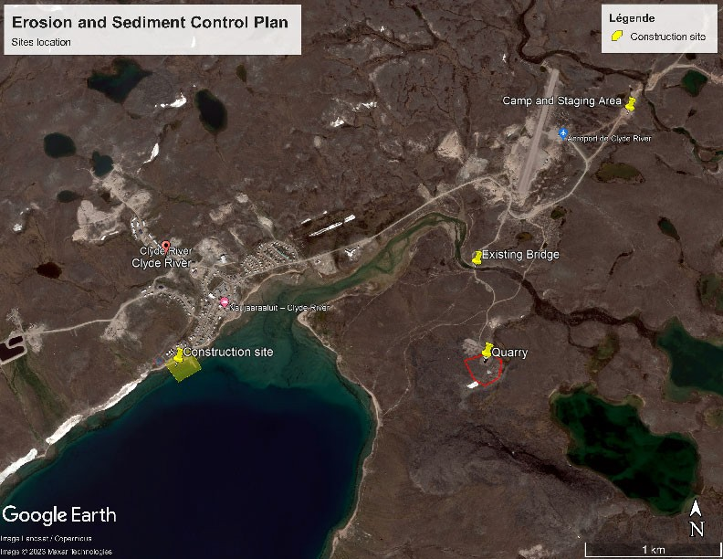

1.1 OBJECTIVE AND DEFINITIONS

Erosion and sedimentation are natural processes of loosening and transporting soil through the action of wind, water, and the subsequent movement and deposition of sediment particles. Construction activities can result in increased erosion and sedimentation. The dredging activities will generate important volume runoff water which will require appropriate mitigation measures. The importance of erosion and sedimentation control is primarily to reduce the potential impact that erosion has on watercourses. Soil consists of many components, the majority of which are organic material, sand, silt and clay. It is the silt and clay that are the most damaging to watercourses as they are comprised of small particles that can be carried for long distances while suspended in water. Small silt and clay particles can cloud the water making it difficult for fish to find food, and also block sunlight reaching aquatic plants. When small silt and clay particles settle on the bottom, they can smother fish and amphibian eggs. There is an added risk that eroded soil may carry hard metals, traces of petroleum product or other pollutants from land into a watercourse. The effects of sedimentation in watercourses can be profound enough to be considered deleterious (harmful or damaging) to fish.

Erosion
Occurs when energy (water in this case) is applied to a soil surface causing the detachment, suspension and transfer of soil particles from a stable mass. The objective is to reduce the water flow that could loosen the soil particles.

Sedimentation
The process whereby the energy of water carrying soil particles is reduced down to the point that those suspended particles are allowed to settle out and be deposited, creating a build-up of sediment at that location. The objective is to create a sedimentation low point in order to reduce the energy and have all the size particles deposited before it enters any water bodies, rivers and streams.

Deleterious
The federal Fisheries Act defines it as “Any substance that, if added to water, would degrade or alter or form part of a process of degradation or alteration of the quality of that water so that it is rendered or is likely to be rendered deleterious to fish or fish habitat or to the use of by man of fish that frequent that water” (Canadian Fisheries Act).

Wind can be a mechanism of erosion, particularly for dry, finely textured soils with low organic content that is exposed by construction activities. Wind erosion can influence local air quality on the project site and be a source of sediment for water bodies. Areas of potential wind erosion are mainly roads and stockpiles.

1.2 EXISTING SURFACE AND VEGETATION CONDITIONS

Most of Clyde River's town and airport are built atop thick, terraced, raised marine and glaciomarine sandy sediments that contain saline permafrost. According to the geotechnical investigation done for this project, the native soils at the harbour water lot and at the harbour uplands primarily consist of silty sand to sand with silt and gravel. It is acknowledged that the sediments present on site are susceptible to be easily transported and will need special attention in order to minimise the erosion and sediment processes during the different construction phases.

EROSION RISKS IDENTIFICATION AND MITIGATION MEASURES
This section describes the risks and presents the mitigation measures. The following construction activities have been identified as operations that could potentially generate erosion and siltation.
- Quarrying (drilling, blasting, excavation)
- Rock crushing
- Haul road and river crossing upgrades
- Breakwater construction
- Dredging and disposal of dredged material

It is important to understand that sedimentation controls themselves are only employed as a second line of defense. Sedimentation controls are designed to provide a place for water to slow down and allow the particles to be deposited that the primary erosion controls were unable to prevent. Sediment fencing does not “filter” the water but rather are meant to slow down the water and allow fine soil particles or other potentially deleterious materials to settle behind it. Other measures related to sediment control will be implemented when necessary and when possible, as the installation of floating silt curtain in the ocean, culverts, ditches, berm construction, embankment work and grading of the working surface.

2.1 QUARRY ACTIVITIES

For construction of the breakwaters, a large amount of rock will have to be blasted and processed from the existing quarry. As presented in figure 1, the existing quarry is located 600 meters southwest of the Clyde River. The topography of the quarry area slops toward the Clyde River. The elevation of the bottom of the quarry is about at 20 meters while the river bottom in this area is at an elevation of around 2 meters. The quarry needs to be kept free of standing water. No significant water accumulation at the bottom of the quarry was observed during the summer 2023. At the end of the quarry operations, a drainage ditch and a sedimentation basin will be built at the north end of the quarry, as presented in Figure 2.1.1. The water that will eventually drain out from the quarry will end into a large wet area.

Some dust could be produced during dry days mainly from heavy equipment movements. This will be addressed into a further section. The rock sorting process will not generate a lot of dust since we will mainly be working with mainly blasted rocks. The blasts do create some dust but only for a very short time. The drilling operation does generate dust but it is mitigated by a dust collector.

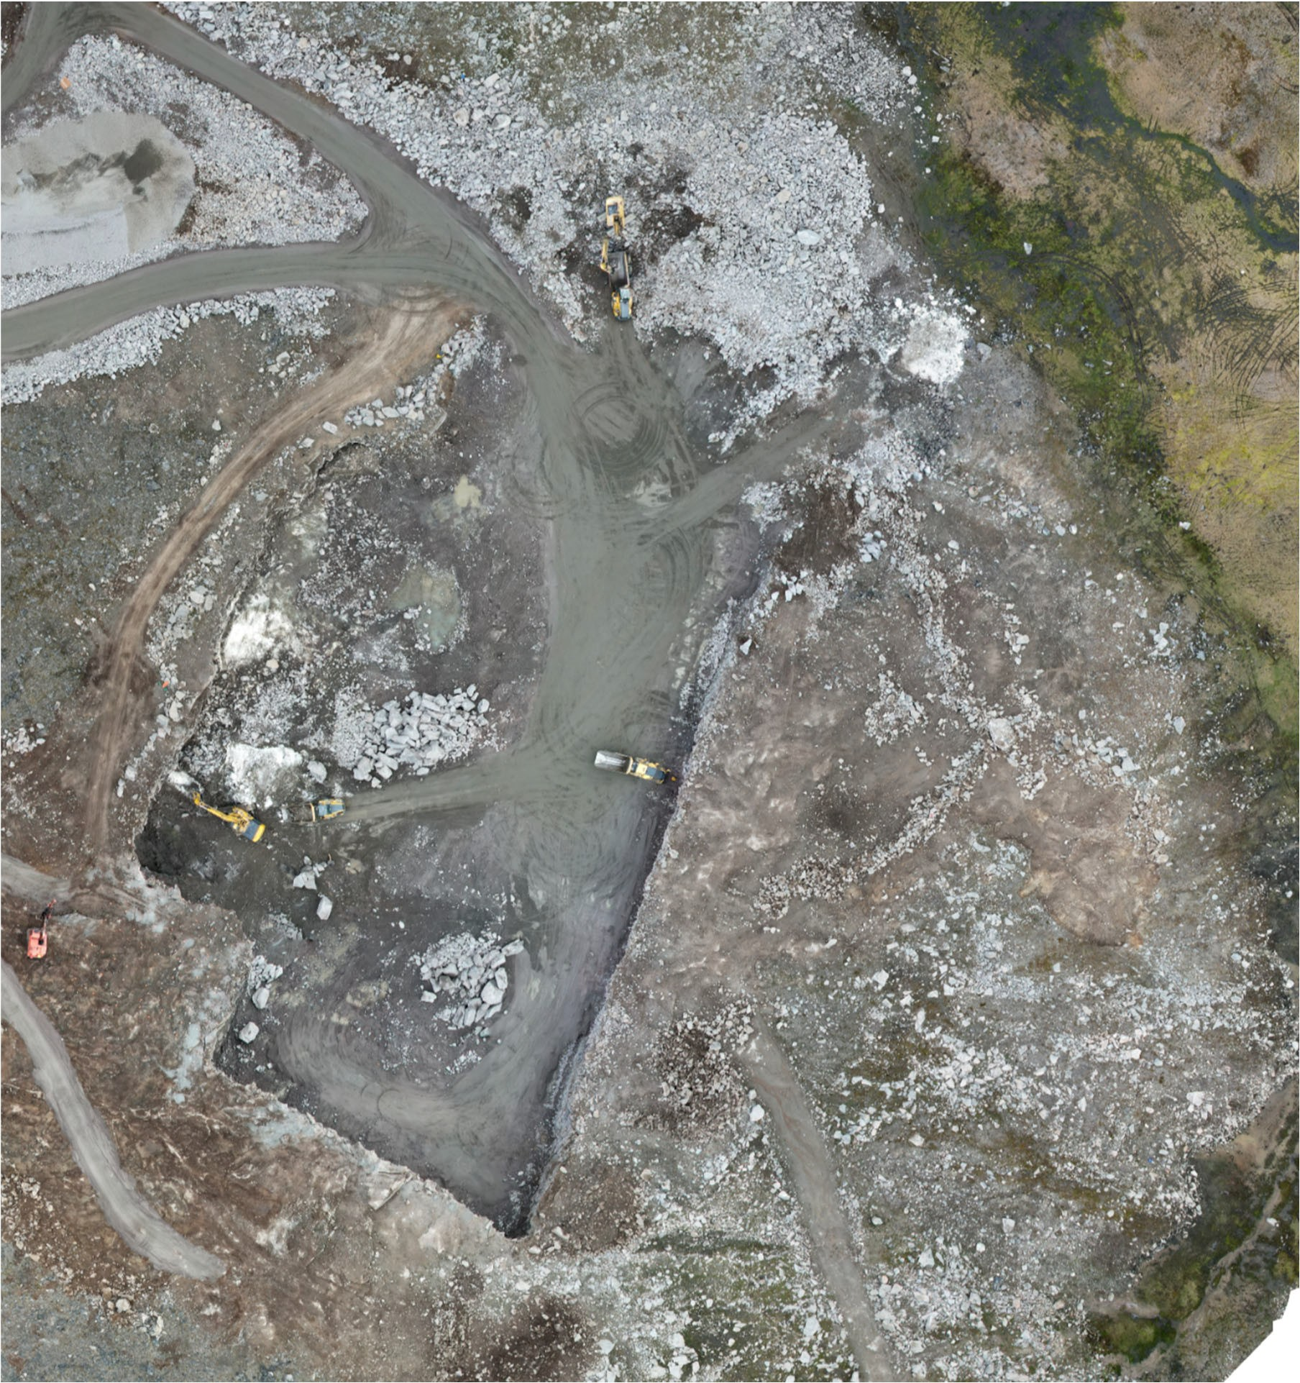Figure 2.1.1: Erosion and sediment control measures to be constructed at the quarry
N
Erosion protection

Sedimentation basin

2.2 MATERIAL PROCESSING AREA

The material processing area and the material stockpiles are located about 150 meters northwest from the quarry. The surface water from this area is mainly draining toward a ditch along the west side of the haul road, as presented in Figure 2.2.1. Through a culvert that crosses the road, the water eventually reaches out a wet land that drains toward the Clyde River. Two check dams made with clear stones and straw rolls were installed upstream from the culvert. The ditch was excavated deeper than the culvert invert in order to act as a sedimentation basin.

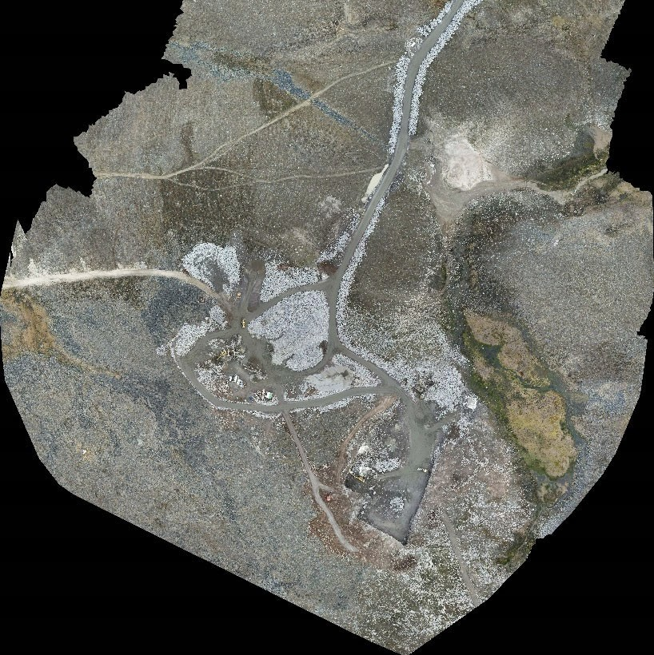Figure 2.2.1: Erosion and sedimentation protection -Material processing area
N
Checker dams made
with clear stone and
straw rolls
Processing area
Quarry

2.3 RIVER CROSSING

The river crossing is done on the renovated bridge. Following the bridge improvements, approaches on each side were enlarged and slopes were protected with rocks. To prevent erosion on the northeast slope, which is steepest than the other sides, clear rocks and straw roles were installed, as shown on the Picture
2.3.1. To prevent the erosion and avoid sediment to reach out the river, checker dams were installed along the southwest side of the bridge approach, as shown on Picture 2.3.2. A culvert was installed under a small ATV access road and a catchment basin was built was built between the culvert and the river, as shown on Picture 2.3.3 and Picture 2.3.4. Due to their size and weight, some equipment might have to use the existing Ford crossing for reaching the other side of the river. This operation will have to be done outside of the fish migration period and under the conditions of the applicable permits.

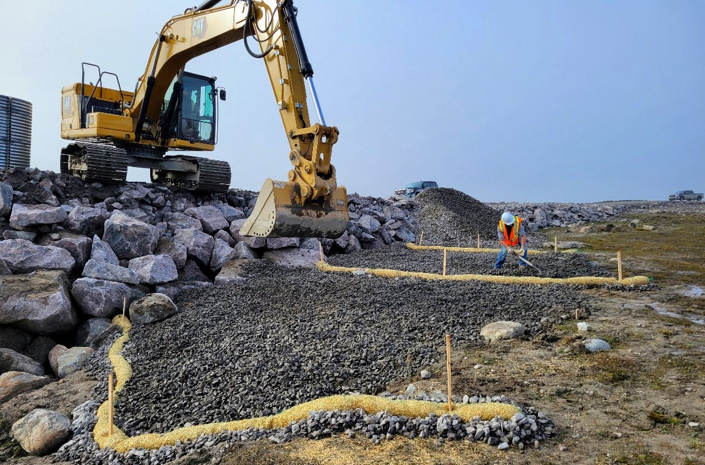
Picture 2.3.1 Erosion and sedimentation protection -Northeast side of Bridge

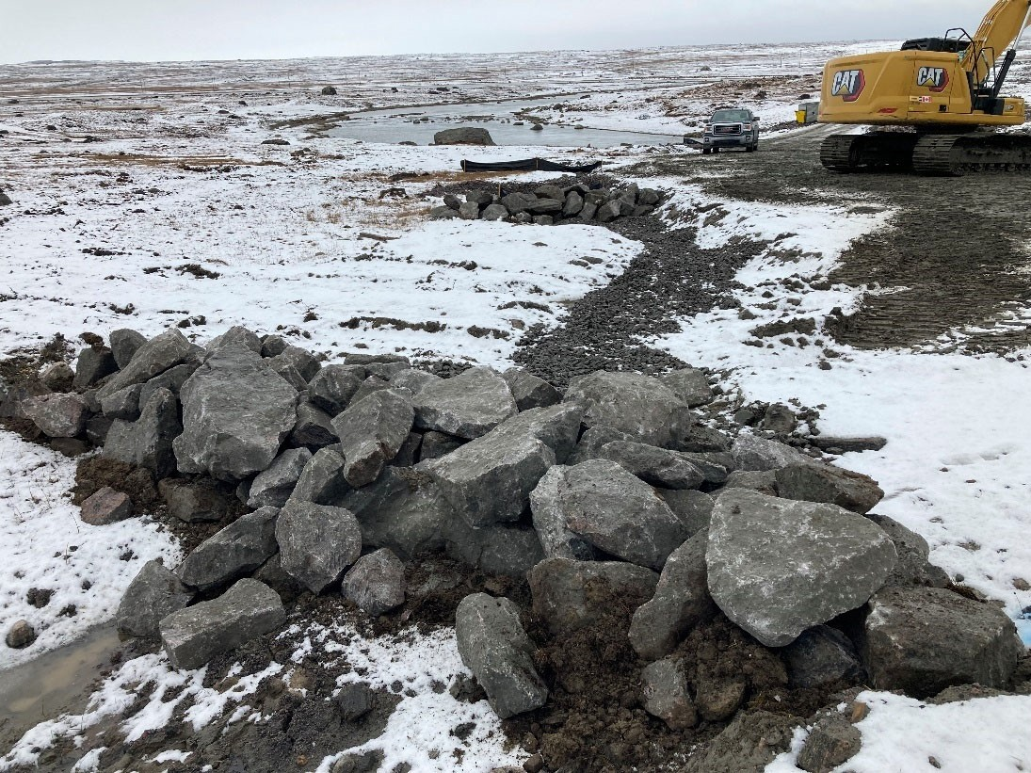
Picture 2.3.2: Checker dams built along the southwest side of the bridge approach

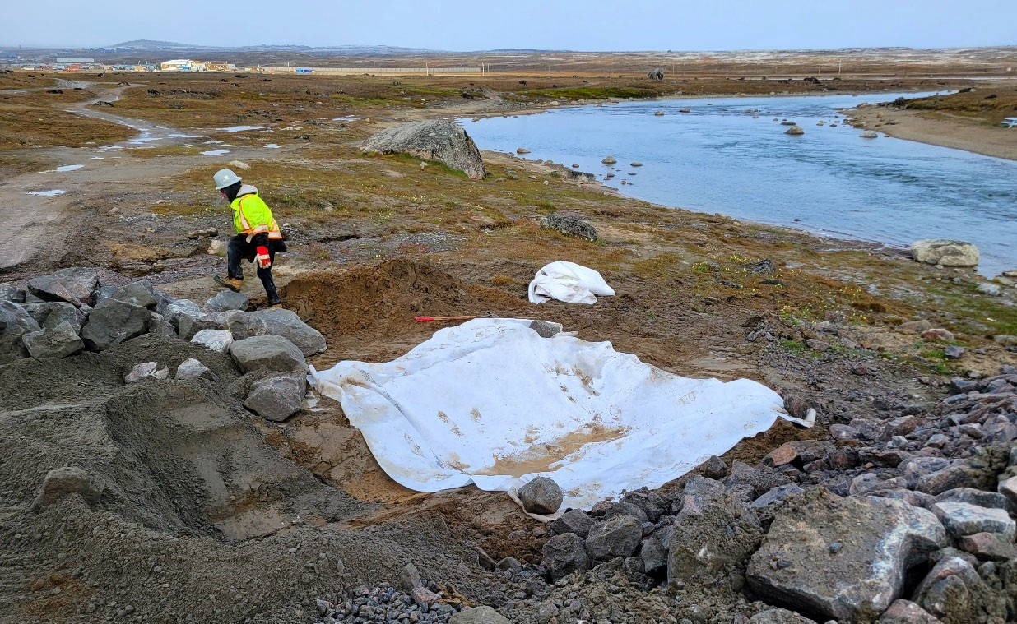
Picture 2.3.3: Catchment basin construction south side of the bridge

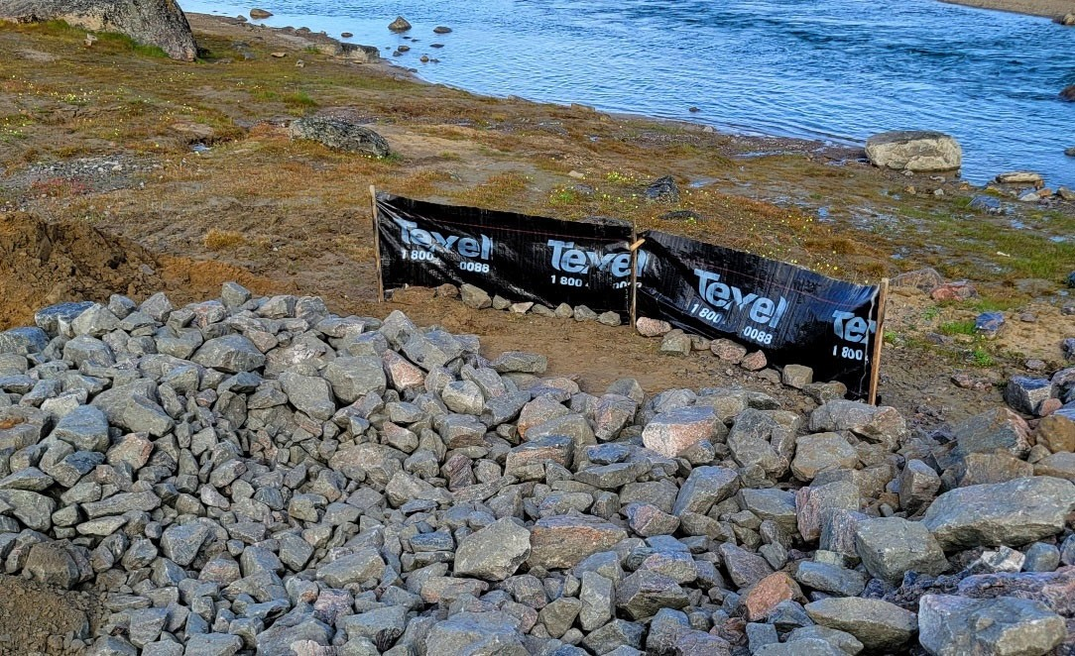
Picture 2.3.4: Catchment basin completed, silt fence was removed later

A control point to measure the variation of the total suspended solids (TSS) was established where the drainage path coming from the haul road meets the Clyde River, as indicated in Figure 2.3.1.

Figure 2.3.1: Erosion protection installed on the northeast side of the bridge approach

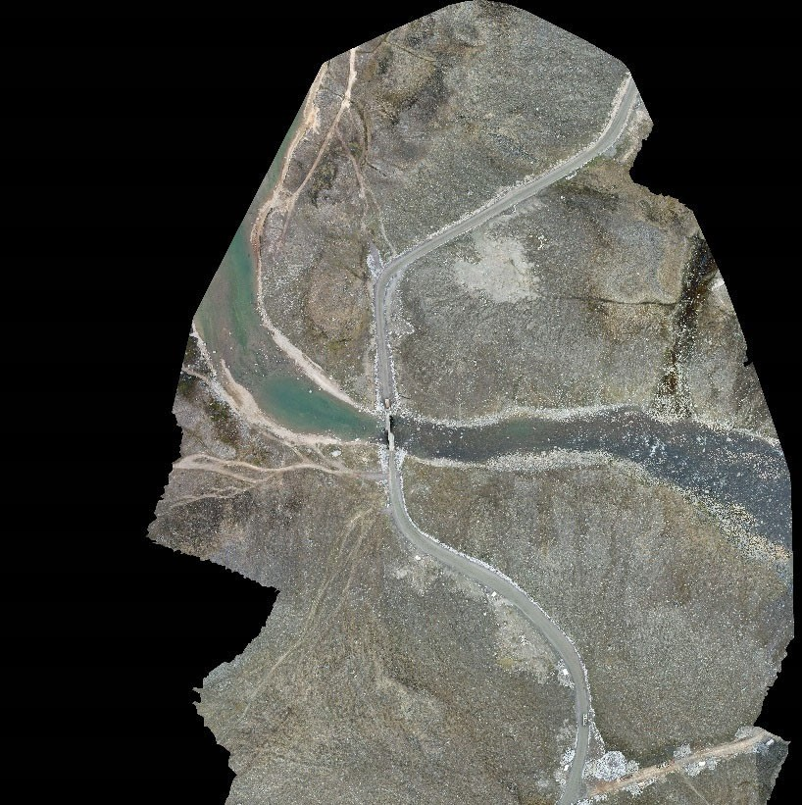N

Catchment basin

Erosion protection made with clear stone and straw rolls

Checker dams

TSS/pH control points measurement

2.4 ROAD AND ACCESS ROAD

The existing roads will be used for the transportation of the rocks and granular material required for the construction of the breakwaters and other features of the new harbour. The total drive distance between the quarry and the construction site is about 5 kilometers. Existing culverts are crossing the road at different places. Some of the culverts might have to be replaced. During the process of replacing a culvert, adequate sediment control measures will be installed. Both culvert entry and exit will be protected with clear stones and geotextile. The access road to the quarry were upgraded. Drainage ditches were improved, and road structure was reinforced in order to avoid rutting, gouging and/or erosion of the ground surface. The existing hamlet roads will be frequently graded in order in order to maintain them in good conditions. Additional crushed gravel will be added in some sections of the road where needed.

Regarding the dust control, water and calcium chloride will be added in order to keep the dust down. The use of calcium chloride was discussed and accepted by the SAO and the hamlet Forman. Water will be pumped out from the Clyde River by our water truck which is equipped with a rear spreader bar. The water collection from the Clyde River must be done under the following water licence conditions:
- Withdraw a maximum of 30 cubic meters per day from the river.
- Use a pump with a screened hose to extract water directly from the river. Water will be pumped into a water truck. The pump will have a maximum flow rate of <0.035 m3/s.
- Water for domestic camp purposes shall continue to be supplied by the Hamlet of Clyde River.
- The Licensee is required to record daily volumes of Water withdrawn from Clyde River and report it to the NWB in their Annual Report submission.

Calcium chloride will be added with a 2 tons spreader installed at the back of a pickup truck. The normal rate of application recommended by the manufacturer is one tonne per kilometer, for a 10 meters wide road. Several applications could be done during one summer, depending upon the weather conditions and the volume of the traffic. Based on daily observations, the environmental monitor will be responsible to determine when the dust suppression application is required.

2.5 BREAKWATER CONSTRUCTION

The breakwaters construction involve the placement of large quantities of rocks and granular material at different depths in the water. Even tough the type of material to be used for the construction of the breakwaters contains almost no fine, the placement of the materials could generate suspended solids coming from the seabed and from the residual fines present on rocks. The core material will be dumped and pushed while the rocks will be placed using an excavator. Even placed with care, this operation will create seafloor disturbance and could increase temporarily the water turbidity. This operation will be followed by the environmental monitor. The ocean water quality will be monitored as per described in

section 4. The method used for the material placement could be adjusted to mitigate the impacts. According to sea conditions and the absence of floating ice, a floating silt curtain could be installed around the work area. The floating silt curtain will be available at the site and installed if needed.

2.6 DREDGING AND DISPOSAL OF DREDGED MATERIAL

The dredging operations involve the construction and removal of temporary roads to access the areas to be dredged, the excavation of the seabed, the transportation, and the management of the dredged spoils. The most part of the dredging operations will be carried only once both breakwaters will have been completed. This will allow the reduction of potential impacts generated during this type of activity. This will also render possible the installation of a floating silt curtain that will enclose the work area to reduce the dispersion of suspended solids in water.

The dredged spoil will be loaded into dump trucks and transported to the dredged spoil disposal area, located on the west side of the tankfarm, as indicated in Figure 2.6.1. The dewatering area was prepared in 2023 to receive a small quantity of dredged material. It will be upgraded as presented in Figure 2.6.2 to receive a larger volume of dredged spoil. A drainage ditch was dug along the west side of the dredged spoil disposal area to intercept the surface water coming from upstream. Retention berms will be constructed around the perimeter of the disposal area and a silt fence will be installed between the drainage ditch and the retention berm. The sedimentation basin and the filtration berm were built during the summer 2023 with clear stones and geotextile, as shown in Picture 2.6.1.

The dredged spoil will be placed to facilitate their drainage. Rocks will be placed in a separate pile and drained material will be either processed for reuse, as per specifications, or spread out and compacted. For the site closing, the top of the placed material will be reshaped to promote a positive drainage. Rocks used for the temporary roads will be placed on the exterior slopes to avoid potential erosion and the silt fences will be removed.

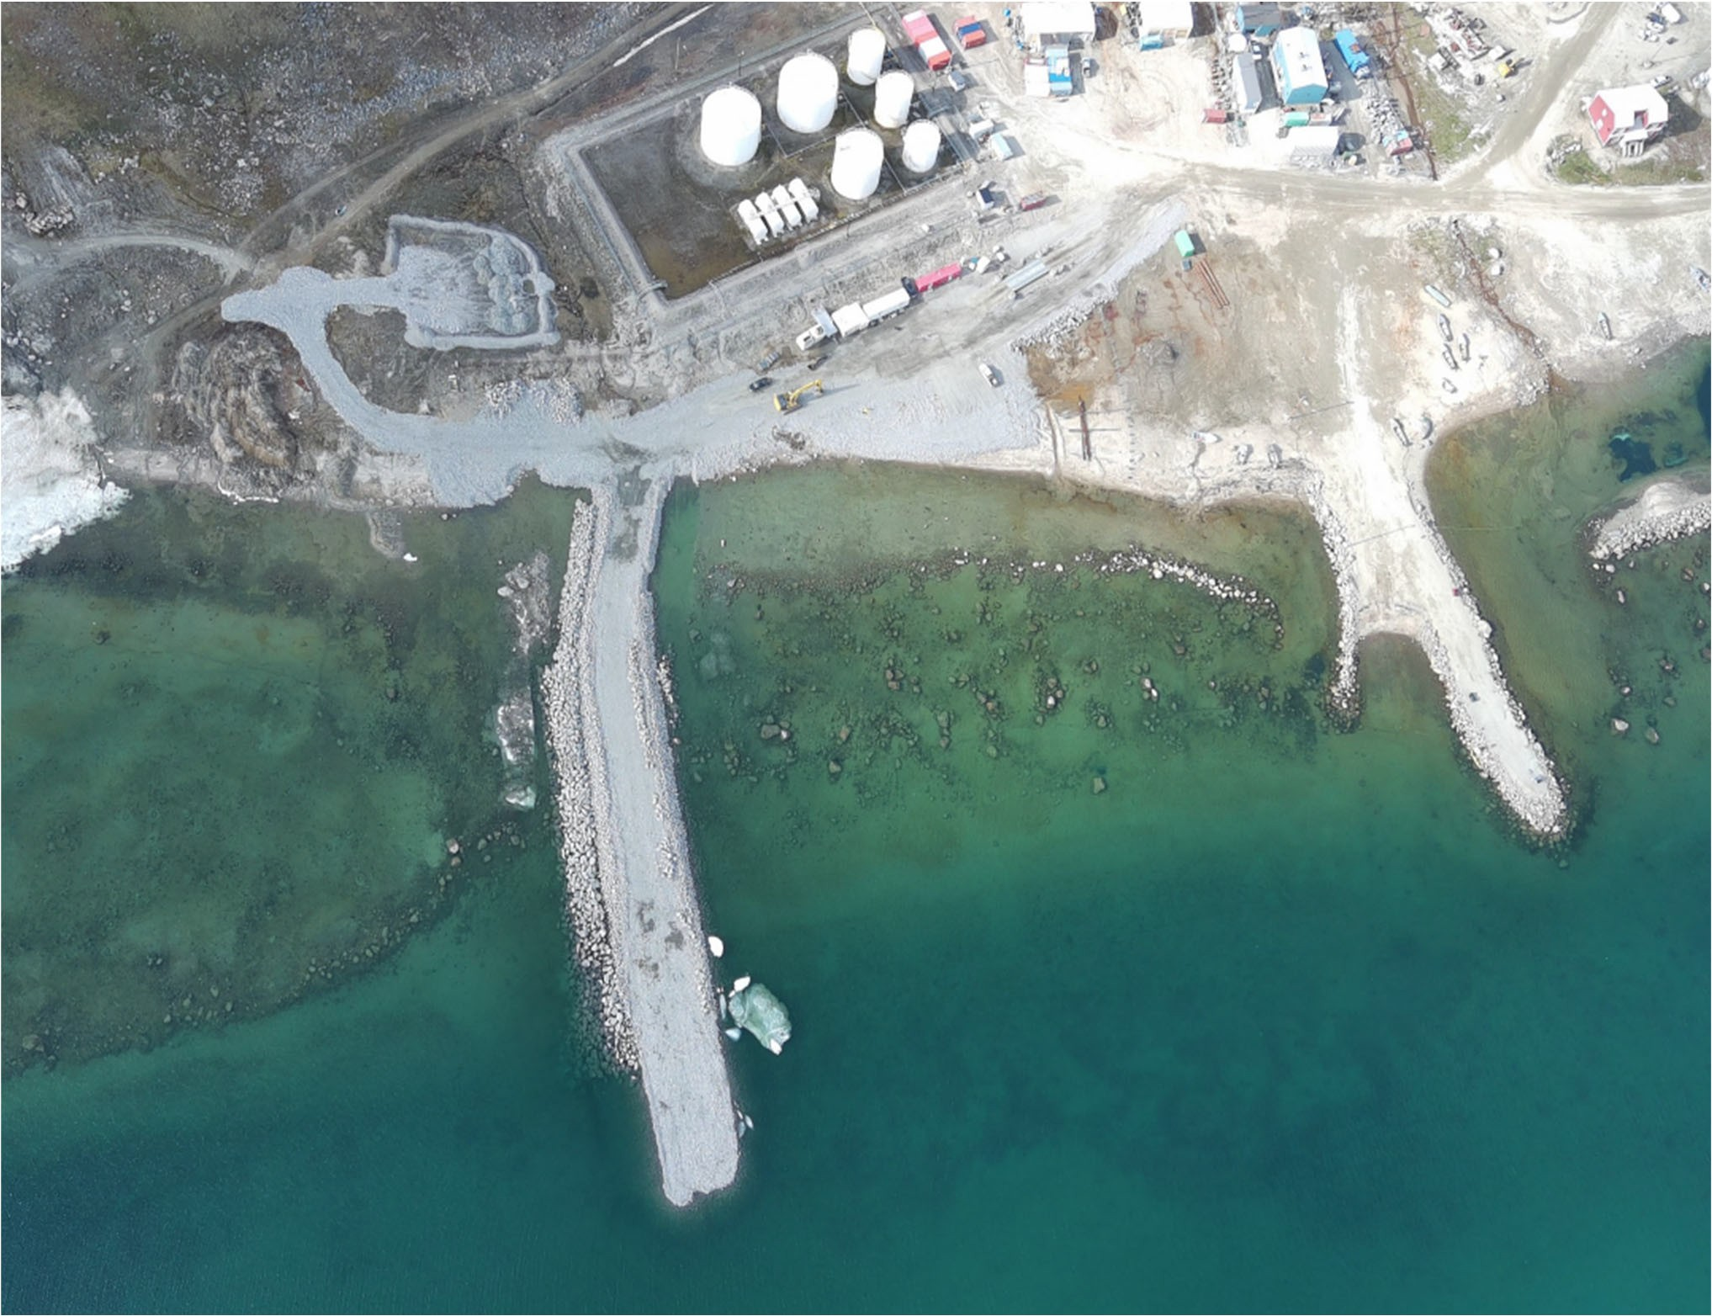Figure 2.6.1: Dredge spoil disposal area and water sampling point

Dredged spoil disposal area

Sediment pound, silt fence and gravel berm
TSS sampling point

Typical sampling point for tubidity measurements

Figure 2.6.2: Dredged spoil processing/disposal area
N
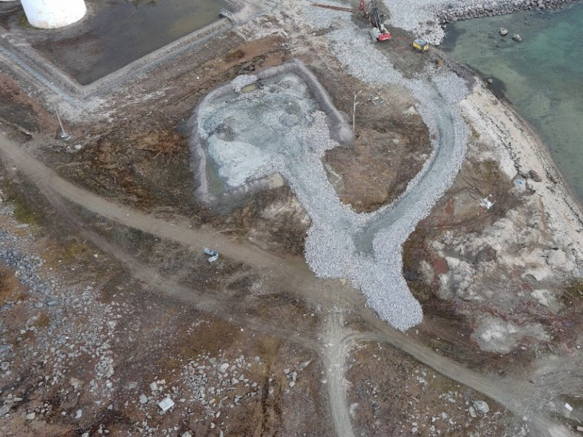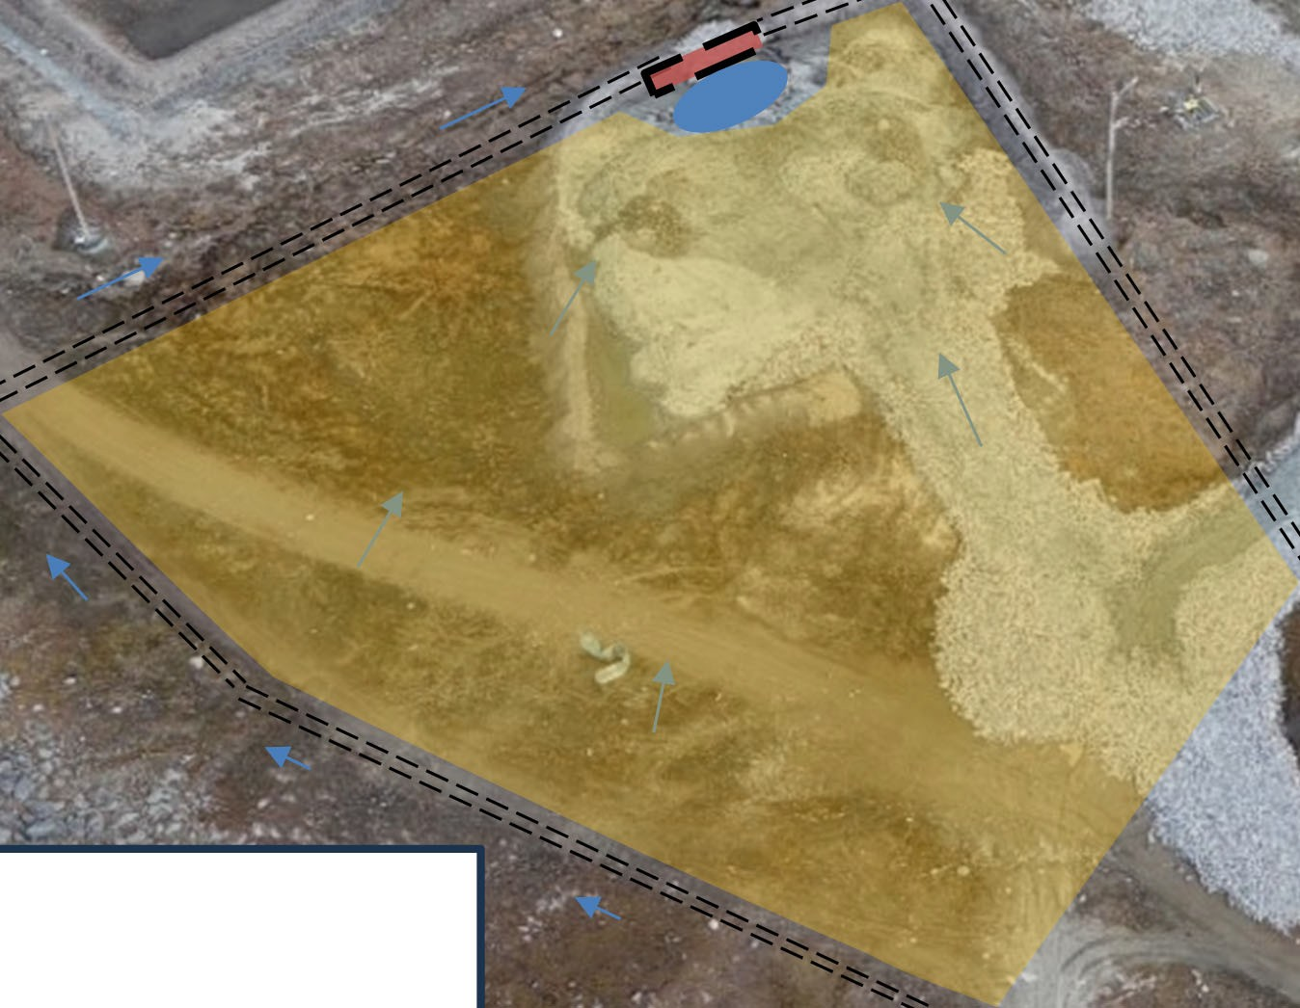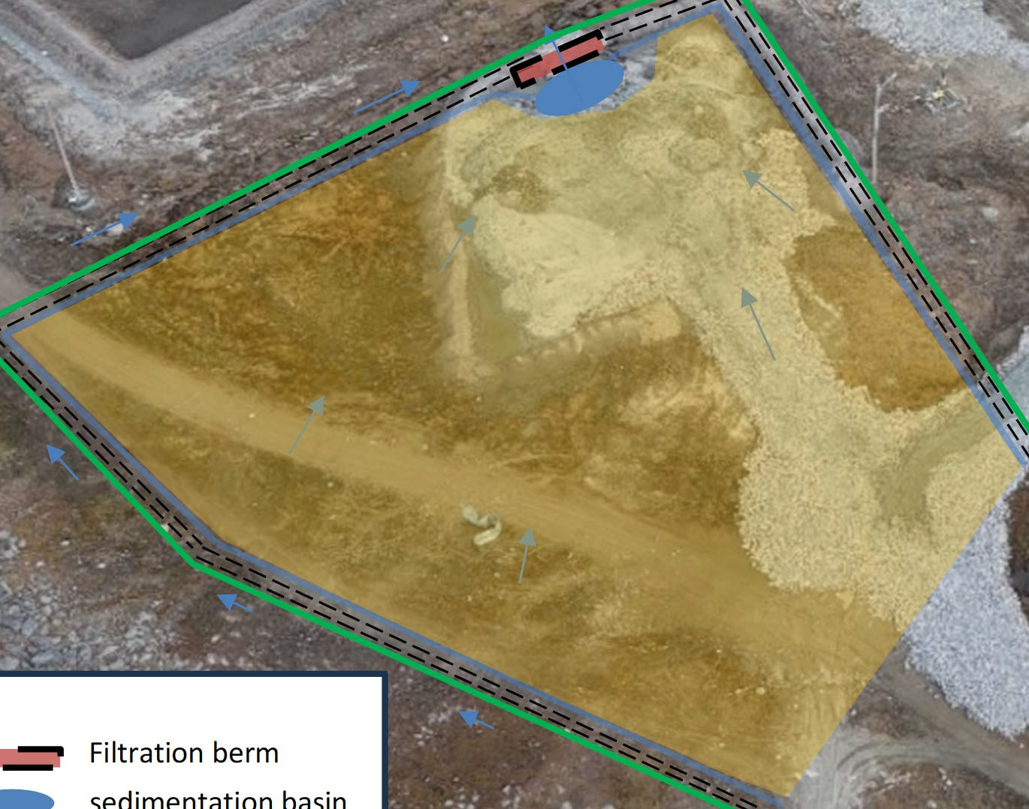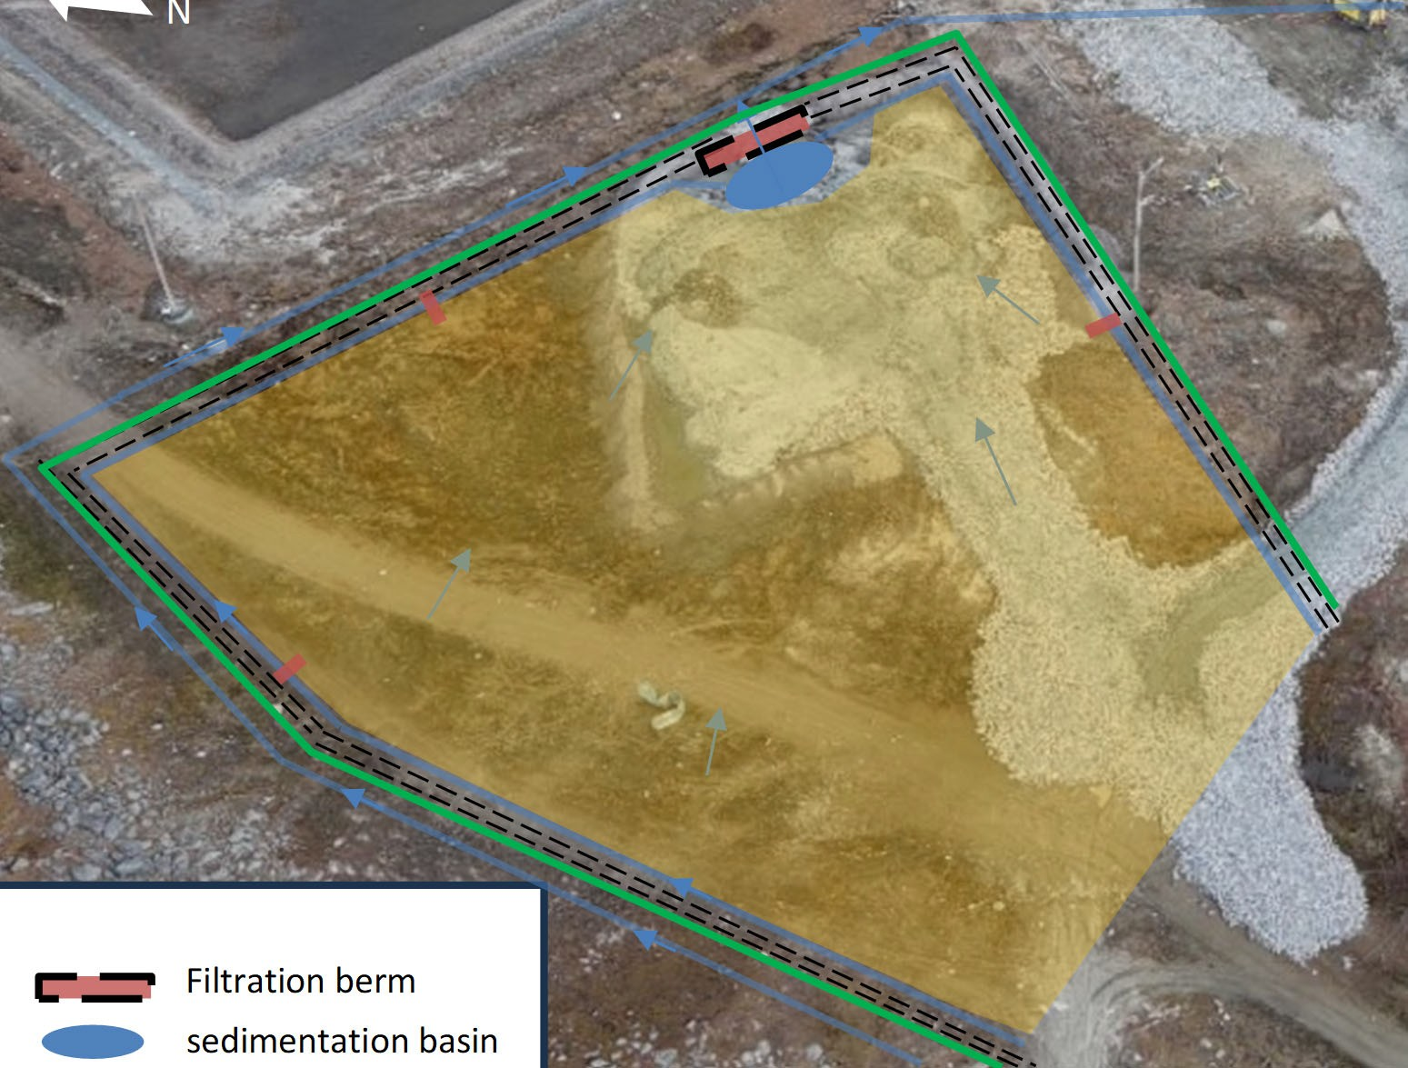
Check dam
Retention berm
Silt fence Drainage ditch Dredge spoil

Picture 2.6.1: Construction of the sedimentation basin and the filtration berm
Filtration berm
sedimentation basin
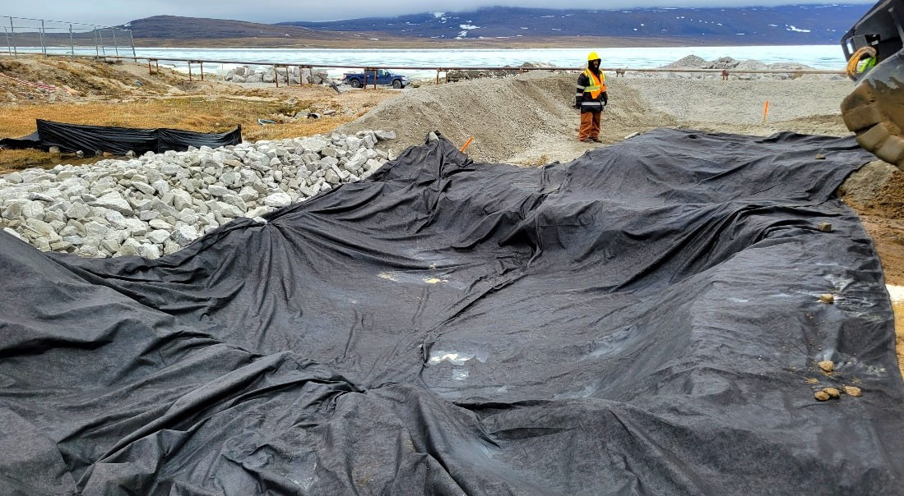

EROSION PROTECTION DEVICES AND METHODS
The erosion and protection devices will be stored nearby the site office. Their installation will be done under the supervision of the environmental monitor.

3.1 SILT FENCES

Silt fences are made with permeable geotextile fabric installed vertically and supported by posts with the bottom of the fabric buried in a trench. They are designed to prevent transport of sediment off site. It acts as an above ground settling pond to provide an area of catchment where water can remain still and allow sediment to settle out. Sediment fencing requires frequent monitoring and maintenance to remain effective.

Application
- Flat Ground
- Anywhere low flow runoff and retention of sediment are a concern
- Sloping Ground
- Stockpiles
- Ditches

Implementation
It is important to note that the correct installation of this sediment control measure is crucial to its effectiveness and the level of maintenance it will require. It should be Installed downslope from construction activities, and used with other control measures (such as straw wattles/roles, or sediment catch basin). Silt fences should follow the contour of the slope with sides going upslope making the shape of a “U” to trap water. The amount of joints in the fabric should be minimized. Regular inspections of the fence should occur, especially after rain events.
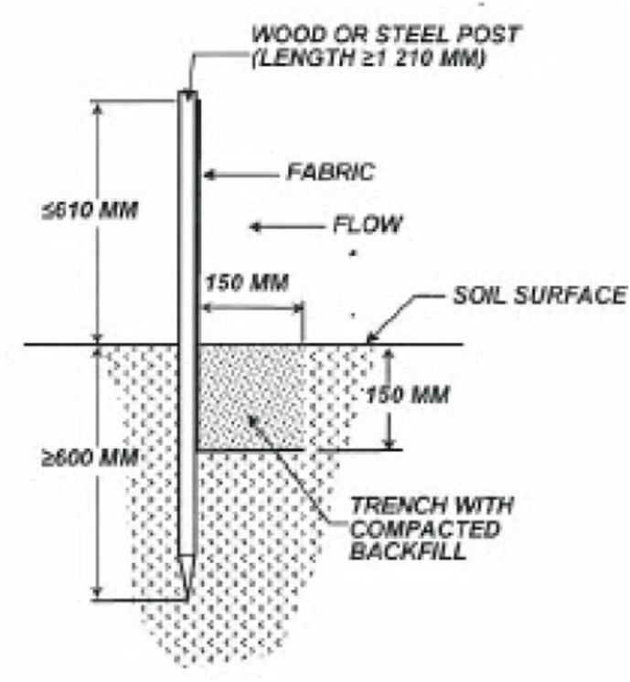

3.2 ORGANIC FIBRES ROLLS

Organic fibres (straw) are encased in a photodegradable plastic net casing that form a roll used primarily for erosion control but also for sediment control as a secondary use. Installed perpendicularly across a slope it reduces erosion by shortening the slope length and by providing grade breaks. They are also effective at slowing flow velocity of overland flow and retaining sediment that accumulates behind the roll instead of migrating down slope.

Organic fibre rolls will be used where slopes are steeper, where the surface has been disturbed and at a risk of erosion. The rolls cannot be installed across ditches, swales or natural water flow paths.
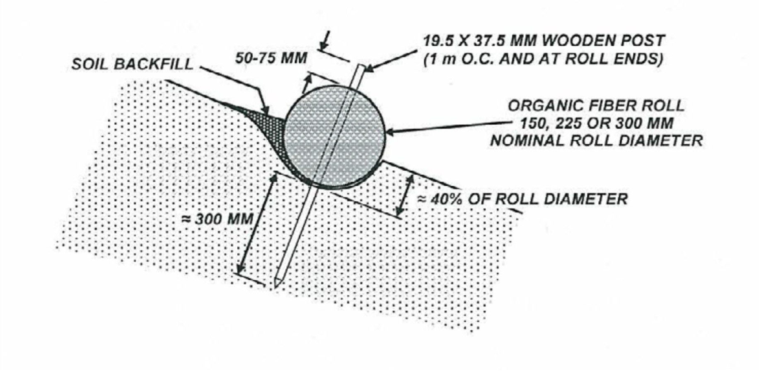

3.3 CHECK DAMS

A check dam is a small barrier or dam constructed across a swale, drainage ditch or other area of concentrated flow for the purpose of reducing channel erosion. Channel erosion is reduced because check dams flatten the gradient of the flow channel and slow the velocity of channel flow. Most check dams are constructed of rock, but hay bales, logs and other materials may be acceptable.

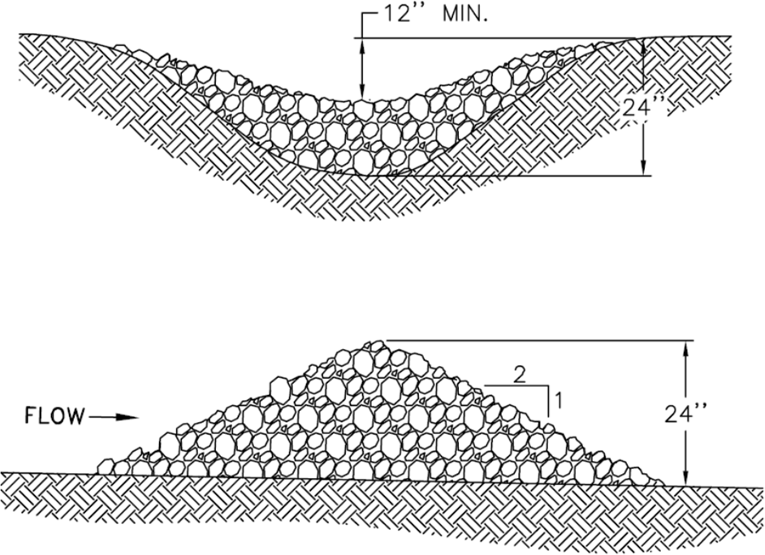

Typical rock check dam

3.4 DITCHING AND BERMS

Ditching and berms will be mainly used at the dredged spoil disposal area in order to manage the water runoff from the saturated soils. Berms will be constructed with available material and compacted. Ditches will be dug and collected to catchment basins where fine sediment will settle downwards.
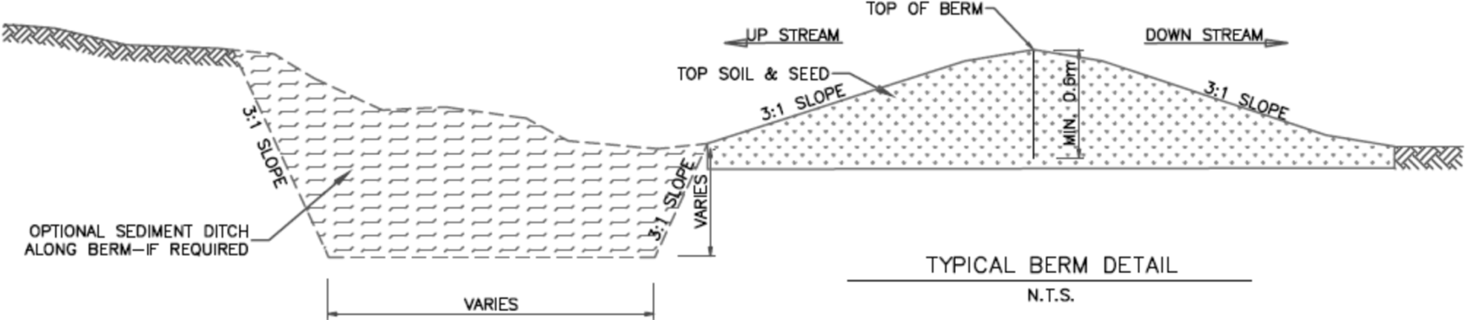

3.5 CATCHEMENT BASSINS

Catchment basins will be installed to collect the sediments from the drainage ditches before they reach out to the existing water courses. The basin sizes will be adjusted to the area drained by the ditches. Each basin will be excavated, lined with geotextile and protected with clear stones.

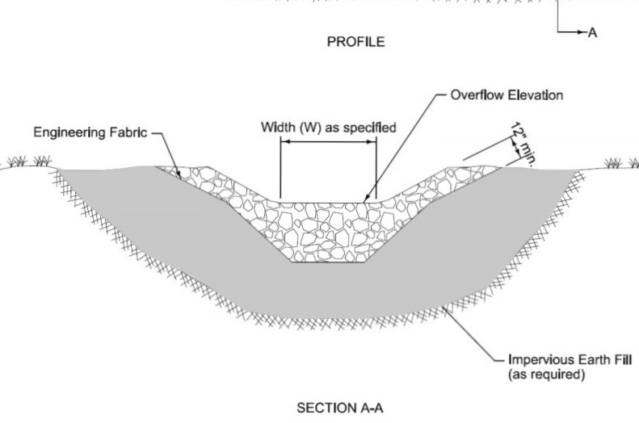

3.6 FLOATING SILT CURTAINS

The floating silt curtains are designed to help prevent particulate materials from leaving the immediate area of construction in the water. Type 2 silt curtains for moderate current conditions will be available for works to be carried out at the harbour site. Type 3 silt curtains for high current conditions will be available for the river crossing site.

Typical installation of a type 2 floating silt curtain
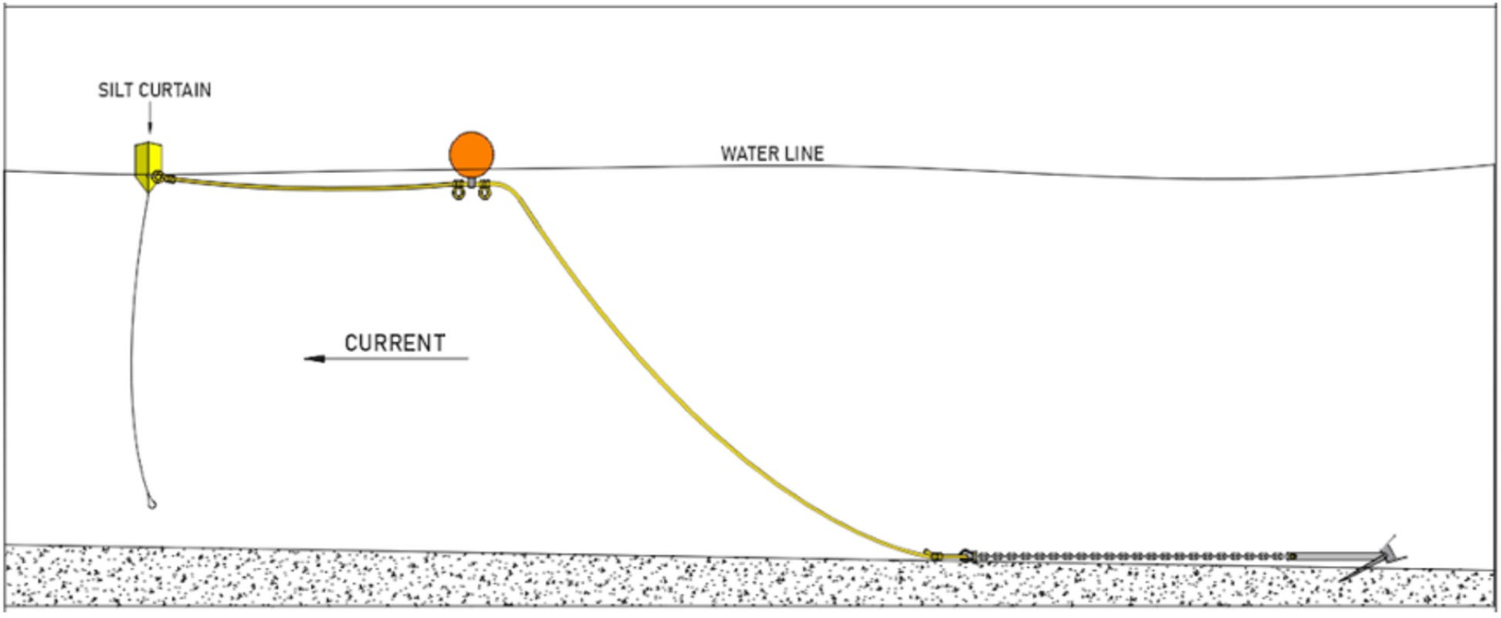

Typical installation of type 3 floating silt curtain
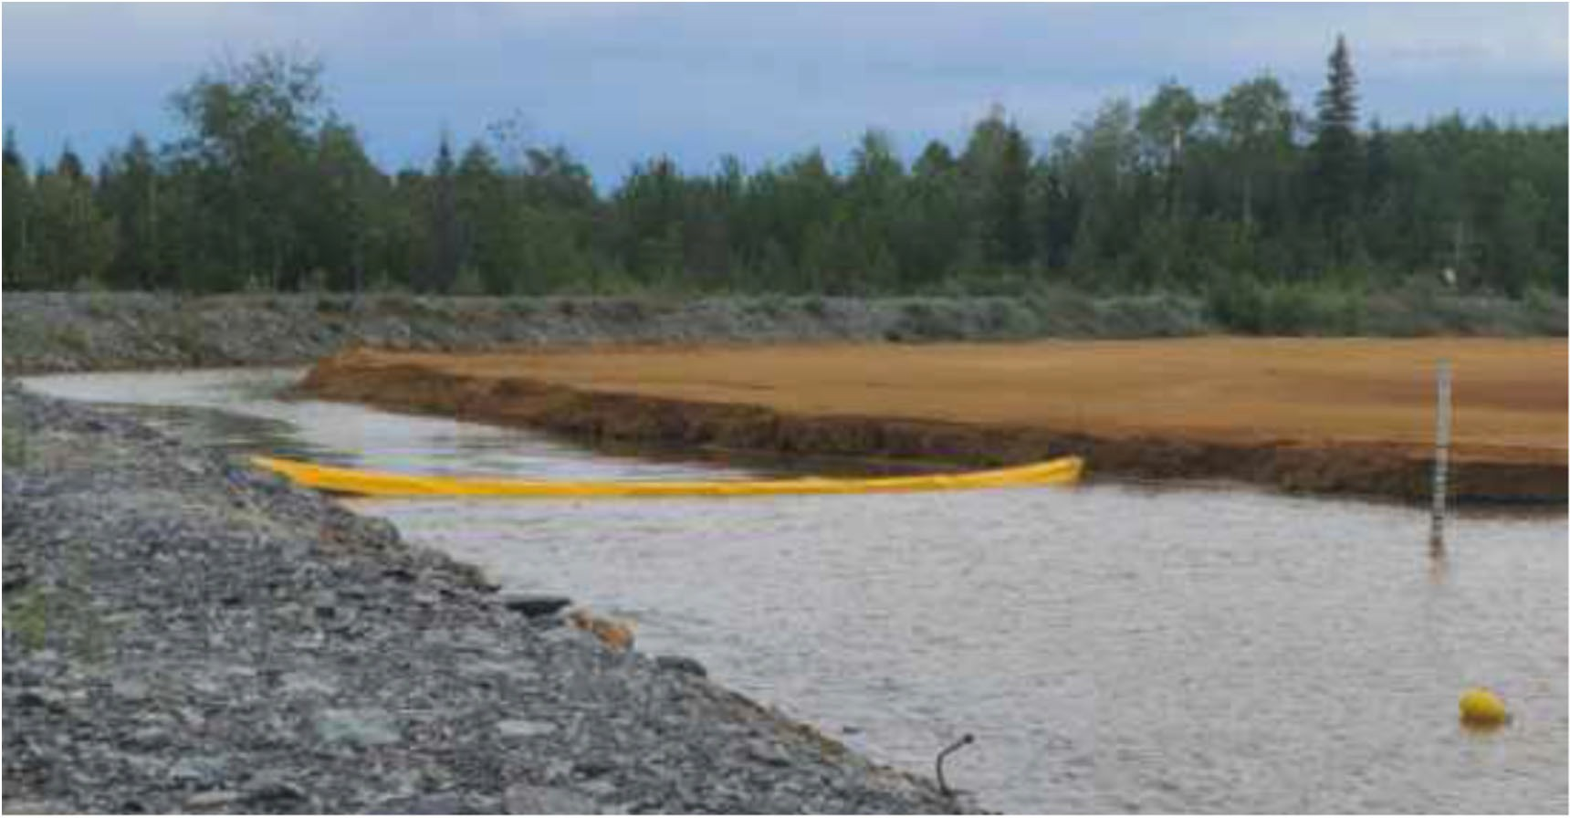

MONITORING AND REPORTING
Monitoring, inspection and adaptive management are necessary to ensure the effectiveness of this plan. It provides confirmation of proper implementation and effectiveness of erosion and sediment control measures. The effects of wet weather during construction activities can have a significant impact on ground conditions and can change otherwise stable soils into soils that are affected by erosion and sedimentation. Freeze thaw cycles at the beginning and at the end of construction seasons can also expose stable soils to an unstable condition overnight and throughout the day.

4.1 EROSION AND SEDIMENT CONTROL MONITORING AND MAINTENANCE

Monitoring will take place until the concern of erosion and sedimentation no longer exists. It is the duty of the environmental monitor to ensure that the erosion and sediment control measures are properly installed, well maintained and functioning as intended. However, it is the responsibility of everyone to report any ineffective erosion and sedimentation control measures or those in need of repair. The inspection of the erosion and sediment control measures will be part of the environmental monitor daily routine. These inspections and repairs will be reported.
Sediment control measures may require accumulated sediment to be removed in order to function properly or to not overload the structure. The removed sediment will be transported to the dredge spoil disposal area.

4.2 WATER QUALITY MONITORING

Marine and land construction activities will be monitored for their potential impact on water quality and marine habitat. The specific purpose of ESCP is to first identify any activities that could increases the potential of sediment erosion by implementing mitigation measures in order to reduce or eliminate soil particulate transport into the existing water bodies (river, steam or ocean). Second, in the case of any event of potentially impacted water reaching the water bodies, direct measurement of the water quality will be carried-out for the total suspended solids (TSS) and the turbidity. If needed, on-site correctives measure will be immediately implemented in order to reduce the load of sediment in the runoff water. In any case of measured quality remaining above the guideline criteria of the CCME guidelines, the EM has the authority to shut down any related construction activities and have corrective measures implemented until guideline criteria are meet. For that specific case, immediate communication will be forwarded to the CBCL and DFO representative for further discussion and correction of the issue. The following section of the plan is detailing the monitoring and reporting actions related to erosion related issues of on-site activities.

All monitoring activities of the ESCP will be documented in a daily report that will include the following elements (see appendix X for a preliminary version of the report sheet).

- Contact information of the sites supervisors and the environmental monitor.

- Identification and location of the work activities causing erosion that could affect water quality.

- Sediment control measures or correction actions to minimize or eliminate the source of sediment transport will be documented in the daily report. These measures could include but are not limited to silt fencing, culvert installation, water channel and berm construction, embankment work and grading of the working surface, etc. On-site modification to the plan and actions could be adapted accordingly as needed and in order to efficiently resolve any impact of water quality issue (s) related to erosion.

- When visual monitoring identifies sediment run-off in the natural water bodies, the direct monitoring of the turbidity and the total suspended solids (TSS) of the water quality will be conducted and documented. The measured parameters (TDS and turbidity) are directly related to the presence of small solid particulates that are suspended in the water and that could affect its quality. These particulates will originate from the washout and leachate of inorganic manipulated soil material, and should not affect the chemical balance of the water. However, according to the water licence conditions, the pH will be measured and recorded. The TSS measurement will be conducted on site with a Hatch portable meter HATSSMETER that measure turbidity and the total suspended solids. The respective range of the probe for TSS and turbidity are between 0.001 to 400 g/L and 0.001 to 9999 FNU. The monitoring program will measure the background values before work begins and at different periods of activities based on visual monitoring and potential effect of the work on the water quality. The location of measurement with the probe will be made at around 1 to 2 meters from the point of entry of potentially impacted water into the water bodies. The monitoring distance can be adjusted based on context, results and visual observations. The measured total suspended solids (TSS) and turbidity are compared to the Canadian Council of Ministers of the Environment (CCME) guidelines for the protection of aquatic life which can be found; (https://ccme.ca/en/res/total-particulate-matter-en-canadian-water-quality-guidelines-for- the-protection-of-aquatic-life.pdf). A resume of these guideline is provided below:
- For TSS:
  - For clear flow, maximum increase of 25 mg⋅L⁻¹ from background levels for any short-term exposure (e.g., 24-h period). Maximum average increase of 5 mg⋅L⁻¹ from background levels for longer term exposures (e.g., inputs lasting between 24 h and 30 d) .
  - For high flow, maximum increase of 25 mg⋅L⁻¹ from background levels at any time when background levels are between 25 and 250 mg⋅L⁻¹. It should not increase more than 10% of background levels when background is >250 mg⋅L⁻¹.

- For turbidity:
  - For clear flow, maximum increase of 8 NTUs from background levels for a short-term exposure (e.g., 24-h period). Maximum average increase of 2 NTUs from background levels for a longer term exposure (e.g., 30-d period).
  - For high flow or turbid waters, maximum increase of 8 NTUs from background levels at any one time when background levels are between 8 and 80 NTUs. It should not increase more than 10% of background levels when background is >80 NTUs.

- Photographs of ‘’before and after’’ work/events will be documented and provided as needed, and also included in the reports.

- At the end of each season, a synthesis of the daily reports (see appendix 1) will be compiled with a focus on presenting the important events that have occurred during the working period. This compilation will be included in the yearly report.

APPENDIX 1
CLYDE RIVER HARBOUR CONSTRUCTION

APPENDIX 1

ESCP DAILY MONITORING SHEET


Environmental Monitoring Daily Report
Clyde River Small Craft Harbour Development
Date | Year/Month/Day
Day | Day
Tide | Tide
EM | Name Environmental Monitor
MMO | Name Marine Mammal observer
Exclusion Zone | Exculsion 500 m or more for piling activities
Weather | Sunny (1), Cloudy (2), Fog(3)
Weather | Rain (1), Snow (2), Blizzard (3), Other (4)
Weather | Mid day temperature (°C)
Activities | Drilling (number) / Blasting
Activities | From Quarry to screen (loads)
Activities | Transport contract (loads)
Activities | transport outside contract (loads)
Activities | Dredging
Activities | Infilling
Activities | Construction
Activities | Sieving test on rocks
Activities | Other
Wildlife | Wildlife Observation (Nb animals)
Wildlife | Wild life Mitigation (refer to daily wildlife  monitoring)
Waterbody Turbidity ocean | Waterbody Turbidity Increase 8 NTU from BG level 24 hr, Max increase 2 NTU from BG level 30 days
Erosion/sediment | Erosion/sediment control & surface water Quality All surface runoff or discharges impacted by construction activities associated with the Project, where flow may directly or indirectly enter Water, shall not exceed the following Effluent quality limits TSS: 50 mg/L max average, 100 mg/L max grab sample  Oil & grease: No visible sheen pH: between 6.0 and 9.5
Traffic Control | Traffic Control

Environmental Monitoring Daily Report
Clyde River Small Craft Harbour Development
Hydroacoustic monitoring | Hydroacoustic monitoring. Underwater sound level  threshold 160 dBRMS re: 1μPa within the exclusion zone and 30 kPa at 10 meters
Dust control | Dust Control Calcium Chloride (Quantity) and area
Water consumption | Water consumption from river (30 m3/day) max as  licence
Water consumption | Water consumption from hamlet Once a month only,  other than dust control (m3/month)
Water consumption | Water usage Once a month only  (other than dust control)
Water consumption | Water at camp (delivered by hamlet) Once a month  only (m3/month)
Water consumption | Water for other construction activities (m3/day)
Spill / Unauthorized discharge | Spill / Unauthorized discharge. Use NU spill line if grater than 100L
Ford crossing | Ford crossing Avoidance during Fish migration:  -Upstream: 2 weeks following ice free river  -Downstream: ± Aug 7 to Sept 15
Stop Work Order | Stop Work Order. Describe nature and duration
Explosive | nearby fisheries waters Not including blasting at the  quarry
Explosive | Explosive at the quarry. Blast and Vibration monitoring
Vessels presence | Vessels presence
Inuit Land use nearby project | Inuit Land use nearby project. Anyone who is  crossing the working area to access territory need to be registered (nb personnes)
Waste management Sunday report only | Waste management Sunday report only
Waste | Waste volume sent to the local facility (m3)
Waste | Hazardous waste
Waste | Salvaged material

Clyde River Harbour Development
NWB 2023 Permit Annual Report rev-01

Clyde River Harbour Development
Clyde River, Nu

APPENDIX 3
CLYDE RIVER HARBOUR CONSTRUCTION

APPENDIX 3

Spill reports and spill and contaminated soil disposal documents

3

lldTAK  ENTERPRISES a | Submittals |  |  | No.: 77  Rev.: 00  Date : November 29, 2023
Project: CLYDE RIVER HARBOUR DEVELOPMENT Project No. : 2022-034
DFO ETO-025-222050
Subject: 2023 waste sent on sealift for recyling, reusing or disposal
Submitted to : CBCL Limited David Parsons
1505 Barrington St davidp@cbcl.ca
Halifax, NS, B3J 3K5 506-633-6650 ext 3233
Copy to : Kenton Thiesson kenton.thiessen@pwgsc-tpsgc.gc.ca
PSPC 204-229-6375
Speciality : environment  Specification section :  Drawing reference :  Submited as : information |  |  | Submitted for : Information Revision required by : December 9, 2023 Color choice required :  Total Page incl. cover: 7
Subcontractor or supplier :

Manufacturer :
Description : 2023 waste sent on sealift for recyling, reusing or disposal

Supplier No :
Comments: Includes the contaminated soil manifest from the disposal facility
Revised and submitted by :  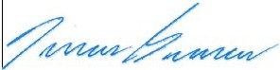  Fran9ois Bourassa, P.Eng. Pilitak Enterprises Ltd.  1519 Federal Road Iqaluit  418-781-6114 ext 213  fbourassa@pilitak.biz |  | Review by the consultant or the client :  Shop Drawing Review  Thisreview is intended to assist the contractor in complying with the requirements of the Contract Documents and does not relieve him of his responsibilities under the contract.  7 reviewed revise and  resubmit reviewed as noted F not required  for review  (4,-_,-h ' -:>rr,  PER  CBCL LIMITED  -;:  ---  PROJEC T DA T E

11dTAK
e
ENTERPRISES§ Cly de River Small Craft Harbour Development
Waste shipped on the 2023 sea lift to sout h ern fa cilities for recycling,re-using or disposal
Type of Waste Hazardous
Quantity & type
Disposal
Volume
(m3)
Coll ected by Camion International Elitefor recycling:
265, Etienne-Dubreuil Quebec (Quebec)
GlM4A6 0.2
Used Oil Tire
Tire
no no
no
20 20 L pale 1 Loader t ire
2 Skytrak tire
1660, av. de l'Energie, Alma (Quebec),G8C 1M6
Coll ected by Pneu Belisle for recycling:
6250 Bd Wilfr id-Hamel, L'Ancienne-Lorette, QC G2E 2H8 4.5
heavy no
Equipment/vehicle parts
Contaminated soils with dieseland hydraulic oil
Scrap metal
no
6 Starter (2),
accumulator (1),
motor (1), gear
box (2)
3 Quatrex 27
Sent to dealers for retrofit/ recycling
2
Sent to Solneuf for disposal:
1304, chemin du site, Neuville (Qc), GOA 2R0
1.1
no
various metals
Sent to Recuperation Fer et Metaux for recycling:
460, rue Bleriot,QC GlP 4N2
3
Empty gas cylinders yes
yes yes
2 Argoshield
12 Oxygen
3 Acetylene
Coll ect ed by Messer Canada for re-using
3

Battery | yes | 5 4D
Battery | yes | 1 8D
Battery | yes | 1 Groupe 31
Battery | yes | 1 151R-Bolt

Battery | yes | 1 BC178
Battery | yes | 1 VSV78DT
Used Oil | no | 2 1000 L tote tank | Coll ect ed by Environnement Sanivac
Used Oil | no | 1 205 L drum | for recycling: 2.6

RECU DE CARGAISON / CARGO RECEIPT [a3]- 00092
c-

Ce re u decargaisol) est emis conlormement et sujet aux termes et conditions du contra! de transport applicable alacargaison a etre transportee et dont ii est failreference aupresent r u.
'
ESPACE RtSERVE A l 'IN FORMATIQUE / SPACE RESERVED FOR DATA PROCESSING
NEAS
N ° RESERVATION
BOOKING NO.
N° REl;UPROVISOIRE
TEMPORARY RECEIPT NO.
DATE/ DATE
I
N° VOY
T:5' °\
NAVIRE / SHIP
t"'A-ntJ.. '"::l
- \-0.oc.
...
°'l="r .
-- -
r-t-
PORT DECHARGEMENT
LOADING PORT

PORT DE O1:CHARGEMENT
UNLOADING PORT
□
RETROGRADE
RETROGRADE

LATERAL
LATERAL
This cargo receipt is issued pursuant toand subject to theterms and conditions ofthecontract ofcontract ofcarriage applicable
to thecargo tobecarried and which isreferred to herein.
Lesmarchandises transporteesen pontee l e sont aux risques duMarchand.
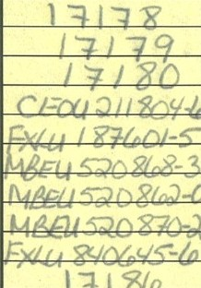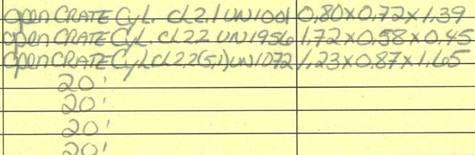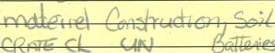Garooes carried on deck are done so at the Merchant's risks.
:: !1-- &.;..L...I.Lt.Bl....:....+- :ai. _;,_-_........,,,;,r_-lt..,......(,,._..c... L ,.-.
'Q..,; 1 l .

+-- - - - ­

N° COLIS
PACK NO.

OTE
QTY

DESCRIPTION
DIMENSIONS
LONGUEUR X LARGEUR X HAUTEUR
LENGHT X WIDTH X HEIGHT
POIDS WEIGHT KG/ LB
CONTENEUR
CONTAINER
PLEIN VIDE
FULL EMPTY
TRANSPORT
S ·PlAli PlA!i-SITE
SITE-BEACH BEACH-Sn£

N° LIV.
DEL.NO.

::JA I
. -
I/
I
V
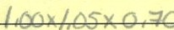
,/..

CHARGEMENT / LOADING
REMARQUES / REMARKS
DECHARGEMENT / UNLOADING

....,
"'\.
vvq
' -
, '

'l_ \
j ()
l 111,,c , Y, roM-

Lateralr u le
Lateral received on

I I ""'-' \..,-
RepresentantM.lltrianc/l'Merchant Representative
t I - _ _, L.
()"1,l-.
- 1• '. '

Representant Marchand I Merchant Representative

• 19--·(.-(..•._ \-A l l d
'
'-
Representant TransporteurI Carrier Representative
Representant Transporteur / carrier Representative
(RE V05r.!1) Blanche-White = TERMINAL MARITIME - Jaune-Yellow = CLIENT I CUSTOMER - Rose-Pink= NAVIRE I VESSEL

SHIPPER'S DECLARATION FOR DANEROUS GOODS
I
I
DECLARATION DE L'EXPEDITEUR POUR MARCHANDISES DANGEREUSES

Shi pper Expediteur  ?{ \1tc{k | Waybill No.  Node LT.A. Page 1 of 1 Pages Page de Pages  Shi ppe r' s Reference Numbe r (opt ional)  Ne de reference de l' expedlteur (facultatlf)
Consigne Destinataire   | Carrier Transporteur  
Two completed and signed copies of this declaration must be handed to the operator.  Deux copies de cett e declaration dOment remplies et signees, doivent etre remises a l 'exploi t ant.  Additional Handling information/Renseignementscomplementaires  NUMERO 24H CANUTEC 613.996-6666 | Warning  Failure to comply in all respects with the applicable Dangerous Goods Regulations may be in breach of the applicable law, subject to legal penalties.  Avertlssement  Le non-respect sur quelque point que ce solt de la Reglementation sur le transport des marchandises dangereuses peut constituer une infraction aux lols en vlgueur, punissable par la loi.
NATURE AND QUANTITY OF DANGEROUS GOODS NATURE ET QUANTITE DE MARCHANDISES DANGEREUSES
Dangerous Goods Identi fication ,;
Identi fication des marchandises dangereuses
UN'or ID Proper S_hipping Name Class or Division Quantity and type of Packing
) Packing group
(Subsidiary Risk) packing instruction
No Designation exacte Groupe Separation UN ou ID d'expedition Classe ou Division d'emballage Quantite et type Instruction
{Risque Subsidiaire) d'emballage d'emballage
5' M-eYies 4 D

Accu mvlo.fe0 r
u l ele- c·.tri e rempli
Cla. <;e
2
..... --
1 bei er;e. <2 D
b.,fte(ie.. Grov 31
1 b.1fo.,;e I$ I R- &)L

Z01

21-iY

.
G\'ele(...-\-ro { -te>
!,,v iJe _{cte,i}&e.- .

UNz r- Y
1 baterie. l:>CI ro
bttVtZrie VsV·f i .DT

N°Identification n° conteneur / boite
Seal n° / N° de scelle
I Dimensions conteneur/ boi te

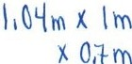
lare(kg)
5'x 4& l"j -= 2•40
I)(. SS'. I Kj ,,. 55, I ..Y
I Y- 20,'l K<;j: 2D,Cf k rf--
1 X 9 , 1 lcj :: . I I<:
/ Masse brute totale (kg)

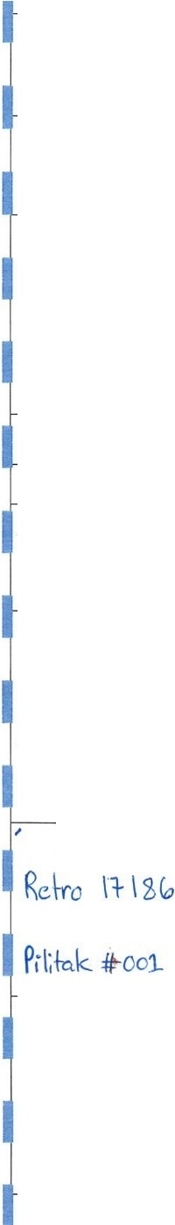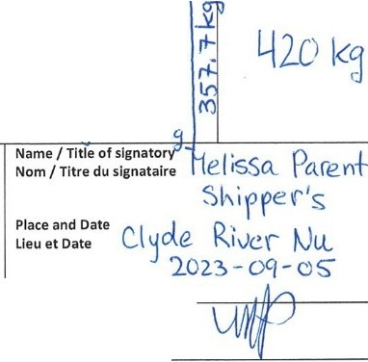

I hereby declare that the contents of this consignment are fully and accurately described above by the proper shipping name, and are classified, packaged, marked and labelled / placarded , and are in all respects in proper condition for transport according to applicable International and National Governmental Regulation. I declare that all of the applicable maritime transport requirements have been met.
Par la presente, je declare que lesrenselgnementsrelatlfs a la description du contenu du chargement et a la designation exacte d'expeditlon du prodult expedle sontcompletset exacts;
et que le contenu est correctement classe, emballe, identifie etiquete / placardeet qu'ilest conforme a tous egards aux reglements gouvernementaux nationaux et lnt er atlonaux en
matleres de transport. Je declare que toutes les prescriptions applicables au transport maritime
& routier ont ete remplies.
l.x ri .:, kj .:: 11... k ro
I• llo,3\c::: i . k

Signature
(See warning above) Signature

SHIPPER'S DECLARATION FOR OANEROUS GOODS
I
DECLARATION DE L'EXPEDITEUR POUR MARCHANDISES DANGEREUSES

Shipper PILITAK ENTERPRISE LTD
Waybill No.

Page 1
I
1 Pages

Expediteur CLYDE RIVER (2022-034)
Nunavut XOA OHO
No de L.T.A.
of
Page de
Pages

Telephone: 1- 866.781-0704
Consigne GELY CONSTRUCTION
Destinataire 1781Route de l'aeroport
Quebec G2E 2PS
Telephone : 1-418-871-3368
Shipper's Reference Number (opti onal) N2 de reference de l'exp diteur (facultati f)
Carrier
Transporteur GELY Construction ltd

Two completed and signed copies of this declaration must be handed to the operator.

Deux copies de cette declaration dOment remplies et signees, doivent etre remises a l'exploitant.
Additional Handling information/Renseignements complementaires NUM RO 24H CANUTEC 613.996-6666
NATURE AND QUANTITY OF DANGEROUS GOODS NATURE ET QUANTITE DE MARCHANDISES DANGEREUSES
Dangerous Goods Identification Identification des marchandises dangereuses
Class or Division
Warning
Failure to comply in all respects with the applicable Dangerous Goods Regulations may be in breach of the applicable law, subject to legal penalties.
Avertissement
Le non-respect sur quelque point que ce soft de la Reglementation sur le transport des marchandises dangereuses peut constituer une infraction aux lois en vigueur, punissable par la loi.

Quantity and type of Packing

UN or ID
NO
Proper Shipping Name
Designation exacte
(Subsidiary Risk) Packing group packing instruction
Groupe

Separation

UN OU ID
d'expedition
Classe ou Division (Risque Subsidiaire)
d'emballage
Quantite et type Instruction
d'emballage d'emballage

UN
1956

UN
1072

UN
1001
GAZ
COMPRIME N,S,A
(Argoshield)

OXVGENE
COMPRIME

ACETYLENE
DISSOUS
2.2

2.2 (5.1)

2.1
2 X 73 kg

12 X 63 kg

3 x80 kg
P200

P200

P200

N° identification n• conteneur / boite

1,-11
\1·,\ 1
It \io
Seal n• / N° de scelle
Dimensions conteneur/boite
Tare (kg)

1142 kg
Masse brute totale (kg)

Kg

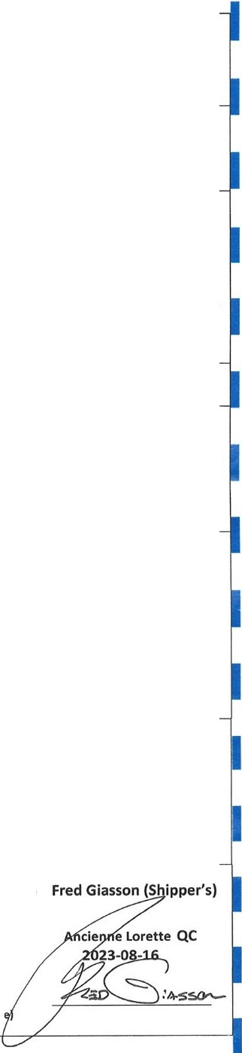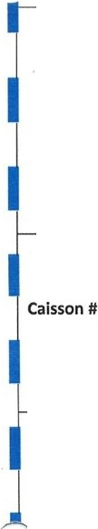
I hereby declare that the contents of this consignment are fully and accurately described above by the proper shipping name, and are classified, packaged, marked and labelled/ placarded, and are in all respects in proper condition for transport according to applicable International and National Governmental Regulation. Ideclare that all of the applicable maritime transport requirements have been met.
Par la presente, Je declare que les renselgnements relatifs a la description du contenu du
.hargement et a la designation exacte d'expedition du produit expedie sont complets et exacts;
et que le contenu est correctement classe, emballe, identifie etiquete / placarde et qu'il est conforme a tous egards aux reglements gouvernementaux l'!at lonaux et internatlonaux en
matleres de transport.Je declareque toutes les prescriptions applicables au transport routler & maritime ont ete rem plies.
Name/ Title of signatory Nom / Titre du slgnatalre

Place and Date Lieu et Date

Signature
(See warning abov Signature

, ©,,r
SolNeuf

CENTRE DE TRAITEMENT POUR LES SOLS SOUILLES AUX HYDROCARBURES LEGERS
www . solneuf. com

Administration
1990, rue Cyrille-Ouquet, bur. 210
Quebec (Qc) GlN 4K8 418.871.8001
418.872.5626

Lieu d'enfouissement de Neuville 1304, chemin du Site Neuville (Qc) GOA 2RO
418.876.2714
418.876.3624
Entree2023.10.2003:36:34PM

CLIENT: ADRESSE:

Contrat: Vehicules: Produit: Destination :
PILITAK ENTREPRISES
1519c, Federal Road lqualuit, Nunavut

4-087CONTRUCTION Gl:LY TERRE A ANALYSER

X0A0H0
Depart 2023.10.20 03:52:08 PM

POIDS BRUT : 13030 kg POIDS VIDE : 11080 kg POIDS NET: 1950kg

CONDIBONS : Net 30 jours. Frais d'adminsltration de 2 % par mois, 24 % par annee sur tout compte passe du. TPS : B45427590RT0001 - TVQ : 1213021253TQ0001

©

SolN euf

CENTRE DE TRAITEMENT POUR LES SOLS SOUILLES AUX HYDROCARBURES LEGERS
www. solneuf .com

Administration
1990, rue Cyrille-Duquet, bur. 210
Quebec (Qc) G1N 4K8·
m 418.87 1.8001
.ii 418 .872.5626
Lieu d'enfouissement de Neuville 1304, chemin du Site Neuville (Qc) GOA 2RO
418.876.2714
418.876.3624

CLIENT: ADRESSE:

Contrat:

PILITAK ENTREPRISES
1519c, Federal Road lqualuit, Nunavut
Entree 2023.10.200. 3:36:34 PM
Depa 2023.10.2003:52:08 PM

X0A0H0 POIDS BRUT:

Vehicules: Prodult: Destination : Source:
4-087CONTRUCTION Gl:LY TERRE A ANALYSER
Clyde river, Nunavut
POIDS VIDE: POIDS NET:

Tonnage
13030kg
11080 kg
1950kg
  - tm

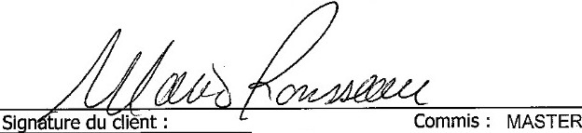
Source:
Clyderiver, Nunavut
Tonnage
1.95tm
NUMERO DE MANlFESTE :
VALERIE
# BILLET : 0000015723
NUMERO DE MANIFESTE :

Signature du client : Commis :MASTER · VALl=RIE #BILLET: 0000015723
CONDIBONS : Net 30 jours. Frais d'adminsitratlon de 2 % par mois, 24 % par annee sur tout compte passe du. TPS : B45427590RT0001-TVQ : 12130212 5'3TQ000 1

!os :;otssQuiUes

C1;oire di; ir,1itemr.ni !Hlllr
auxw1 1lrnr:11rhurns:i611rs

MANIFESTE DE TRANSPORT DES SOLS
Pour rec epti on : 418 871-8001
Cellu ioire : 4 l 8 554-4281 Cou rriel : lnfo@solneuf.com

N° de projet: _ _ _ _ _ _ _ _ _ _ _ _

A. Origine (a remplir par l'expediteur) B. Destination (a rempllr par le destlnataire)
Date: 2_ Q I La I 2-0?..J Date J1 :l_j , IQ _{I} 2,0
Heure : 4).-.'0Q Heure:

1. Client
Norn : /l_iL;,'f4k- fu.).l u , L 'ii2
- Lieu d'e limination
SolNe uf inc .

Adresse : _ !l/_L & E&,,9--
Lieu d'enfouissementsanitaire de Neuville 1314, chemin du Site
Neuville (Quebec) GOA 2R0

Ville: C L."IIJ.1::. R/ t.. Code postal :
- Sols re us

Tel. : ( )
- Te !ec. : ( JifJ... 0850
Conlonne Non-conlorme Remarques

Responsob le des trovoux :
- Provenance des sols - Generateur
Quantite : □ □
Elat physique : □ D
Typ e de sol: □ □

Adresse:
C L'lJ1i /./V£.£, A.JU/114.JLUJ
Contamina tion : □ □

N° d'ec han til!on : - -

Transport: D □
3

- Nature des sols recuelllis
L. 3

Quant ile :
.r..
- Pesee
Brui :
tonne(s)
13a?d

Eta! physique : li(J Sec D Humide D Boueux Type d e sols : m_Grov e leux la Sab leux □Argileux
D Silteux fii:I. Co llloux-blocs □Debris dive rs
Contam ina tion : □ A-B 0 B-C □ >C 0 >RESC
□C10- C oo/HAP □BTEX
Tore : 1-/fl&
D Vo ir le coupon de pesee n° /£l.2 j ·
Net :
- . Acceptation au site

t esp onsab fe :
W/LE (L( f. _!2 Q

Autre. specifie r : /}/l;<i,f,J.. r Nu/1 I-/'[ /}f&vtf ,-

□A car a ct e riser a la reception
  - Transport
Signa ture :
  - Echantlllonnage a la reception

Tronspo rteu r : C o/Y?t1_1l.vc.r left? G,r1:t.
□Oui □Non No

lmma tricula tion : L 7L1 .•c ,
1!!'1o roues D 12 rove s
D Semi-remorque : ble 0 Conleneur n°
°;1;:!::;::,w

Cha u ffeoc r
Signa ture :. C:::
5 . Superviseur - Expedition
En1reprise : P1'LLLf±.le_ &J;t( ft14s l 'D).
Resporuoble
:--0 -
Signature :
  - Facturation
0 Client D Aulre. preciser :
  - Renselgnements supp le me ntaires

S. V.P. retourner la copie blanche a
SolNe uf inc.
1990, rue Cyrille-Duq ue t, bur. 210 Quebec (Quebec) Gl N 4K8
Tel.: 418 871-8001 Telec.: 418 872-5626

Tel. : (_ )
- Cell. : (!/1.J.J....2Jo.- 08.Q)
Copie blanche : SolNeul Cople Jaune : expedlteur

Clyde River Harbour Development
NWB 2023 Permit Annual Report rev-01

Clyde River Harbour Development
Clyde River, Nu

APPENDIX 4
CLYDE RIVER HARBOUR CONSTRUCTION

APPENDIX 4

NWB Annual Reporting Form

4

NWB70 | Annua2l8Re | p2o9r.t6

License No:
Year being reported: 
Issued Date: Expiry Date:
October 31, 2025
January 20, 2022
8BC-CLY2225
2023

Project Name:
CLYDE RIVER SMALL CRAFT HARBOUR DEVELOPMENT

Licensee:
FISHERIES AND OCEAN CANADA

Mailing Address:
Fisheries and Oceans Canada – Small Craft Harbours 501 University Crescent
Winnipeg, Manitoba R3T 2N6

Name of Company filing Annual Report (if different from Name of Licensee please clarify relationship between the two entities, if applicable):
General Contractor: Pilitak Enterprises Ltd
P.O. Box 727, 1519 Federal Road,
Iqaluit, Nu. X0A 0H0

General Background Information on the Project (*optional):
Construction of a small craft harbour

Licence Requirements: the licensee must provide the following information in accodance with

A summary report of water use and waste disposal activities, including, but not limited to: methods of obtaining water; sewage and greywater management; drill waste management; solid and hazardous waste management.

Water Source(s):
Water Quantity:
Hamlet water for camp
6 m³/day | Quantity Allowable Domestic (cu.m)  Actual Quantity Used Domestic (cu.m)
2.4 m3/day

Water Source(s):
Clyde River for dust control
30 m³/day | Quantity Allowable (cu.m) Actual Quantity Used (cu.m)
Total for season:190 m3 Max per day: 30 m3 | Quantity Allowable (cu.m) Actual Quantity Used (cu.m)

Water Quantity:

Waste Management and/or Disposal
Solid Waste Disposal Sewage
Drill Waste Greywater Hazardous
 Other:

Additional Details:
Domestic water supplied by hamlet, total 304 m3 for the construction season Water for dust control: Withdrawn from Clyde River, south side of bridge to Cape Christian, 70 29 21.14 N 68 29 30.64 W
Sewage collected by the hamlet sewage truck
Solide waste: Transported to the hamlet solide waste facility Hazrdous waste: shipped off-site to a licenced disposal facility

Spill No.:
July 4 and September 14th
2 & 5
A list of unauthorized discharges and a summary of follow-up actions taken.
July 5 and Sept 14th
Date of Spill:
Date of Notification to an Inspector:

(as reported to the Spill Hot-line)

Additional Details: (impacts to water, mitigation measures, short/long term monitoring, etc)
All spills were under 100L. For the two spills happened nearby the water, the Nunavut spill line was contacted. No corrective action was instructed by the Nunavut Spill Line authorities.

Revisions to the Spill Contingency Plan

Additional Details:
The revision 1 was attached to the 2022's annual report. The rev-02 was issued to adreess the board's comments

Revisions to the Abandonment and Restoration Plan

Additional Details:
Not applicable, refer to the following section

Progressive Reclamation Work Undertaken
Additional Details (i.e., work completed and future works proposed)
A reclamation plan for the quarry was included in the Quarry Development Plan submitted within the last year's report. No modification to this plan was done. The reclamation works will starts in 2025.

Results of the Monitoring Program including:

The GPS Co-ordinates (in degrees, minutes and seconds of latitude and longitude) of each location where sources of water are utilized;

Additional Details:
Monitoring station 01: Southwest side of the bridge to quarry 70 28 29.6 N 68 31 59.22 W
Monitoring station 02: Construction site 70 28 5.39 N 68 36 0.52 W
Runoff water monitored for TSS, pH and visible hydrocarbon sheen
No exeecdance of these parameters was observed during the monitoring

The GPS Co-ordinates (in degrees, minutes and seconds of latitude and longitude) of each location where wastes associated with the licence are deposited;

Additional Details:

Results of any additional sampling and/or analysis that was requested by an Inspector

Additional Details: (date of request, analysis of results, data attached, etc)

Any other details on water use or waste disposal requested by the Board by November 1 of the year being reported.

Additional Details: (Attached or provided below)

Any responses or follow-up actions on inspection/compliance reports

Additional Details: (Dates of Report, Follow-up by the Licensee)

Any additional comments or information for the Board to consider

Date Submitted:
December 5, 2023
François Bourassa
Tel: Fax:  email: | (418) 930-0850
Tel: Fax:  email: | fbourassa@gely.biz

Submitted/Prepared by:
Contact Information:

