NWB File No: 8BW-LUP----
October 16, 2019

Kenny Ruptash
Nahanni Construction Ltd.
P.O. Box 2076 Yellowknife, NT
X1A 2P6
E-mail: kenny@nahannincl.com

Re: Acknowledgement and Receipt of Water Use Fee Deposit for Water Licence Application – 8BW-LUP----Lupin Water Access Project - Kitikmeot

Dear Mr. Ruptash:

The Nunavut Water Board acknowledges receipt on October 16, 2019 of your water use fee deposit, cheque numbers 014761 and 014762, for the above project. Your information for payment has been forwarded to Crown Indigenous Relations and Northern Affairs Canada in Iqaluit for processing. A receipt will be issued through their office for fees totaling $60.00 for water use fee deposit). Full payment of the water use fee is required prior to issue of any water licence.

Please refer to the calculation for water use fees, in the Nunavut Waters Regulations, Section 12, to ensure that the correct fee has been submitted. A copy of this regulation is available from our ftp site or by contacting this office. This is an annual fee which is required to be submitted yearly on the anniversary of the issuance of your water licence.

Please call the undersigned at (867) 360-6338 or e-mail licensing@nwb-oen.ca if you have any questions.

Sincerely,

Kayla Carter
Licence Administrator Assistant

Cc: Sarah Forté, CIRNAC
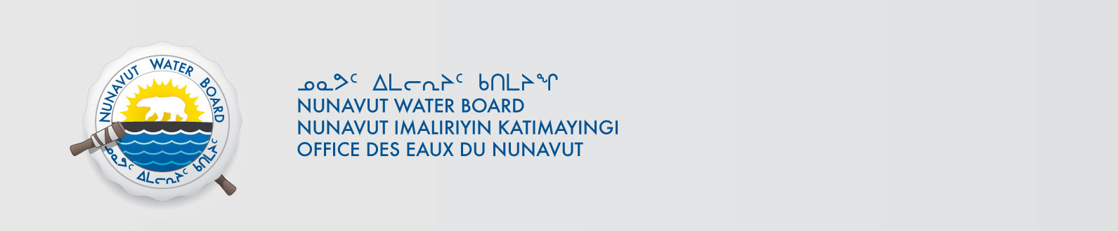
Margaret Mike, CIRNAC

