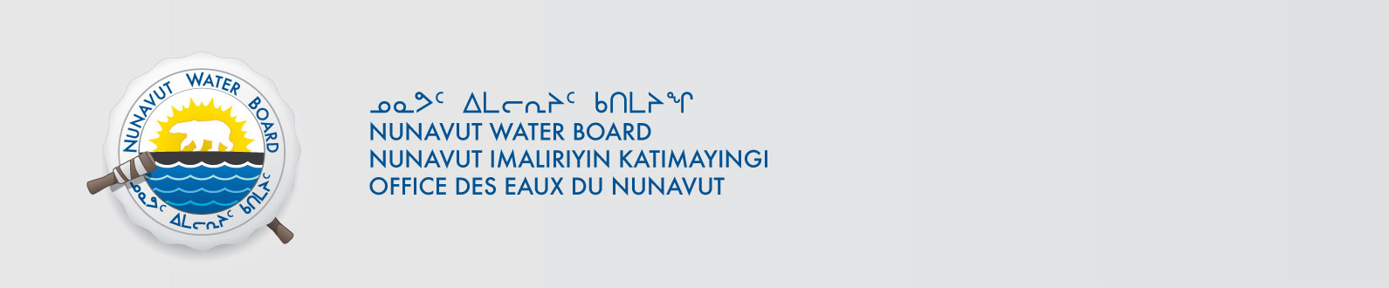

October 08, 2024 NWB File No: 8BW-LUP1924

Kenny Ruptal | Frazer Bourchier
Nahanni Construction Ltd. | Lupin Mines Incorporated
100 Nahanni Drive | c/o Mandalay Resources Corp.
Yellowknife NT | Suite 3720 – 155 University Avenue
X1A 2P6 | Toronto, ON M5H 3B7
E-mail : Kenny@nahannincl.com | f.bourchier@mandalayresources.com

Re: Assignment of Water Licence 8BW-LUP1924

On October 4, 2024 the Nunavut Water Board (NWB) received an application from Nahanni Construction Ltd. for the assignment of 8BW-LUP1924 to Lupin Mines Incorporated.

This application is subject to applicable provisions of Article 13 of the Agreement Between the Inuit of the Nunavut Settlement Area and Her Majesty the Queen in Right of Canada (Nunavut Agreement). Accordingly, the NWB is required to give public notice of the application before approving it.

Documents pertaining to the assignment are available through the internet on our ftp site. We also ask that the Assignee/Assignor make available to the public, upon request and free of charge, copies of documents pertaining to this application.

The Nunavut Water Board is accepting written concerns and comments with regard to this application on or before 5:00 pm MT on October 24, 2024.

Sincerely,

Richard Dwyer

Copy Kitikmeot Region Distribution List

