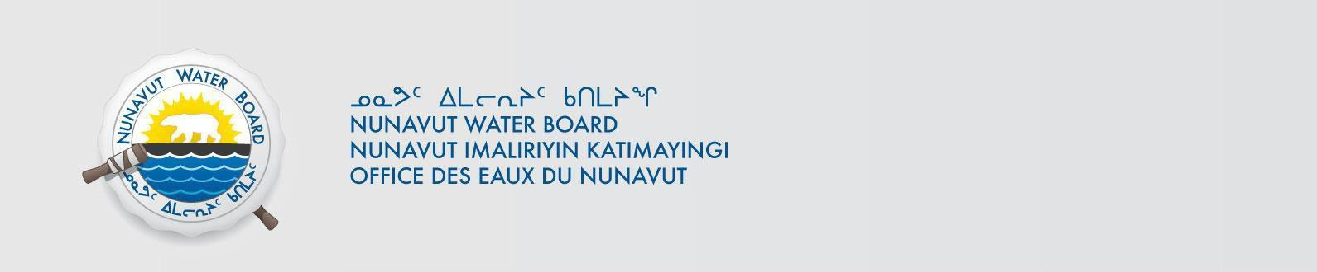

INUNGNUT TUHAQHIT NUTAMUN TUKHIRAUT Nahanni Construction Nanminilgit
Malikhugit Nakataani 55(1) tapkunani Nunavut Imait tamnalu Nunavut Nunap Qangani
Piyungnautiliriyit Apiqhuiyiralaat Piquyat (“Piquyat”), tuhaqhittiyut tapkuat Nahanni Construction Nanminilgit tunihiyut tamatkiumayunik tukhiraut talvani Aktuupa 9, 2019 nutamun imaqmun laisakhaq tapkununga Nunavut Imaliriyit Katimayit (“Imaliriyit”)
atuqnianut imaq iqaqnilu iqakut imaqnut tapkununga havanguyut:

Titiqat Nappaa: Inaa:
8BW-LUP----
Lupin Ukiumi Tikilaruta

Ungalaata Pinganaani -
111.23415939
Nigiata Akinnaani -
109.719437488

65.779171217
65.030828286

Pityuta: Nutaq
Qanurittunia: “B”

Tuhaumayumayut inungnut hatqiqtitiquyauyut talvani hivuaniluniit Nuvipa 12, 2019
talvunga: Maniyauyuq Laisaliqutinut
Nunavut Imaliriyit Katimayit
Titiraqaqvia 119, Uqhuqtuuq, Nunavut X0B 1J0
Hivayauta: (867) 360-6338; Faxkut: (867) 360-6369
Qaritauyakkut: licensing@nwb-oen.ca

Ayyikkutai tamaita tukhirautit titiqat piyaulat aktuayauyunit piqatauyut, akiittumik, atuqlugu qaritauyakkut talvani ftp qaritauyakkuviptingni maliklugu atatyuta:
ftp://ftp.nwb-oen.ca/registry/8%20MISCELLANEOUS/8B/8BW%20-%20Watercourse/8BW-LUP----
%20Nahanni%20Construction%20Ltd/1%20APPLICATION/2019/
uvaluniit turaqlugu:
Kenny Raptush, Nahanni Construction Nanminilgit
Hivayauta: (867) 873-2975
Qaritauyakkut: kenny@nahannincl.com

Kiungitpat uumunga Tuhaqhit Tukhirautmun qangiqtitnagu taihimayuq pivikha tammaityutauniaq pilarutmik utiqviuniq, malikhugit Nakataini 58 tikitlugu 61 tapkunani Piquyat.

Current date October 18, 2019

