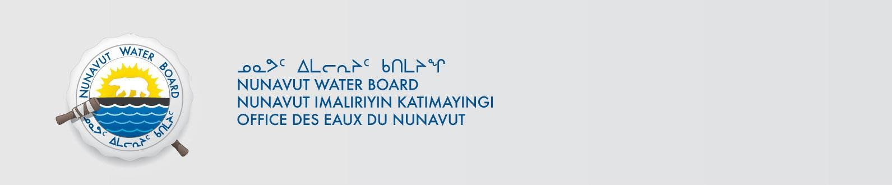

File No: 8BW-LUP----

October 18, 2019

To: Local Organizations – Request to Post Notices

The Nunavut Water Board requests that you post on a bulletin board, until November 12, 2019, the attached notice (in English and Inuinaqtun), where they can be viewed by the public. The attached letter is for your information only and does not require posting.

Your time and effort is greatly appreciated.

Sincerely,

Kayla Carter
Licence Administrator

Cc: CLARC & KIA – Kugluktuk (867) 982-3311
Mayor of Kugluktuk |  | (867) 982-6505
HTO – Kugluktuk |  | (867) 982-5912
Hamlet of Kugluktuk |  | (867) 982-3060
Northern Store |  | (867) 982-3607
Kugluktuk Co-op |  | (867) 982-3070

