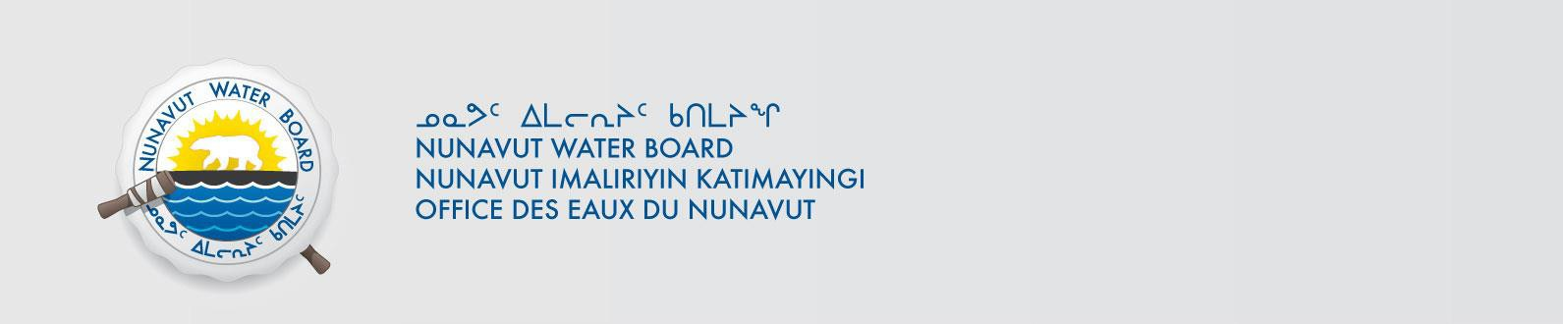

PUBLIC NOTICE OF NEW APPLICATION Nahanni Construction Ltd.
Pursuant to Section 55(1) of the Nunavut Waters and Nunavut Surface Rights Tribunal Act
(“Act”), notice is given that Nahanni Construction Ltd. filed a complete application on October 9, 2019 for a new water licence to the Nunavut Water Board (“NWB”) to use water or deposit of waste into water for the following project:

File #: Project: | 8BW-LUP----  Lupin Winter Access
Location:
 | NW -111.23415939  SE -109.719437488 | 65.779171217  65.030828286
Purpose: | New
Type: | “B”

Interested persons are invited to make representations on or before November 12, 2019
to: Manager of Licensing
Nunavut Water Board
P.O. Box 119, Gjoa Haven, Nunavut X0B 1J0
Phone: (867) 360-6338; Fax: (867) 360-6369; E-mail: licensing@nwb-oen.ca

Copies of all application documents may be obtained by affected parties, free of charge, through the internet on our ftp site at the following link:
ftp://ftp.nwb-oen.ca/registry/8%20MISCELLANEOUS/8B/8BW%20-%20Watercourse/8BW-LUP----%20Nahanni%20Construction%20Ltd/1%20APPLICATION/2019/
or by contacting:
Kenny Raptush, Nahanni Construction Ltd. Phone: (867) 873-2975
E-mail: kenny@nahannincl.com

Failure to respond to this Notice of Application within the specified period shall result in the loss of the right to be compensated, pursuant to Sections 58 to 61 of the Act.

Current date October 18, 2019

