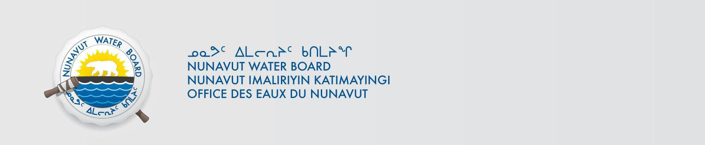

PUBLIC NOTICE OF RENEWAL APPLICATION
Lupin Mines Incorporated
Pursuant to Section 55(1) of the Nunavut Waters and Nunavut Surface Rights Tribunal Act (“Act”), notice is given that Lupin Mines Incorporated. filed a complete application for water licence renewal to the Nunavut Water Board (“NWB”) to use water or deposit of waste into water for the following project:

File #: | 8BW-LUP1924
Project: Location: | Lupin Winter Access Decimal Degree Format  NW -111.234159398 | 65.779171217
 | SE -109.719437488 | 65.030828286
Purpose: | Renewal
Type: | “B”

Interested persons are invited to make representations on or before November 19, 2024 to: Manager of Licensing
Nunavut Water Board
P.O. Box 119, Gjoa Haven, Nunavut X0B 1J0 Phone: (867) 360-6338; Fax: (867) 360-6369; E-mail: licensing@nwb-oen.ca

Copies of all application documents may be obtained by affected parties, free of charge, through the internet on our ftp site at the following link:

ftp://ftp.nwb-oen.ca/registry/8%20MISCELLANEOUS/8B/8BW%20-%20Watercourse/8BW-LUP1924%20Lupin%20Mines%20Incorporated/1%20APPLICATION/2024%20Renewal

or by contacting:
Kellie Leedham, Falkirk Environmental Consultants Ltd.
Phone: (403) 808-1534
E-mail: Kellie@falkirk.ca

Failure to respond to this Notice of Application within the specified period shall result in the loss of the right to be compensated, pursuant to Sections 58 to 61 of the Act.

CURRENT DATE: OCTOBER 29, 2024

