Spill Response Plan
WORK PLAN
Tower Arctic LTD.

Contract Number: | 15255-00331-07
Project Number: | 15255-00331
Tower Arctic Number: | 21807
Document Number: | TA-21807-WP-0003
Submitted From: | Tower Arctic LTD.
Submitted To: | Government of Nunavut, Advisian
Date Submitted: | June 15th, 2018

Contents
1. INTRODUCTION 3
2. PEOPLE RESPONSIBLE 3
3. COMMUNICATION PATTERNS 5
4. INVENTORY OF HAZARDOUS MATERIALS STORED ON SITE 5
5. GENREAL CONTINGENCY PLAN 6
6. OTHER MEASURES 8
7. CONCLUSION AND RECOMMENDATIONS 9

INTRODUCTION

This document is a general contingency plan in case of accidental spill of hazardous materials in the environment. This document is presented as part of the Pond Inlet Marine Infrastructure, by the company Tower Arctic LTD.
This document demonstrates the organization that structures the environmental procedures that Tower Arctic LTD. will execute in case of an accidental spill of hazardous material happens in the environment.

PEOPLE RESPONSIBLE

Manager of the environment for Tower Arctic on site:
SUPERINTENDENT
MR. MARTIN DESCHESNES
Cell : 581-996-7254

PROJECT DIRECTOR / PROJECT MANAGER :
MR. SIMON GOULET Eng. / SIMON BROCHU Eng.
T : 418-872-0600 # 3068
Cell : 418-955-3068 / 418-563-1128

COMMUNICATION PATTERNS

The communication patterns are shown in appendix A and will be posted in the following area:
    - In all Tower Arctic office trailers

INVENTORY OF HAZARDOUS MATERIALS STORED ON SITE

The layout of hazardous materials is submitted in the appendix C:
- Storage tank 500 liters (diesel fuel)
- Support for gas bottle (acetylene, oxygen, propane)
- Various types of hydrocarbons (oil, grease)

GENREAL CONTINGENCY PLAN

For Tower Arctic LTD, the speed of operations is the key element in this plan which ensures an effective response from different mobilized resources on site when an accidental spill happens. For this reason, the activities executed during an operation must be coordinated while respecting the following pattern as much as possible:
FIRST STEP
As soon as an accidental spill of a hazardous material in the environment is reported.
Tower Arctic LTD. will proceed with the following:
- Control the leak
Quickly locate the contaminant source
If possible, immediately neutralize the leak
Evaluate amount of damage on site
- Confinement of spilled product (Minimize the risk of contamination)
Put up barriers to reduce spread of spilled material by laying down socks, pads or absorbent aggregate. The locations of the spill kits are shown on the sketch in appendix D, this drawing is also posted in our office trailers.
Protect sensitive areas such as watercourses, water well sources, catch basins, and wildlife habitats.

- Inform the people responsible
Describe the incident to the superintendent and/or the project manager and fully collaborate with the participants. Inform the responsible on which type of hazardous material were currently spilled on site, the amount released, the source of the leak, the area affected and the immediate action taken to solve the situation.

SECOND STEP
1. Recover hazardous and residual materials
Recover the spilled material manually or mechanically as the case may be.
Haul the hazardous and residual material to the specific container
Dispose of the hazardous material as per the law and good practice.
2. File the Environmental Report / Investigation Report
Copy the report provided in appendix B.
A copy of the report will be provided to Government of Nunavut and a spill log will follow and be discussed.
Proof of hazardous waste disposal will be issued at Government of Nunavut.

OTHER MEASURES

- Towers Arctic LTD. will ensure that the cleaning of the area will be carried out as per the law. The transport and disposal of the recovered hazardous waste will be carried out by a specialized company.
- If necessary, a company specialized in the disposal of hazardous waste will be contacted as soon as possible. Coordination and follow up of their operations will be ensured on site to enable a fast execution.

- If necessary, recommendations from PWGSC or opinions of specialists from the Ministry of Environment Canada will be considered.

CONCLUSION AND RECOMMENDATIONS

This document has been presented to you to show the structure that Tower Arctic LTD. will put in place if an accidental spill in the environment occurs during this project.

An emergency structure and communication pattern will be developed in order to ensure a guick and efficient response during an environmental incident.
(see Appendix A)

APPENDIX A

EMERGENCY STRUCTURE
AND
COMMUNICATION PATTERN

APPENDIX B

REPORT FOR ACCIDENTAL SPILL

Spill Report
Location: |  |  |  |  |  |  |  | Report Date: (DD/MM/YYYY)
Reported by:
Party Responsible:
Date of Spill: (DD/MM/YYYY) |  |  |  |  |  |  | Time of Spill: AM PM
Material Spilled: |  |  |  |  |  |  | Estimated Quantity:
Cause of Spill:
Is Spill: | Terminated |  |  |  | Continuing |  |  |  | No Containment required
Weather conditions anticipated during clean-up operations:
Briefly describe what was affected by the spill/release (identify surface areas, where practical to do so:
Briefly describe measures/actions taken to control spill/release (include equipment, materials, etc.):
Action Taken to Contain, Cleanup or Dispose:
Assistance required? |  |  |  |  |  | Yes |  |  |  | No
If yes, Indicate manpower and equipment:
Did the spill affect:
Sewers/drainage system |  | Yes | No | Waterways |  | Yes |  | No | Parkland | Yes | No
Public access to any  location |  | Yes | No | Private  property |  | Yes |  | No | Wildlife | Yes | No
Other(explain):
Who was notified:
Submit a copy of this document within 24 hours along with the EBC/Northec accident report.
For Spills Exceeding 100 litres in size please inform the Safety Department Immediately

APPENDIX C

LAYOUT PLAN _ HAZARDOUS MATERIALS

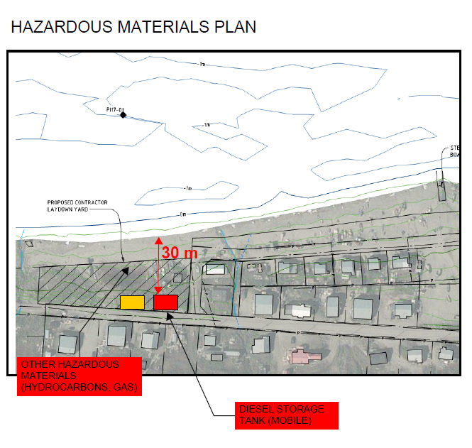

APPENDIX D

LAYOUT PLAN _ SPILL KITS

