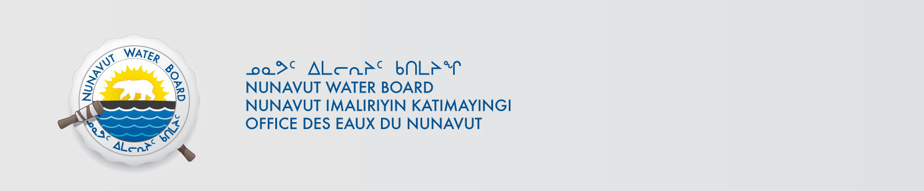

October 27, 2025 NWB File No: 8WLC-ACC----

Michelle Blade
PhD Candidate
McGill University
Unit 210, 4104 Road to Nowhere
Iqaluit, NU, X0A2H0
Phone: (867) 333-0903
E-mail: michelle.blade@mail.mcgill.ca

Re: Acknowledgement and Receipt of Application Fee for your Application for Approval Without Licence – Assessing changing cryohydrogeologic conditions with locally-relevant landscape indicators in Nunavut, Canada Project.

Dear Ms. Blade:

The Nunavut Water Board acknowledges receipt on October 27, 2025 of your Credit Card information for an application fee for the above project. Your information for payment has been forwarded to Crown Indigenous Relations and Northern Affairs Canada in Iqaluit for processing. A receipt will be issued through their office for fees totaling $30.00.

Please call the undersigned at (867) 360-6338 or e-mail licensing@nwb-oen.ca if you have any questions.

Sincerely,

Original signed by:

Robert Hunter
Licensing Administrator

Cc: Andrew Keim, CIRNAC

Margaret Mike, CIRNAC

