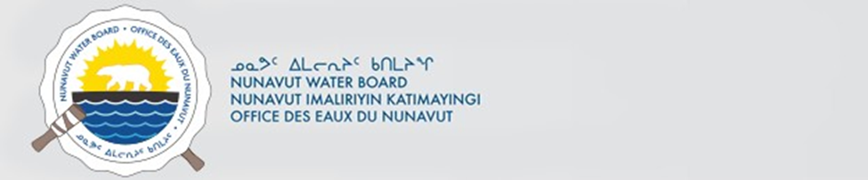

April 22, 2026 NWB File No: 8WLC-CBA2627

Melissa Lafreniere
Dept Geography and Planning MC D208
Queen’s University
Kingston, ON K7L 3N6

E-mail: melissa.lafreniere@queensu.ca

Re: Application Fee Payment 8WLC-CBA2526

Dear Melissa Lafreniere:

The Nunavut Water Board acknowledges receipt on April 22, 2026 of your Visa information for water use fee payment. Your information for payment has been forwarded to Crown Indigenous Relations and Northern Affairs Canada in Iqaluit for processing. A receipt will be issued through their office for fees totaling $30.00 for payment of:

- Application Fee $30.00

Please call the undersigned at (867) 360-6338 or e-mail licensing@nwb-oen.ca if you have any questions.

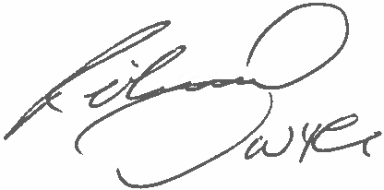
Sincerely,
Richard Dwyer

Cc: Margaret Mike, CIRNAC Andrew Keim, CIRNAC CIRNA Inspectors



