Summary report, 8WLC-CBA2324

Date: January 06,2024
Prepared by: Samuel Poirier. M.Sc. Student, Department of Geography and Planning, Queen’s University, Kingston, ON, K7L 3N6, 506-650-9077, samuel.poirier@queensu.ca
and
Melissa Lafreniere, Professor, Department of Geography and Planning, Queen’s University, Kingston, ON, K7L 3N6, 613-533-6000 x78720, melissa.lafreniere@queensu.ca

Activity began: May 27, 2024
Activity ended: July 30th, 2024

All activities proceeded as planned. No fuel spills occurred during camp activity. The camp was closed on July 30th, 2024, with all garbage and empty fuel containers removed to Resolute.
Water consumption:
Photos of water logbook can be seen below. An error in record taking was made and consumption was marked under grey water, a table has been made to show the correct values indicating the correct consumption. Sources of water vary through the season with water being taken from East Lake and West Lake from May 27 – June 7th, and West River the rest of the season.
Total consumption: May 27th-July 30th: 1699L
Estimated grey water disposal in sump pit (filled at the end)
An error in the recording of grey water production was also made, from June 19th to July 30th daily grey water production was estimated based on per capita production from May 27th to June 18th.
May 27th-July 30th: 1365 L
Fuel storage as of July 30th, 2024:
Propane, 100 lb Qty 10
Propane, 25 lb Qty 7
Gasoline, 2x 200L Drum and 4 x j20L Jerry can (stored on spill containment behind tents)
Motor and skidoo oil, 4 X 1 L (stored in tent on spill containment)
Jet Fuel 3x200L Drum (stored on spill containment in front of tents)
Camp was left clean and all materials left secured in tents or in durable outside containers. Field camp inspection occurred in early July.

Table Of Water Log with Values in the Correct Columns
Date | Source | Volume (L) | Waste Type | Volume | People in Camp
27-May | West Lake | 60 | Grey | 4 | 4
28-May |  |  | Grey | 10 | 4
29-May | East Lake | 60 | Grey | 12 | 4
30-May | West Lake | 20 | Grey | 16 | 4
31-May |  |  | Grey | 12 | 4
01-Jun | West Lake | 60 | Grey | 18 | 4
02-Jun |  |  | Grey | 14 | 4
03-Jun | East Lake | 80 | Grey | 60 | 4
04-Jun |  |  | Grey | 45 | 5
05-Jun |  |  | Grey | 12 | 5
06-Jun |  |  | Grey | 14 | 5
07-Jun | East Lake | 80 | Grey | 12 | 5
08-Jun | Catchment | 3 | Grey | 13 | 5
09-Jun | Catchment | 3 | Grey | 14 | 5
10-Jun | West River | 23 | Grey | 14 | 5
11-Jun | Catchment | 3 | Grey | 18 | 5
12-Jun | Catchment | 3 | Grey | 12 | 5
13-Jun | West River | 23 | Grey | 12 | 5
14-Jun | Catchment | 3 | Grey | 16 | 5
15-Jun | West River | 46 | Grey | 16 | 5
16-Jun | Catchment | 3 | Grey | 12 | 5
17-Jun | West River | 43 | Grey | 13 | 5
18-Jun | Catchment | 3 | Grey | 14 | 5
19-Jun | West River | 43 | Grey | 18 | 5
20-Jun | Catchment | 3 | Grey | 18 | 5
21-Jun | West River | 43 | Grey | 18 | 5
22-Jun | Catchment | 3 | Grey | 18 | 5
23-Jun | West River | 63 | Grey | 18 | 5
24-Jun | Catchment | 3 | Grey | 18 | 5
25-Jun | Catchment | 3 | Grey | 18 | 5
26-Jun | West River | 36 | Grey | 18 | 5
27-Jun | West River | 46 | Grey | 18 | 5
28-Jun |  |  | Grey | 18 | 5
29-Jun |  |  | Grey | 18 | 5
30-Jun |  |  | Grey | 18 | 5
01-Jul | West River | 60 | Grey | 18 | 5
02-Jul |  |  | Grey | 18 | 5
03-Jul |  |  | Grey | 18 | 5
04-Jul | West River | 40 | Grey | 18 | 5
05-Jul | West River | 40 | Grey | 18 | 5
06-Jul | West River | 20 | Grey | 28.8 | 8
07-Jul | West River | 40 | Grey | 28.8 | 8
08-Jul |  |  | Grey | 28.8 | 8
09-Jul | West River | 40 | Grey | 28.8 | 8
10-Jul | West River | 40 | Grey | 28.8 | 8
11-Jul | West River | 100 | Grey | 28.8 | 8
12-Jul |  |  | Grey | 28.8 | 8
13-Jul | West River | 40 | Grey | 28.8 | 8
14-Jul | West River | 40 | Grey | 28.8 | 8
15-Jul | West River | 40 | Grey | 28.8 | 8
16-Jul | West River | 40 | Grey | 28.8 | 8
17-Jul | West River | 60 | Grey | 28.8 | 8
18-Jul | West River | 40 | Grey | 28.8 | 8
19-Jul | West River | 20 | Grey | 28.8 | 8
20-Jul |  |  | Grey | 28.8 | 8
21-Jul |  |  | Grey | 28.8 | 8
22-Jul | West River | 40 | Grey | 28.8 | 8
23-Jul | West River | 40 | Grey | 28.8 | 8
24-Jul | West River | 40 | Grey | 28.8 | 8
25-Jul | West River | 40 | Grey | 28.8 | 8
26-Jul |  |  | Grey | 28.8 | 8
27-Jul | West River | 40 | Grey | 28.8 | 8
28-Jul | West River | 40 | Grey | 21.6 | 6
29-Jul | West River | 40 | Grey | 21.6 | 6
 | Total Consumed | 1699 | Total Grey | 1365.8

Photos of Camp Logbook
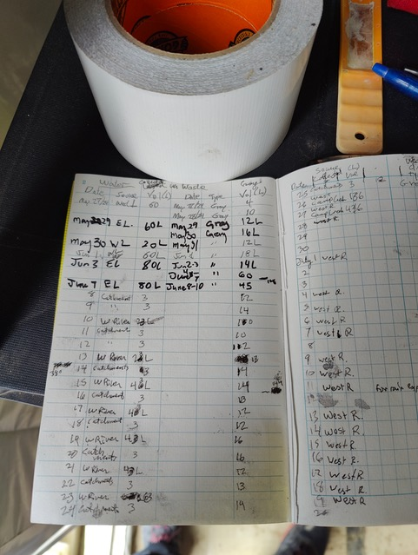
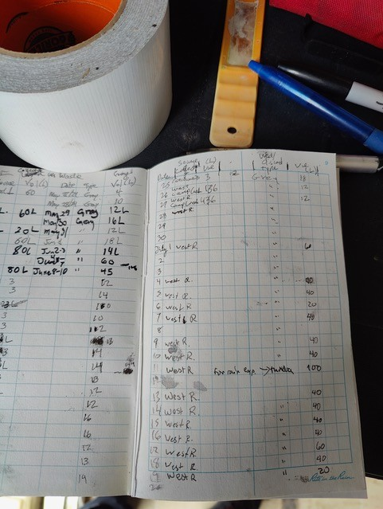
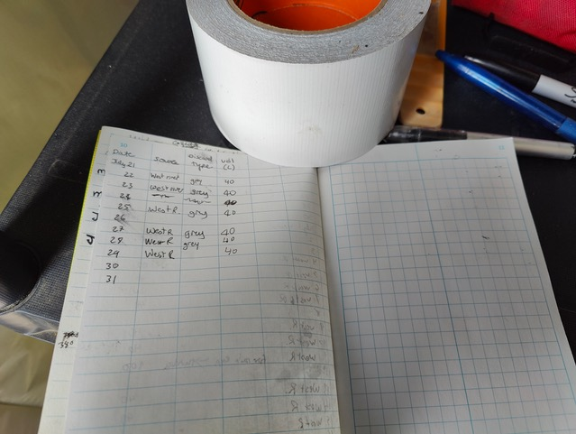
Close up of photo above that illustrates some of the volumes recorded on our log sheets (.e.g. July 26, 20L, July 26 11 L, … etc.)

