Summary report, 8WLC-CBA2526

Date: April 10, 2026
Prepared by: Melissa Lafreniere, Professor, Department of Geography and Planning, Queen’s University, Kingston, ON, K7L 3N6, 613-533-6000 x78720, melissa.lafreniere@queensu.ca
Activity began: July 11th, 2025
Activity ended: August 9, 2025

All activities proceeded as planned. No fuel spills occurred during camp activity. The camp was closed on August 9th, 2025, with all garbage and empty fuel containers removed to Resolute.
Water consumption:
Photos of water logbook can be seen below. The water source for 2025 was soley the West River, as camp was established after the streams were flowing.
Total comsumption: 1699L
Estimated grey water disposal in sump pit (filled at the end)
An error in the recording of grey water production was also made, from June 19th to July 30th daily grey water production was estimated based on per capita production from May 27th to June 18th.
May 27th-July 30th: 1365 L
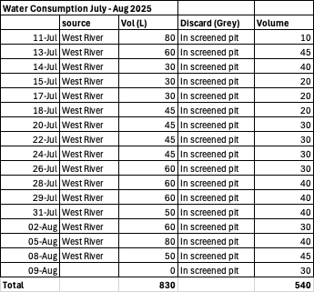

Fuel storage as of Aug 9, 2025:
Propane, 100 lb 11Qty
Propane, 25 lb Qty 10
Gasoline, 2 x 200L Drum + 1 Drum with ~30-L remaining (stored on spill containment)
Motor and skidoo oil, 4 X 1 L (stored in tent on spill containment)
Jet Fuel 6x200L Drum (stored on spill containment in front of tents) (PCSP)
Camp was left clean and all materials left secured in tents or in durable outside containers.
All fuel was in fuel containment.

Photos of Camp Logbook
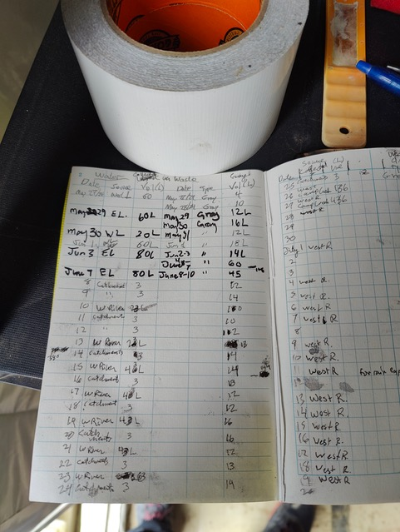
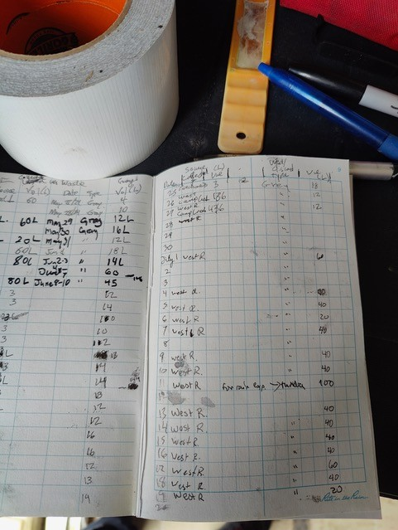
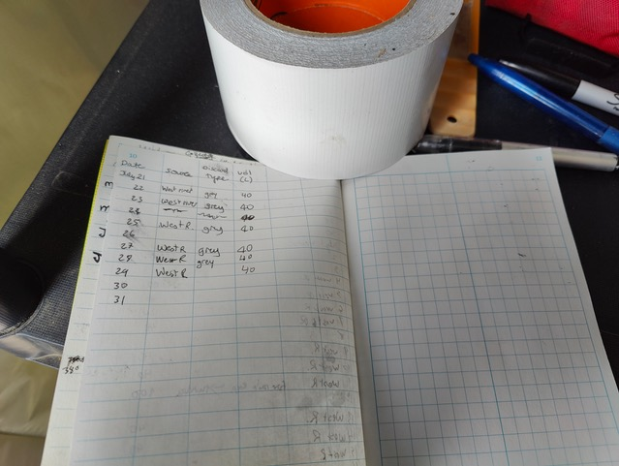
Close up of photo above that illustrates some of the volumes recorded on our log sheets (.e.g. July 26, 20L, July 26 11 L, … etc.)

