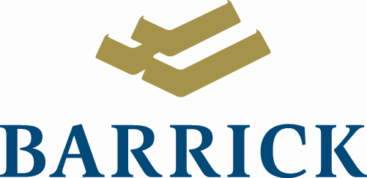
Barrick Gold Corporation
Brookfield Place, Canada Trust Tower
Suite 3700, 161 Bay Street
P.O. Box 212
Toronto, Ontario M5J 2S1
Tel: (416) 861-9911
Fax: (416) 861-2492

5-July-2018

RE: Application for approval for the use of water or deposit waste without a license

To the NWB Licensing Manager

Please find enclosed an Application for approval for the use of water or deposit waste without a license relating to a helicopter support field reconnaissance trip to the Cullaton & Griffin Lake areas.

Project Description

The proposed project is an outcome of some regional scale geological work we have been doing looking at the mineral prospectivity of the Western Canadian Shield. The Cullaton/Griffin lake area was highlighted from this study.

Having identified the ground as geologically interesting the next step is to get into the field and confirm our interpretations by looking at the rocks on the ground, this is the purpose of the August Field visit.

The plan is to setup a lightweight temporary four-person campsite on the existing Barrick tenements, near the existing core storage facility at the Cullaton Lake mine site. We are aiming to be on site there for ten days this August and the work we undertake will involve review of the existing drill core at the mine site and using a helicopter to enable field visits to outcropping rocks to understand the geology. The field work component would involve taking surface rock chip samples but no systematic exploration or ground disturbance. Water use will be for camp needs and washing and the only waste generated will be greywater and sewage.

Nicolas Rosengren

Principal Geologist
Global Project Generation
Global Exploration
Barrick Gold
+1 647 283 4097

