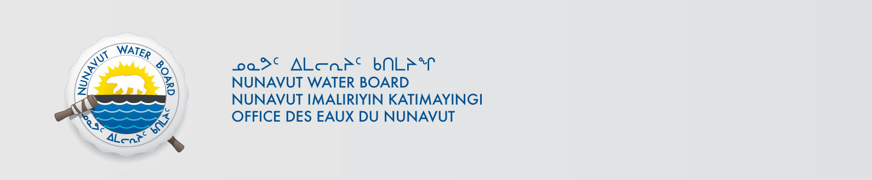

June 24, 2013 File No: 8WLC-EMG----

Marie-Claude Williamson
Research Scientist
Natural Resources Canada
Geological Survey of Canada
Email: mwilliam@nrcan.gc.ca

Subject: 8WLC-EMG----, Environmental Mineralogy and Geochemistry, South Fiord, Axel Heiberg Island, Nunavut, Application for Approval for the Use of Water or Deposit of Waste Without a Licence

Dear Ms. Williamson:

The Nunavut Water Board (NWB or Board) acknowledges receipt on May 29, 2013 of your application for approval for the use of water or deposit of waste without a licence for the above project and confirms that the Application has been deemed administratively complete by the NWB Licensing Department.

The Application has been assigned NWB File Number 8WLC-EMG---- and posted to the NWB’s Public Registry and FTP site and is accessible from the following link: ftp://nunavutwaterboard.org/1%20PRUC/8%20MISCELLANEOUS/8WL/8WLC%20-%20Camp/8WLC-EMG----%20NRCan/ , username is public and password is registry.

Your Application has been forwarded to the NWB Technical Department for a technical assessment. As part of the NWB’s technical assessment you may be contacted to provide additional information. If you are not contacted to provide additional information you may expect a decision on the application within approximately fifteen (15) working days, from the date of this letter.

Sincerely,

Original signed by:

Robin Ikkutisluk
Licence Administrator Assistant

/ri

Cc: Dave Hohnstein – DTS
Cory Zyla - TA

