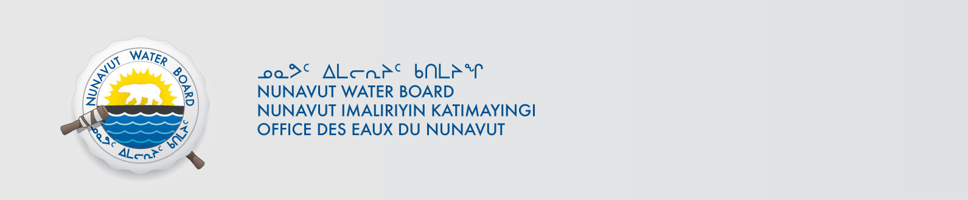
March 24, 2015 File No: 8WLC-ENN----

Aziz Kheraj
994458 Nunavut Limited
1 Main Street
P.O. Box 300
Resolute Bay, NU X0A 0V0
Email: azizkheraj@qiniq.com

Subject: 8WLC-ENN----, Arctic Haven Lodge - Application for Approval for the Use of Water or Deposit of Waste Without a Licence

Dear Aziz:

The Nunavut Water Board (NWB or Board) acknowledges receipt on March 10, 2015 of your application for approval for the use of water or deposit of waste without a licence for the above project and confirms that the Application has been deemed administratively complete by the NWB Licensing Department.

The Application has been assigned NWB File Number 8WLC-ENN----and posted to the NWB’s Public Registry and FTP site and is accessible from the following link: ftp://ftp.nwb-oen.ca/1%20PRUC%20PUBLIC%20REGISTRY/8%20MISCELLANEOUS/8WL/8WLC%20-%20Camp/ username is public and password is registry.

Your Application has been forwarded to the NWB Technical Department for a technical assessment. As part of the NWB’s technical assessment you may be contacted to provide additional information. If you are not contacted to provide additional information you may expect a decision on the application within approximately fifteen (15) working days, from the date of this letter.

Sincerely,

Phyllis Beaulieu
Manager of Licensing

PB/pb

Cc: Dave Hohnstein – DTS
Brady MacCarl - TA

