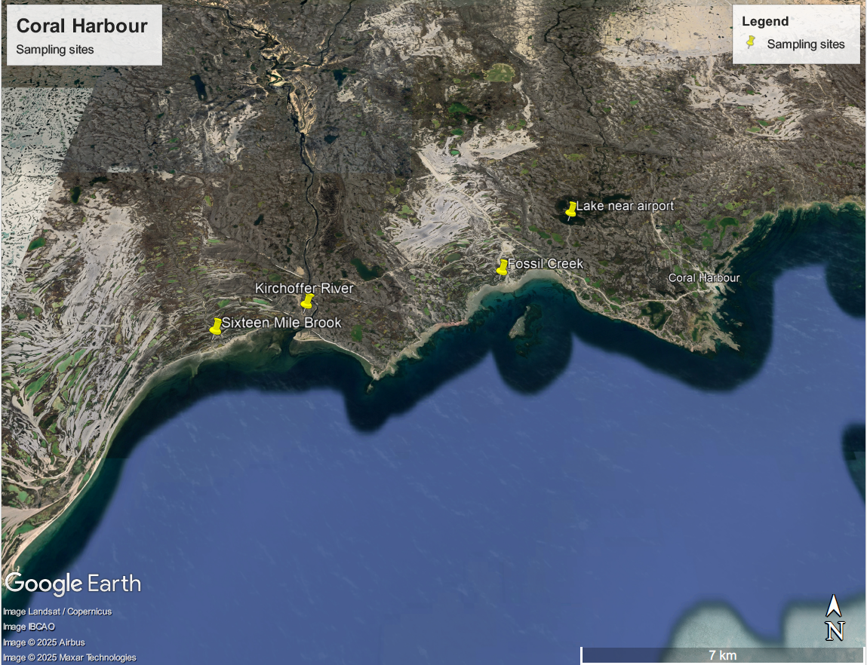
Figure 1. Coral Harbour sampling sites
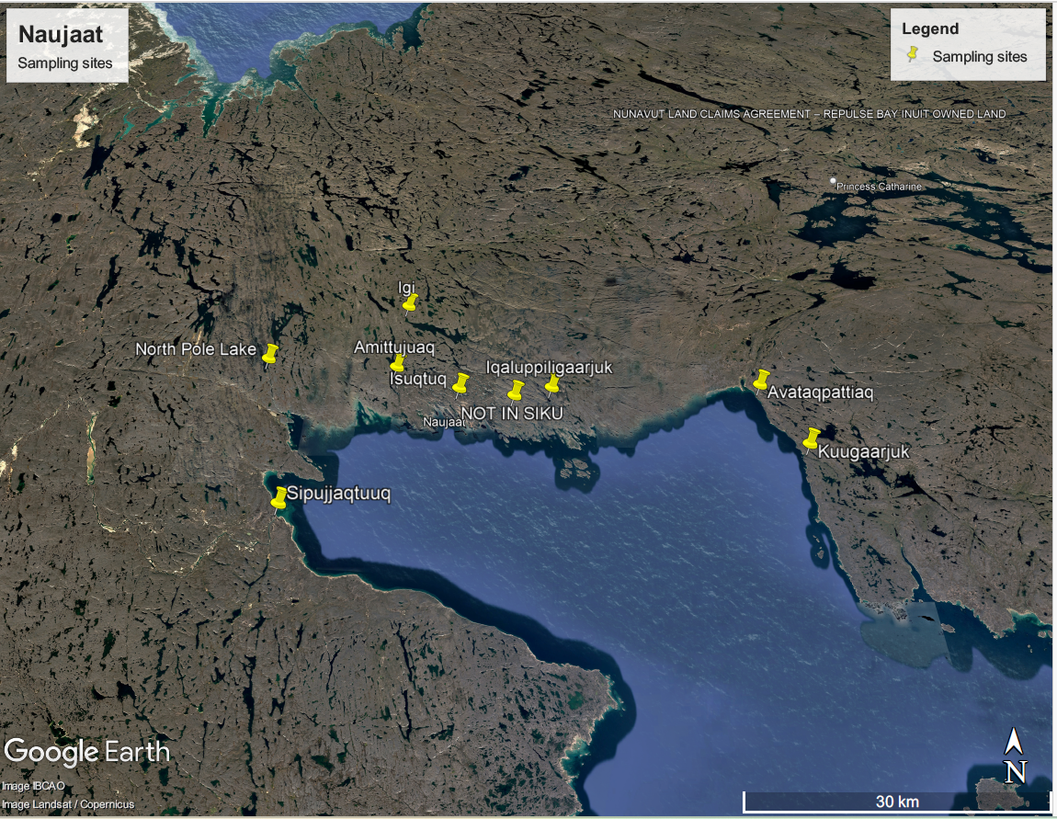
Figure 2. Naujaat sampling sites.

