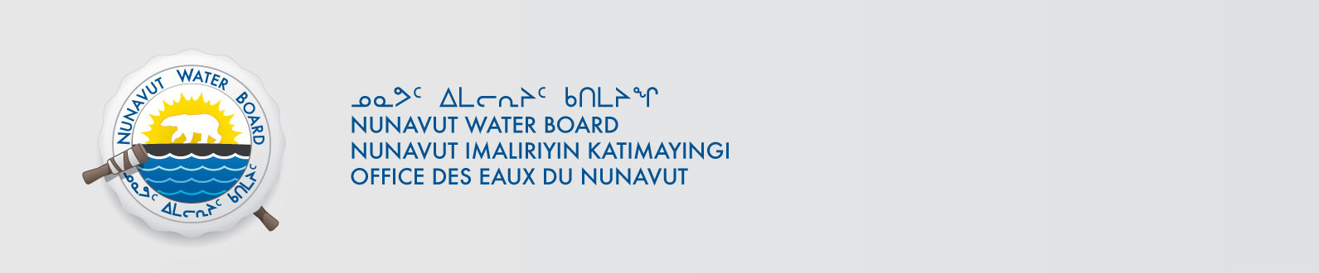

February 26, 2014 File No: 8WLC-LAE----
Dr. John Smol Emily Stewart
Department of Biology Department of Biology
Queen’s University Queen’s University
Kingston, ON K7L 3N6 Kingston, ON K7L 3N6
Email: smolj@queensu.ca email: em.stewart16@queensu.ca

Subject: 8WLC-LAE----, Limnology and Aquatic Ecology of High Arctic Lakes and Ponds Project, Application for Approval for the Use of Water or Deposit of Waste Without a Licence

Dear Dr. Smol and Ms. Stewart:

The Nunavut Water Board (NWB or Board) acknowledges receipt on February 14, 2014 of your application for approval for the use of water or deposit of waste without a licence for the above project and confirms that the Application has been deemed administratively complete by the NWB Licensing Department.

The Application has been assigned NWB File Number 8WLC-LAE---- and posted to the NWB’s Public Registry and FTP site and is accessible from the following link ftp://nunavutwaterboard.org/1%20PRUC/8%20MISCELLANEOUS/8WL/8WLC%20-%20Camp/ , username is public and password is registry.

Your Application has been forwarded to the NWB Technical Department for a technical assessment. As part of the NWB’s technical assessment you may be contacted to provide additional information. If you are not contacted to provide additional information you may expect a decision on the application within approximately fifteen (15) working days, from the date of this letter.

Sincerely,

Original signed by:

Phyllis Beaulieu
Manager of Licensing

/pb

Cc: Dave Hohnstein – DTS
Sonia Aredes - TA

