Richard Dwyer
Manager of Licensing
Nunavut Water Board
Re: Application for approval of the use of water or deposit of waste without a licence
Dear Richard Dwyer,
I am part of a team that is requesting to come to the Canadian High Arctic Research Station (CHARS) in May and August 2025 to conduct research within the Iqaluktuuttiaq (Cambridge Bay) area for a project titled “Assessing the ecological risk associated with critical mineral extraction and low-sulfur fuels in Northern ecosystems”.
Our research aims to improve understanding of Arctic organisms' sensitivity to two types of toxicants: metal contaminants (copper, zinc, cobalt, nickel, and lithium) and oil-related chemicals (including perfluoroalkyl and polyfluoroalkyl substances (PFAS) and other substances from low-sulfur fuels). To do this, we will conduct toxicity studies at CHARS using organisms collected from the sea ice within the Cambridge Bay area (in May) and freshwater from Granier Lake (in August).
To allow us to complete our research, we will require using small quantities of water for our laboratory work. Water will be collected from our sampling sites (saltwater from the sea ice area in Cambridge Bay and freshwater from Grainier Lake) to use for our toxicity studies. We will also be using small quantities of deionised/filtered water from the laboratory facilities at CHARS for related research activities such as equipment cleaning. We estimate that no more than 24.2 litres of water will be used per day across the 65 combined days in the area (<1567 litres across all research activities), resulting in <681 litres of greywater/wastewater.
All experiments will be safely contained within CHARS laboratories, and water used in tests will be treated before disposal to remove harmful substances. Different cleaning methods, such as biochar filtration, chelating resins, and activated charcoal, will remove metals and chemicals, ensuring that no potentially harmful contaminants are released into the environment during the research project.
Thank you in advance for assessing our application.
Sincerely,
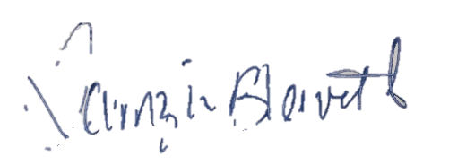
Tamzin Blewett
On behalf of the research team

