Fuel Management Plan
Background Information
Project Title: Mapping Pearya Terrane
Proponent
Thomas Hadlari
Natural Resources Canada
3303 33 Street Northwest, 2nd Floor, Room. 239
Calgary, AB
Canada T2L 2A7
Telephone: (403) 292-7018
E-mail: thomas.hadlari@nrcan-rncan.gc.ca
Time Horizon
Proposed Start Date: 10 July 2024
Proposed Completion Date: 1 August 2024
Positioning is planned for late June or early July 2024 by fixed-wing aircraft. Removal of empties and unused fuel will be carried out air at the end of the field season (August/September) of 2024. Empty fuel drums (Jet-A) will be shipped to a proper disposal site.
1.2 Purpose and Scope
The primary objective of this Fuel Management Plan (FMP) is to provide straightforward procedures for the storage and handling of fuels for the purpose of reducing the risk of environmental contamination and to ensure the health and safety of all personnel from the accidental release of petroleum products. The FMP includes the following:
▪ Promote safe handling and use of all types of fuel;
▪ Reduce the likelihood of spills of all types of fuel;
▪ Identify responsibilities and procedures for all staff and contractors;
▪ Provide site specific information about the facilities and contingencies in place;
▪ Comply with federal and territorial government regulations and guidelines pertaining to
transportation, storage, handling and disposal of any type of fuel

Other Plans
The Fuel Management Plan should be considered within the context of overall regulatory systems, including the Nunavut Planning Commission and Nunavut Impact Review Board. All operations will conform to conditions annexed to and forming part of CIRNAC land use permit number n2024n0009.
Licencing and permitting received or in progress for this project include:

Permit | Permit No./ID | Date of Issue
NPC Conformity Check | NPC 150179 | 1 December 2023
NIRB Screening | 23YN074 | 28 March 2024
Nunavut Research Institute (NRI) | Scientific Research License 02 021 24N-A | 10 April 2024
Nunavut Water Board (NWB) |  | In progress
Parks Canada Permit |  | In progress
CIRNAC Class A permit | Land Use Permit # N2024N0009 | 17 April 2024
Nunavut Dept. of Culture Elders, Language and Youth (Paleontology Research permit Category: Class 2) |  | In progress
Qikiqtani Inuit Association (QIA) Application for Access to Inuit Owned Land |  | In progress

Legislative Requirements
Applicable acts, regulations, and legislation that relate to the storage, handling, and transport of fuel are presented in the following:
Federal
▪ Canadian Centre for Occupational Health and Safety Act
▪ Hazardous Products Act
▪ Canadian Environmental Protection Act
▪ Fisheries Act
▪ Nunavut Waters and Nunavut Surface Rights Tribunal Act
▪ Transportation of Dangerous Goods Act
▪ National Fire Code of Canada
▪ Northern Land Use Guidelines
▪ Workplace Hazardous Materials Information System (“WHMIS”)

Territorial
▪ Fire Prevention Act
▪ Environmental Protection Act
▪ Safety Act
▪ Nunavut Occupational Health and Safety Regulations
▪ Environmental Guideline for the General Management of Hazardous Waste
▪ Contingency planning and spill reporting in Nunavut
▪ A Guide to Spill Contingency Planning & Reporting

Brief Summary of the Project Description
The Geological Survey of Canada is undertaking a mapping and assessment project of Canada’s north under the GEM-GeoNorth program to increase geologic knowledge for future natural resource exploration, better informed land use, balanced conservation, and responsible resource development.
The proposed research project “Mapping Pearya Terrane”, (Fig. 1) in collaboration with German federal Institute for Geosciences (BGR), is a continuation of a long-term study of the geological history of the Canadian Arctic Islands. Through sampling at faults, researchers are looking to model how the ancient continents collided to form the modern Arctic Archipelago. Sampling for metal content of black shales would help researchers to learn more about the initial presence and subsequent movement of naturally occurring metals as a consequence of modern climate change. This project would also produce modernized and updated bedrock maps of northern Ellesmere Island.
The research team, led by Dr. Thomas Hadlari, Geological Survey of Canada (NRCan), plans to setup a camp at Yelverton Inlet for approximately 2 weeks (stage 1), in early July 2024, with no more than 9 personnel on site. We hope to employ the services and expertise of a wildlife monitor from Grise Fiord. There will be a 40-drum fuel cache for a helicopter. We would use the helicopter for daily transportation to rock outcrop sites. A second stage of 1 week would be based at the Eureka weather station, and similarly visiting sites by helicopter. There is no drilling or blasting. A Eurocopter AS350 Écureuil with a fuel consumption of approximately 180 litres of Jet A aviation fuel per hour, will be used throughout the duration of the field work.

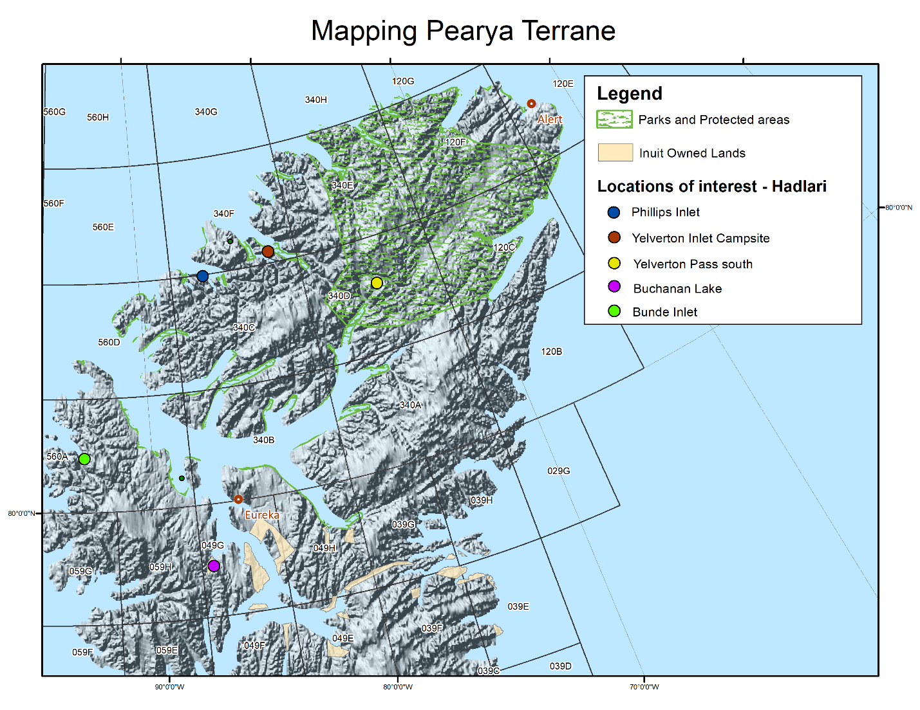
Figure 1. The areas of the proposed research activity. The fuel cache will be located on federal crown land.
Environmental Policy
There could be potential impacts associated with storing fuel on the land. In the case of a spill, the contaminated soil will be removed by shovel and a bucket of contaminated soil will be removed from site for proper disposal. If large spill occurs, CIRNAC inspectors will be advised. The crew will take photographs and coordinates of the spill site. A detailed Fuel Management Plan is outlined below. Other environmental impacts are largely from the use of a helicopter, mainly noise. To decrease stress on animals, we will follow the recommended altitude for aircraft by the Government of Nunavut of 610 meters during point-to-point travel. In addition, we will provide a wide birth to any animals spotted, including migratory birds. The field camp, 9 persons or less, will also impact the environment with the use of water and the production of waste. We will have safety protocols in place for predatory wildlife.
Project Location
Location of fuel cache and campsite (approximate): 81°50’15” W 82°6’24” N
Project Extents (degrees minutes seconds format)
NW 75°4’40” W 83°8’10” N
NE 74°36’51” W 80°51’1” N
SE 86°58’6” W 79°8’23” N
SW 100°15’54” W 80°56’16” N

NTS map sheets: 49G, 340C, 340D, 340F, 560A
Fuel Inventory
Identification of Petroleum Products and Allied Petroleum Products
Jet A helicopter fuel: 40 x 205 litres
Propane: 2 x 20 lb tanks
Storage, Containment and Fuel Transfer
There are currently 60 drums of fuel stored at the Eureka weather station. Forty drums will be shifted from Eureka to a cache near the campsite at Yelverton Inlet (Fig. 1). A fuel drum holds about 205 litres (44 Imperial/55 U.S.) of Jet A fuel. Positioning is planned for late June or early July 2024 by fixed-wing aircraft. Removal of empties and unused fuel will be carried out air at the end of the field season (August/September) of 2024. Empty fuel drums (Jet-A) will be shipped to a proper disposal site.
Jet A fuel will be stored in lined steel drums stored in a 20’x30’x12” plastic berm with a capacity of 4,888 USG. Manual and electric pumps will be used for the transfer of petroleum products. Smoking, sparks, or open flames are prohibited in fuel storage and re-fueling areas at all times. A spill kit will be placed with clear signage in all areas of fuel storage and re-fueling. Daily visual inspections will be conducted to identify any damaged or leaking containers. In the event that a leak is discovered, the substance will either be used immediately or transferred
to an undamaged container
Propane cylinders are equipped with a pressure release valve that opens and closes to prevent a buildup of excessive internal pressure. Labels, showing data such as date of manufacture and re-testing dates, are affixed to the collar of the cylinders. Propane is nontoxic and will not contaminate soil; therefore, secondary containment berms are not required for storage. All propane cylinders will be secured for safety and stored away from any sources of ignition.
All members of the field team will have available a copy of the Spill Prevention and Response Plan, Appendix A, below. All team members will be directed to take action based on the instructions outlined in the plan. Digital and paper copies of the NT-NU Spill Report form for oil, gasoline, chemicals and other hazardous materials will be available in camp.

Appendix A Spill Prevention and Response Plan
Initial Action in the Event of a Fuel Spill
In the event that a fuel spill has occurred, below is a list of procedures and suggested course of action of the first person on the scene who has detected a problem.
- Be alert and consider your safety first. If possible, identify the product spilled;
- Assess the hazards to persons in the vicinity of the spill and alert or take appropriate evacuation measures if needed (e.g., eliminate sources of ignition);
- If possible, control danger to human life;
- Assess whether the spill can be readily stopped or brought under control;
- If safe to do so, and if possible, try to stop the flow of material (e.g., stop fuelling, shut off valve (if present), manoeuvring a leaking drum);
- Gather information on the status of the situation;
- Report the spill without delay to the spill response person/team affiliated with the project and ensure that where applicable the government is notified at the same time according to via the 24 Hour Spill Report Line for Nunavut
Nunavut and NWT 24-hour Spill Report Line
Phone (867) 920-8130
Fax (867) 873- 6924
- Resume any effective action to contain, clean up, or stop the flow of spilled material.
Procedure
The person who first discovers a fuel spill should follow the procedures set out in the ‘Initial Action’ section (above) of this document.
If the spill is not easily contained and/or cleaned up by the person who first discovers it, then that person will immediately report the incident to Stephen Day at Natural Resources Canada (contact information provided above under Initial Action). Together the situation will be reassessed, and effective actions will be carried out in order to contain, clean up, and stop the flow of the spillage.
Procedure for Spills on Snow
By its nature, snow is an absorbent, and fuel spilled on snow is collected with relative ease,
either by shovel, in the case of small-range spills, or other means in the case of more
extensive spills.
- The person who first discovers a fuel spill should follow the procedures set out in
the ‘Initial Action’ section of this document.
- Assess the nature of the spill. Necessary equipment might include shovels, plastic tarp(s), and empty drums.
- Shovel or scrape contaminated snow and deposit in empty refuge drums. If the spill is more extensive, build compacted-snow berms with plastic over top, around the affected area.
4. Either during or immediately after the incident, notify the 24-Hour Spill Line.
5. Receive instructions on the preferred disposal method (e.g., storage in empty drums, incineration, or deposit in an appropriately placed area.
Procedures for Spills on Ice
Spills on ice are handled in a similar fashion as those on snow. However, as ice presents the
added danger of immediate access to water, care must be taken to respond quickly to such
spills. Should fuel seep or flow through cracks or breaks in the ice, despite all precautions,
assistance should be sought immediately.
- The person who first discovers a fuel spill should follow the procedures set out in the ‘Initial Action’ section of this document.
2. Construct a compacted-snow berm around the edge of the spill area.
3. Although hard ice will retard or prevent fuel entry to the receiving waters below, all contaminated snow and ice, as well as objects embedded in the ice (such as gravel) must be scraped from the ice surface and disposed of in an appropriate manner.
4. Contact the 24-Hour Spill Line.
5. Receive instructions on the preferred disposal method (e.g., storage in empty drums,
incineration or deposit in an appropriately placed area.
Preventive Measures
While response plans are necessary in the event a fuel spill occurs, all involved with fuel handling and storage should strive to take all necessary feasible precautions to ensure fuel spills do not occur. To minimize the risk of a fuel spill many preventative measures and standard operating procedures should be implemented. Some key preventive measures include:
- All fuel will be stored and transported in approved sealed containers.
- No fuel storage containers will be placed within 31m of the ordinary high-water mark of any water body.
- No fuelling or servicing of equipment will be done within 31m of a water body, except where it is impractical due to the size or use of the equipment (e.g., refuelling a small boat, ski work on sea ice). Any portable fuel storage not in use will be placed a minimum of 31m from the ordinary high water mark of any water body.
- Precautions will be taken in the transportation and handling of fuels to prevent contamination of soil or water.
- Fuel storage areas and equipment will be inspected regularly to detect leaks and overall condition. Leaks will be repaired immediately.
- Those refuelling will be trained on proper fuelling procedures (e.g., uses of drip pans, proper drum storage) and equipment (e.g., hand and electric transfer pumps, filter units, spill kits).
Drum Storage
When a fuel cache is established, it is assumed that the drums will be stored onsite, with minimal human presence for the majority of the storage time. Therefore, drums should be stored in a manner to minimize possible accidents or leaks. Drums can be stored either upright or on their side.
Upright storage:
Fuel drums should be stored canted or tilted slightly to keep water from covering bungs or stored with a canvas cover on the top tier. This will minimize water infiltrating the drums and altering fuel quality. Where ground subsidence or settling is expected to occur, fuel drums should be stored on wooden pallets, or using other means of stabilizing the base.
Horizontal storage:
Fuel drums should be stored on their side, with bungs at the 3 o’clock and 9 o’clock positions, and with bungs seals immersed in fuel. Proper support may also be required beneath the first tier of drums to ensure the drums do not settle into the soil. Also, where drums are stored on their side, blocks or spikes should be used to prevent them from rolling, displacing drums stored in higher tiers.
Transferring Fuel
Fuel transfers are often the primary causes of fuel contamination, thus all individuals involved with refuelling should undertake reasonable measures to ensure that fuel transfers are done properly to avoid spills and contamination. To minimize the risks of fuel contamination during a fuelling event all persons should be trained and aware of the following:
- Safe operation of the equipment they use;
- Operation of emergency controls;
- Procedures to be followed in the event of a fuel spill or leak and in response to an emergency condition.

Nunavut Telephone Numbers
Nunavut 24 hour Spill Line
(867) 920-8130
Department of the Environment (Nunavut)
(867) 975-5900
12.7 Emergency Contacts
Director
David Mate
Director, GSC - Northern Division, LMS/GSC/GSC-NC
Natural Resources Canada
601 Booth Street, 3rd Floor, Room. 367
Ottawa, ON
Canada K1A 0E8
Telephone: (343) 548-5542
Fax : (613) 998-8103
Program Manager
Véronique Séguin
GEM-GeoNorth Program Coordinator
Natural Resources Canada
601 Booth Street, 2nd Floor, Room. 239
Ottawa, ON
Canada K1A 0E8
Telephone: (819) 431-8454
E-mail: veronique.seguin@nrcan-rncan.gc.ca
Project Manager
Dr. Danny Wright
Sub-Division Head, LMS/GSC/GSC-NC/NEH/EAU
Natural Resources Canada
601 Booth Street, 3rd Floor, Room. 375
Ottawa, ON
Canada K1A 0E8
Telephone: (613) 947-8760
E-mail: danny.wright@nrcan-rncan.gc.ca
Project Officer
Martin W. McCurdy
GEM-GEONorth Project Officer
Natural Resources Canada
601 Booth Street, 2nd Floor, Room. 279
Ottawa, ON
Canada K1A 0E8
Telephone: (613) 859-5835
E-mail: martin.mccurdy@nrcan-rncan.gc.ca

