ARCTIC GOOSE BANDING IN CANADA
Project Summary

Applicant Name and Contact Information
Frank Baldwin
Aquatic Unit, Canadian Wildlife Service, January 2023
Frank.Baldwin@ec.gc.ca
204-430-6416

Number of Personnel/Visitors to be covered under MBS Permit
Up to 30 people (5 sites, up to 6 personnel per site).

Project Objectives
The Arctic Goose Banding Program is the primary means of monitoring the status of arctic-nesting geese, and involves banding of Lesser Snow Geese, Ross’ Geese, White-fronted Geese, Cackling Geese and Brant at several concentration areas in the Canadian arctic (Figure 1). Long term banding of arctic geese takes advantage of information provided by hundreds of thousands of North American waterfowl hunters who report band numbers from marked birds that they harvest, providing detailed information not only about population dynamics and distribution of these species, but also factors that influence those patterns. When used in combination with harvest survey data, band recoveries can be used to estimate population size via Lincoln’s method, and this technique is especially appropriate for such large, remote, and geographically widespread populations. As knowledge of arctic goose populations has increased over time, efforts have been made to consolidate and improve the efficiency of arctic goose banding programs, with the aim of providing representative banding of all species of arctic geese in the most efficient way possible. Cost sharing among more than 30 partner agencies from the United States and Canada ensures a stable source of funding with which to maintain this important monitoring function for 5 species (7 populations; including greater snow geese and western arctic snow geese not covered in this proposal) of arctic geese that nest in Canada. Past detailed evaluations of arctic goose populations have shown that banding data can provide comprehensive information about population status, as well as factors influencing population dynamics of these species. Information derived from banded individuals is the basis for decision-making outlined in all arctic goose management plans in the Atlantic, Mississippi, and Central Flyways.

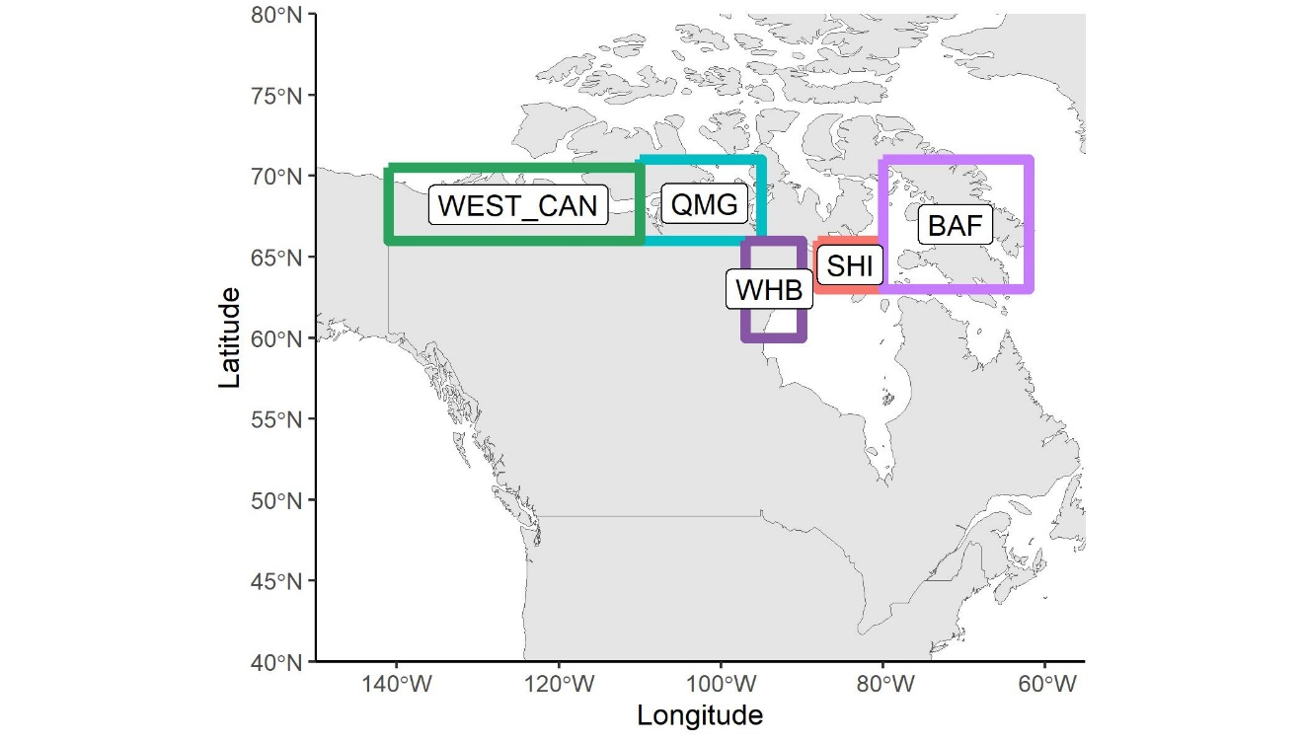
Figure 1. Regions of the Canadian arctic where arctic goose banding has historically occured. WEST-CAN=Western Canadian Arctic, QMG=Queen Maud Gulf, Central Arctic (includes Perry River), SHI=Southampton Island, BAF=Baffin Island).

The main parameters derived from the banding program are survival and harvest rates, harvest distribution, measures of productivity, and estimates of population size. This information is used to monitor trends, and to evaluate and predict impacts of management actions on the populations. The recommended frequency for banding is annual to maintain a continuous dataset for estimating parameters with reasonable precision. Long term maintenance of banding programs is preferred to periodic banding efforts for several reasons: (1) lower annual sample sizes can deliver better precision than can short term programs with much higher sample size requirements, (2) establishment and maintenance of banding sites requires maintenance of infrastructure to support banding efforts (e.g., fuel storage, field camps, field equipment) in order to reduce costs over the long term, (3) maintenance of partnership funding is more reliable for ongoing monitoring programs than for costlier short term efforts, (4) increasing experience and familiarity with long term sites leads to improved safety and efficiency. In addition, some species of arctic geese have undergone, and are undergoing, significant changes in distribution in response to changes in agricultural and other land use on migration and wintering areas, increasing the need for continuous monitoring. There would be substantial risks to management, conservation and partnerships if this program was eliminated or reduced, because there are few reliable alternatives for monitoring these important species.

Project Location
Ahiak Migratory Bird Sanctuary, NU (67.683, -102.166)
Dates: 2023-07-08 to 2023-07-18
Midcontinent white-fronted and cackling geese are banded in the Queen Maud Gulf region from about 7-15 July each year. The crew is based out of the field camp at Perry River, NU. Access to the camp is by twin otter (mud landing strip) and helicopter. Cackling geese are generally captured incidental to white-fronted geese, but weather permitting, future efforts will be made to increase the number of cackling geese banded. Historically, lesser snow and Ross’s geese were also banded in this area, but due to lack of light geese in close proximity to the Perry River camp, light goose banding efforts in 2023 will focus on the Anderson Bay area (~25 miles south-east of Cambridge Bay).

Qaqsauqtuuq and Ikkattuaq Migratory Bird Sanctuaries (64.196, -83.358)
Dates: 2023-07-19 to 2023-07-30
Banding on Southampton Island is typically conducted from 20-28 July each summer, basing out of Coral Harbour, NU. All work is done using a Bell 206 LR on fixed floats, based out of the community of Coral Harbour. Species targeted include Atlantic Brant, and snow/Ross’s/cackling geese.

Kuugaarjuk Migratory Bird Sanctuary, NU (61.109, -94.062)
Dates: 2023-08-01 to 2023-08-7
Banding at West Hudson Bay is proposed to occur from 1-7 August each year, basing out of Arviat, NU. This effort is part of a community-based monitoring program initiated by the Aqqiumavvik Society, working closely with individuals from Ujjiqsuiniq. In spring 2022, a virtual banding workshop was held by CWS with members from both organizations. Some individuals have been previously involved in CWS banding and goose research in the area during the period 2003-2006, highlighting local capacity existing within the community. All-terrain vehicles will be used to locate and herd groups of flightless geese,. Travel will be along the tidal flats, or on established trails, as per guidance from community members . CWS has committed to support this community-based program through provision of several experienced banders and assistance with logistics and some permitting.

Isulijarnik Migratory Bird Sanctuary, NU (66.562, -71.353)
Dates: 2023-08-01 to 2023-08-10
Banding at southwest Baffin Island is typically conducted from 1-10 August each year, and is based out of the field camp on Nikko Island, in the Koukjuak River. The camp is accessed by twin otter (gravel landing strip) and helicopter. All banding is done using a Bell 206 LR on fixed floats. Species targeted include Atlantic Brant, and snow/Ross’s/cackling geese.

Summary of Activities and Rationale
The arctic goose banding program is the primary means of monitoring the status of arctic-nesting geese, and involves representative banding of Lesser Snow Geese, Ross’ Geese, White-fronted Geese, Cackling Geese and Brant at several concentration areas in the Canadian arctic. Almost all banding occurs on federal Migratory Bird Sanctuaries, and multiple species are banded at each site to improve efficiency. All species are are hunted annually throughout North America, therefore managers require up-to-date information on harvest and survival rates, productivity, harvest distribution, and in some cases, population trends. Banding data are used in the regulation setting process for every species of arctic-nesting goose, and are the main monitoring components in international harvest management plans. Banding data is used to evaluate the effects of regulatory changes on these parameters, as well as to target regulatory changes in specific areas where they are intended to have the most effect (i.e., often in areas where harvest pressure is most intense for the species in question).
Consolidation and better coordination of banding efforts began in the early 2000s, and gradual changes to site-specific banding targets have resulted in better representation of all species in arctic banding totals. The Arctic Banding Program continues to adapt, as changes in distributions of some populations occurs. The addition of new partners, and cost-sharing among many agencies provides a stable and efficient means for monitoring arctic goose populations, and maintains a long-term database essential for understanding changes in productivity, survival and harvest rates, harvest distribution, migration chronology, and population size. Importantly, the program provides a means for evaluating regulatory changes, and satisfies data requirements specified in management plans. Proposed annual banding targets for the Arctic Goose Banding Program for 2024-2028 are included below (Table 1):

Table 1. Proposed sample size targets are arctic goose banding sites supported by CWS for 2024-2028.

Location | Site Lead | Species | Banding target
Southampton Island, NU | CWS, AU | Atlantic brant | 1000
 |  | Cackling geese | 1000
 |  | Ross's geese | 500
 |  | Lesser snow geese | 1500
Baffin Island, NU | CWS, AU | Atlantic brant | 500
 |  | Cackling geese | 1500
 |  | Ross's geese | 500
 |  | Lesser snow geese | 3000
Queen Maud Gulf (Perry River), NU | CWS, AU | White-fronted geese | 1500
 |  | Cackling geese | 500
Victoria Island, NU | CWS, AU | Lesser snow geese | 3000
 |  | Ross's geese | 3000
West Hudson Bay, NU | CWS, AU  Aqqiumavvik Society | Lesser snow geese  Cackling geese | 2000  1500
 | CWS, AU  Aqqiumavvik Society | Ross’s Geese | 1000

Measures to Avoid Dangerous Wildlife Encounters
Polar and grizzly bears are avoided whenever possible. Most work involves aircraft, and before landing, personnel perform a scan of the surrounding habitat to check for bears. Firearms and bear bangers are carried while conducting all field work. All personnel are trained in bear safety and are proficient/licenced in use and possession of firearms. Accumulation clutter is minimized at Research Stations and garbage is incinerated regularly (and stored in closed buildings until incinerated, if required) to avoid attacting bears. Cabins are winterized with nail boards covering windows and doors to minimize potential for bear damage, and food is stored in bear-proof containers.

Community Consultation and Involvement
We have consulted and engaged with the ACMCs and local HTOs over the duration of the project, dating back to the 1990s. Since that time, the monitoring objectives of the program have remain unchanged. The most recent meetings occurred in March 2023 (Ahiak- Cambridge Bay), February 2023 (Coral Harbour), and June 2022 (Arviat). Our last communication with Cape Dorset HTO was in 2019. Community members (primarily from Arviat and Coral Harbour) have participated in this project, providing assistance in a variety of field activities, including banding. We have consulted with Nunavut Department of the Environment for the purpose of obtaining wildlife research permits. We support a variety of local service and supply companies in Cambridge Bay, Coral Harbour, Arviat, and Iqaluit.

Future Plans
The Arctic Goose Banding Program is a long-term monitoring initiative, supported by more than 30 wildlife agencies in Canada and the USA. It is the primary means of monitoring arctic nesting geese, and thus banding is expected to continue annually into the foreseeable future.

