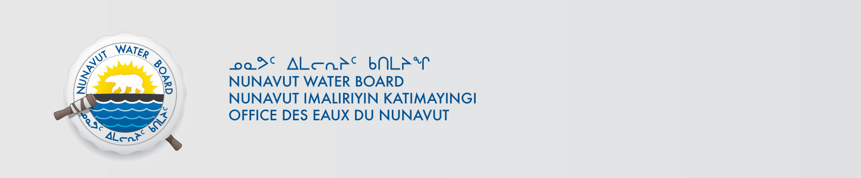

May 11, 2016 File No: 8WLC-OPN----
Captain Andrew Ngo
Northern Coordinator
P.O Box 10500 Station Forces
Edmonton, AB T5J 4J5
Andrew.ngo@forces.gc.ca

Subject: 8WLC-OPN----, Kivalliq Region, Operation Nanook 2016, Incomplete Application for Approval for the Use of Water or Deposit of Waste Without a Licence

Dear Joint Task Forces North, Captain Andrew Ngo:

The Nunavut Water Board (NWB or Board) acknowledges receipt on April 28, 2016 of your application for approval for the use of water or deposit of waste without a licence for Operation Nanook 2016. The NWB Licensing Department has conducted a preliminary review of your application and has determined that it is incomplete. The following information is deficient:

- Application Signed
- NPC Determination Conformity
- NIRB Screening Decision Report

In order to proceed the application must be completed, re-signed and re-submitted with the deficient information. Please reference the assigned file number on re-submission.

If you have any questions please contact myself at valerie.kogvek@nwb-oen.ca or the Technical Advisor, Sean Joseph sean.joseph@nwb-oen.ca
Sincerely,

Valerie Kogvek
Licensing Administrator
/vk

Cc: Dave Hohnstein – Director Technical Services
Sean Joseph – Tech Advisor

