Environment Canada’s Arctic Shorebird Research

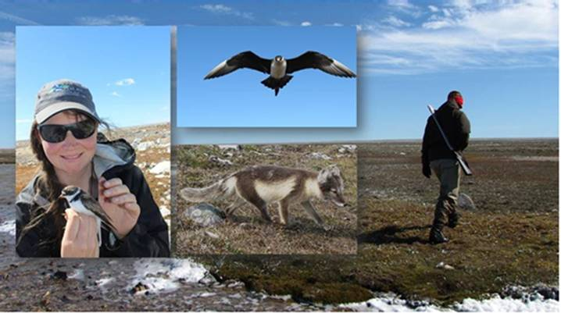

2014 Field Report on camps covered under Nunavut Water Board permits:
8WLC-PCO1415 and 8WLC-PCE1415

Project Overview
Many populations of shorebirds around the globe are declining. This is particularly true for the long-distance migrants who breed in the North America Arctic and migrate to wintering grounds in the Southern Hemisphere. At the same time, conditions in the Arctic are changing rapidly. Ice, weather and habitat are profoundly influenced by long-term shifts in climate. Contaminants transported over long-distances could be affecting tundra-breeding birds or their food webs in unknown ways. Changes in farming practices in the United States have supported dramatic increases in populations of arctic geese, and these now abundant geese are degrading coastal wetlands in some areas where they breed and stop over to refuel during migration. The extent of this degradation and how it might influence other wildlife is unknown.

Environment Canada seeks to understand the ways in which coastal tundra wetlands are changing, and how these changes influence bird populations. We are examining the factors that affect shorebird population variation and breeding success, and are trying to determine the degree to which changes in the North could be responsible for population declines of these species. Recently, our research has been particularly focussed on whether/how snow goose breeding colonies are affecting shorebird populations and nest success. By comparing shorebird breeding success in areas experiencing different degrees of pressure from snow goose colonies, we hope to quantify the effects of goose related changes in habitat structure and predation pressure on shorebird populations, and determine whether these factors play a role in the observed declines in shorebird numbers. In the coming years, we will expand this research to include other wetland birds such as Sabine’s Gulls and Arctic Terns.

Research Partnerships
Our research programs at East Bay and Coats Island are a combined effort of many people and organisations. Principle investigators in 2014 included Dr. Paul Smith, Jennie Rausch and Dr. Grant Gilchrist (Environment Canada), Dr. Erica Nol (Trent University), Dr. Mark Mallory (Acadia University), Dr. Oliver Love (University of Windsor), Dr. Stephen Brown (Manomet Center for Conservation Sciences), and Dr. Larry Niles (Conserve Wildlife Foundation of New Jersey). The project coordinators were Christine Eberl and Mike Janssen (Environment Canada). The project is integrated into various international initiatives such as The Arctic Shorebird Demographics Network (ASDN), the Program for Regional and International Shorebird Monitoring (PRISM), and the Arctic Goose Joint Venture (AGJV).

2014 Research Highlights
Fieldwork at Coats Island and East Bay involved finding and monitoring nests of shorebirds, capturing and banding adult shorebirds, collection of invertebrate specimens, and sampling of nest habitat/vegetation. Nests were located and monitored throughout the breeding season to track changes in the timing of breeding, monitor hatching success and determine the impacts of nest predators. Birds were banded with metal bands and some individuals were tagged with geolocators or VHF radio transmitters (nanotags) to determine migration routes, wintering locations and migratory behaviour. Sample sizes for nests and banded birds are outlined in Table 1.

Nest densities and nest success were low at the sites in 2014 in comparison to previous years, despite what appeared to be ideal weather conditions throughout the breeding season. Birds were late to arrive, and some of the latest arriving individuals appear to have not bred. Notably, Sabine’s Gulls and Arctic Terns returned to the typical locations of their colonies at East Bay but did not breed in 2014; this is the first time we have seen this in our 15 years of research at the site. This pattern of late arrival and poor breeding effort or success was seen at other sites in the Eastern Arctic, but the cause has not yet been determined.

Table 1. The number of nests found at our East Bay and Coats Island sites, the number of birds banded and the number of tracking devices deployed.
Research Site | Bird Species Studied | Nests Monitored | Birds Banded | Geo-locators Recovered | Tracking Devices Deployed
East Bay Mainland | Black-bellied Plover, American Golden-Plover, Dunlin, Red Phalarope, Ruddy Turnstone, White-rumped Sandpiper, Semipalmated Plover, Sabine’s Gull and Arctic Tern | 63 | 36 | 2 | 6 geologgers  10 nanotags
Coats Island | American Golden-Plover, Black-bellied Plover, Dunlin, Red Phalarope, Ruddy Turnstone, Semipalmated Sandpiper, Semipalmated Plover, White-rumped Sandpiper | 77 | 28 | 2 | 8 geologgers  29 nanotags

Preliminary Results
Shorebird Capture, Banding and Sampling
Work at each site occurs within an area of approximately 12km². Intensive surveys of birds were completed in six - 400m x 300m survey plots at Coats Island and East Bay, and these intensively surveyed plots will form the basis of a new index of breeding abundance at the sites, to be tracked for the long-term. Nest abundance was comparatively low at both sites in 2014 in comparison to previous years. In terms of nests found, the most abundant species at Coats Island was Semipalmated Sandpiper (30 nests), followed by Dunlin (11), and Red Phalarope (7). At East Bay, the most abundant species were White-rumped Sandpipers (19) and Black-bellied Plovers and Semipalmated Plovers (11 of each). Apparent nest success (n hatched/n found) was approximately 42% on Coats but less than 33% at East Bay. Samples including blood and feathers were collected for a variety of projects. For example, blood samples will be analysed to determine parasite loads, physiological conditions and “stress” levels of birds in areas degraded by geese versus intact areas, while feather samples will be analysed for stable isotope signatures in order to determine where birds overwintered. Tissue samples collected are summarised in Table 2.

Nest Vegetation
As part of the ongoing Ph.D. projects assessing the effects of overabundant geese on tundra-nesting shorebirds, vegetation surveys were conducted at all nest sites at both Coats Island and East Bay. Data from each camp location will be compared in order to determine the effect of goose grazing on shorebird nest-site selection.

Table 2. The shorebird tissue samples and tracking tag deployments collected at the Coats Island and East Bay field camps.

Sample  (Coats Island / East Bay) | American Golden-Plover | Black-bellied Plover | Dunlin | Red Phalarope | Ruddy Turnstone | Semipalmated Sandpiper | Semipalmated Plover | White rumped Sandpiper | Total
Total Banded | 8/2 | 1/5 | 6/1 | 5/4 | 7/1 | 1/0 | 0/7 | 0/16 | 28/36
Blood samples | 8/2 | 1/5 | 6/1 | 3/4 | 7/1 | 13/0 | 0/7 | 0/16 | 39/36
Primary Coverts | 0/0 | 0/0 | 0/0 | 0/0 | 0/0 | 25/0 | 0/0 | 0/0 | 25/0
Geolocators | 8/0 | 0/5 | 0/0 | 0/0 | 0/1 | 0/0 | 0/0 | 0/0 | 8/6
Nanotags | 0/0 | 0/2 | 0/0 | 0/0 | 0/0 | 29/0 | 0/0 | 0/8 | 29/10

Goose Damage Assessments
In 2014, we tested a protocol developed by Dr. Ken Abraham and collaborators in Canadian Wildlife Service, to measure the extent of goose grazing. These goose damage assessments were conducted in each primary habitat type at our Coats Island and East Bay sites, to determine the extent of goose-induced habitat degradation. Briefly, these assessments consisted of walking 2 -100m strip transects along which the dominant cover type was recorded at each metre mark, and the height, stage of florescence and presence of goose-grazing was recorded every ten metres. We conducted more than 70 such assessments at the two sites, and also at sites spread across Southampton Island, accessed by helicopter in late June. Building on the successes of 2014, a revised version of this protocol will be applied at sites across the North American Arctic in 2015.

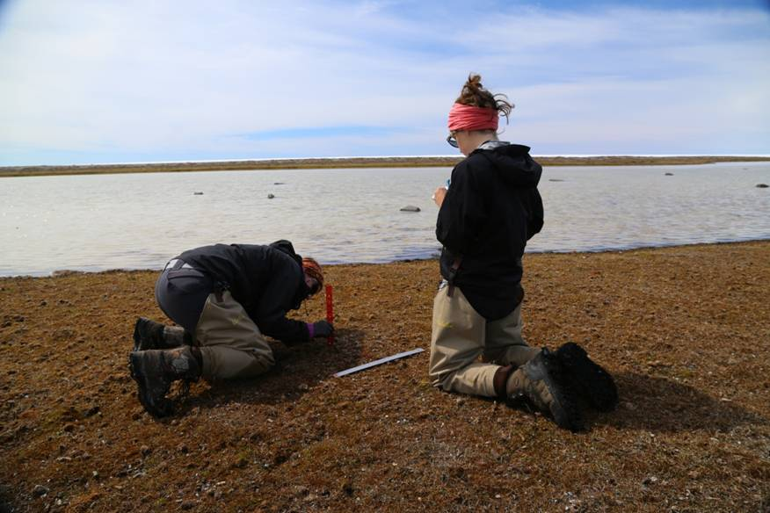

Figure 1. Lisa Kennedy and Emma Davis measure the height of vegetation within the snow goose breeding colony at East Bay. We carried out assessments of habitat damage at sites distributed across Southampton Island in 2014.

Effects of Habitat Change on Aquatic Ecosystems
Ponds and wetlands are a ubiquitous feature of coastal arctic tundra. The habitat changes wrought by geese grazing in terrestrial habitats have the potential to influence aquatic ecosystems as well. Working with Weston Postdoctoral Fellow Dr. Heather Mariash, we initiated a study in 2014 to examine whether geese are altering the flow of nutrients through these systems, and whether communities of aquatic invertebrates (prey for other bird species) are affected. Analyses are still underway, and on the basis of preliminary results, we may undertake additional sampling in 2015.

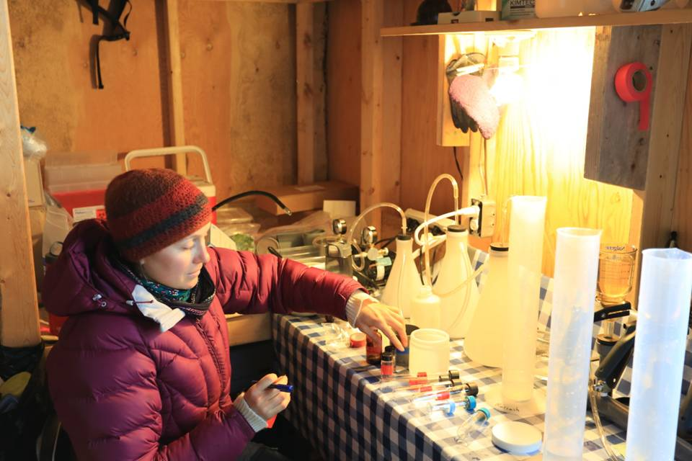
Figure 2. Dr. Heather Mariash filtering water for detailed analyses of nutrient flow from terrestrial to aquatic ecosystems, and through the various trophic levels of aquatic invertebrates.

Invertebrate Sample Collection
Invertebrates are the primary prey of shorebirds and a number of other small tundra birds. Invertebrate samples were collected every three days using pitfall traps placed in dry and moist habitats, as has been done in prior years at these sites. The abundance and diversity of invertebrate species will be calculated to determine the effects of goose grazing on shorebird prey items. We also collected invertebrates from each habitat type in order to develop a library of stable isotope signatures of these prey items, for future diet studies of insectivorous birds.

Tracking Shorebird Migration Using Geolocators
We continued our project using solar geolocators to track migration routes of shorebirds in 2014. This summer, as part of a collaborative study with Jean-Francois Lamarre (UQAR), eight geolocators were deployed on American Golden-Plovers. Retrieval of these, next summer, will help us track the migration routes of this species and contribute to a collaborative effort to understand migratory connectivity across their range. At East Bay, two previously deployed geolocators were recovered from Ruddy Turnstones. One of these was deployed five years ago and has provided us with data from seven migrations. This bird appears to have carried the device without any problems. Six more geolocators were deployed at East Bay: five on Black bellied Plovers and one on a Ruddy Turnstone, which we hope to retrieve next year.

In 2013, collaborators from the Manomet Center for Conservation Sciences deployed 35 geolocators on Semipalmated Sandpipers. In 2014, only two of these were recovered. This rate of return is below that expected based on our previous studies of banded birds, however, 2014 was an exceptionally poor year for breeding and this might have contributed to the low recovery rate. We are investigating this more fully through a detailed analysis across a network of arctic sites to determine whether geolocators might reduce the return rates (presumed to reflect reduced survival) of small bodied shorebirds. If effects are documented, we will adapt our research plans accordingly.

MOTUS Wildlife Telemetry Array
Recent advances in technology have greatly reduced the cost of VHF tracking receivers, making it possible to deploy many receivers across a broad geographic area. This is currently happening in Eastern North America, with hundreds of towers now up at a variety of key stopover locations for shorebirds and other birds. We are an important collaborator in this effort and carried out a variety of projects with this technology in 2014. For example, at the Coats Island and East Bay camps, we deployed small towers to track local movements of birds (within 20km). Using these towers, and by attaching very small tags (<1g) to birds’ backs with glue, we can better understand behaviour during the breeding season. And because the towers are solar powered and operate year-round, we can determine exactly when birds arrive or depart the breeding grounds, even if we’re not present at the site. Ph.D. student Lisa Kennedy from Trent University will use these data to understand how habitat damage from geese influences foraging range and timing of breeding and departure, while M.Sc. student Sarah Neima from Mount Allison University assisted us with tag deployment on the breeding grounds, and then travelled to her field site in the Bay of Fundy to await the arrival of “our” birds during southbound migration, where she monitored their stopover behaviour and length of stay. This new information will help to improve our monitoring of shorebird populations at stopover sites, and information from the breeding grounds will help to identify the possible effects of overabundant geese on birds’ condition, departure, and subsequent migration behaviour.

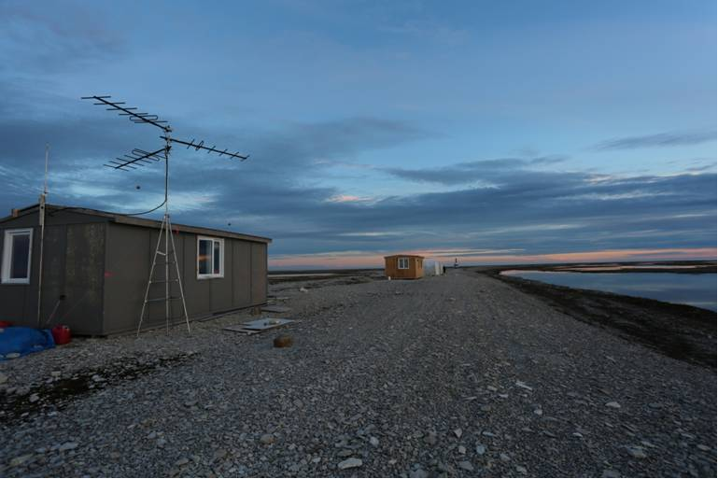

Figure 3. The VHF telemetry tower at East Bay. This tower monitors radio signals emitted by tiny tags deployed on shorebirds breeding in the area, in order to monitor their behaviour and timing of departure for migration.

Monitoring Predators and Rates of Shorebird Nest Success
We deployed time lapse cameras at shorebird nests in order to determine which predators are most common and to better understand the timing and nature of predation events. We also deployed cameras at random locations near and far from goose colonies, in order to monitor the abundance and activity of predators. Forty-five PlotWatcher Pro time-lapse cameras were deployed, and although analyses are ongoing, several predation events were successfully recorded (on Coats Island - Table 3). All predation events recorded to date were from Arctic Fox, although Parasitic Jaegers (a presumed shorebird nest predator) were present at both sites. In 2015 we plan to continue with camera deployments to capture more predation events, and will begin working with honours B.Sc. Shawna-Lee Masson to make further use of these camera data.

Table 3. Shorebird nest predation events captured by time-lapse cameras on Coats Island.

 | AMGP | BBPL | DUNL | REPH | RUTU | WRSA | Total
Cameras Deployed at Nests | 4 | 4 | 3 | 2 | 2 | 2 | 17
Predation Events Captured | 3 | 3 | 1 | 0 | 0 | 0 | 7

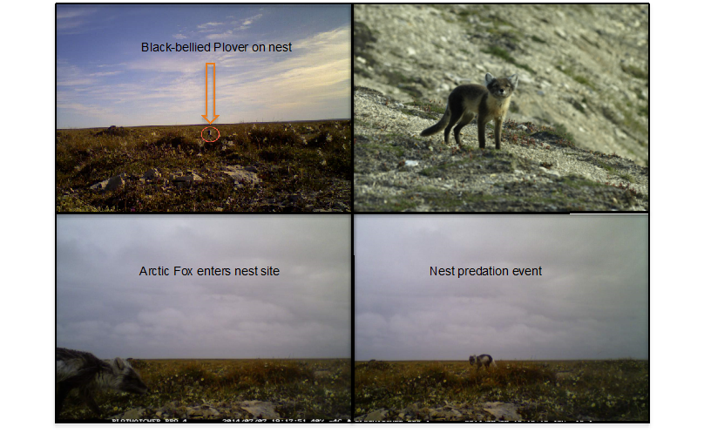
Figure 4. The arctic fox is the most important predator of shorebird nests at the East Bay and Coats Island sites. Our research will determine whether the foxes attracted to goose colonies have a negative effect on shorebirds’ breeding success.

Red Knot Tracking and Habitat Mapping on Southampton Island
The rufa Red Knot was recently listed as Endangered in Canada, and is under consideration for listing in the United States. Beginning in 2013, we carried out aerial surveys, ground based habitat surveys and VHF telemetry to better understand the distribution and habitat use of this species across Southampton Island, in the core of its range. In 2013, a ground crew led by collaborator Dr. Larry Niles (Conserve Wildlife Foundation of New Jersey) searched for breeding rufa Red Knots across the island, while in 2013 and 2014, Environment Canada carried out helicopter- and ground-based surveys in late June. Measurements of breeding habitat were recorded, and in combination with satellite imagery, these data have helped to develop a model of preferred habitat for knots across Southampton Island (Figure 5). This model can also be extended to other areas, to predict where this sparsely distributed species is expected to occur, and where surveys should be conducted in the future.
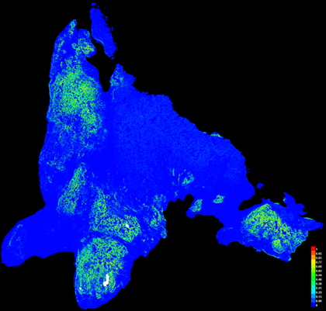
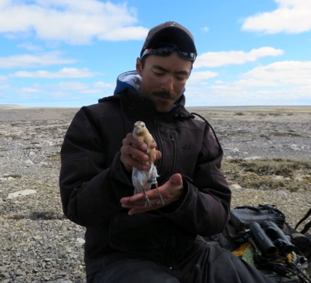
Figure 5. The rufa Red Knot is endangered in Canada and under consideration for listing in the United States. Southampton Island is within the core of its breeding range. Working with collaborators Larry Niles (Conserve Wildlife Foundation New Jersey) and Rick Lathrop (Rutger’s University), we have produced a model describing preferred habitat across Southampton Island. Warmer colours (greens and yellows) indicate preferred habitat, while blue indicates unsuitable areas.
Field Teams and HQP

The 2014 field crews at Coats Island and East Bay consisted of a mix of experienced arctic researchers, students and Inuit guides. Ph.D. candidates/team leaders Scott Flemming and Lisa Kennedy began their studies in 2014, and will spend at least the next two seasons at alternating camps, studying the effects of overabundant geese on tundra-breeding shorebirds. The 2014 Coats Island Team included: Scott Flemming, Sarah Neima, Karissa Reischke, Brad Winn and Shiloh Schulte. Brad Winn and Shiloh Shulte are collaborators from the Manomet Centre for Conservation Sciences, and joined the Coats Island crew in June to retrieve the geolocator tracking devices that they deployed last year. Sarah Neima and Karissa Reishke conducted research related to their MSc theses on migration behaviour of Semipalmated Sandpipers and remotely sensed indices of goose-related habitat change, respectively. The 2014 Team at East Bay included: Lisa Kennedy, Paul Smith, Jennifer Gale, Victoria Putinski, Emma Davis, Stephen Parmiter, Heather Mariash, Josiah Nakoolak and Jupie Angootealuk. Postdoctoral Researcher Dr. Heather Mariash, is studying how geese influence nutrient flow through the food webs of tundra wetlands. From late May through June, we were joined by Josiah Nakoolak and Jupie Angootealuk of Coral Harbour. Josiah has more than 20 years’ experience assisting with our research and is mentoring Jupie. Josiah and Jupie also constructed a new kitchen cabin at the site in 2014, which will offer a safer and more comfortable arrangement for the crew in future years. In 2015, we will be joined by honours B.Sc. students Shawna Lee-Masson and Kevin Young, from Trent University.

Logistical support was provided by Christine Eberl, Mike Janssen and Christie Macdonald.

Contact
If you have any questions, comments or concerns, please contact:

Paul Smith
National Wildlife Research Center or National Wildlife Research Center
Environment Canada Environment Canada
Telephone: (613) 998-7362
Email: PaulAllen.Smith@ec.gc.ca

