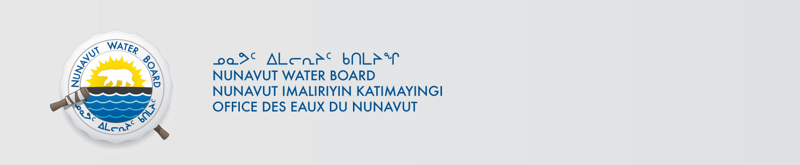
June 4, 2013 File No: 8WLC-PSC----
Mr. Grant Gilchrist
National Wildlife Research Centre
Carleton University
1125 Colonel By Drive (Raven Road)
Ottawa, ON K1A 0H3
Email: Grant.Gilchrist@ec.gc.ca

Subject: 8WLC-PSC----, Kivalliq Region, Population Studies of Shorebirds at Coats Island Project, Application for Approval for the Use of Water or Deposit of Waste Without a Licence

Dear Mr. Gilchrist:

The Nunavut Water Board (NWB or Board) acknowledges receipt on May 28, 2013 of your application for approval for the use of water or deposit of waste without a licence for the Population Studies of Shorebirds at Coats Island Project and confirms that the Application has been deemed administratively complete by the NWB Licensing Department.

The Application has been assigned NWB File Number 8WLC-PSC---- and posted to the NWB’s Public Registry and FTP site and is accessible from the following link ftp://nunavutwaterboard.org/1%20PRUC/8%20MISCELLANEOUS/8WL/8WLC%20-%20Camp/8WLC-PSC----%20NWRC/, username is public and password is registry.

Your Application has been forwarded to the NWB Technical Department for a technical assessment. As part of the NWB’s technical assessment you may be contacted to provide additional information. If you are not contacted to provide additional information you may expect a decision on the application within approximately fifteen (15) working days, from the date of this letter.

Sincerely,

Original signed by:

Phyllis Beaulieu
Manager of Licensing

/pb

Cc: Dave Hohnstein – DTS
Cory Zyla – TA
Christie Macdonald - EC

