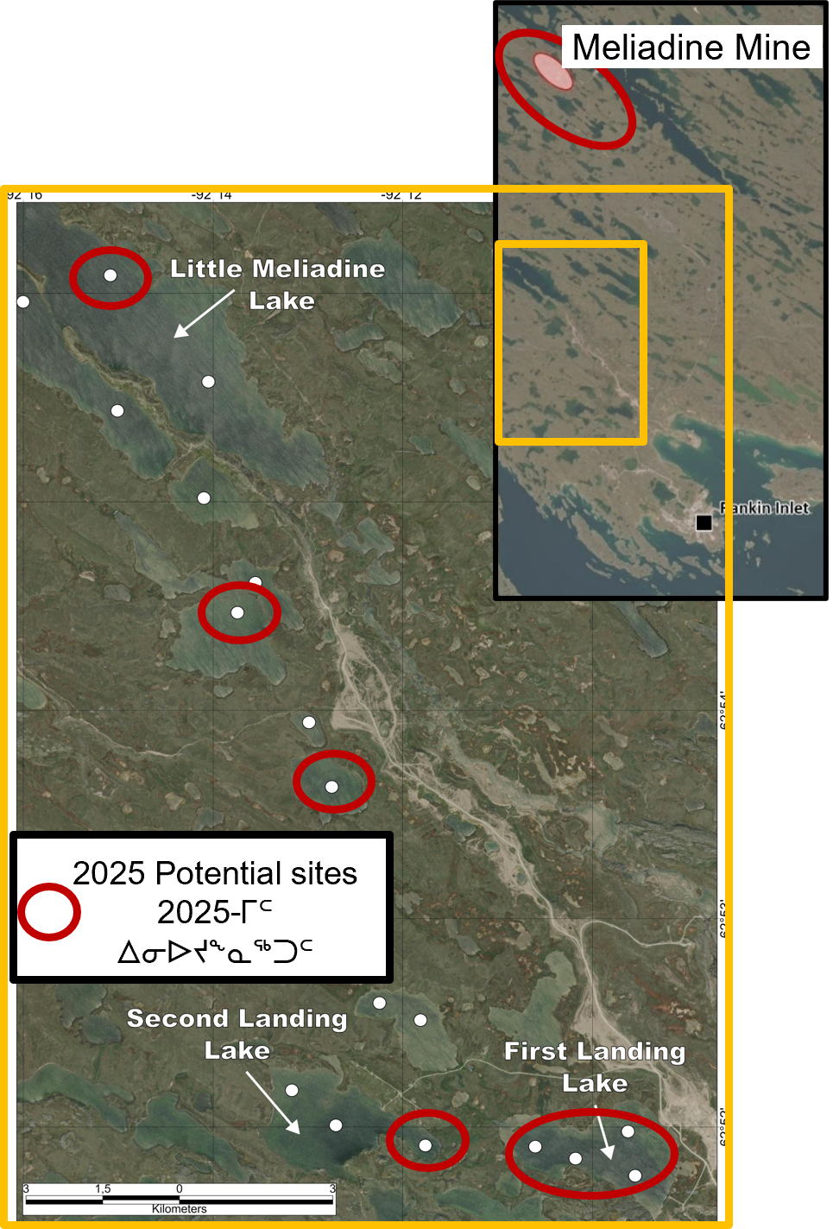
Figure 1: Map of the project area showing locations of 2025 proposed water sampling sites (red circles). Note: white dots are sampling location of 2024.

