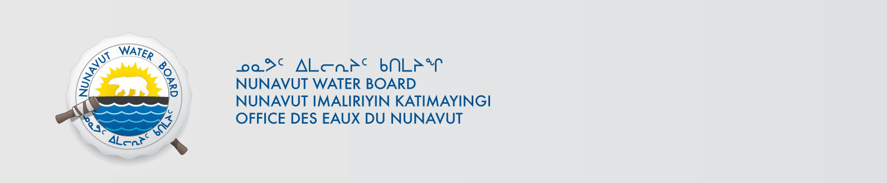

May 15, 2024 NWB File No: 8WLC-UUM----

Sean Desjardins
Arctic Centre, University of Groningen
Aweg 30
9718 CW Groningen, The Netherlands

E-mail: s.p.a.desjardins@rug.nl

Re: Acknowledgement of credit card information for application fee payment for 8WLC-UUM----

Dear Susan Rubin:

The Nunavut Water Board acknowledges receipt on March 21, 2023 of your Visa information for application fee payment. Your information for payment has been forwarded to Crown Indigenous Relations and Northern Affairs Canada in Iqaluit for processing. A receipt will be issued through their office for fees totaling $30.00.

Please call the undersigned at (867) 360-6338 or e-mail licensing@nwb-oen.ca if you have any questions.

Sincerely,

Richard Dwyer

Cc: Margaret Mike, CIRNAC

Andrew Keim, CIRNAC

