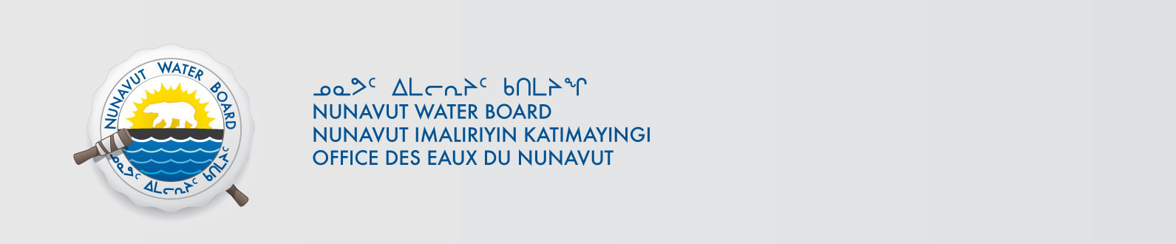
September 28, 2020 File No: 8WLC-WAG2020

Gabriel Choquette
Combustion Performance Inc.
P.O Box 2049
Iqaluit NU, X0A 0H0
gabe@combustionperformance.com

Subject: 8WLC-WAG1920 Wash & Go Project - Combustion Performance Inc., Application for Approval for the Use of Water or Deposit of Waste Without a Licence

Dear Gabriel:

The Nunavut Water Board (NWB or Board) acknowledges receipt on August 19, 2020 of your application for approval for the use of water or deposit of waste without a licence for the Wash & Go Project. The NWB Licensing Department has conducted a preliminary review of your application and has determined that it is incomplete. The following information is deficient:

- English Summary
- Inuktitut Summary
- 2019 Report of Activities

In order to proceed the application must be completed and re-submitted with the deficient information. Please reference the assigned file number on re-submission.

If you have any questions please contact myself at robin.ikkutisluk@nwb-oen.ca.

Sincerely,

Robin Ikkutisluk
License Administrator
/ri

Cc: Richard Dwyer, Manager of Licensing

